INSERT YOUR extended abstract TITLE HERE (FONT ARIAL, uppercase, size 12 pt)
(2 lines spacing here)
Name Surname ¹, Name Surname ² & Name Surname ³
(FULL NAME, Use “ARIAL” font, size 10 pt)
(1 line spacing here)
^{1,3} Affiliation Institution 1, City, Country, (ACRONYMS IN INSTITUTION NAMES AND FULL ADDRESS ARE NOT RECOMMENDED)
e-mail (Use “Arial” font, size 8pt)
² Affiliation Institution 2, City, Country,
e-mail (Use “Arial” font, size 8pt)
(2 lines spacing here)
ABSTRACT (Use “Arial” font, uppercase, Bold, size 10pt)
(1 line spacing here)
This document presents the instructions needed to prepare the 2 page- extended abstract (850-1000 words) in length including figures and references). The various components of your extended abstract [title, text, heads, etc.] are already defined on the style sheet, as illustrated by the portions given in this document. A concise abstract is required. The abstract (in one paragraph of 150 words or less) should state briefly the purpose of the research, the essential new information, the principal results and major conclusions. The abstract must be able to stand-alone and references to the manuscript should therefore be avoided. Extended Abstracts must be written in English. (Use “Arial” font, size 10pt for the abstract texts). Pages should not be numbered.
(1 line spacing here)
Keywords: please list a maximum of 5 keywords separated by commas and full stop at the end. (Use lowercase “Arial” font, size 10pt).
(2 lines spacing here)

- INTRODUCTION (Use “Arial” font, uppercase, Bold, size 10pt)
Please follow the format described here and demonstrated by example with regard to placement of extended abstract title, length and width of text. These instructions serve as an example for proper manuscript production. The figures can be in color since the extended abstract is published online. (Note: No spacing between paragraph)
The authors of the accepted abstracts must submit the extended abstract before the deadline through congress web site. Extended abstract must be submitted PDF via the congress website abstract link.
All standard extended abstract components have been specified for three reasons: ease of use when formatting individual extended abstracts, automatic compliance to electronic requirements that facilitate the concurrent or later production of electronic products, and conformity of style throughout the extended abstract. Margins, column width, line spacing, and type styles are built-in; examples of the type styles are provided throughout this document and are identified in red boldface, within parentheses, following the example.
You can delete this sample text and replace it with the text of your extended abstract. However please note that extended abstract must strictly follow this sample, and therefore we strongly recommend you that you keep an initial version of this file for reference.
First, confirm that you have the correct template for your paper size. Please use A4 size paper, in one column format with “Arial” font. Margins are as follows Top: 1.2cm; Bottom: 1.6cm; Left: 2.0cm; and Right: 1.8cm. Header is at 1.2cm and Footer at 1cm from the page limit, respectively.
The template is used to format your extended abstract and style the text. All margins, column width, line spaces, and text fonts are prescribed; please do not change them.
(1 line spacing here)
- TITLE, AUTHORS AND AFFILIATIONS (Use “Arial” font, uppercase, Bold, size 10pt)
Type the title of the extended abstract in 10pt boldface and in upper case, with a leading (interline spacing) of 12pt and a spacing of 20pt before and after. Authors’ names are set in 10pt and in upper case, with a leading (interline spacing) of 10pt and no spacing before and after. Affiliation and contacts are in 8pt italics, with a leading (interline spacing) of 6pt and a double spacing of 10pt after.

(1 line spacing here)
- HEADINGS AND BODY OF TEXT (Use “Arial” font, uppercase, Bold, size 10pt)
(1 line spacing here)
  - Headings (Use “Arial” font, size 10pt)
Please preserve the style of the headings, text font and line spacing in order to provide a uniform style for the Proceedings.
The Heading 1 should be set in 10pt “Arial” boldface, with a leading (interline spacing) of 10pt and a single spacing of respectively, before and after.
The Heading 2 should be set in 10pt “Arial” regular face, with a leading (interline spacing) of 10pt and a single spacing.

    - Third level headings (Use “Arial” font, size 10pt)
The third level headings should in 10pt “Arial” italic face, with a leading (interline spacing) of 12pt and a spacing of 6pt before and after.

  - Body of texts
The normal texts should be set in 10pt “Arial” with a leading (interline spacing) of 10pt and a single spacing. Lines are single-spaced. The paragraphs should be justified at left and right margins of the text.

- USING THE TEMPLATE FOR SEVERAL COMPONENTS (Use “Arial” font, uppercase, Bold, size 10pt)

  - Equations
Equations should be centered and numbered consecutively, as in Eq. [1]. An alternative method is given in Eq. [2] for long sets of equations where only one referencing equation number is wanted.
(1 line spacing here)

 |  | [1]
where, | (1 line spacing here)
 |  | [2]

  - List
Lists can be provided using either numbers or bullets:
- List item 1 like this;
- List item 2 is an example of a longer list item that wraps to a second line, where the second line is indented.
The example for bulleted items like this:
- List item 1;
- List item 2.

  - Tables and figures
Tables and figures should appear in one column of a page and be numbered consecutively. Figures and texts may appear on the same page, and a centered caption should appear directly beneath the figure. It is preferable that figures be mounted in portrait style and figure captions are no longer than two lines. On figures showing graphs, both axes must be clearly labeled (including units if applicable).
Tables should be designed to have a uniform style throughout the extended abstract, following the style shown in Table 1. Table captions should be in 10pt “Arial” bold, centered, and the texts in Table should be set in 9pt “Arial” font.

Table 1. Caption heading for a table should be placed at the top of the table and within table width.
(Use “Arial” font, size 10pt, No spacing after table title)
 | A | B | C | D
A | Aa | Ab | Ac | Ad
B | Ba | Bb | Bc | Bd
C | Ca | Cb | Cc | Cd
D | Da | Db | Dc | Dd
E | Ea | Eb | Ec | Ed

Authors are advised to prepare their figures in either black and white or color. Please prepare the figures in high resolution (300 dpi) for half-tone illustrations or images. Pictures must be sharp enough otherwise they will be rejected. Figures must be originals, computer-generated or drafted, and placed within the text area where they are discussed. Figure 1 shows one example. Figure captions should be in 10pt “Arial” font, bold, centered. When applicable, the texts in graphs, illustrations or images should be set in 8pt “Arial” font. Full stop at the end of the caption.
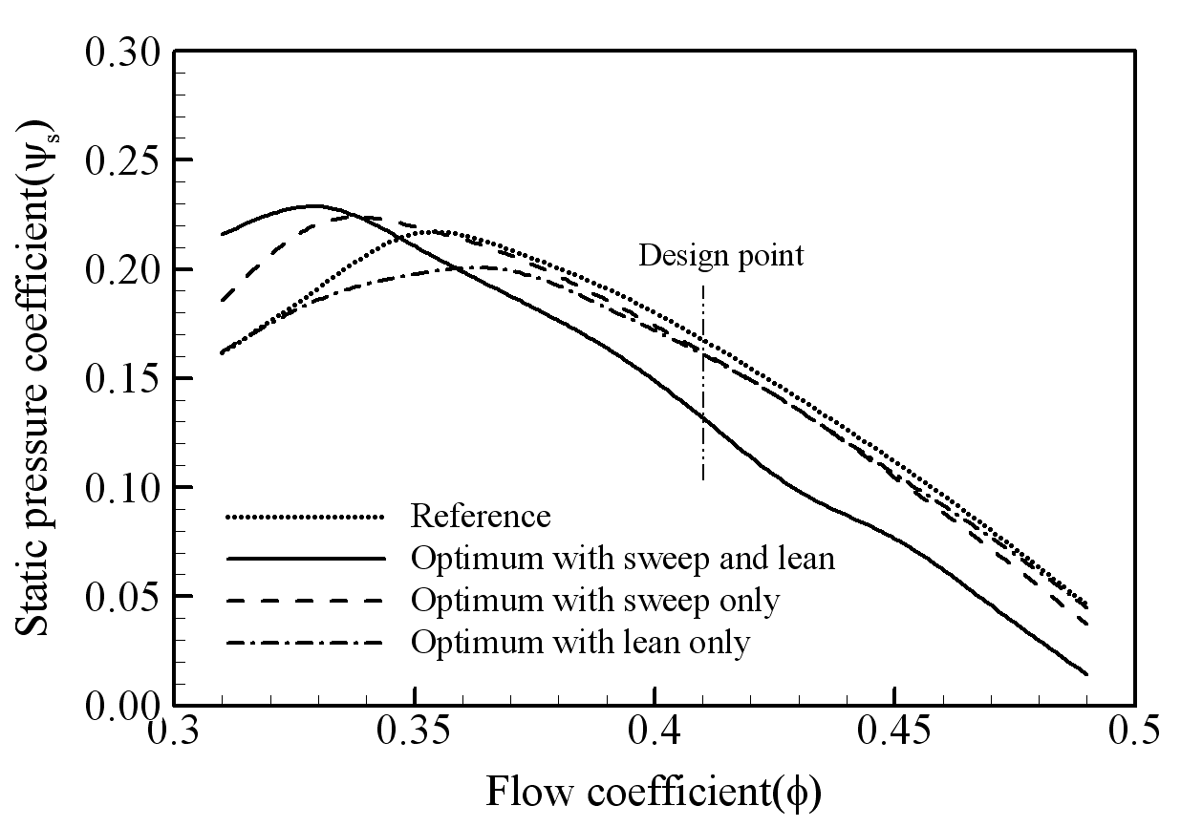
Figure 1. The caption heading for a figure should be placed below the figure and within figure/illustration width. (Use “Arial” font, size 10pt, no spacing between title and figure)

  - Footnotes
Footnotes are denoted by a character superscript in the text b.

  - Units
Use either SI (MKS) as primary units. English or CGS units may be used as secondary units (in parentheses). Avoid combining SI and CGS units. This often leads to confusion because equations do not balance dimensionally. If you must use mixed units, clearly state the units for each quantity that you use in an equation. Do not mix complete spellings and abbreviations of units. Spell out units when they appear in text.

- CONCLUSIONS
If the formatter still needs to create a component which is not prescribed here, please incorporate applicable criteria that follow the styles provided (e.g., spacing and typeface).

ACKNOWLEDGEMENTS (Use “Arial” font, uppercase, bold, size 10pt)
This is where one acknowledges funding bodies, etc. Note that section numbers are not required for Acknowledgements and References.
We appreciate the cooperation and efforts of all authors in producing the Proceedings. This will be a great congress following the tradition of our sponsoring organizations.

REFERENCES (Use “Arial” font, uppercase, bold, size 10pt)
References should appear together at the end of the extended abstract, listed alphabetically by last name of the first author. Thereafter sorting is made by co-authors and year. However, in the text, sorting is done by year (Don et al., 2005; Gran, 1992). References in the text consist of the author name and publication year in parentheses, as found in Don et al. (2005). If several references are cited collectively, they are enclosed on parentheses with no additional parentheses around dates. All references listed should be cited in the text. Example reference citations are provided at the end of this paper. Here are examples:

Dong, N.C.(note: no spacing between alphabets), Araki, H., Yamanishi, H., and Koga, K. (2005). Simulation of groundwater flow and environmental effects resulting from pumping. Environmental Geology, 47 (3), 361-374.
Donelan, M.A. (1978). Whitecaps and momentum transfer. NATO Conf. on Turbulent fluxes through the sea surface, wave dynamics, and prediction, Ed. A. Favre and K. Hasselmann, Plenum, NY, 273-287.
Gran, S. (1992). A course in ocean engineering. Elsevier, 583 pp.
Hwang, P.A., Hsu, Y.H.L. and Wu, J. (1990). Air bubbles produced by breaking wind waves: a laboratory study. J. Phys. Oceanography, 20, 19-28.

b Just like this one.

