DEVELOPMENT OF SCIENTIFIC APPROACHES FOR ENVIRONMENTAL FLOW ASSESSMENT IN UKRAINE

VIACHESLAV MANUKALO
Standardization Section, Ukrainian Hydrometeorological Institute, 37, Nauki Prospect,
Kyiv, 03028, Ukraine

VALENTYN KHILCHEVSKYI
Geographic Faculty, Taras Shevchenko National University of Kyiv, 64/13, Volodymyrska Street,
Kyiv, 01601, Ukraine

The intensive use of surface waters of Ukrainian rivers necessitated providing limits of water abstraction from water objects, which should guarantee of their environmental functions. The quantitative determination of environmental flow is the extremely important task and are currently the subject of vigorous scientific, social and, event, political debates. Results of studies of Ukrainian scientists in the field of developing methods of environmental flow assessment with emphasis on the current state of affairs in this matter, as well as to indicate practical issues which to be solved in the coming years, are presented. The study is carried out on the basis of analysis of scientific publications of Ukrainian scientists for the last 40-45 years. Researches of the environmental flow assessment have started in Ukraine from the 1970s. The hydrological assessment methods were based on estimation of natural flow regime as a key indicator of ecological status of water objects. The terms 'sanitary flow' (for sanitary needs) or 'ecological flow' (for fishery needs) were used as a close synonym of the term 'environmental flow'. In the absence of detailed data about the ecological status of rivers, this approach allowed to determine the so-called "ecological thresholds", i.e., environmentally sound water abstraction from rivers. A new stage in the study of environmental flow began in the 1990s. The hydraulic-habitat methods and then holistic methodologies have been started to develop. Besides the hydrological and hydraulic data the ecological data have been used: ecological estimation of riparian zone, hydromorphological estimation, inventory of habitats, hydrobiological data. The practical application of environmental flow assessment methods requires the adoption of relevant legislation as well as the improvement of water quantity and quality monitoring system formed in 1960-1970. To meet these objectives, during 2016 - 2018 the Ukrainian Parliament and Government issued legal acts aimed to develop the water monitoring system according to the European Union recommendations. Measures to be taken different agencies participating in monitoring system, to meet these acts, are considered.

1 INTRODUCTION
In Ukraine there are about 63000 rivers of different geomorphological types (lowlands, hills, mountains) with a total length about 170000 km.: eight rivers have catchment areas more than 50000 km2, 82 ones - from 2000 up to 50000 km2, others - less than 2000 km2. The runoff of Dnipro, Dniester, Siversky Donets, Bug, Southern Bug, Danube rivers with their tributaries as well as of small rivers of the Crimean peninsuala and rivers belonging to the Black and Azov Seas basins is a main source of fresh waters in Ukraine (Figure).
Practucally, all Ukrainian rivers are used intensively for different purposes: drinking, industrial and agriculture water supply, energy production, fish-farming, irrigation, transport use and recreation. The increase of using water resources has necessitated an introduction of limits of water abstraction from rivers, which should guarantee a preservation of environmental function of watercourses. This also has raised the question of how much fresh water should remain in watercourses to ensure proper ecological conditions in river ecosystems. That is why, the quantitative determination of environmental flow is the extraordinary pretentious task and are currently the subject of vigorous scientific, social and, event, political debates in the country.
At the present a number of Ukrainian water-related institutions are involved in the activity which has been undertaken in the framework of implementation of the Integrated Water Resources Management principles as well as the Water Regulations of the European Union. The development of methods of evaluation of environmental flow to be considered as the very important part of applying these principles and regulations on river basin scale.
Views on the definition and quantification of environmental flow in Ukraine have developed considering: a) developing scientific approaches in this area; b) increasing an use of water resources and a deterioration of their quantitative and qualitative characteristics; c) changing priorities in the country's economic and environmental policy. The purpose of this article is to present results of study of Ukrainian scientists in the field of developing methods of environmental flow assessment with emphasis on the current state of affairs in this matter, as well as to indicate practical issues which to be solved in the coming years.
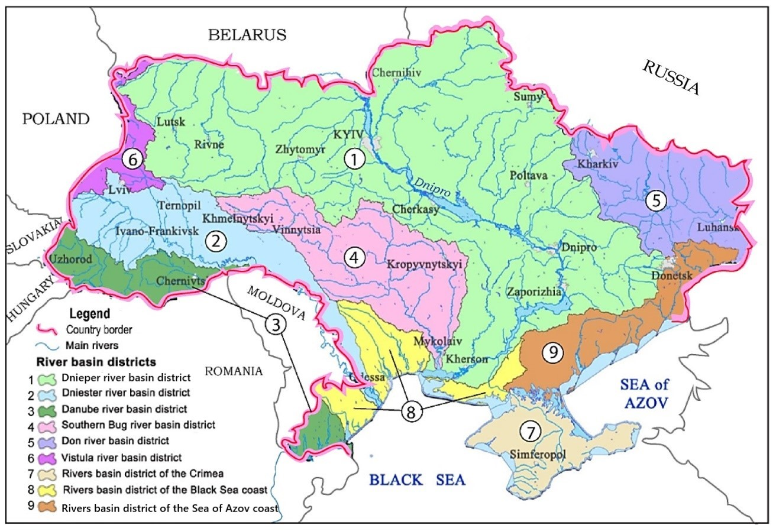
Figure. Map of hydrographic zoning of the territory of Ukraine [1]

2 USED METHODS AND MATERIALS
The article has been prepared on the basis of: a) results of researches which carried out by authors within the scientific theme: 'Development of scientific recommendations for improving environmental requirements for integrated water management activities in river basins of Ukraine up to 2030'; b) analysis of researches of Ukrainian scientific community published in Ukrainian and foreign scientific literature. The list of used literature sources is given below.

3 RESULTS

3.1. General Remarks
The ability to use surface water resources with necessary quantitative and qualitative indicators is the basis of sustainable socio-economic development and provision of ecological society needs. That can be done through a creation of effective water resources management system, which includes a number of structural (in particular, a construction of dams and reservoirs), and non-structural (in particular, a development of early warning systems) measures. Due to the fact that structural measures are built in river basins, a regime of natural flow of water bodies is seriously changing, which often leads to a flow reduction. The consequences of this are changes in the hydraulic and morphometric parameters of river flow, which reduces the self-cleaning and transport capacity of watercourses and negatively affects the water quality and ecological conditions of rivers.
The deterioration of ecological conditions in the main river basins of Ukraine has set scientists the task of developing scientific principles for determining environmentally-relevant limits on water abstraction from the rivers in order to provide the minimum amount of water that must remain in watercourses to preserve river ecosystems.
The flow, which aims to preserve environmental conditions in rivers, has received various definitions in the literature, in particular: 'minimum allowable flow', 'instream flow needs', 'ecological reserve', 'ecological demand of water' [2]. It can be explained by a fact that researchers from various scientific disciplines have been involved in studies of environmental issues of river flow. That has changed the conceptual approaches to a definition and study of environment flow [2,3].
In this article the term 'environmental flow' is considered as 'the quantity and quality of water in rivers assuring the preservation of ecological balance respectively preserving the status of rivers as natural aquatic ecosystems'. We also support the proposal [2] to take into consideration geomorphological changes in riverbeds when determining environment flow.

3.2. History of Researches
Researches of environmental flow assessment have started in Ukraine in the period from 1970s when Ukraine was the part of the former Soviet Union. It should be noted during the first period the theoretical basis of these studies were scientific developments of scientists who lived outside the Soviet Union. The overview of these foreign studies is given in the publication [2,3]. In Ukraine, these studies were concentrated in research institutions from areas of water management and protection which were located in Kyiv (the capital of the country) and Kharkiv (the large scientific centre of the country) cities.
According to the accepted classification [2], methods of environmental flow assessment of this period belong to the 'hydrological methods'. In the absence of detailed data about the ecological status of rivers, this approach allowed to determine the so-called 'ecological thresholds', i.e., environmentally sound water abstraction from rivers. They were based on estimation of natural flow regime as a key indicator of ecological status of water objects. The terms 'sanitary flow' (for sanitary needs) or 'ecological flow' (for fishery needs) were used as a close synonym of the term 'environmental flow'. In these methods, a number of certain quantitative characteristics of river flow were used as the indicator of environmental flow.
In the publication [4] it was proposed to determine the minimum 'ecological' flow as equal to 75–80% of the minimum monthly river discharges of 0.95% of probability of exceeding. In the article [5] it was proposed to take as environmental flow the lowest average monthly water discharge for observation period or the minimum water discharge of certain probability of exceeding.
In the interdepartmental normative document used in the Hydrometeorological Service and Water Management Authority of Ukraine [6], the value of minimum 'environmental' water discharges that must remain in the riverbed are calculated as 75% of average water discharge in the month with the lowest flow in the year with the annual runoff of 95% probability of exceeding .
Thus, these methods for determining environmental flow are based on the assessment of hydrological regime of rivers, but they do not reflect the process of interaction between water flow and river channel, that significantly determines the environmental situation in watercourses. Only by knowing quantitative indicators of flow hydraulics, it is possible to comprehensively address issues of ecological balance in river systems, taking into account hydrological, hydrochemical and hydrobiological regimes, as well as geomorphological features of riverbed structure and adjacent part of catchment.
The hydraulic - habitat methods [1 ] allow to take into account to much greater extent processes of environmental flow assessment. With these methods, environmental flow requirements can be defined by assessing hydromorphological conditions needed to meet specific habitat requirements for biota using data of water regime of stream flow, riverbed hydraulic and morphological characteristics: water depth, flow velocity, substrate composition, channel geometry.
This group of methods began to develop in a number of scientific and educational institutions of the independent Ukraine in 1990s. Initially, these studies were based on results of foreign publications, but since the 2000s, more and more original researches by Ukrainian scientists has begun to appear.
The author of the publication [ 7 ] develops the concept of environmental flow in depending on such factors as minimum water discharges during low-water periods (taking into account wastewater, value of biochemical oxygen demand, oxidation of bottom sediments, etc.) and conditions for maintaining a bio productivity of rivers and their floodplains. The author has calculated the environmental flow in the range of water discharges from 99% to 25% of probability of exceeding, which are most often used in the water management practice. He also has proposed transition coefficients to determine the environmental flow for water discharges of different probability of exceeding. It can be say that in this publication it began to be used holistic approaches to assess environmental flow requirements by considering of interaction of different components of aquatic and riparian ecosystems.
In the article [ 8 ] under environmental flow has been offered to understand river discharges which do not break the self-regulating system 'stream-riverbed'. That are water discharges, which correspond: a) to the water flow during a passage of high floods and provide the main flow volume of suspended and bottom sediments: b) to the water discharges with non-silting speeds, at which only the flow of suspended sediments is observed in the low flow period.
It should be noted that the use of this group of methods of environmental flow assessing required the expansion of data on hydraulic and morphometric characteristics of watercourses and river floodplains, as well as data on water quality, which determine the living conditions of aquatic organisms. The sources of data were results of observations on the networks of the State Hydrometeorological Service and the State Agency of Water Resources, as well as materials of special field researches. These field studies required significant amounts of additional funding for a purchase special equipment as well as for providing rather long field works. The real economic situation in the country did not allow to ensure adequate financing of field work, which complicated the development and widespread use of hydraulic - habitat methods for environment flow assessing.

3.3. Measures necessary for practical application of environmental flow assessment methods
In Ukraine, there are a number of problematic issues that hinder the introduction of advanced methodologies for environmental flow assessment in water management and water protection practices, which can be divided into three groups: legislative, institutional and financial.
In the country, the concept of environmental flow is not fixed legislatively, and there are no approved uniform methods of its assessment. The use of modern methods for assessing the environmental flow requires an expansion of monitoring data on hydrological, hydrochemical, hydraulic and hydrobiological regimes of rivers. This, in turn, requires institutional and technological improvements of the state surface water monitoring system formed in 1960s - 1970s.
The institutional development of the monitoring system is to improve the coordination works among monitoring programs carried out by various government agencies involved in this activity. It should be noted that there is now some duplication of certain types of observations in monitoring programs. The extremely urgent task is the technological re-equipment of monitoring system. Existing measuring instruments and laboratory equipment do not meet current requirements, which makes it difficult to obtain the data needed to assess environmental flow.
The technological re-equipment requires significant investments from the state budget, which is quite difficult to do in the present economic conditions. Therefore, the important area of activity of the Ukrainian Government is the cooperation with international financial organizations in order to get targeted loans for the modernization of monitoring system.
To meet these objectives, the Ukrainian Parliament and Government issued legal acts aimed the developing the water monitoring system according to the European Union recommendations. In pursuance of these Government decisions, the State Hydrometeorological Service and the State Agency of Water Resources have amended their surface water monitoring programs. In particular, the Hydrometeorological Service has started to carry out the hydromorphological monitoring, the data of which are very important for the environmental flow assessment [ 9 ].
The Ministry of Nature Protection together with the Hydrometeorological Service and the Water Resources Agency prepared and submitted to the Cabinet of Ministers of Ukraine for approval a draft of government resolution on the introduction of environmental flow assessment methodologies into the national water management and protection activity.
The researches in the field of developing environmental flow assessment methods is currently concentrated at the Ukrainian Hydrometeorological Institute, Taras Shevchenko National University of Kyiv, Odesa State Ecological University and the Institute of Hydrobiology.

REFERENCES

- Khilchevskyi V., Grebin V, Zabokritska M., Zhoynir V., Bolbot H., Plichko L. Hydrographic characteristic of ponds distribution in Ukraine - basin and regional features, Journal of Water and Land Development, No46 (VII-IX), (2020), pp. 140-145.
- Guidance on Environmental Flow. Integrating E-flow Science with Fluvial Geomorphology to Maintain Ecosystem Services, the World Meteorological Organization Publication - No1235, (2019), 52 p.
- Tharme R.E. A global perspective on environmental flow assessment emerging trends in the development and application of environmental flow methodologies for rivers, River research and applications, No 19, (2003), p. 397–441.
- Gatillo, P., Filipovich, I., Questions of assessment of minimum necessary water flows of the rivers. In: Problems of Use of Water Resources, The Collection of Scientific Works, (1971), Minsk, pp. 26 - 42 (in Russian).
- Velner H., Kask A., Determination of limiting minimum water discharge. In the book: E ecological models of small rivers and reservoirs, (1985), pp. 21-27, (in Russian).
- Regulations on the procedure for assessment and information on low water (hydrological drought) on water bodies of Ukraine, (2020), Kyiv, Ukrainian Hydrometeorological Center, 13 p. (in Ukrainian).
- Yatsik A., Water Management Ecology, (2004), Vol. 3, Kyiv, Geneza, 376 p. (in Ukrainian).
- Obodovsky O., Hydrological and ecological assessment of riverbed processes on the example of rivers of Ukraine, Kyiv, 2001, Nica Center, 274 p. (in Ukrainian).
- Osadchyi V., Khilchevskyi V., Manukalo V., National Hydrometeorological Service in Ukraine - 100 Years of System Monitoring (1921-2021). Proceedings 15th International Scientific Conference on Monitoring of Geological Processes and Ecological Conditions of the Environment, Vol. 2021, (2021), pp. 1-5.

