New Methods for Connectivity Assessments of River Ecosystems

Sebastian Schwindt, Maximilian Kunz, Silke Wieprecht
Institute for Modelling Hydraulic and Environmental Systems (IWS), University of Stuttgart,
Stuttgart, Baden-Württemberg 70569, Germany

Shanghong Zhang
North China Electric Power University
Beijing, Changping District, China

Jin Zhang
School of Civil Engineering, Yantai University
Yantai, Shandong Province, China

Caihong Tang, Le Wang
North China Electric Power University
Beijing, Changping District, China

Abstract: Anthropological development fragmented many river ecosystems and disrupted their connectivity. Affected river landscapes changed from natural fluvial landforms with a high degree of biodiversity into monotonous streams. In addition, many rivers are longitudinally divided by dams and laterally confined by hydraulic structures (e.g., for bank protection or water diversion). The expected hydro-climatic change will additionally impinge on the runoff regime of many rivers and further increase the stress on aquatic ecosystems. Since pristine river ecosystems are vital for the global food chain (e.g., as a habitat for many microorganisms) and provide resilience against natural disasters (e.g., floods and droughts), river restoration has become a primary action to prevent climate change impacts. This is why thousands of river restoration projects are currently in progress worldwide though the scientific baseline is disappointing and a transfer of knowledge from project-external findings is often lacking. For this reason, in a new Sino-German study, we are identifying new parameters for assessing lateral, vertical, and longitudinal connectivity of rivers and how combined connectivity affects ecosystem quality. While lateral and longitudinal connectivity as well as their interactions have already been extensively studied, vertical connectivity between rivers and their hyporheic zones is rarely considered as an integral element for ecosystem functioning. Furthermore, we analyze the link between three-dimensional (lateral, longitudinal, and vertical) connectivity and ecological assessment criteria, such as the Habitat Suitability Index. The Yellow River in China and the German Middle Rhine serve as testbeds and merging the findings from both sites will finally enable a transfer of results and vetting of hypotheses for two river ecosystems. This choice was made because the ecosystems of the Yellow River in China and the Rhine in Germany emblematically testify to the evolution of ecosystem degradation that came along with industrialization in the last two centuries. The here presented component of our study focuses on the Rhine, where we combine lateral connectivity parameters with vertical profile characteristics of parameters such as hydraulic conductivity or oxygen concentration. To this end, we conduct intensive fieldwork in which we sample grain sizes at and underneath the surface of alluvial plains. For instance, we use a freeze core technique in combination with structure from motion to derive a digital twin of the in-situ sediment matrix. Ultimately, at the end of this study, we want to establish a globally applicable scientific foundation to holistically assess and improve ecosystem connectivity.
Keywords: ecology, habitat suitability, hydrology, Rhine, Yellow River

- INTRODUCTION
Affected by global change and multiple stresses of human legacies such as dams, channelized rivers, and urbanization, the Earth's surface has experienced partially irreversible changes [1,2]. For instance, today, more than three thousand dams fragment the Chinese Yellow River watershed and hinder fish migration [3]. On the other side of the world, the Rhine was “corrected” for navigation purposes already at the beginning of the 19th century [4] with dramatic consequences for the aquatic ecosystem [5,6]. While energy production and agriculture still depend on past river modifications, their impacts on the ecosystem increasingly endanger food security. In addition to the anthropologically influenced changes of rivers, hydro-climatic change is expected to exacerbate the stress on the environment [7].
The Yellow River and the Rhine represent two characteristic, heavily modified waterways that experienced significant degradation of their ecosystems. Both rivers created morphologically similar fluvial landscape pattern, but in hydrologically and geologically different environments (see Figure 1) and with different legacies.

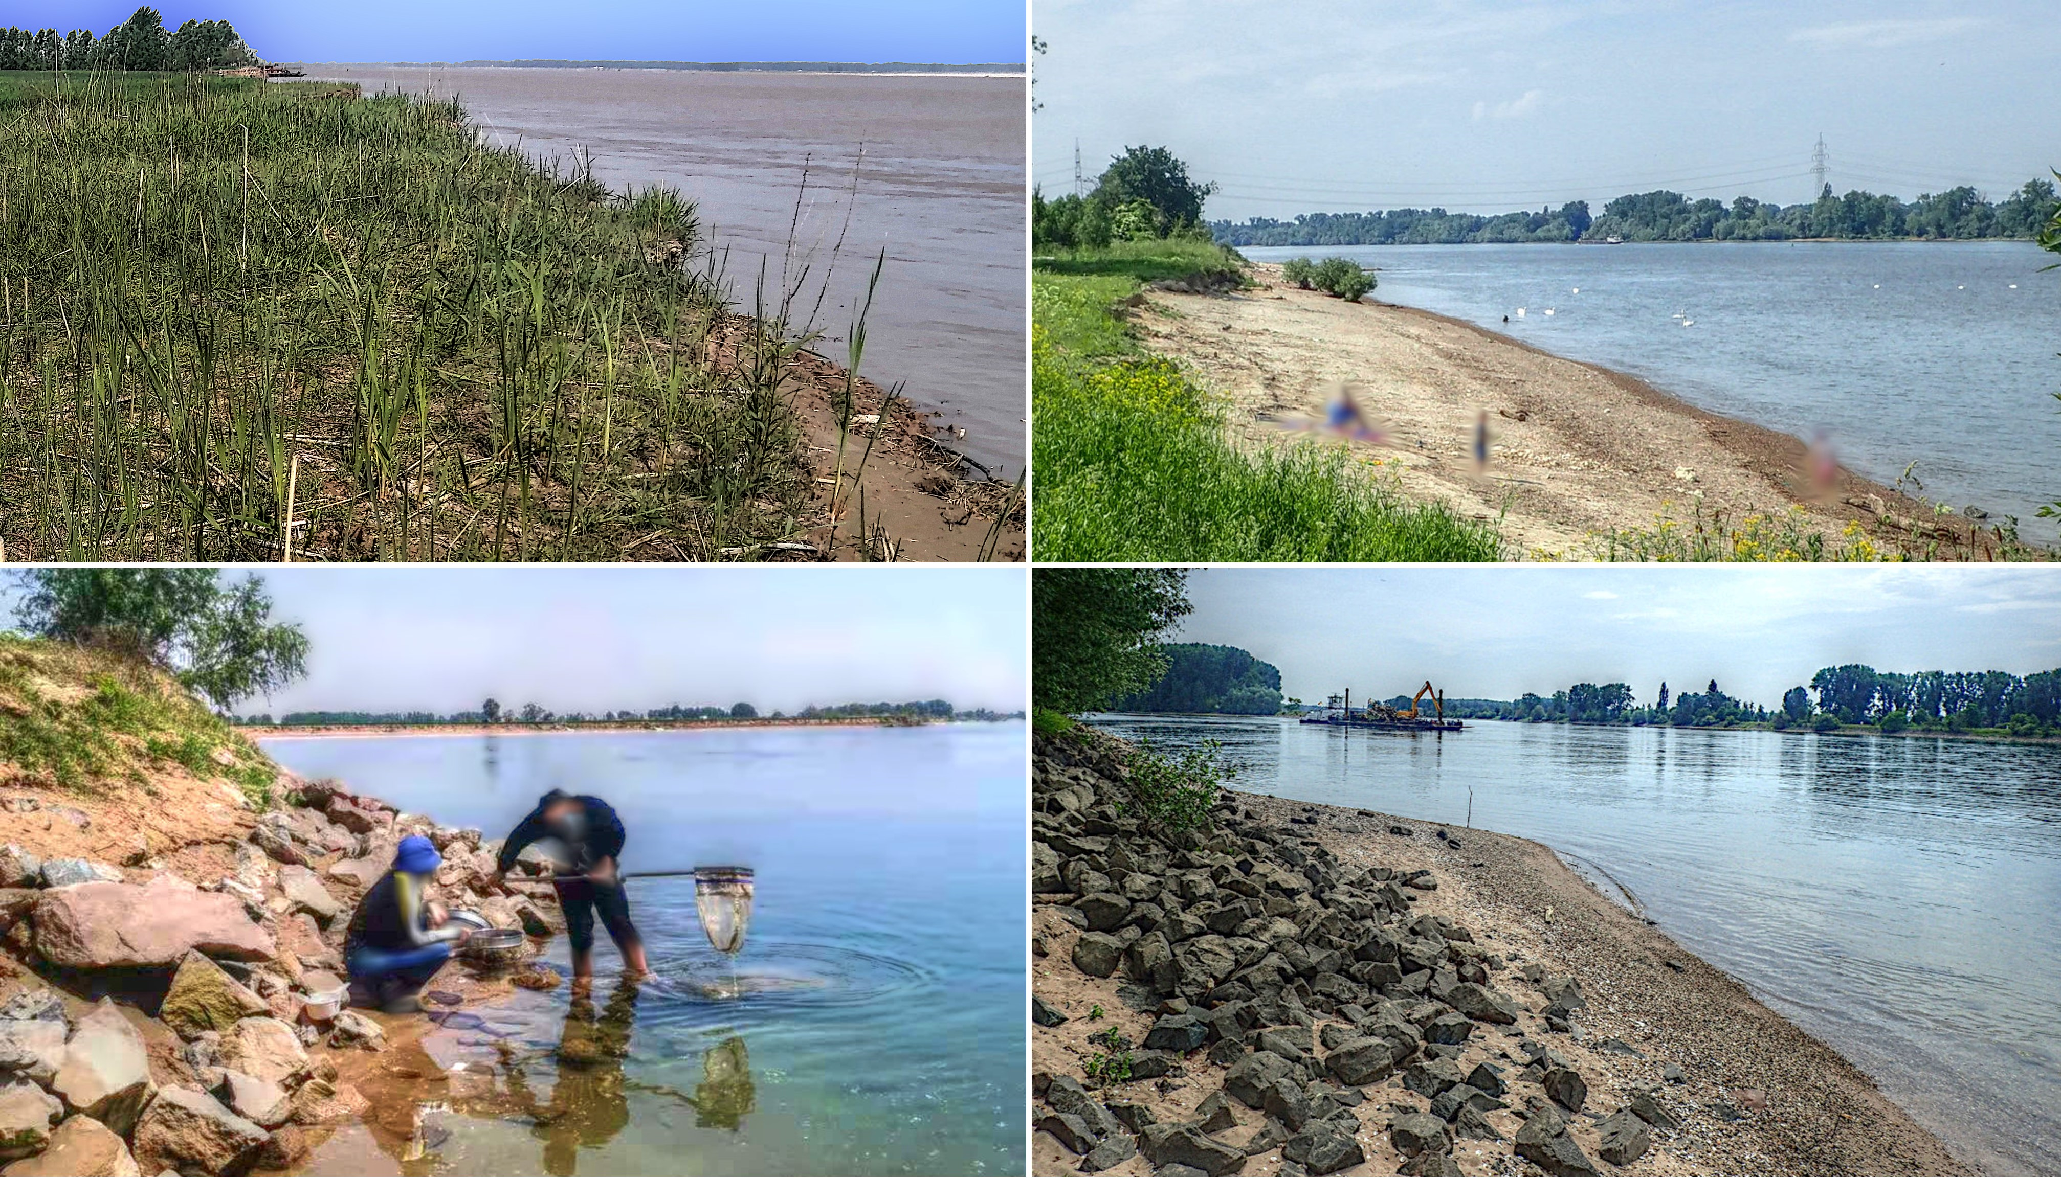
Figure 1 The left column shows pictures from the Yellow River (source: Le Wang) and the right column shows the Rhine (source: Sebastian Schwindt). Morphological similarities appear in the first row in the form of sandy beaches and in the second row by shot-rock bank protection.

At both rivers, legacies and hydro-climatic change impose similar challenges, where extended drought periods and intensified floods are likely to occur [8]. The sustainable deployment of hydrological control structures and nature-based engineering can potentially mitigate the consequences of the expected climate change. For instance, large dams at the Yellow River provide storage capacities that enable releasing of so-called environmental flows, which describe quantities, quality, and pattern of discharge fluctuation required to sustain the aquatic flora and fauna [9]. Thus, environmental flows aid in restoring the longitudinal, hydrological connectivity of rivers. In the absence of storage capacity for environmental flow control, river ecosystems can be sustained through direct, local measures on the river reach scale (~up to 100 channel widths). Such measures involve terraforming and nature-based solutions with indigenous vegetation and aim at the restoration of lateral and vertical connectivity to simultaneously enhance habitat quality and flood safety [10].
Dynamic, self-maintaining, and regenerating good habitat is characterized by the presence of hydraulic, ecological, and morphological diversity [11], which can also be parametrically expressed [12]. Several approaches exist for the parametric description of hydrological and morphologically healthy ecosystems, but they often imply subjective expert assessments. This is why comprehensive studies on parametric and objective ecosystem assessments developed schemes, such as biological index-driven habitat analysis [13,14], fuzzy logic habitat assessments [15,16], and numerically driven river restoration planning [14,17].
Numerical modeling plays a key role in the parametrization of river ecosystems where hydro-morphodynamic modeling in combination with habitat suitability modeling aids in better understanding the state of river ecosystems and urgent needs for actions [13,16,18]. However, the translation of morphodynamic modeling and ecosystem characterizations into the generation of new, well-connected aquatic habitat represents a great challenge for researchers worldwide. To solve this problem, this study introduces a unique collaboration between Chinese and German researchers for a sustainable transfer of knowledge and to layout the baseline for future restoration actions in heavily modified rivers. We intend building green interdisciplinary bridges between hydrologists, engineers, ecomorphologists, as well as between China and Germany. With this goal in front of us, we analyze the longitudinal, lateral, and vertical connectivity of the Yellow River and upper Rhine River ecosystems.

METHODS
  - Overview
At the Yellow River, we perform eco-hydrological analysis regarding longitudinal connectivity to improve the guidance for ecologically friendly dam releases and river restoration actions toward robustness against global change. At the Rhine River, we focus on lateral and vertical connectivity analysis. Thus, we are developing a two-fold approach in two different environmental setups. The two-fold approach involves a longitudinal connectivity optimization through hydrological improvement of ecologically sustainable dam releases in China and a combined lateral-vertical connectivity evaluation at the Rhine. Ultimately, we aim to develop a parametric description of river ecosystems to leverage novel, connectivity-improving restoration design approaches. In addition, this Sino-German collaboration will endow its results with global relevance by merging expertise and complementary hydrological-morphological analysis.

  - Lateral and Vertical Connectivity
Based on existing literature on the ecosystem of the Rhine, its past evolution, target species and restoration activities, we identified publicly available and internal data resources (e.g., flow series, hydraulic data, habitat suitability curves, substrate classifications, and existing terrain models), which are needed for numerical models of the Rhine and ecosystem optimization. Thus, the analysis of the hydro-climatic environment of the Rhine uses existing data and classifications of the current flow regime, as well as an assessment of hydro-climatic change scenarios with their consequences for extreme hydrological events. For instance, during longer periods of drought, lateral riparian habitats are expected to dry out. In contrast, during major flood peaks, greater hydraulic forces will have destructive effects on habitats, and potentially on infrastructure, too.
The available data sets served to identify two 1-2 km-long study sites at the Rhine, which we are modeling numerically with two different codes. First, we use the open-source software Telemac [19] for a wide-ranging hydrodynamic model of a several hundred kilometers long stretch of the Rhine, in which the two study sites are located. Second, we use the results of the wide Telemac model for boundary conditions in another detailed numerical model that we are building with the open-source software OpenFOAM [20]. The detailed model depicts the flows above and underneath the riverbed in high resolution.
To calibrate the models, we use publicly available information on stage-discharge relationships from gauging stations and field data that we are collecting. To this end, the fieldwork measurement campaigns use devices for measuring hydraulic quantities, such as flow velocity and water depth, and sediment characteristics, such as grain size distribution, porosity, Oxygen, and hydraulic connectivity. Assessing the riverbed (i.e., hyporheic zone) characteristics in the form of vertical profiles of grain sizes, porosity, Oxygen, and hydraulic conductivity requires complex equipment that was developed along with the so-called MuliPAC and VertiCo approaches [21,22]. In this context, Figure 2 a) shows the creation of a freeze core by filling liquid Nitrogen into an iron tube. The sediment freezes around the iron tube, which is then pulled out of the ground and put on a spinning device to shoot imagery for structure-from-motion (SfM, cf. Figure 2 b). The SfM imagery later serves for deriving the soil porosity from the freeze core. Once melted, the sediment is sieved to also get the grain size distribution of the hyporheic zone. In addition, Figure 2 a) indicates the implementation of the VertiCo method, in which another iron tube (red head) with small side openings is hammered into the riverbed. A double-packer device that slides inside this second iron tube then builds a small, mobile chamber in the tube. This sliding chamber is then moved vertically and step-wise to the side openings and water (and air) is sucked up with a pump from the chamber. The only way that water and air can get into the chamber and sucked out of the chamber is through the side openings of the tube. Thus, the more porous or loose the ground, the more water and air can be sucked through the chamber. With this technique, the hydraulic conductivity and Oxygen content of the sediment matrix can be derived in a complex post-processing of the measurement data [22,23].

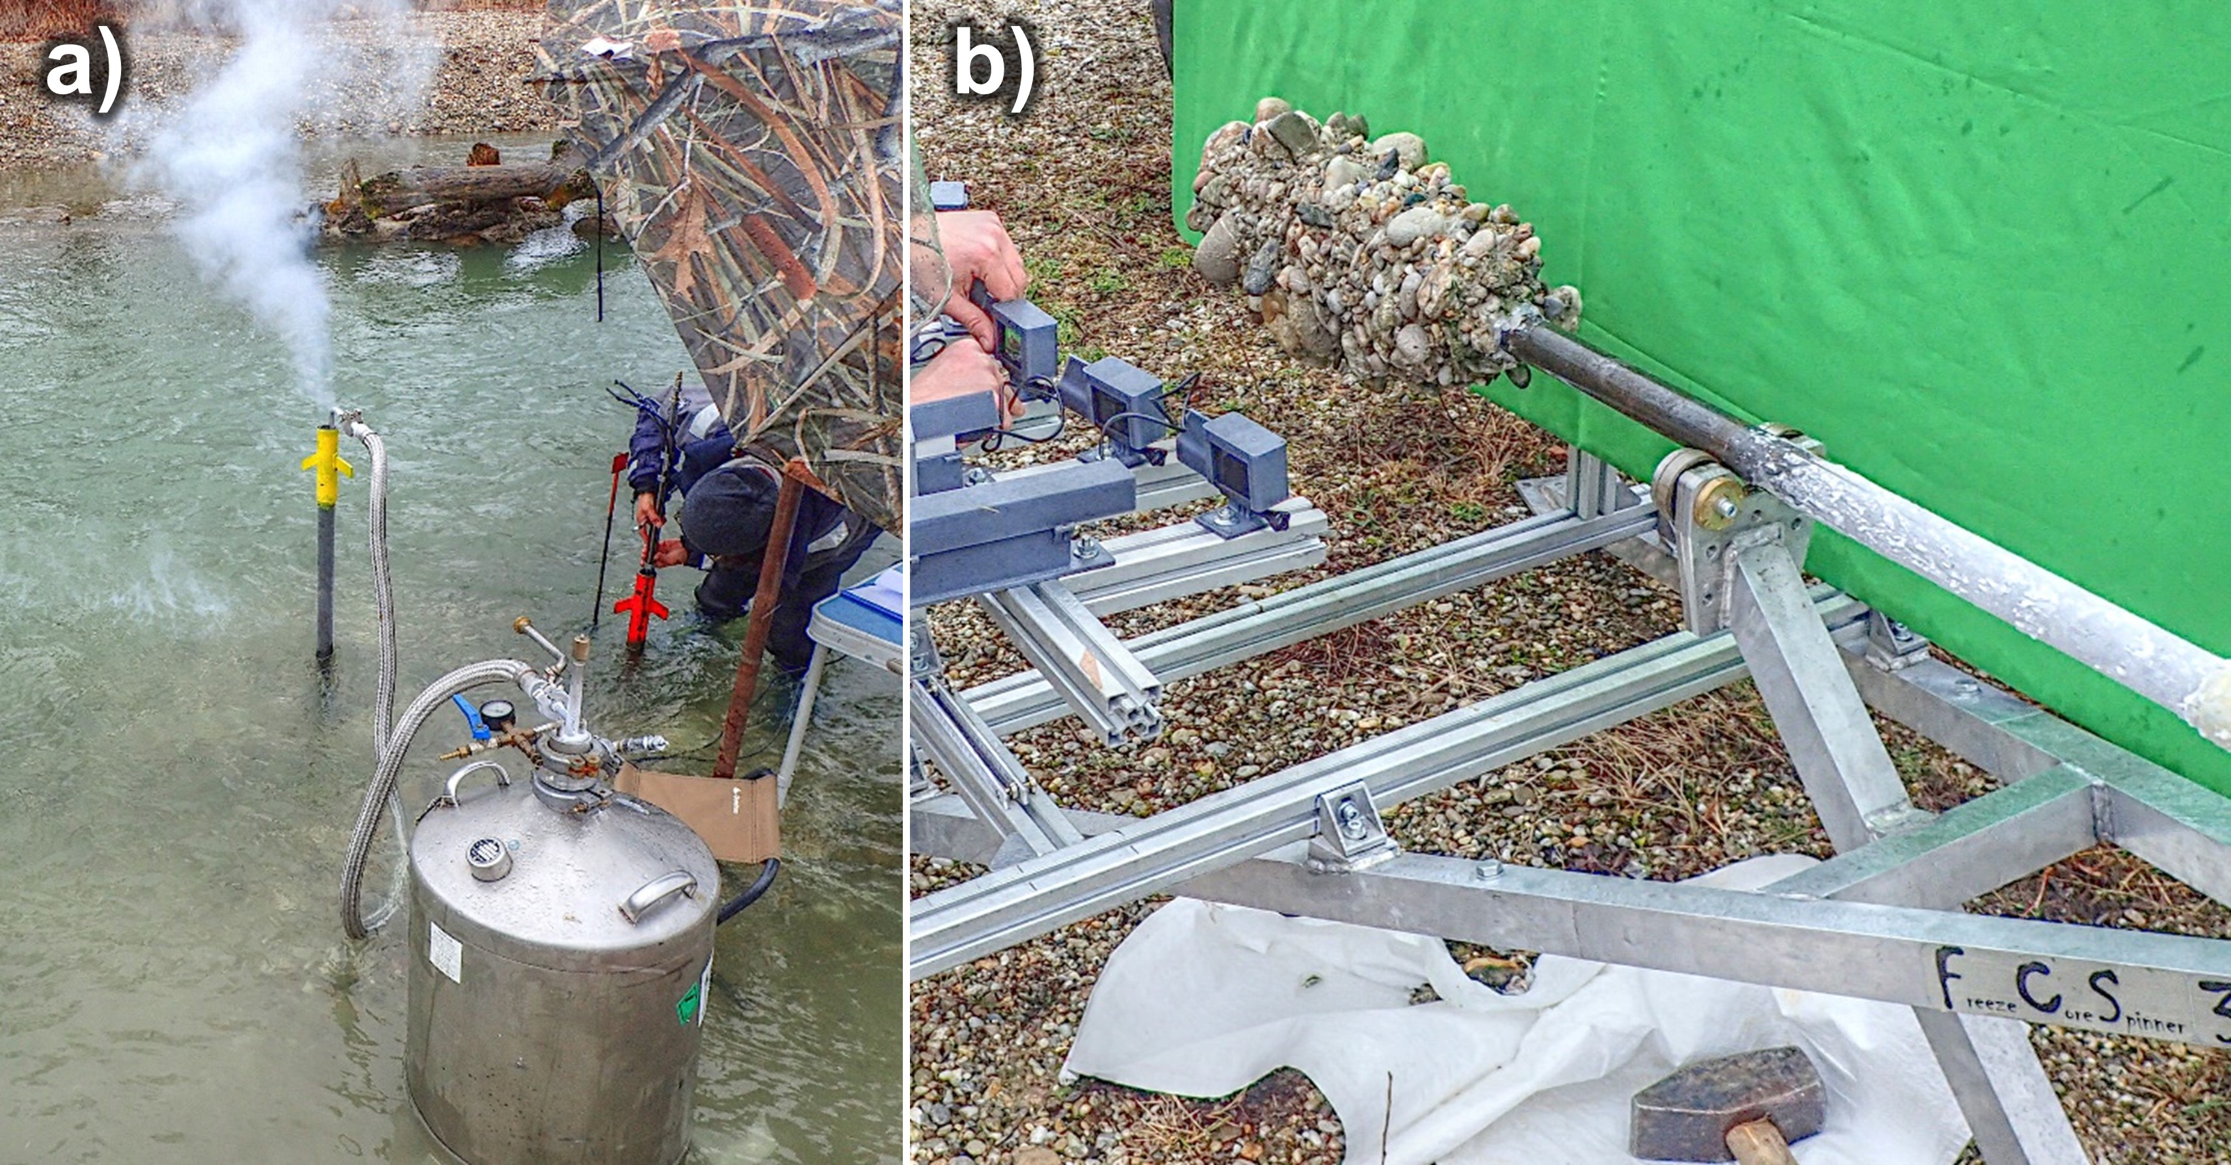
Figure 2 a) shows the creation of a freeze core by filling liquid Nitrogen into the yellow-headed iron tube. The red-headed iron tube shows the VertiCo procedure for measuring Oxygen and hydraulic conductivity of the hyporheic zone; b) shows a setup for structure-from-motion imagery to derive the soil porosity from a freeze core (source: Sebastian Schwindt).

Translation into River Restoration Support
With the numerical, hydraulic-morphodynamic models of the selected sites and the collected data, we aim to improve and newly develop landscape modeling schemes and algorithms (e.g., similar to River Architect [14]). Such ecological landscape design will have the ultimate goal to enhance the habitat quality for target species. In addition, we are examining climate change scenarios and how those might affect the habitat quality because of hydraulic and hydrological extremes. For instance, a climate change scenario may alternate (in time and magnitude) extreme drought and flood hydrographs at the upstream boundary conditions of the numerical models. Thus, we will be able to identify the consequence of shorter or longer wetting of the alluvial planes. In this context, we are particularly focusing on vegetation and how vegetal restoration features may aid in improving the physical habitat quality.

- ANTICIPATED RESULTS
The expected results will describe the response relationship of hydro-morphodynamic river ecosystem adjustments (i.e., restoration actions) and how those can be optimized to mitigate hydro-climatic change impacts. In particular, the application of restoration actions such as riparian vegetation planting and recruitment, streambank protection removal, and environmental flow regimes will be analyzed. Thus, we will establish robust hydrological and hydro-morphodynamic design schemes for the adaptation of river ecosystems to attenuate impacts caused by extreme droughts and floods.
Currently, we are developing a database that contains specific characteristics of the soil matrix of the hyporheic zone. The database is the first step toward (re-)defining boundary conditions for the numerical models of the free surface and subsurface flow. To this end, we are also in the process of calibrating the two numerical models with Telemac (coarse resolution of free surface flows) and OpenFOAM (detailed resolution of free surface and subsurface flows.
Finally, we want to take advantage ofa transfer of knowledge on hydrological, longitudinal connectivity findings from the Yellow River to and from the vertical and lateral connectivity assessments of the Rhine River.

- ACKNOWLEDGMENTS AND REFERENCES
This research project is funded by the German Research Foundation (Deutsche Forschungsgemeinschaft, DFG) under the project number 448833641 and the National Natural Science Foundation of China (NSFC).

- Allan D.J. and Castillo M.M., “Stream Ecology - Structure and Function of Running Waters”, Second. Dordrecht, The Netherlands, Springer (2007).
- Kalff J., “Limnology : inland water ecosystems”, Upper Saddle River, N.J. , USA, (2002). https://trove.nla.gov.au/version/40255631
- Yu B., Zhang J.Z. and Liu Y.O., “Influence of water sediment regulation in Xiaolangdi reservoir on plankton in the Yellow River”, Hebei fisheries, Vol. 1, (2013), pp 15-20.
- Tulla J.G. “Die Grundsätze, nach welchen die Rheinbauarbeiten künftig zu führen seyn möchten [The principle according to which the future construction works at the Rhine need to be managed]”, (1812).
- Blackbourn D., “The Conquest of Nature: Water, Landscape and the Making of Modern Germany”, London, United Kingdom, Pimlico, (2006). https://link.springer.com/article/10.1007/s11024-007-9078-3
- Ochs K., Egger G., Kopecki I. and Ferreira T., “Model-based reconstruction of the succession dynamics of a large river floodplain”, River Res Appl, Vol. 35, No. 7, (2019), pp 944-54.
- Demars B.O.L., Wiegleb G., Harper D.M., Bröring U., Brux H. and Herr W., “Aquatic Plant Dynamics in Lowland River Networks: Connectivity, Management and Climate Change”, Water, Vol. 6, No. 4, (2014), pp 868-911.
- Trenberth K.E., “The Impact of Climate Change and Variability on Heavy Precipitation, Floods, and Droughts”, In: Encyclopedia of Hydrological Sciences. American Cancer Society, (2008). https://onlinelibrary.wiley.com/doi/abs/10.1002/0470848944.hsa211
- Acreman M., Arthington A.H., Colloff M.J., Couch C., Crossman N.D., Dyer F., et al. “Environmental flows for natural, hybrid, and novel riverine ecosystems in a changing world”, Front Ecol Environ, Vol. 12, No. 8, (2014), pp 466-73.
- Schwindt S., Pasternack G.B., Bratovich P.M., Rabone G. and Simodynes D., “Hydro-morphological parameters generate lifespan maps for stream restoration management”, J Environ Manage, Vol. 232, (2019), pp 475-89.
- McCormick A., Fisher K. and Brierley G., “Quantitative assessment of the relationships among ecological, morphological and aesthetic values in a river rehabilitation initiative”, J Environ Manage, Vol. 153, (2015), pp 60-7.
- Gostner W., Alp M., Schleiss A.J. and Robinson C.C., “The hydro-morphological index of diversity: a tool for describing habitat heterogeneity in river engineering projects”, Hydrobiologia, Vol. 712, No. 1, (2013), pp 43-60.
- Noack M,, Ortlepp J. and Wieprecht S., “An Approach to Simulate Interstitial Habitat Conditions During the Incubation Phase of Gravel-Spawning Fish”, River Res Appl, Vol. 33, No. 2, (2017), pp 192-201.
- Schwindt S., Larrieu K., Pasternack G.B. and Rabone G., “River Architect”, SoftwareX, Vol. 1, No. 11, (2020), pp 100438.
- Schaefer Rodrigues Silva A., Noack M., Schlabing D. and Wieprecht S., “A data-driven fuzzy approach to simulate the critical shear stress of cohesive sediments”, In: Wieprecht S., Haun S., Weber K., Noack M., Terheiden K. (editors). River sedimentation. Stuttgart, Germany, Taylor & Francis Group, London, UK, (2016). pp 387-93.
- Wieprecht S., Tolossa H.G. and Yang C.T., “A neuro-fuzzy-based modelling approach for sediment transport computation”, Hydrol Sci J, Vol. 58, No. 3, (2013), pp 587-99.
- Schwindt S., Pasternack G.B., Bratovich P.M., Rabone G. and Simodynes D., “Lifespan map creation enhances stream restoration design”, MethodsX, Vol. 6, (2019), pp 756-759.
- Noack M., “Modelling approach for interstitial sediment dynamics and reproduction of gravel-spawning fish”, Institut für Wasser- und Umweltsystemmodellierung, Stuttgart, Germany, (2012). http://elib.uni-stuttgart.de/handle/11682/485
- Hervouet J.M. and Ata R., “Telemac2d User Manual”, EDF-R&D, France, (2020). http://www.opentelemac.org/
- Weller H.G., Tabor G., Jasak H. and Fureby C., “A tensorial approach to computational continuum mechanics using object-oriented techniques”, Comput Phys, Vol. 12, No. 6, (1998), pp 620-631.
- Seitz L., “Development of new methods to apply a multiparameter approach - A first step towards the determination of colmation”, Institut für Wasser- und Umweltsystemmodellierung, Stuttgart, Germany, (2020).
- Haun S., Negreiros B., Kunz M., Schwindt S., Galdos A.A., Noack M. and Wieprecht, S., “MultiPAC: A novel approach to quantify the clogging degree of a riverbed”, EGU22, Vienna, Austria, (2022). https://meetingorganizer.copernicus.org/EGU22/EGU22-1318.html
- Noack M., Negreiros B., Kunz M., Galdos A.A., Schwindt S., Haun S. and Wieprecht, S., “De-clogging riverbeds with artificial flushing in a near-natural bypass channel”, EGU22, Vienna, Austria, (2022). https://meetingorganizer.copernicus.org/EGU22/EGU22-7006.html

