EFFECT OF VEGETATION COVER ON HYPORHEIC VELOCITY AND PHOSPHORUS REMOVAL IN A POOL-RIFFLE SEQUENCE

FAZELEH KABIRI
Water and Environmental Engineering, Shahid Beheshti University
Tehran, 16765/1719, Iran, E-mail: Fazele.kabiri68@gmail.com

MOHAMMAD REZA MAJDZADEH TABATABAI
Water and Environmental Engineering, Shahid Beheshti University
Tehran, 16765/1719, Iran, E-mail: m_majdzadeh@sbu.ac.ir

MOHAMMAD SHAYANNEJAD
Department of Irrigation, College of Agriculture, Isfahan University of Technology
Isfahan, 84156-83111, Iran, E-mail: shayannejad@cc.iut.ac.ir

Rivers are one of the essential sources of development in human societies, their optimum protection and management are the most important responsibilities to be made by human beings. Natural habitats in rivers are created and developed through pool-riffles sequences and vegetation cover has a great effect on river water and sediment quantities as well as water quality variables. The presence of vegetation in the riverbed and banks of increases the roughness of the mobile boundaries and reduces the average flow velocity. Hyporheic zone is the area of interaction between surface water and subsurface water that exists in the riverbed and banks with the potential to reduce scattered pollutions. Water moves inwards and outwards of the hyporheic zone, leading to interactions that are vital in biological and physiochemical processes. The morphology of the river bed affects the residence time in the hyporheic zone due to the pressure difference. The hyporheic zone controls important physicochemical processes such as filtration of pollutants and the cycle of phosphorus and creates a sustainable ecosystem that includes species live there temporarily and permanently. In this study, the effect of vegetation cover on the reduction of pollutants such as phosphorus in the hyporheic zone in a pool-riffle sequence is investigated to compare with non-vegetated cover. Data collected in a laboratory flume at Isfahan University of Technology with a length of 15 meters, width of 90 cm, height of 60 cm and a maximum flow of 50 liters per second. Completely submerged, dense and flexible artificial grass with a height of 30 mm is established to cover the entire bed on the top of the gravel surface. To trace the flow in the hyporheic zone, edible color and "GrapherTM from Golden Software, LLC" are used. It is observed that the vegetation cover increases the residence time, which in general, reduces the hyporheic velocity. As phosphorus removal is occurred by through flow in sediments which may reduce the hyporheic velocity and increase phosphorus removal. At a flow rate of 50 liters per second with the vegetation cover, the rate of phosphorus removal in the period of 12 hours is 93.7%, which is almost 30% higher than that of the none-vegetated bedform. . The amount of phosphorus removal reached 100% in a flow discharge of 30 liters per second and in the presence of vegetation cover in a period of 11 hours. The results clearly show that the vegetation cover in the hyporheic zone increases the phosphorus removal efficiency, in other words, the process of phosphorus absorption in the hyporheic region could be improved.

KEYWORDS: Hyporheic zone, Phosphorus removal, Pool-riffle sequence, Vegetation cover, Residence time

INTRODUCTION
Rivers are one of the essential sources of development in human societies [1], their optimum conservation and management are the most important responsibilities to be made by human beings [2]. At equilibrium conditions, water and sediment discharges, bed and bank material size distributions, bank vegetation and valley slope control channel morphology [3]. Sediment erosion and deposition are created by the interaction between vorticities and sediment particles motion. When the velocity does not exceed the threshold of bed material motion, this leads to pool-riffle sequence formation in rivers [4]. Natural habitats are created and developed through pool-riffle structures, while quantity, quality and transfer of sediment are influenced by vegetation cover [5]. From a hydraulic standpoint, vegetation increases the flow resistance and decreases the carrying capacity of the river channel [6]. The vegetation effect on the channel processes is divided into two main components, the roughness effect on hydraulics and the resistance effect on sediment erosion [7]. Vegetation characteristics usually include height, density and flexibility of stem [8], and different plant species coefficients [9]. Understanding the interaction of flow and vegetation is important in the morphological development of the river [10]. Hyporheic zone is the area of interaction between surface and subsurface water that exists in the riverbed and has the potential to reduce scattered pollutions [11]. Water moves inwards (i.e. downwelling) and outwards (i.e. upwelling) of the hyporheic zone, leading to interactions that are vital in biological and physiochemical processes [12, 13]. The morphology of the river bed affects the residence time in hyporheic zone due to the pressure difference induced by variations in bed levels [14]. The hyporheic zone controls important physicochemical processes such as filtration of pollutants and the cycle of nitrogen, carbon, and phosphorus to create a sustainable ecosystem of species to live temporarily and permanently [15]. In recent years, non-point sources of phosphorus have become one of the most important factors in decreasing the water quality in the world [16]. Phosphorus is not only an essential nutrient for organisms but also a major contributor to the eutrophication of fluvial ecosystems [17]. Phosphorus uptake by plants in the hyporheic zone can significantly reduce the risk of water pollution [18]. In this study, attempts have been made to investigate the effect of vegetation cover on the reduction of pollutants such as phosphorus in the hyporheic zone in a pool-riffle sequence to compare with non-vegetated cover. As this could help to identify the effective parameters on hyporheic zone and river self-purification.

MATERIALS AND METHOD

Experimental setup
Laboratory flume of the Isfahan University of Technology with a length of 15 m, a width of 0.9 m, a height of 0.6 m and a maximum discharge of 50 liters per second is used to carry out the experiments to collect the required data. The flow in the channel is circulated by a pump (Figures 1-a and b). The bottom and sidewalls of the flume are made of plexiglass. The flow is directed from the downstream reservoir to the inlet tank which is upstream of the flume by a pump. There is a flow calming chamber made of perforated bricks and honeycomb in the inlet tank. A sluice gate in the channel downstream is controlling the water surface. The flow is directed to the outlet tank after crossing the overflow and then enter the downstream reservoir. Flow discharge is adjusted by a digital flow meter which is installed downstream of the pump, and the flow is starting by a pump through an electrical panel (Figure1-b).

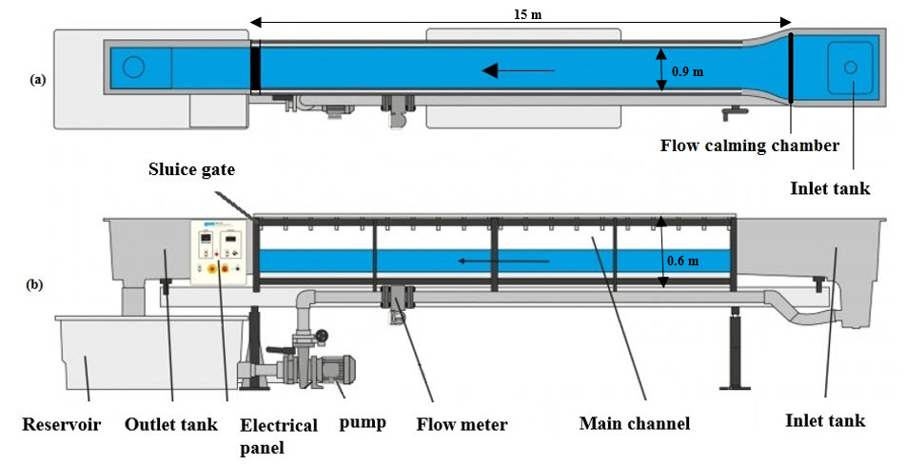
Figure 1. Schematic diagram of the laboratory flume (a) plan view, (b) longitudinal profile [5]

The bed material size frequency curve has been obtained from Figures 2 that was explained in details in [5] and the bed material size parameters are defined in Table 1.

Table 1. Grain Size Parameters [5]
D_{g} | G_{r} | σ_{g} | d₈₄ )mm) | d₅₀ )mm) | d₁₆ )mm)
19.7 | 1.16 | 1.16 | 23 | 20 | 17

Dimensions of the bedform (i. e. wavelength, height and angle) were selected based on studies on the Kaj River by an upstream slope of less than 12° (Figure 2). The ratios of channel width (W) to the flow depth (H) which is called aspect ratio were 9 and 3 at crest and trough, respectively. The bedform was made at a distance of 8.46 m away from the entrance, where the boundary layer thickness was fully developed [5]. Flume sidewalls were joined by a thin metal plate.

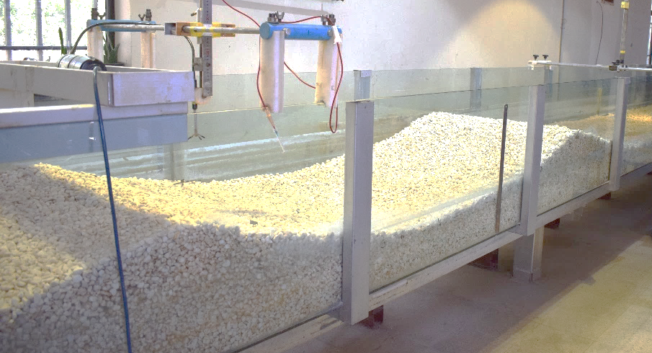
Q
Sidewalls joint
Figure 2. Non-vegetated bedform in the laboratory

Fully submerged, densed and flexible artificial grass with a height of 30 mm (Figure 3-a) was established to cover the entire bed on the top of the gravel surface, tightened by clips (Figure 3-b).

(a) 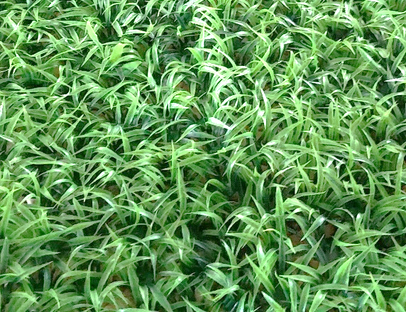
(b) 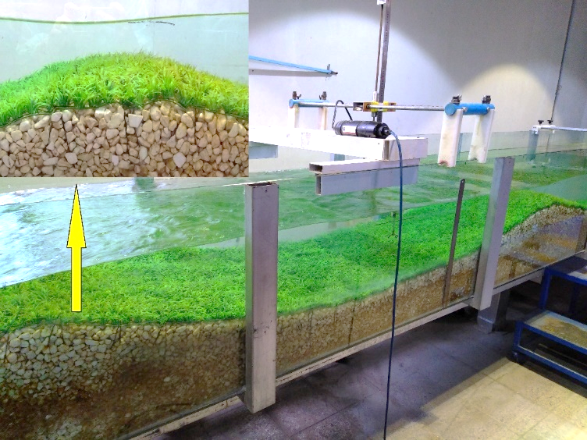
Q
Figure 3. (a) Artificial grass and (b) The modeled vegetated bedform [5]

Tracing hyporheic path
To trace the path in the hyporheic zone, edible color and video recording at 29 frames per second are used and the residence time and length of hyporheic path were calculated by "GrapherTM from Golden Software, LLC". Tracing is measured 3 times for each path line in both vegetated and non-vegetated bedform and the average value of that was calculated to use for rest of computation. The path lines for vegetated and non-vegetated bedforms are shown in the stoss (upstream of the crest) (Figures 4-a and 4-c) and the lee (downstream of the crest) (Figures 4-b and 4-d).
Q
Q
Q
Q
Figure 4. Tracing hyporheic path with edible color; (a) non-vegetated bedform in the stoss, (b) non-vegetated bedform in the lee, (c) vegetated bedform in the stoss and (d) vegetated bedform in the lee

Phosphorous Test
Time duration of each experiment was 12 hours and the phosphorus sampling was made every hour to measure the concentration. The initial concentration of phosphorus was 1.8 mg/lit, which was selected based on maximum value of the studies in Iranian rivers [19, 20, 21]. The concentration was measured using the 4500-p method presented in the standard method [22] and DR6000 HACH device.

In Table 2, the summary of laboratory conditions and calculated parameters are presented, the Froude and Reynolds numbers are calculated, showing that the flow is subcritical and turbulent. To make sure of the fully developed flow, vertical velocity profiles were measured at 8.46, 8.56 and 8.66 meters away from the channel inlet (Figure 5).

Figure 5. Vertical velocity profiles of flow where z = point depth, u = streamwise velocity, u max = maximum streamwise velocity

Table 2. Summary of Laboratory Conditions
 | Non-vegetated bedform | Vegetated bedform
Flow depth (H), m | 0.10 (crest) | 0.10 (crest)
Flow discharge (Q), Lit/s | 50 and 30 | 50 and 30
Bedform height (Δ), m | 0.2 | 0.2
Δ/λ (λ is the bedform length) | 0.09 | 0.09
Stem density (number of stems/m²) | _ | 8900
Froude number | 0.56 and 0.33 (crest) | 0.56 and 0.33 (crest)
Reynolds number*10³ | 55.56 and 33.33 (crest) | 55.56 and 33.33 (crest)
Initial phosphorous concentration, mg/lit | 1.8 | 1.8
Phosphorous removal time, hr | 12 | 12

RESULT AND DISCUSSION
Hyporheic path lines of a non-vegetated pool-riffle sequence for flow discharge of 50 L/s are shown in Figure 6. Distance between each injection point is 10 cm. No hyporheic path observed at points 15, 16, 17, 18, 19, 20 and 21, which was also observed by [23, 24]. No injection point selected in between pairs points of 7 and 9, and 19 and 20, due to the presence of sidewalls joints (Figure 2). Some injection points are traced in depth like 4, 6, 8 and 10. A comparison of the flow pattern is also made for discharge value of 30 L/s for both vegetated and non-vegetated bedforms [Figure 7]. This indicates that the difference between the patterns is not noticeable with an average relative difference of 7.6%, maximum of 14.3% and minimum of 1.7%. It is worth noting that for both of the bedforms, the hyporheic flow patterns are comparable, however, their residence times appear to be different (Figure 9). This, in-turn, highlights effective role of vegetated cover in the residence time of hyporheic path. Therefore, it is wise to deduce that for a pool-riffle sequence bedform, flow pattern in the hyporheic zone will remain the same, while bed roughness (i.e. vegetation cover) affects residence time of hyporheic flow pattern.
In general, when excess shear stress is less than zero, no motion occurs in the bed and static equilibrium is resulted which shows effect of bed roughness on the residence time of hyporheic flow pattern. Meanwhile, dynamic equilibrium of the bedform where excess shear stress is greater than zero could lead to both variations in flow pattern and residence time.

Figure 6 illustrates two sets of hyporheic flow path lines. The first set includes lines of 1-14 and second set 22-29. The former has formed on the first crest which indicates subsurface flow occurrence in the direction of surface flow (from upstream to downstream) while the latter is formed downstream of the crest with the difference that subsurface flow occurs in opposite direction of the surface flow. The point at which the formers and the latters converge may lead to a hypothetical line which is called flow divide line [24]. Hyporheic flows consist of downwelling flows supplying dissolved oxygen and organic matter to microinvertebrates inhabiting the subsurface region underneath river beds, while upwelling flows supplying nutrients to stream organisms [25, 26].

Figure 6. Hyporheic lines of a non-vegetated pool-riffle sequence for Q=50 L/s

Figure 7. Hyporheic lines of a vegetated and non-vegetated pool-riffle sequence for Q=30 L/s

Hyporheic velocity is defines as hyporheic distance along the path line divided by residence time. Hyporheic velocity values for both vegetated and non-vegetated bedforms for two flow discharges of 30 and 50 L/s are shown in Figure 8. It illustrates that increasing flow discharge causes increasing hyporheic velocity for the same bedformm. Howerver, vegetation cover may decreases the hyporheic velocity an average 22.71% and 10.24% for Q=50 L/s and Q=30 L/s, respectively. It is conventional to note that the negative velocity values are related to hyporheic path lines, which occure downstream of flow divide line. No hyporheic path observed at points 15, 16, 17, 18, 19, 20 and 21 for both vegetated and non-vegetated bedforms, and also the same thing at points 14, 22 and 23 only for vegetated bedform. This could be justified by low residence time (Figure 9).

Figure 8. Hyporheic velocity values for vegetated and non-vegetated bedforms for Q=50 L/s and Q=30 L/s

Figure 9 shows the residence time for two vegetated and non-vegetated bedforms for two flow discharges of 30 and 50 L/s. Increasing flow discharge leads to decrease time residence for the same bedform. Vegetation cover increases the residence time about 31.18% and 13.48% for Q=50 L/s and Q=30 L/s, respectively comparing with non-vegetated cover. This means that for a constant discharge, vegetation cover may cause an increase in residence time. The higher the discharge value, the lower the time of residence appears to be.

Figure 9. Residence time values for vegetated and non-vegetated bedforms for Q=50 L/s and Q=30 L/s

Figure 10 shows the effect of flow discharge and vegetation cover on phosphorus removal. In the non-vegetated bedform, at a flow discharge of 30 and 50 liters per second and at a residence time of 12 hours, the phosphorus removal was 64.2% and 75.1%, respectively. So, it can be concluded that the amount of phosphorus absorption increases with the decrease of the flow discharge. Also, the effect of vegetation cover on phosphorus removal in the hyporheic zone was investigated and shown that vegetation cover increases phosphorus removal. At a flow dischatge of 50 liters per second and with the presence of vegetation cover, the amount of phosphorus removal in 12 hours was 93.7%, which has increased the efficiency by almost 30% compared to the non-vegetaed bedform. In addition, the amount of phosphorus removal reached 100% in a flow discharge of 30 liters per second and in the presence of vegetation cover in a period of 11 hours. The results clearly show that the presence of vegetation cover in the hyporheic zone increases the efficiency of phosphorus removal, in other words, the absorption process is improved in the hyporheic zone [28]. Vervier et al. (2009) suggested that in downwelling zones, surface-derived dissolved phosphorous can be trapped in hyporheic sediments, and that much of this phosphorous becomes stored in refractory particulate forms [27]. By increasing residence time, more pollutants like phosphorous will be absorbed and rivers self-purification will be resulted with high efficiency.

Figure 10. Effect of flow discharge and vegetation cover on phosphorus removal in a pool-riffle sequence

CONCLUSION
This study shows that the bedforms have no significant effect on hyporheic flow pattern under the same flow condition. Increasing flow discharge causes an increase in hyporheic velocity and a decrease in residence time for the same bedform. However, vegetation cover may decreases the hyporheic velocity and increases in residence time for different flow discharges. The quantity of phosphorus absorption increases with the decrease of the flow discharge and vegetation cover. The results show that the presence of vegetation cover in the hyporheic zone increases the efficiency of phosphorus removal. In other words, the absorption process is improved in the hyporheic zone as a result of which rivers self-purification efficiency could be increased.

REFERENCES

[1] Mark, E., and Powell, A., "Rivers as living systems", Aquatic Conservation: Marine and Freshwater Ecosystems, Vol. 12, No. 4, (2002), pp 329-337.
[2] Ralf, S., Lautenbach, S., and Volk, M., "Identifying trade-offs between ecosystem services, land use, and biodiversity: a plea for combining scenario analysis and optimization on different spatial scales", Current Opinion in Environmental Sustainability, Vol. 5, No. 5, (2013), pp 458-463.
[3] Hohensinner, S., Hauer, C., Muhar, S., “River morphology, channelization, and habitat restoration”, Riverine ecosystem management, (2018), pp 41-65.
[4] Zhixian, C., Carling, P., and Oakey, R., "Flow reversal over a natural pool–riffle sequence: a computational study", Earth Surface Processes and Landforms: The Journal of the British Geomorphological Research Group. Vol. 28, No. 7, (2003), pp 689-705.
[5] Kabiri, F., Tabatabai, M. R. M., and Shayannejad, M., “Effect of vegetative bed on flow structure through a pool-riffle morphology”. Flow Measurement and Instrumentation, (2022), pp 102197.
[6] Zhao, B., Zhang, L., Xia, Z., Xu, W., Xia, L., Liang, Y., Xia, D., “Effects of rainfall intensity and vegetation cover on erosion characteristics of a soil containing rock fragments slope”, Advances in Civil Engineering, (2019).
[7] Sandercock, P. J., and Hooke J. M., "Assessment of vegetation effects on hydraulics and of feedbacks on plant survival and zonation in ephemeral channels", Hydrological Processes: An International Journal, Vol. 24, No. 6, (2010), pp 695-713.
[8] Rupprecht, F., Möller, I., Evans, B., Spencer, T., and Jensen, K., "Biophysical properties of salt marsh canopies—Quantifying plant stem flexibility and above ground biomass", Coastal Engineering No.100, (2015), pp 48-57.
[9] Vargas‐Luna, A., Crosato, A., and Uijttewaal, W., "Effects of vegetation on flow and sediment transport: comparative analyses and validation of predicting models", Earth Surface Processes and Landforms, Vol. 40, No. 2, (2015), pp 157-176.
[10] Vargas‐Luna, A., Duró, G., Crosato, A., and Uijttewaal, W., "Morphological adaptation of river channels to vegetation establishment: A laboratory study", Journal of Geophysical Research: Earth Surface, Vol. 124, No. 7, (2019), pp 1981-1995.
[11] Krause, S., Hannah, D., Fleckenstein, J., “Hyporheic hydrology: interactions at the groundwater-surface water interface”, Hydrological Processes, Vol. 23, No. 15, (2009), pp 2103–2107.
[12] Banks, E.W., Simmons, C.T., Love, A.J., Shand, P., “Assessing spatial and temporal connectivity between surface water and groundwater in a regional catchment: Implications for regional scale water quantity and quality”, Journal of Hydrology, Vol. 404, No. 1–2, (2011), pp 30–49.
[13] Zhang, J., Song, J., Long, Y., Zhang, Y., Zhang, B., Wang, Y., Wang, Y., “Quantifying the spatial variations of hyporheic water exchange at catchment scale using the thermal method: a case study in the Weihe River”, China. Adv. Meteorol. 20178, (2017).
[14] Naranjo, R. C., Niswonger R. G., and Davis C. J. "Mixing effects on nitrogen and oxygen concentrations and the relationship to mean residence time in a hyporheic zone of a riffle‐pool sequence", Water Resources Research, Vol. 51, No. 9, (2015), pp 7202-7217.
[15] Hershey, A. E., Lamberti, G. A., Chaloner, D. T., Northington, R. M., "Aquatic insect ecology", Ecology and classification of North American freshwater invertebrates, (2010), pp. 659-694.
[16] Liu, R., Zhang, P., Wang, X., Chen, Y., and Shen, Z., "Assessment of effects of best management practices on agricultural non-point source pollution in Xiangxi River watershed", Agricultural Water Management, No. 117 (2013), pp 9-18.
[17] Jin, G., Chen, H., Zhang, Z., Jiang, Q., Liu, Z., and Tang, H., “Transport of Phosphorus in the Hyporheic Zone”, Water Resources Research, Vol. 58, No. 3, (2022), pp e2021WR031292.
[18] Dosskey, M. G., Vidon, P., Gurwick, N. P., Allan, C. J., Duval, T. P., and Lowrance, R., "The role of riparian vegetation in protecting and improving chemical water quality in streams 1", JAWRA Journal of the American Water Resources Association, Vol. 46, No. 2, (2010), pp 261-277.
[19] Shayeghi, M., Shahtaheri, S., and Selseleh, M., “Phosphorous insecticides residues in Mazandaran river waters”, Iran, (2000).
[20] Mohseni-Bandpei, A., & Yousefi, Z., “Status of water quality parameters along Haraz river”, International Journal of Environmental Research, Vol. 7, No. 4, (2013), pp 1029-1038.
[21] Ranjbar, M.H., Hadjizadeh Zaker, N., “Estimation of environmental capacity of phosphorus in Gorgan Bay, Iran, via a 3D ecological-hydrodynamic model”, Environmental monitoring and assessment, Vol. 188, No.11, (2016), pp 1-12.
[22] “American Public Health Association (APHA)”, (1999). In: Standard Methods for Examination of Water and Wastewaters, twentieth ed. U.S. Environmental Protection Agency, Washington D.C.
[23] Fruetel, C., "Analysis of Hyporheic Flow Induced by a Bar in a Gravel Stream: an Experimental Study", PhD diss., (2016).
[24] Fruetel, C., Mumford, K. G., Ferreira da Silva, A. M., Rey, A., Bascom, K. S. "A laboratory method for the visualization and quantification of hyporheic flow paths and velocities", Canadian Journal of Civil Engineering, Vol. 46, No. 5. (2019), pp 448-457.
[25] Boulton, A.J., Findlay, S., Marmonier, P., Stanley, E.H., Valett, H.M., “The functional significance of the hyporheic zone in streams and rivers”, Annual Review of Ecology and Systematics, Vol. 29, No. 1, (1998), pp 59-81.
[26] Hakenkamp, C.C., Palmer, M.A., “The ecology of hyporheic meiofauna”, Streams and ground waters, (2000), pp 307-336.
[27] Vervier, P., Bonvallet‐Garay, S., Sauvage, S., Valett, H. M., Sanchez‐Perez, J. M., “Influence of the hyporheic zone on the phosphorus dynamics of a large gravel‐bed river, Garonne River, France”, Hydrological Processes: An International Journal, Vol. 23, No. 12, (2009), pp 1801-1812.
[28] Lewandowski, J., Nützmann, G. “Nutrient retention and release in a floodplain's aquifer and in the hyporheic zone of a lowland river”. Ecological Engineering, Vol. 36, No. 9, (2010), pp 1156-1166.

