Diffusion characteristic of floating particles in vegetated open channel flow

Xiaoguang Liu
River Department, Changjiang River Scientific Research Institute, Wuhan 430010, China.
Key Laboratory of River and Lake Regulation and Flood Control in the Middle and Lower Reaches of the Yangtze River of Ministry of Water Resources, Changjiang River Scientific Research Institute, Wuhan 430010, China.
State Key Laboratory of Water Resources and Hydropower Engineering Science, Wuhan University, Wuhan 430072, China.

Yuhong Zeng
State Key Laboratory of Water Resources and Hydropower Engineering Science, Wuhan University, Wuhan 430072, China.

wang jiasheng
River Department, Changjiang River Scientific Research Institute, Wuhan 430010, China.
Key Laboratory of River and Lake Regulation and Flood Control in the Middle and Lower Reaches of the Yangtze River of Ministry of Water Resources, Changjiang River Scientific Research Institute, Wuhan 430010, China.

zhaohui Chai
River Department, Changjiang River Scientific Research Institute, Wuhan 430010, China.
Key Laboratory of River and Lake Regulation and Flood Control in the Middle and Lower Reaches of the Yangtze River of Ministry of Water Resources, Changjiang River Scientific Research Institute, Wuhan 430010, China.

Advection-diffusion models have been widely applied to describe the transport of particles through vegetation with assuming that the particle transport is driven by the mean flow velocity, and few studies on the diffusion process with considering the retention time. In this study, the authors conduct flume experiments of four runs with different vegetative densities, extract and analyze the trajectories of floating particles. Retention time of trapping events due to the capillary between particles and the stem has been proved to follow a three-parameter double exponential distribution, duration time of both short and long retention events increases with the bulk flow velocity increasing, and the proportion of long-time trapping events decreases with the bulk flow velocity increasing. The transport velocity of floating particles is considered to be decided by the constricted cross-section velocity and temporary trapping events. The diffusion coefficient of floating particles is validated independent of vegetative densities and increases with the flow velocity increasing, and which is about 100 times that of the solute in flow through emergent vegetation under similarity condition.

introduction
The transport, retention, and deposition of organic matter (e.g., seeds, propagules, spawns and larva) are fundamental processes for wetlands ecosystems [1][2][3][4]. The riparian ecosystem as an example, dispersal of propagules (seeds, fruits and nutritional organs) is decisive for local plant community composition and structure and is a prerequisite for community succession, which can increases species richness and abundance and enhances their own ability to withstand potential ecological risk. Because of its greater fertility, higher water table and soil moisture levels compared with other area [5], riparian zone can give propagules all it needs to colonize, germinate and survive, and is deemed as the primary source of propagules for dispersing [6].
Dispersal modes of riparian plant propagules may be varied, dispersal via water is the primary method of seed dispersal and enables long-distance (sometimes hundreds of kilometres) dispersal along river corridors and consequently enhances longitudinal connectivity and gene flow between distant parts of a catchment. Many aquatic plant seeds have the ability to float, meaning that an extended floating time enhances dispersal distances by mean advection [5][8]. A number of models use empirical or semi-empirical approaches to describe seed transport in the form of a so-called dispersal kernel [4][9]. Dispersal kernels represent the probability of finding a seed at some finite distance from the maternal plant. Empirical approaches describe plausible mathematical shapes for the dispersal kernel that are then used to predict distribution of herbaceous plants and their communities [10]. Mechanistic approaches, such as the semi-empirical Gaussian plume equations have also been used to describe dispersal kernels using mean velocity and hydraulic geometry as variables [9].
In slow open channel flows, when the mean gap between vegetation elements is large compared to the particle size, surface tension is the main mechanism for particles colliding with vegetation stems [11], surface tension and wake influence are the main factors for particles being trapped by vegetation stems. Defina and Peruzzo [5] proposed a stochastic model to describe the transport and diffusion of floating particles and the trapping mechanisms by emergent flexible vegetation with varied density. Furthermore, Peruzzo et al. [15] investigated the effect of surface tension on the fate of floating particles’ dispersal in slow open channel flows featured with emergent vegetation. Liu et al.[13] further revealed the mechanisms responsible for floating particles dispersal in slow-moving flow with emergent vegetation by combining kinematic and statistical models of particle-stem interactions. These prior efforts primarily dealt with particle collision and trapping by stems due to surface tension at low flow velocity [14][15][16]
In moderate to high open channel flows, surface tension between stems and particles may be small and even ignored. The stems generate wake turbulence and mechanical dispersion that distort the particle trajectory from streamlines set by the mean flow in the vicinity of the stem. The stems modify particle trajectory when a collision occurs that can lead to rebound or trapping. Dispersal mechanism of floating particles and corresponding particle-stem interaction have rarely been investigated, however, which may terminate long-distance transport and change the fate of floating seeds within vegetated flows. Liu et al. [17] focused on the interaction between floating particles and emergent stems in fast-moving free surface flows in which collision and trapping events exist but not due to surface tension.
For longitudinal diffusion of the solute within the array of emergent stems, stem-scale and depth-scale dispersion dominate the total longitudinal dispersion, and the motion of floating particles stays in the horizontal plane, depth-scale dispersion can be ignored. The magnitude of longitudinal dispersion within vegetated canopies has been very well studied (e.g., Nepf et al., [18]; White and Nepf, [19]; Lightbody and Nepf, [20]). Within sparse canopies (the area fraction of cylinders is less than 0.1), stem-scale dispersion results primarily from velocity heterogeneity due to the presence of stems. Within denser canopies (the area fraction of cylinders is greater than 0.1), stem-scale dispersion will be dominated by the trapping and release of mass within the boundary-layers and wakes of individual cylinders.
Advection-diffusion models have been widely and successfully applied to describe the transport of particles through vegetation by assuming that the particle transport is driven by the mean flow velocity [18][21][22][23][24], but the key parameter, the longitudinal diffusion coefficient (D_{l}) of floating particles, is less investigated, most of these diffusion model directly adopted the diffusion coefficient of the solute in flow through emergent. The mechanism of longitudinal diffusion of floating particles in flow through emergent vegetation is disputed, the effects of the flow velocity and vegetative density on longitudinal diffusion has not been specified. Basically, the bulk transport velocity of floating particles and the estimation of longitudinal diffusion need to be further clear.
This study aims at covering the gap in knowledge of the longitudinal diffusion of floating particles in moderate flow through emergent vegetation, which the trapping events occurs and permanent trapping events can be ignored. The authors attempt to reveal the longitudinal diffusion process through experiments, determine the transport velocity and longitudinal diffusion coefficient, and analyze the detention time of trapping events.

Experimental study
Laboratory experiments were conducted in a rectangular flume 18 m long, 1.0 m wide, and 0.5 m deep, with glass sidewalls and bottom. The recirculated flow discharge (Q) is measured by an electromagnetic flowmeter, and the tailgate located at the exit of the flume can be adjusted to maintain an approximately uniform flow, the bulk average velocity is the cross-section average velocity with removing the area fraction of vegetative stems, summary of experimental conditions in this study is shown in Table.1. A random array of rigid clean cylindrical wooden dowels with a diameter of 0.6 cm and height of 25cm, which is uniformly constructed on two polyvinyl chloride boards to create a test section 4 m long. Wooden sphere with the diameter of 0.6 cm was adopted to mimic buoyant seeds or other organisms.
All particles are evenly painted with white dye to ensure improved observation and tracking, and cylinders juts out of the water surface small enough (ranges from 1 to 3cm) that trapped or detained particle cannot be sheltered. A total of 200 particles were divided into 10 groups, and 50 cm upstream of the test section (see Figure 1) was released group by group, each runs of this study are independently replicated many times. All the experimental runs were recorded by a digital camera (25 Hz) mounted over the flume. A total of four different random arrays are constructed, the vegetative densities (n_{s}) ranged from 554 to 1164 m⁻², i.e., the area fraction of stems (λ) ranged from 0.016 to 0.033, and four discharges are tested for each array. The quantitative relation between vegetative densities and the area fraction of stems can be expressed as
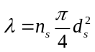 (1)
By analyzing the recorded video of particle tracking using the video analysis software Image-Pro Plus, trajectories of floating particles within the areas 10 cm close to the glass sidewalls are removed. The Weber number, the ratio of inertial effect and surface tension, is adopted to quantify the effect of capillarity between the stem and floating particles,
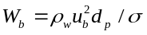 (2)
where ρ_{w} is the water density, σ is the surface tension. According to the research of Liu et al. [13], when W_{b} < 1.0, the vegetative flows can be approximately considered slow or moderate moving, and the events that particles are trapped due to surface tension may occur.

Table 1. Summary of experimental conditions in this study
Run | u_{b}(m/s) | N_{S}(m⁻²) | R_{d} | W_{b}(10⁻²) | d_{p}(m) | a(1/m) | λ
1-1 | 0.0426 | 1164 | 255.6 | 14.957 | 0.006 | 6.984 | 0.033
1-2 | 0.0529 | 1164 | 317.4 | 23.064 | 0.006 | 6.984 | 0.033
1-3 | 0.0636 | 1164 | 381.6 | 33.338 | 0.006 | 6.984 | 0.033
1-4 | 0.076 | 1164 | 456 | 54.074 | 0.006 | 6.984 | 0.033
2-1 | 0.0388 | 932 | 232.8 | 12.407 | 0.006 | 5.592 | 0.026
2-2 | 0.043 | 932 | 258 | 15.239 | 0.006 | 5.592 | 0.026
2-3 | 0.0529 | 932 | 317.4 | 23.944 | 0.006 | 5.592 | 0.026
2-4 | 0.074 | 932 | 444 | 45.132 | 0.006 | 5.592 | 0.026
3-1 | 0.039 | 720 | 234 | 11.590 | 0.006 | 4.320 | 0.020
3-2 | 0.0474 | 720 | 284.4 | 18.517 | 0.006 | 4.320 | 0.020
3-3 | 0.0585 | 720 | 351 | 28.205 | 0.006 | 4.320 | 0.020
3-4 | 0.082 | 720 | 492 | 47.604 | 0.006 | 4.320 | 0.020
4-1 | 0.0388 | 554 | 232.8 | 12.407 | 0.006 | 3.324 | 0.016
4-2 | 0.0469 | 554 | 281.4 | 18.129 | 0.006 | 3.324 | 0.016
4-3 | 0.0538 | 554 | 322.8 | 23.855 | 0.006 | 3.324 | 0.016
4-4 | 0.072 | 554 | 432 | 50.143 | 0.006 | 3.324 | 0.016
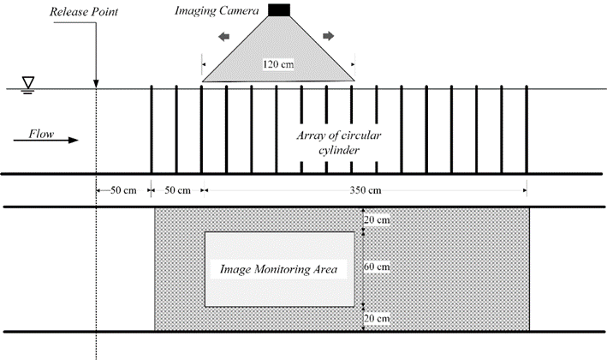
Figure 1. Lateral views of the experimental flume channel. Flow is from left to right.
Camera can move left or right to alter recording position.

Analysis of the trajectories
The trajectories of floating particles was extracted from the recording video using the Matlab program and image analysis software (Image-pro plus). The design principle of the image interpretation of this program was similar to Prada et al. [25] and Jia et al. [26]. The frame rate of recording video was 25 fps, it means that the retention time less than 0.04s can’t be identified, accuracy in reconstructing instantaneous particle position is millimeter-scale. According to the findings of Defina & Peruzzo [12] and Jia et al. [26], the extracted trajectories were reasonable and credible.
The transport patterns of floating particles in flow is significantly affected by the existent of vegetation, the movement characteristic value is calculated by centre difference method:
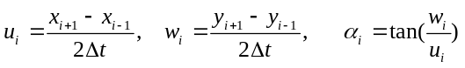 (3)
where u_{i} and w_{i} are the longitudinal and transversal instantaneous velocity of floating particles, (x_{i+1}, y_{i+1}) is the centroid coordinate of the floating particle in (i+1)th frame of images, and (x_{i-1}, y_{i-1}) is the centroid coordinate of the floating particle in (i-1)th frame of images, Δt is the time interval between the two frame. α_{i} is instantaneous vector angular. The retention time of particles in this paper are interpreted as time interval between the velocity instantaneously drops to zero and returns to larger than zero.
The representative trajectories of Runs 1~4 are shown in Figure 2, the trajectories curve (s) are composed of over 100 independent repeated experiments. The bulk transport velocity (u_{p}) depends on the trapping events and the constricted cross-section velocity, the both are associated with the stem density and the bulk velocity, but has no connection to the stem-scale turbulence. As shown in Figure 3, as the stem array is dense enough (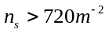), the transport velocity of the floating particle is less than the bulk velocity, 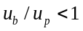, which is dominated by the “blockage effect” and in agreement with the result of Liu et al. [13]. Despite having only four vegetative densities, it is quite certain that the effect of “blockage effect” on u_{p} makes no difference for sparse vegetative densities, u_{p} is only decided by u_{b}; when the stem array is sparse enough, u_{p} is decided by u_{b} and n_{s}.
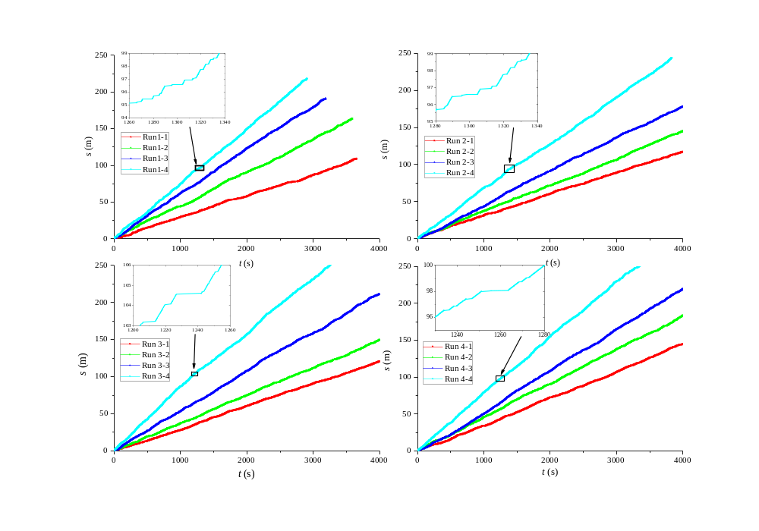
Figure 2. The cumulative trajectories of floating particles for Runs 1~4 with many independent repeated experiments. The inset shows the retention process of the trapping event.
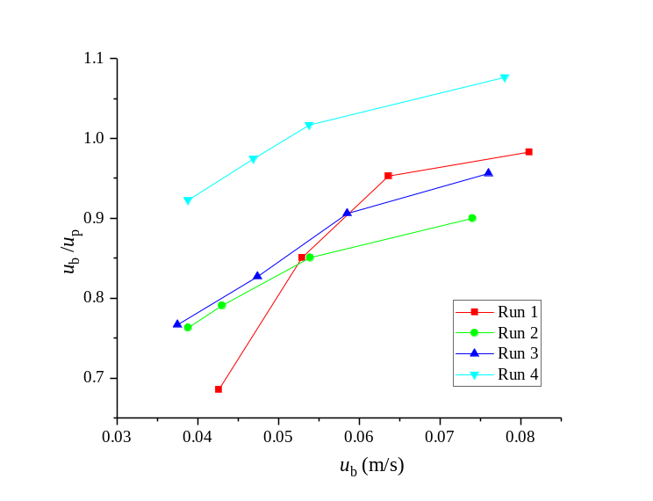
Figure 3. The ratio of the bulk velocity and the transport velocity of floating particles for Runs 1~4.

Results and discussion
4.1 Retention time
The statistical regularities of the retention time are shown in Figure 4, the cumulative probability P(T>t) is then estimated on the basis of the relative cumulative frequency as
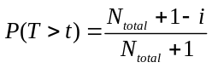 (4)
where i is the number of measured data T with a value smaller than the reference value t, N_{total} is the total retention events. Analogous to Defina and Peruzzo [12], we use a three-parameter double exponential distributions with parameters P_{L}, T_{L} and T_{S} to describe the distribution of retention time for numerous independent repeated experiments:
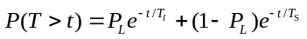 (5)
where T_{S} and T_{L} are duration time of short and long retention events, P_{L} is the proportion of long-time trapping events to total retention events. Defina and Peruzzo [12] has verified the reliability of the assumption through the comparison of measured and modeled arrival time distribution. Liu et al. [17] attempted to explain the formation mechanism of short-time and long-time retention events, and the mechanisms include collisions between a particle and stems (mechanical dispersion) and subsequent wake trapping effect (wake turbulence dispersion).
Using nonlinear numerical fitting analysis and comparison among different functional models, it turns out that P_{L} increases exponentially as R_{d} increasing (see Figure 5), T_{L} and T_{S} decrease logarithmically with R_{d} increasing (see Figure 5). Moreover, T_{L} is about five times more than T_{S}, and almost irrelevant to R_{d}. The empirical relationships between T_{L}, T_{S}, P_{L} and R_{d} are represented as Eq. (6).
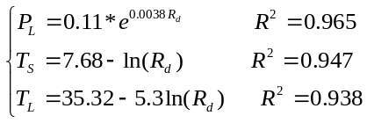 (6)
In fact, the prediction of parameters T_{L}, T_{S} and P_{L} can be more precise, the starting point is analyzing the trapping and the rapping mechanism, including the dynamic balance and kinematic characteristics, Liu et al. [16] has started some basic research works, and proposed a dimensionless parameter which proposed to evaluate the attraction capacity of the floating particle attached to the stem.
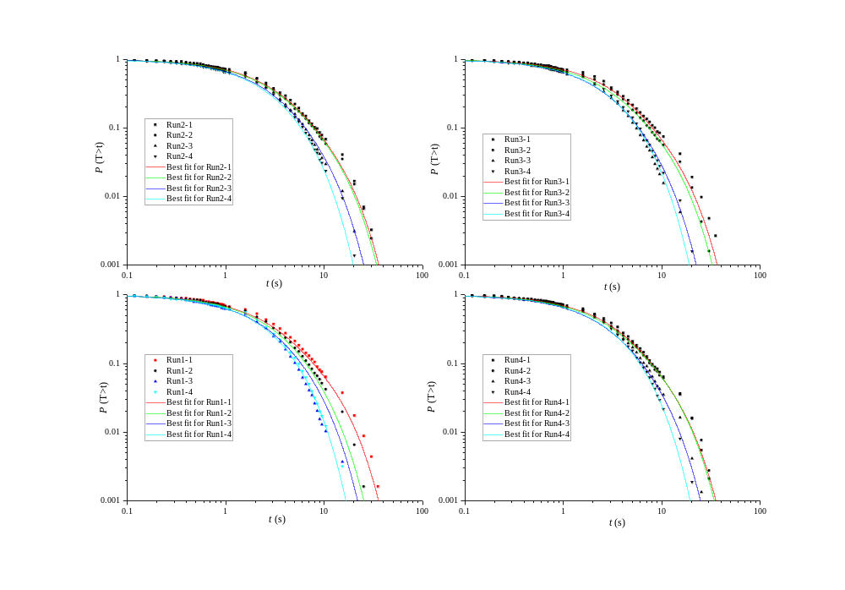
Figure 4. Cumulative retention time distribution of trapping events compared to the double exponential distributions for Runs 1~4.
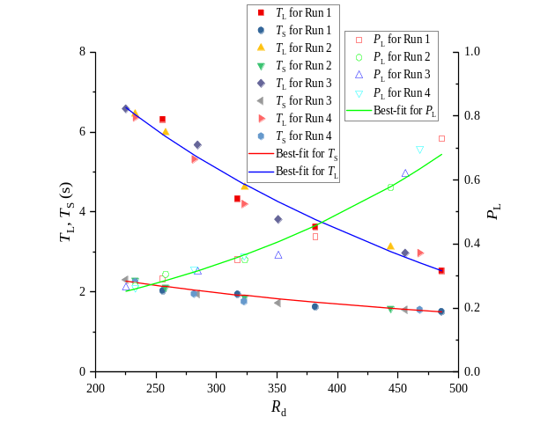
Figure 5. The variation relationship of T_{L}, Ts, P_{L} and R_{d} for Runs 1-4.

4.2 Diffusion coefficient
The variance of the longitudinal displacement, σ²_{x}, is extracted from the trajectories. The variation relationships of σ²_{x} and t for Runs 1~4 are shown in Figure 6, σ²_{x} is linearly proportional to t, and the diffusion process of floating particles in flow through emergent vegetation obeys Fick’s law, provided the vegetative stems are evenly distributed. The retention time of this study obeys exponential distribution, belongs to light-tailed distribution, according to the research results of Metzler and Klafter [27], σ²_{x} should be linearly proportional to t, which is consistent with this study. Predictably, for patchy-distribution of vegetative stems, the diffusion process of floating particles belongs to anomalous diffusion.
D_{l} of each run obeys to normal distribution with the same variance, we found no significant correlation between D_{l} and n_{s} (see Figure 7, p=0.9925, different run ANOVA), and any two runs have no significant difference, as shown in Table.2. Nepf [28] developed and tested a physically based model that predicted the turbulence intensity and diffusion within emergent vegetation. Turbulent and mechanical diffusion are independent Fickian processes, their contribution to total diffusion is additive, and mechanical diffusion becomes important at high vegetative densities.
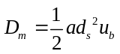 (7)
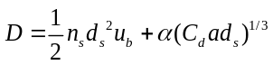 (8)
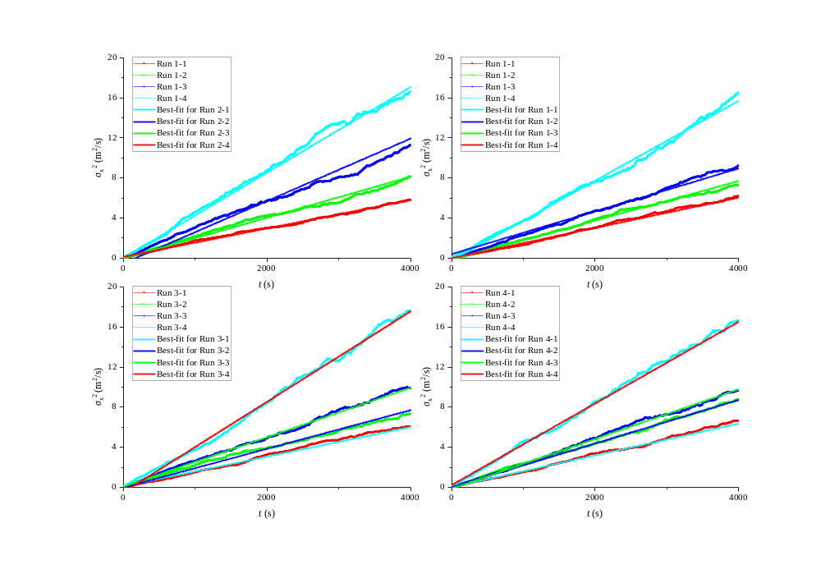
Figure 6. The variation relationship of σ²_{x} and t for Runs 1~4 with the best-fit curve.

where α is the scale factor, C_{d} is the bulk drag coefficient. The variation relationship between D_{l} and R_{d} for Runs 1~4 in this study and results of Nepf [28] for the solute diffusion in vegetative flows are shown in Figure 8. The vegetative densities and flow conditions in this study are similar to these of Nepf [28]. D_{m} and D are calculated in this study, as shown in Figure 8, 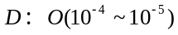and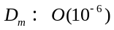, which are significantly lower than 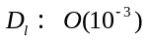 of floating particles, especially for mechanical diffusion.

Table 2. Results of different run ANOVA comparing Dl and ns
Source | SS | df | MS | F | p
Run 1~4 | 1.2522e-07 | 3 | 4.1742e-08 | 0.0303 | 0.9925
Error | 1.6526e-05 | 12 | 1.3772e-06
Total | 1.6652e-05 | 15
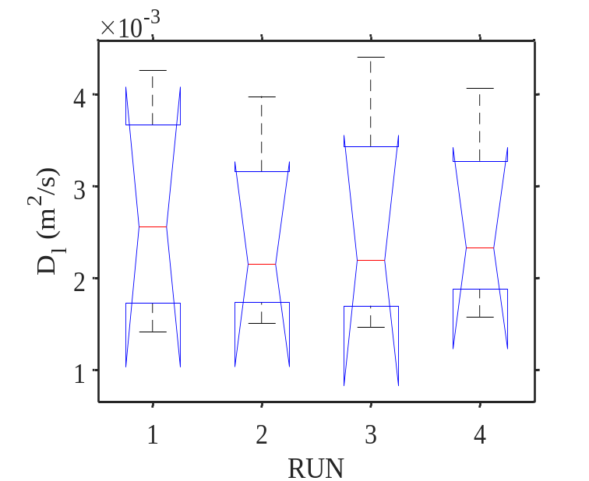
Figure 7. The boxplot for the longitudinal dispersion coefficient of Runs 1~4
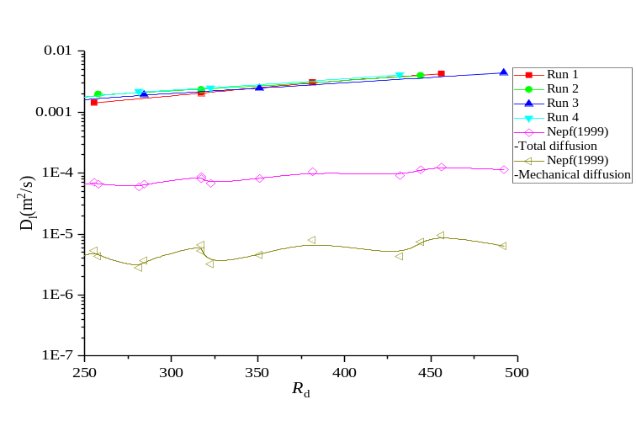
Figure 8. The variation relationship of D_{l} and R_{d} for Runs 1~4 in this study, and results of Nepf [28] for the solute diffusion in vegetative flows.

As shown in Figure 8, D_{l} can be considered independent of vegetative density, and almost linearly increases with R_{d} increasing.
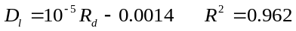 (9)
The longitudinal diffusion of floating particles in flow through emergent vegetation mainly depends on the retention events, including the probability of collision between the stem and floating particles, and corresponding retention time. The former has been discussed with different velocity scale level by Peruzzo et al. [15], Liu et al. [14] and Liu et al.[16]. The dominant factors of the collision probability are vegetative densities, R_{d}, and physical characteristics of particles and stems. Thus, using the diffusion coefficient of the solute to simulate the diffusion of floating particles in flow through emergent vegetative stems may be thoughtless.

Conclusion
This paper investigates the diffusion process of floating particles in flow through uniformly distributed emergent vegetation, including the transport velocity, retention time and diffusion coefficient, experiments of four runs with different vegetative densities are conducted. For the moderate open channel flows, i.e., capillary between stems and particles may be small and can’t be ignored, the trapping events occurs. The trajectories of floating particles were extracted and analyzed. The retention times of trapping events follows the three-parameter double exponential distribution, the proportion of long-time trapping events decreases with R_{d} increasing. Duration time of both long and short retention events decreases as R_{d} increasing, the former is about five times more than the latter, which is independent of vegetative densities, and the authors present the empirical formulas of three key parameters.
The diffusion process of floating particles in flow through emergent vegetation is obviously distinguished from that of the solute, due to the capillary between particles and stems. The variance of the longitudinal displacement is linearly proportional to the transport time, which obeys Fick’s law. The authors find that the diffusion coefficient of floating particles 100 times that of the solute in flow through emergent vegetation under similarity condition. The diffusion coefficient increases with R_{d} increasing, which is independent of vegetative densities, and the authors present the empirical formula.
The effect of physical characteristics of particles (such as, particle size, density and shape) on the diffusion process has not yet been taken account, which deserves further investigation in order to model floating particle dispersion in flows through vegetation more accurately. Further, the distribution form of retention time will directly determine the diffusion characteristic, such as, heavy-tailed, light-tailed and moderate-tailed, which needs more theoretical analysis and calculation.

ACKNOWLEDGMENT
The authors acknowledge support from the Fundamental Research Funds for Central Public Welfare Research Institutes (Grant/Award Number: CKSF2021438/HL, CKSF2021530/HL), Open Foundation from the State Key Laboratory of Water Resources and Hydropower Engineering Science (Grant no. 2021HLG02), and support from National Natural Science Foundation of China (51879197).

References
- Merritt, David M., and Ellen E. Wohl. "Processes governing hydrochory along rivers: hydraulics, hydrology, and dispersal phenology." Ecological applications 12.4 (2002): 1071-1087.
- Peterson, Jennifer M., and Susan S. Bell. "Tidal events and salt‐marsh structure influence black mangrove (Avicennia germinans) recruitment across an ecotone." Ecology 93.7 (2012): 1648-1658.
- Garcia, Tatiana, et al. "Development of a fluvial egg drift simulator to evaluate the transport and dispersion of Asian carp eggs in rivers." Ecological modelling 263 (2013): 211-222.
- Shi, Wei, et al. "Modelling long‐distance floating seed dispersal in salt marsh tidal channels." Ecohydrology 13.1 (2020): e2157.
- Nilsson, Christer, et al. "The role of hydrochory in structuring riparian and wetland vegetation." Biological Reviews 85.4 (2010): 837-858.
- Camporeale, C., and Luca Ridolfi. "Riparian vegetation distribution induced by river flow variability: A stochastic approach." Water resources research 42.10 (2006).
- Danvind, Maria, and Christer Nilsson. "Seed floating ability and distribution of alpine plants along a northern Swedish river." Journal of Vegetation Science 8.2 (1997): 271-276.
- Riis, Tenna, and K. A. J. Sand‐Jensen. "Dispersal of plant fragments in small streams." Freshwater biology 51.2 (2006): 274-286.
- Groves, Jeremy H., et al. "Modelling of floating seed dispersal in a fluvial environment." River Research and Applications 25.5 (2009): 582-592.
- Levine, Jonathan M. "A patch modeling approach to the community‐level consequences of directional dispersal." Ecology 84.5 (2003): 1215-1224.
- Vella, Dominic, and L. Mahadevan. "The “cheerios effect”." American journal of physics 73.9 (2005): 817-825.
- Defina, Andrea, and Paolo Peruzzo. "Floating particle trapping and diffusion in vegetated open channel flow." Water Resources Research 46.11 (2010).
- Defina, Andrea, and Paolo Peruzzo. "Diffusion of floating particles in flow through emergent vegetation: Further experimental investigation." Water Resources Research 48.3 (2012).
- Liu, Xiaoguang, Yuhong Zeng, and Wenxin Huai. "Modeling of interactions between floating particles and emergent stems in slow open channel flow." Water Resources Research 54.9 (2018): 7061-7075.
- Peruzzo, Paolo, Andrea Defina, and Heidi Nepf. "Capillary trapping of buoyant particles within regions of emergent vegetation." Water Resources Research 48.7 (2012).
- Liu, Xiaoguang, Yuhong Zeng, and Wenxin Huai. "Floating seed dispersal in open channel flow with emergent vegetation." Ecohydrology 12.1 (2019): e2038.
- Liu, Xiaoguang, et al. "Longitudinal dispersal properties of floating seeds within open-channel flows covered by emergent vegetation." Advances in Water Resources 144 (2020): 103705.
- Nepf, H. M., C. G. Mugnier, and R. A. Zavistoski. "The effects of vegetation on longitudinal dispersion." Estuarine, Coastal and Shelf Science 44.6 (1997): 675-684.
- White, Brian L., and Heidi M. Nepf. "Scalar transport in random cylinder arrays at moderate Reynolds number." Journal of Fluid Mechanics 487 (2003): 43-79.
- Lightbody, Anne F., and Heidi M. Nepf. "Prediction of velocity profiles and longitudinal dispersion in salt marsh vegetation." Limnology and oceanography 51.1 (2006): 218-228.
- Cunnings, Adrienne, Edward Johnson, and Yvonne Martin. "Fluvial seed dispersal of riparian trees: transport and depositional processes." Earth Surface Processes and Landforms 41.5 (2016): 615-625.
- Di Nitto, Diana, et al. "Modelling drivers of mangrove propagule dispersal and restoration of abandoned shrimp farms." Biogeosciences 10.7 (2013): 5095-5113.
- Richards, Shane Anthony, Hugh Philip Possingham, and B. J. Noye. "Larval dispersion along a straight coast with tidal currents: complex distribution patterns from a simple model." Marine Ecology Progress Series 122 (1995): 59-71.
- Shi, Wei, Paolo Peruzzo, and Andrea Defina. "An Eulerian model for the transport and diffusion of floating particles within regions of emergent vegetation." Water Resources Research 57.8 (2021): e2021WR029625.
- Prada, Andres F., et al. "Survival and drifting patterns of grass carp eggs and larvae in response to interactions with flow and sediment in a laboratory flume." PLoS One 13.12 (2018): e0208326.
- Jia, Wen-Fei, et al. "A laboratory investigation of the transport mechanism of floating fish eggs: A case study of Asian carps." Aquaculture 519 (2020): 734855.
- Metzler, Ralf, and Joseph Klafter. "The random walk's guide to anomalous diffusion: a fractional dynamics approach." Physics reports 339.1 (2000): 1-77.
- Nepf, Heidi M. "Drag, turbulence, and diffusion in flow through emergent vegetation." Water resources research 35.2 (1999): 479-489.

