Flow resistance caused by golden mussel (Limnoperna fortunei) biofouling in East River

Jiahao zhang, MENGZHEN XU, wei liu, lujie han
Department of Hydraulic Engineering, Tsinghua University
Beijing, China

Water transfer projects are constructed worldwide to alleviate the uneven distribution of water resources. Some of them face the risk of invasion and biofouling by mussels. Specifically, water transfer projects in Asia and South America risk biofouling by golden mussels, and water transfer projects in North America risk biofouling by zebra mussels. The East River Water Source Project (ERWSP) in Guangdong, China is a typical golden mussel-affected project. Mussels attach to the channel/tunnel walls with a density of up to 96000 individuals/m², forming biofouling clusters and layers, increasing the wall roughness and flow resistance, and reducing the water conveyance capacity. Based on the relationship between mussel attachment density and hydraulic roughness obtained from a bespoke laboratory open-channel flow, a 1D model for the entire ERWSP was applied to study the effect of golden mussel biofouling on flow resistance. The hydraulic roughness denoted by k_{s} of different sections was set according to the actual attachment densities observed during project maintenances. The model was calibrated with field data. Results show that high attachment density occured where the flow velocity was suitable for golden mussels. It is estimated that the head loss caused by the biofouling of golden mussels would increase by up to 25% every year. Therefore the prevention of golden mussel invasion would be crucial for the sustenance of water transfer projects and should be considered at the design and early implementation stages.

Introduction
Golden mussel, Limnoperna fortunei (Dunker 1856), is an epibenthic mytilid invasive species, which was firstly found in the Pearl River basin in South China and could have not cross geographical barriers by itself. The species has extremely high tolerance of high flow velocity and low dissolved oxygen (Darrigran and Damborenea 2011) so that it can settle in many hostile habitat conditions. With the rise of trans-oceanic trade and inter-basin water diversion activities, the species has then spread to Hong Kong in 1965, Japan in the 1990’s and South America in 1991 through ballast water discharge. It was even found in the Shisanling reservoir in Beijing (Ye et al. 2011).
The accumulation of the mussels at a wall is called biofouling. The growth and development of mussels consists in a series of planktonic larval stages, including trochophore, veliger and D-shaped larval stages (Cataldo 2015). The planktonic larvae enter facilities along with water and use their byssal threads to attach to solid walls. Once attached, the mussels are able to aggregate in extremely high density and cause serious problems to hydraulic structures, such as plugging pipes, corroding concrete or metal structures, affecting the safety and operation of mobile structures, and increasing the wall roughness and flow resistance (Darrigran 2002; Ricciardi 1998).
Roughness increase resulted from golden mussel attachment will lead to water surface uplift in open channel and pressure increase in pressure tunnel for a given discharge. Therefore, it is important to quantify the impact of golden mussel attachment on roughness and thus on water conveyance efficiency to ensure the well performance of the water transfer projects.

METHODS
The East River Water Source Project (ERWSP, Guangdong, China, Fig. 1) is located in the native range of golden mussel. It is suffering sever biofouling problems. To assess the effect of golden mussel on flow resistance, we used one-dimension numerical simulation to analyze the flow dynamics of ERWSP. The ERWSP consists of pump stations, open channels, aqueducts, tunnels, control gates and many other structures. We did a field survey to determine the attachment density in the project. And the continuity and motion equations (eq. (1)) of one-dimensional steady non-uniform flow in channels were used to calculate the water level increase. The one-dimensional analysis will give a global view of the effect of golden mussel attachment on the project.
(1)
where Q is the discharge, z is the water level, A is the section area, n is the Manning’s roughness coefficient, R is the hydraulic radius.
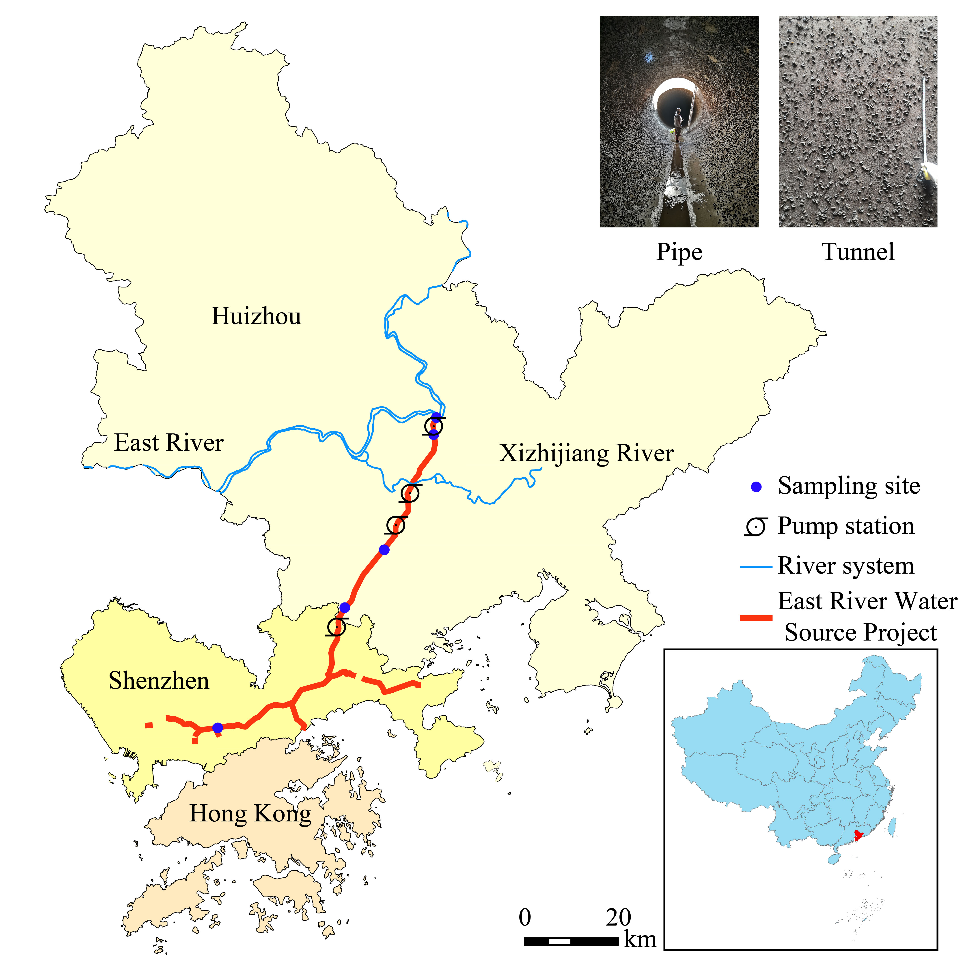
Figure 1. Map of the East River Water Source Project. The pictures on right top show the golden mussel attachment on the wall.

RESULTS
The filed results show that mussel attachment increased after the pumping station and reached to high attachment density (around 100,000 ind./m²). The wall roughness would obviously increase with the attachment density increase which will reduce water flow velocity, but when the mussel covered the whole surface, the increasing of density would not have such strong influence on roughness. Here, we kept the water diversion discharge remains unchanged, and simulated the water level and water pressure increase. The results showed that the water level and pressure increased with golden mussel attachment. And the upstream of Yonghu pump station was more affected for the higher attachment density. In the downstream, water discharge decreased due to diversion and attachment density decreased for long transportation, which result in less increase of water level and pressure. And the result also showed that the sections and regions with high attachment density were where the flow velocity were suitable for golden mussel. Flow velocity will decrease with mussel attachment, which means that the pioneers will transform the environment to suit for attachment and survival, thus forming a vicious circle. According to the simulation results, mussel attachment would cause excess energy loss and velocity decrease. And it was estimated that the energy consumption increases of up to 25% every year. It will greatly affect the safety of water supply and the project itself. Therefore, prevention of golden mussel invasion in water transfer projects is crucial for project safety, and should be taken into consideration at the design and early implementation stages of water transfer projects. And to prevent man-made structures from golden mussel invasion, strategies focusing on the veliger might be a better choice, like integrated ecological prevention method (Xu 2015) and killing with high-frequency turbulence (Rehmann et al. 2003; Zhang et al. 2017).

REFERENCES
- Cataldo, D. H., “Larval Development of Limnoperna fortune”, Invad Nat Spring Ser (2015), pp 43-53, doi:10.1007/978-3-319-13494-9_2.
- Darrigran, G. & C. Damborenea, “Ecosystem Engineering Impact of Limnoperna fortunei in South America”, Zoological Science, Vol.28, No.1, (2011), pp 1-7, doi:10.2108/zsj.28.1.
- Darrigran, G. J. B. I., “Potential impact of filter-feeding invaders on temperate inland freshwater environments”, Biological Invasions, Vol. 4, No.1-2, (2002), pp 145-156.
- Rehmann, C. R., J. A. Stoeckel & D. W. Schneider, “Effect of turbulence on the mortality of zebra mussel veligers”, Can J Zool, Vol.81, No.6 , (2005), pp 1063-1069, doi:10.1139/Z03-090.
- Ricciardi, A., “Global range expansion of the Asian mussel Limnoperna fortunei (Mytilidae): Another fouling threat to freshwater systems”, Biofouling, Vol.13, No.2, (1998), pp 97-106, doi:Doi 10.1080/08927019809378374.
- Xu, M. Z., “Distribution and Spread of Limnoperna fortunei in China”, Invad Nat Spring Ser, (2015): pp 313-320 doi:10.1007/978-3-319-13494-9_17.
- Ye, B. M., X. W. Cao, M. Z. Xu, Z. Y. Wang & C. C. Lin. “Study of Limnoperna fortunei invasion in water transport project”, Water Wastewater Eng, Vol.37, (2011), pp 99-102.
- Zhang, C. D., M. Z. Xu, Z. Y. Wang, W. Liu & D. D. Yu. “Experimental study on the effect of turbulence in pipelines on the mortality of Limnoperna fortunei veligers”, Ecol Eng, Vol.109, (2017), pp 101-118, doi:10.1016/j.ecoleng.2017.08.024.

