Benchmarking 3D CFD for studies on turbulent flow around fish-shaped bodies

Ali hassan khan*
Department of Computer Systems, Tallinn University of Technology
Ehitajate tee 5, 19086 Tallinn, Estonia

Karla ruiz hussmann, dennis powala, stefan hoerner
Institute for Fluid Mechanics and Thermodynamics, Otto-von-Guericke Universität
Universitätplatz 239106 Magdeburg, Germany

maarja kruusmaa, Jeffrey a. tuhtan
Department of Computer Systems, Tallinn University of Technology, Ehitajate tee 5
19086 Tallinn, Estonia

Abstract: Fish use their lateral line flow sensing system to locate food, avoid predators and to navigate in turbulent, dark and turbid waters. Biophysical studies of the lateral line indicate that fish are capable of sensing pressure, velocity, and acceleration of the near-body flow field, as well as their gradients at rates between 20 and 400 Hz. This allows fish to perceive minute changes in the hydrodynamic environment, referred to as “touch at a distance”. Previous investigations on near-body flows around fish have illustrated that basic fish-flow interactions can be evaluated using computational fluid dynamics (CFD). Despite these promising findings, there remains a gap in applying CFD to lateral line studies, largely because it is not known which turbulence models are suitable to simulate flows around fish-shaped bodies. To address this, RANS turbulence models are used to simulate a benchmark turbulent flow (Re=6.8x10⁵) around the body of a 3D printed brown trout in an open channel flume. Three different RANS models, the standard k- ϵ, k-ω SST, and Spalart Allmaras were selected based on their applicability. The RANS model assessment was validated in a 1:1 physical open channel flume from laser doppler anemometer (LDA) measurements taken at 250 points distributed around the fish-shaped body, as near as 3 mm from the surface. Furthermore, the effects of modelled and resolved boundary layers were also evaluated. The results of this open source and open data benchmark study provide a numerical model can be used by others for further CFD research on fish flow interactions in fishways, rivers and possibly even to study turbine passage.

Keywords: Fish habitat, turbulence models, boundary layer

INtroduction
A rapid decline in freshwater fish populations across Europe are caused in part by anthropogenic effects and climate change, forming a persistent threat to river ecology [1]. Understanding how fish perceive flow parameters such as velocity, pressure, and acceleration to navigate through the complex habitats is a critical, but poorly understood component of aquatic habitat preservation [2]. Fish have evolved a mechanosensory system to navigate through complex turbulent flows. This sensory system is comprised of tiny hair-like structures on the surface of fish known as superficial neuromasts, and is capable of detecting as low as 20 Hz of water fluctuations, and canal neuromasts can detect higher frequencies up to 400 Hz [3]. Fish can sense upstream and in the lateral direction up to 20% of their body length, efficiently navigating through highly turbulent flows [4].
Turbulence in natural river habitats can be characterized by four major elements: intensity, periodicity, orientation, and scale [5]. Woody material, boulders, vegetation and local bedforms generate turbulence in the form of eddies which cascade from large to small in space and time [6], [7]. The spatial scales of these eddies can be up to several meters and the time scale of turbulence eddies over which it interrupts the mean flow, ranges from a small i.e., Kolmogorov microscale to large convective time scales. In addition, the riverbeds in natural environments are highly heterogeneous and non-uniform which disrupts the mean flow resulting in a non-uniform boundary layer and turbulent eddies which affects the fish’s swimming efficiency. A fish’s response to unpredictable turbulence can therefore also be unpredictable. Fish may take advantage of the turbulence during the normal swimming gait cycle to improve their swimming efficiency. However, it is also possible that turbulent eddies decrease the overall swimming performance [8], [9]. A recent study shows that even if there are similar turbulence levels in different locations, the fish responses will not be the same [2]. This is likely because in addition to turbulence, other factors can play a crucial role in the fish’s behavioral response to flow, including illumination, sound and scent. Multiple studies focus on quantifying fish habitats from the observer’s perspective do not typically consider how a fish perceives its environment [10]. To begin to address this issue, studies of flow fish interactions are required which describe the flow fields around fish-shaped bodies including the velocity, pressure and their gradients.
Recent advancement in computer technology and the up-gradation of computational resources, has increased the possibility to model such complex flows through numerical approximations. Computational fluid dynamics (CFD) has shown promising results in the past modelling river flows on large scales [11]. But at the microscale, the boundary layer contributes towards flow separation on the body, as well as vortex generation in the wake [12]. Previous studies have emphasized fish swimming kinematics as well as the propulsion and drag forces [13]–[15]. However, very few studies have discussed how these may relate to a fish’s sensing capabilities. For example, [16] tested a blind Mexican fish (Astyanax fasciatus) facing a wall laterally or approaching a wall and found that it can sense up to 20% of its body length (BL) at normal swimming speeds. Similarly [12] showed that 3D simulations can be used to detect the spatial patterns of pressure gradients around fish bodies generated by a dipole source. Both studies highlighted the significance of the boundary layer at the body surface to detect the near-body pressure gradients stimulating the lateral line.
In this work, a 3D CFD study around a fish-shaped body provides a benchmark using Reynolds Averaged Navier-Stokes (RANS) turbulence models to estimate the velocity and pressure fields. Furthermore, we present fish and flow interaction in the presence of a boundary layer and the investigate the significance of resolving the boundary layer in perceiving the flow fluctuations on the fish body surface. The significant contribution of this work is the open-source numerical model it provides, which can be applied by future researchers in new CFD studies. This work is significant because it is the first to assess the effects of boundary layer and turbulence modelling on flow fields around fish-shaped bodies using the RANS approach.

methodology

Numerical Modelling
An open-source numerical model was developed in the OpenFOAM framework, modelling the flow around a steady fish in an open channel flume. OpenFOAM is a C++ toolbox for solving continuum mechanics problems with the efficacy of customizing the numerical solvers, and pre-and post-processing utilities. Modelling a section of a flume, with a particular interest in the spatial flow parameters, reduces the computational cost and time. Therefore, a section of flume with dimensions 1850 × 800 × 600 mm³ was modelled in this study (Fig 1). In this work, only RANS turbulence models are taken into account for a single-phase flow due to their robustness and low computational costs. A numerical model using Large Eddy Simulation (LES) or Direct Numerical Simulation (DNS) would require a very fine mesh discretization of the flume, which intuitively requires more computational resources and time. We tested three different RANS turbulence models; the Standard k-ϵ model, k-ω SST model, and the Spalart Allmaras model. Modelling physical flow problems in the finite volume method (FVM) assures that the pressure velocity coupling at the center of each cell. The pressure velocity coupling is solved through an iterative solution strategy, ‘Semi-implicit method of pressure linked equations (SIMPLE)’ [17]. An advantage of using this iterative solution strategy is that it can be applied to simulations with high Courant-Friedrichs-Lewy (CFL) numbers. As the primary focus of this study is to simulate the boundary layer (BL) around the surface of fish, with a very fine mesh (with cell size up to a few mm). Simulating the boundary layer is an important consideration for fish sensing because within the BL, the viscous forces dominate over inertial forces and large pressure gradients permeate the flow field. These flow field gradients are key factors in determining the fish’s active sensory space. Thus, five different model setups are purposed in this study corresponding to the turbulence models with the possibility of both resolving and modelling the boundary layer at the surface of fish. All five model setups were validated later with the experimental data obtained. The summary of these model setups is provided in Tab 1.

Tab 1. Overview of the numerical model setups investigated in this work as combinations of near-wall treatments and RANS turbulent models.

Near-wall  treatment | RANS turbulence models
Near-wall  treatment | Standard k-ϵ | k-ω SST | Spalart Allmaras
Boundary layer  Unresolved | BL modelled  Wall treatment through wall functions  (30<y⁺<300) | BL modelled  Wall treatment through wall functions  (30<y⁺<300) | -
Boundary layer  Resolved | BL fully resolved  (y⁺<1) | BL fully resolved  (y⁺<1) | BL fully resolved  (y⁺<1)

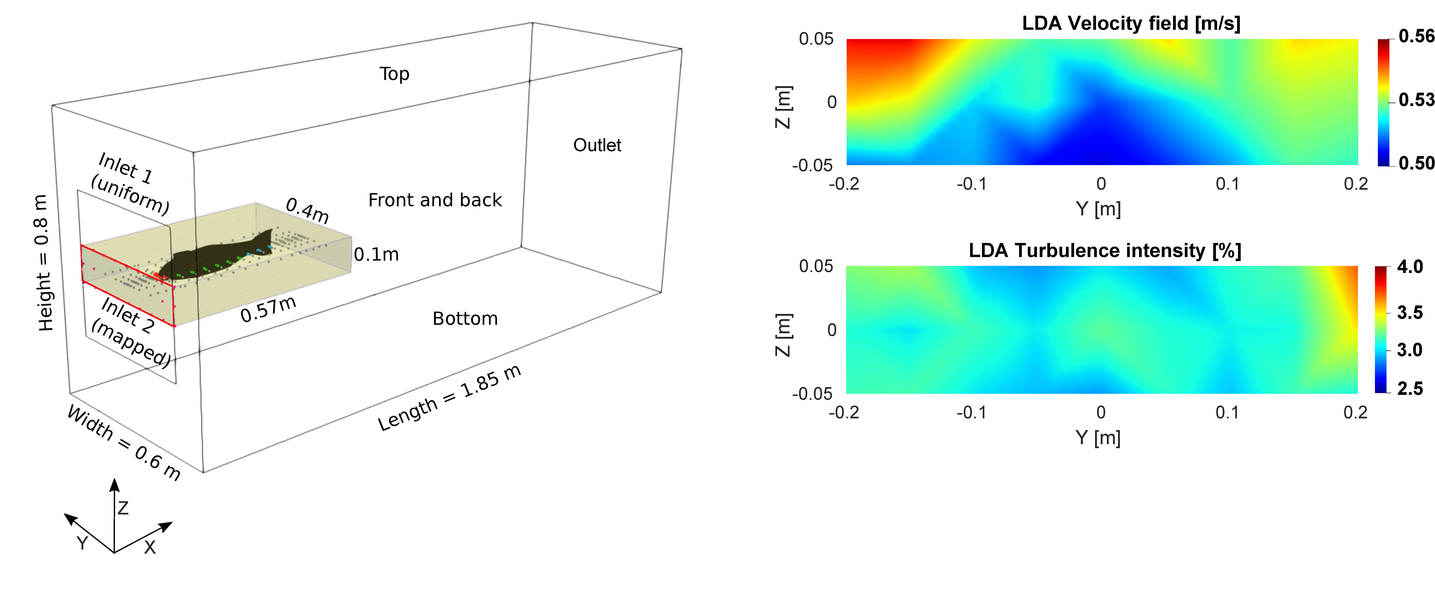
Fig 1. Overview of the numerical and the experimental domains; (Left) fish-shaped body, the spatial distribution of measurement points around the physical model and at the upstream boundary of the CFD model. (Right) Inlet velocity and turbulence distributions at the inlet patch (red rectangle in the left panel) were measured with LDA and later applied as a mapped inlet condition in the numerical model.

For resolved boundary layer cases, mesh discretization in the vicinity of fish is very fine (y⁺<1). In these model cases, low Reynolds wall functions are used to model the flow within the boundary layer. Whereas for modelled boundary layer cases, high Reynolds wall functions are enacted in OpenFOAM.

Geometry and mesh
A three-dimensional model of a brown trout (Salmo trutta) was generated in computer-aided design (CAD) software. This model was imported into OpenFOAM as an stl. file which was later snapped into the domain and meshed with hexahedral cells of different sizes. The mesh cell size increases from the surface of fish to outer domain boundaries. The meshing strategy followed a two-step approach, in the first step the flume domain was generated with a blockMesh utility and discretized with hexahedral cells around a cavity, in the second step the fish was snapped and discretized with hexahedral cells through cfMesh utility which was later merged into that cavity and stitched with the existing mesh (Fig 2). The whole meshing algorithm was automated through a bash file in the Linux system to save time. For a grid independence study, five different mesh sizes were generated with the cell size ranging between 0.1 m to 0.01 m.

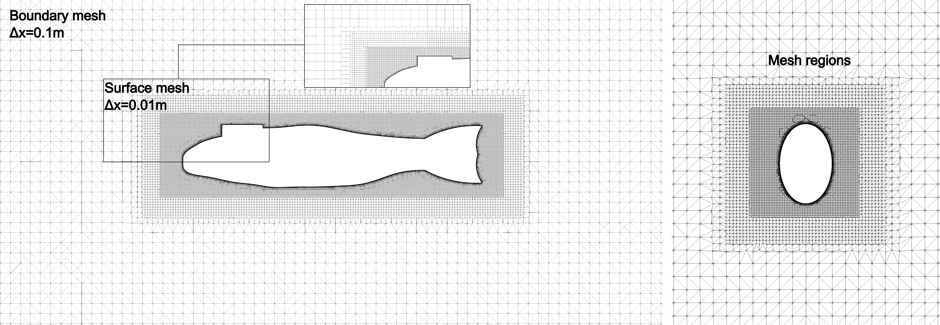
Fig 2. Mesh discretization of the domain; (Left) frontal section showing the boundary mesh and fine discretization of mesh boundary layers around the surface of fish (zoomed section illustrates the boundary layers around the fish body). (Right) Lateral discretization of mesh with different mesh regions around the fish body.

Boundary conditions
Specification of the boundary conditions as well as the initial values at the inlet and outlet patches in a numerical setup for simulating physical flow problems is the first step of CFD analysis. Flow within the flume is highly turbulent (Re = 6.8x10⁵ at the fish surface), with a time-averaged velocity of 0.54 ms⁻¹ and turbulent intensity of 3.16 %. For the development of a numerical model representing similar fldow characteristics, the inlet patch is divided into two sub-patches. The inlet patch upstream of the fish head is specified with the flow velocity mapped from the LDA experiments through a second-order polynomial else the mean velocity was enacted in the free stream surrounding region. A no-slip boundary condition was applied to all the patches except the atmospheric patch where a slip boundary was applied.

Experimental Setup
A lab experimental facility was designed at Otto-von-Guericke University Germany in which 2D LDA measurements were recorded around a rigid 3D printed fish model for velocity and turbulence intensity in a 10 m long and 1.2 m wide flume. The water depth inside the flume was kept constant at a height of 0.68 m. The LDA system was projected from underneath the flume with optical access to 0.6 m in length, 0.53 m in width, and 0.26 m in height. The LDA velocity measurements were recorded at 253 locations in total with an increasing sample density closer to the surface of the fish. This includes the measurements taken upstream, near the body, and in the wake region. To ascertain the velocities in the vicinity of the fish body within the boundary layer the closest distance was set to 3mm along the body and 2.5mm along the tail. Single plane measurements (at z = 0) were taken into account to demonstrate the velocity tendency around the fish body. Within the scope of this study, only U_{x} and U_{y} velocities are considered (neglecting the U_{z}). The measurements are grouped into head, body, and tail regions of interest to compare the performance of wall treatments and turbulence models. To ensure the reproducibility over several multiple days of measurements, a grid of 18 measurement points upstream of fish was analyzed at the beginning of each experiment. The LDA data was post-processed and stored with a commercial software BSA Flow using a Dantec Flow Explorer DPSS 300 2D which allowed for the acquisition of raw data at a single measurement location. It also calculates the signal quality for each measurement based on the signal-to-noise ratio (SNR) which was used for LDA qualitative assessment before actual measurements.

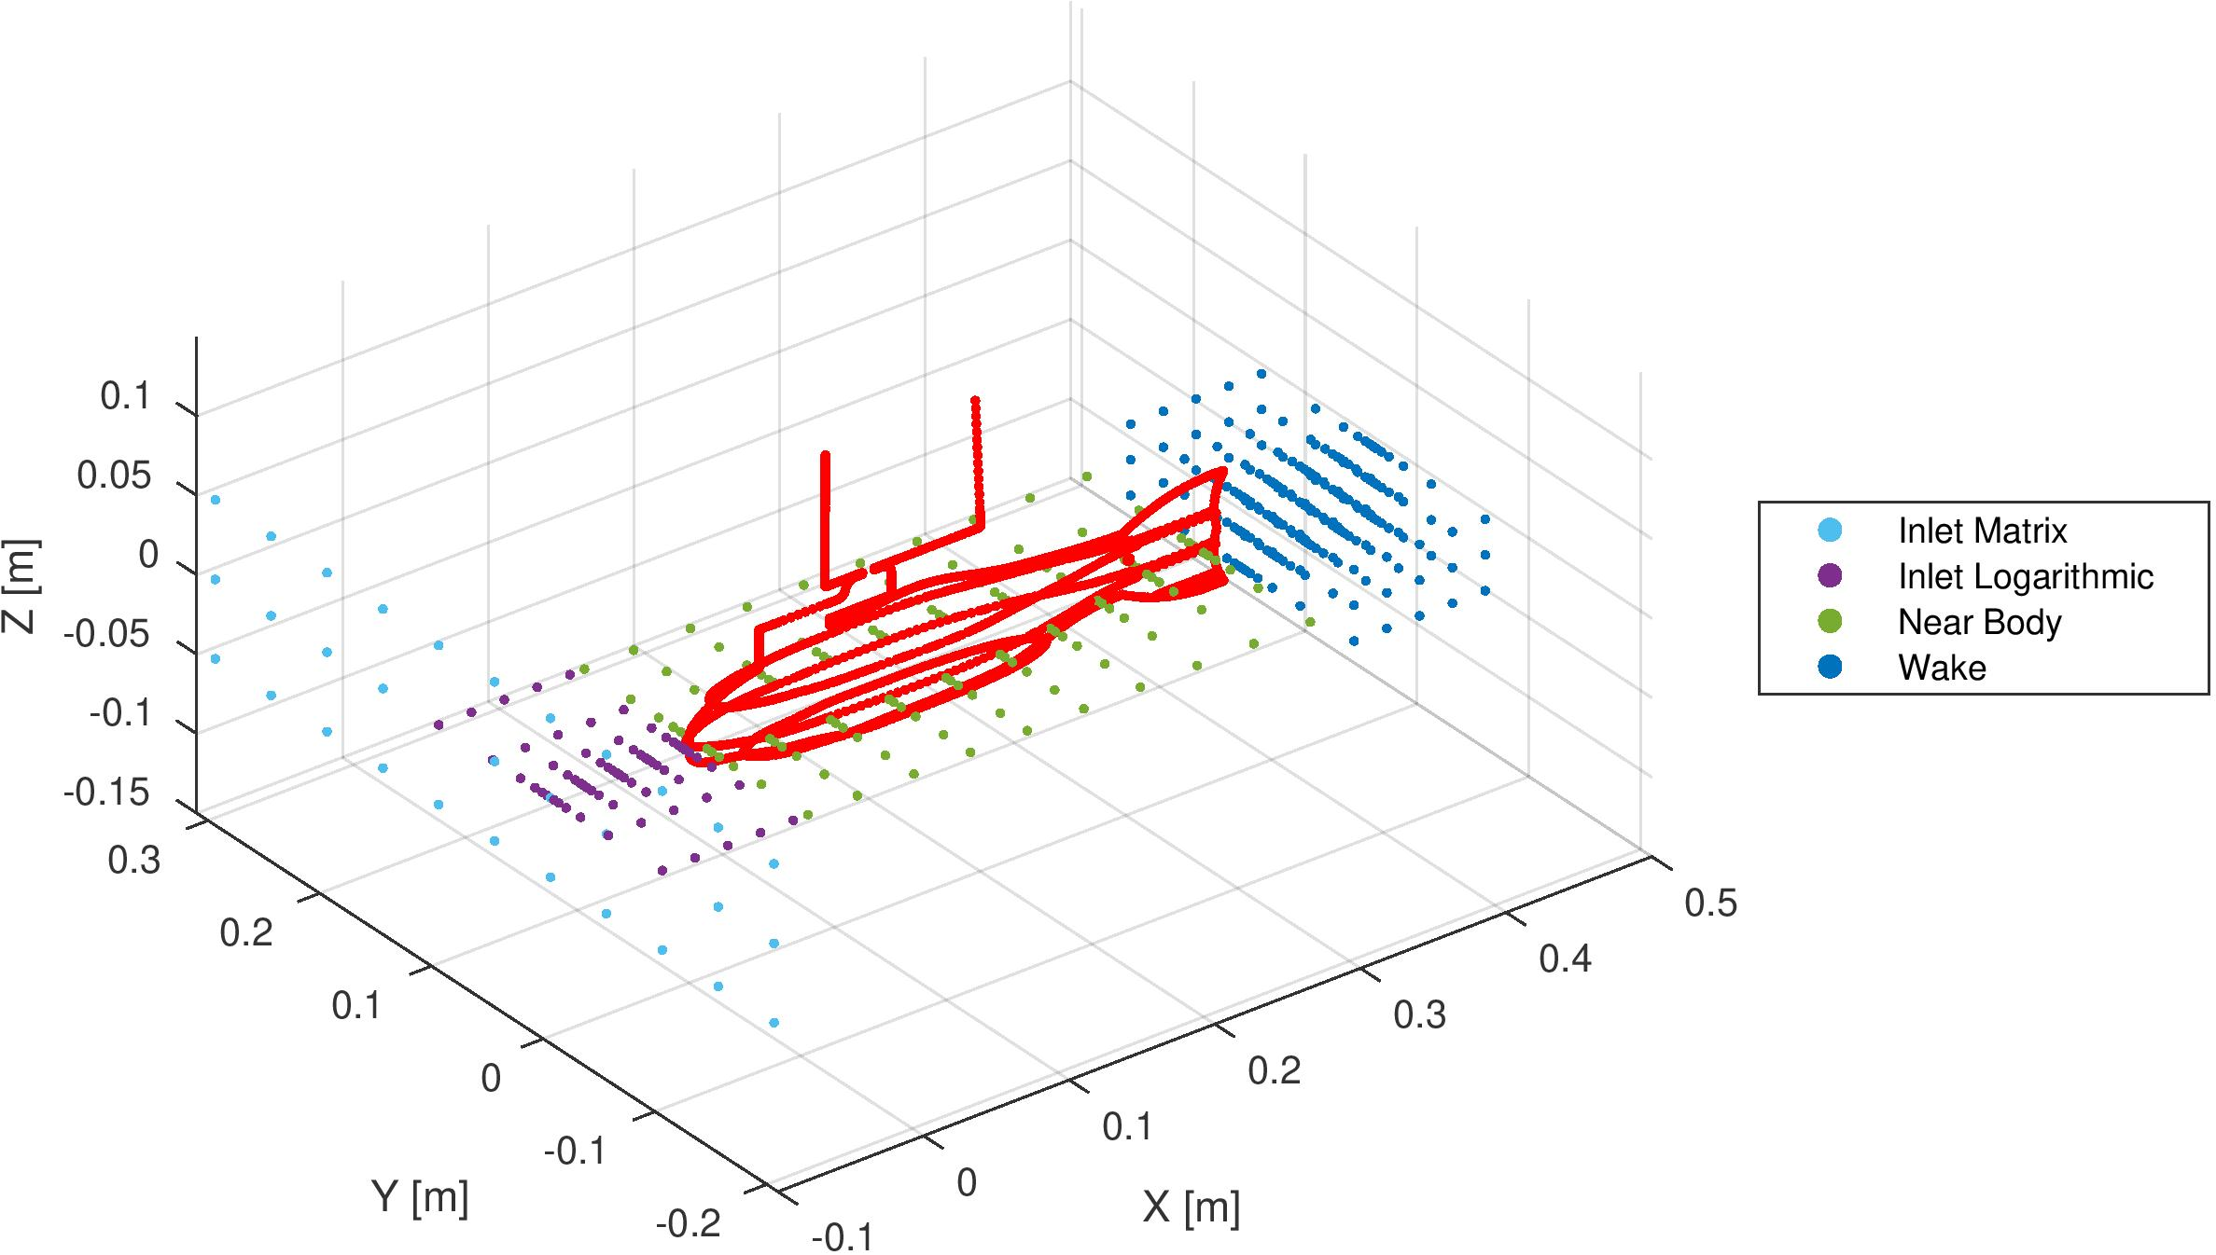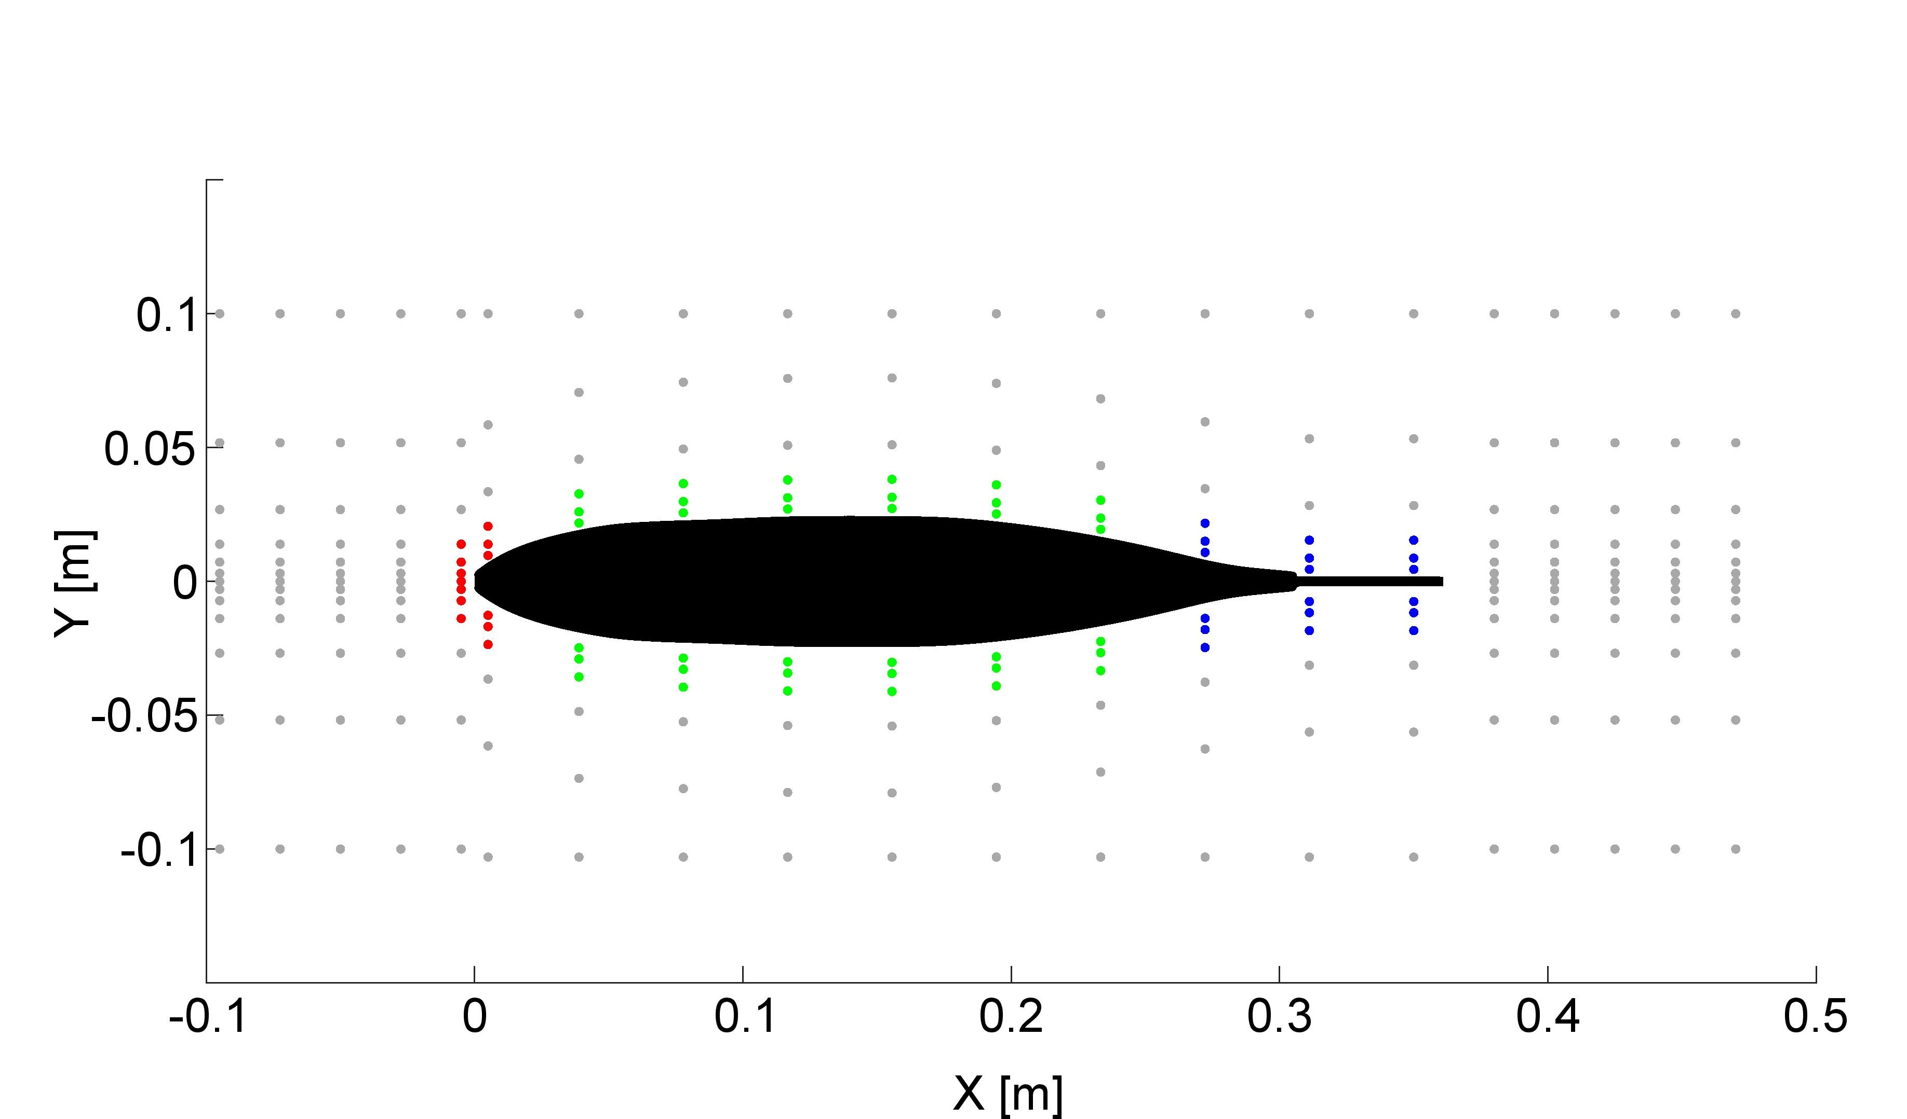
Fig 3. Left: Position of all measurement points in the 3D experimental domain indicated by each targeted group. Right: Velocity measurements and numerical probes around the fish body in the 2D plane with three regions: head (red), body (green), and tail (blue) inside the boundary layer. Gray points further away from the body surface correspond to LDA measurement locations not taken into account for boundary layer measurement.

Results and discussions

Mesh and time sensitivity analysis
The mesh sensitivity analysis was achieved through ASME criteria [18]. The evaluation factor chosen for mesh sensitivity analysis was, ‘drag coefficient (c_{d})’. It is convenient to consider the drag coefficient as an evaluation metric because it manifests the pressure and shear forces over the entire surface of the fish body. Five different setups with varying mesh sizes were tested for the calculation of drag coefficient and analyzed through grid convergence index (GCI). It is worth mentioning here that for all setups it was ensured that the y⁺ remained in the viscous range.
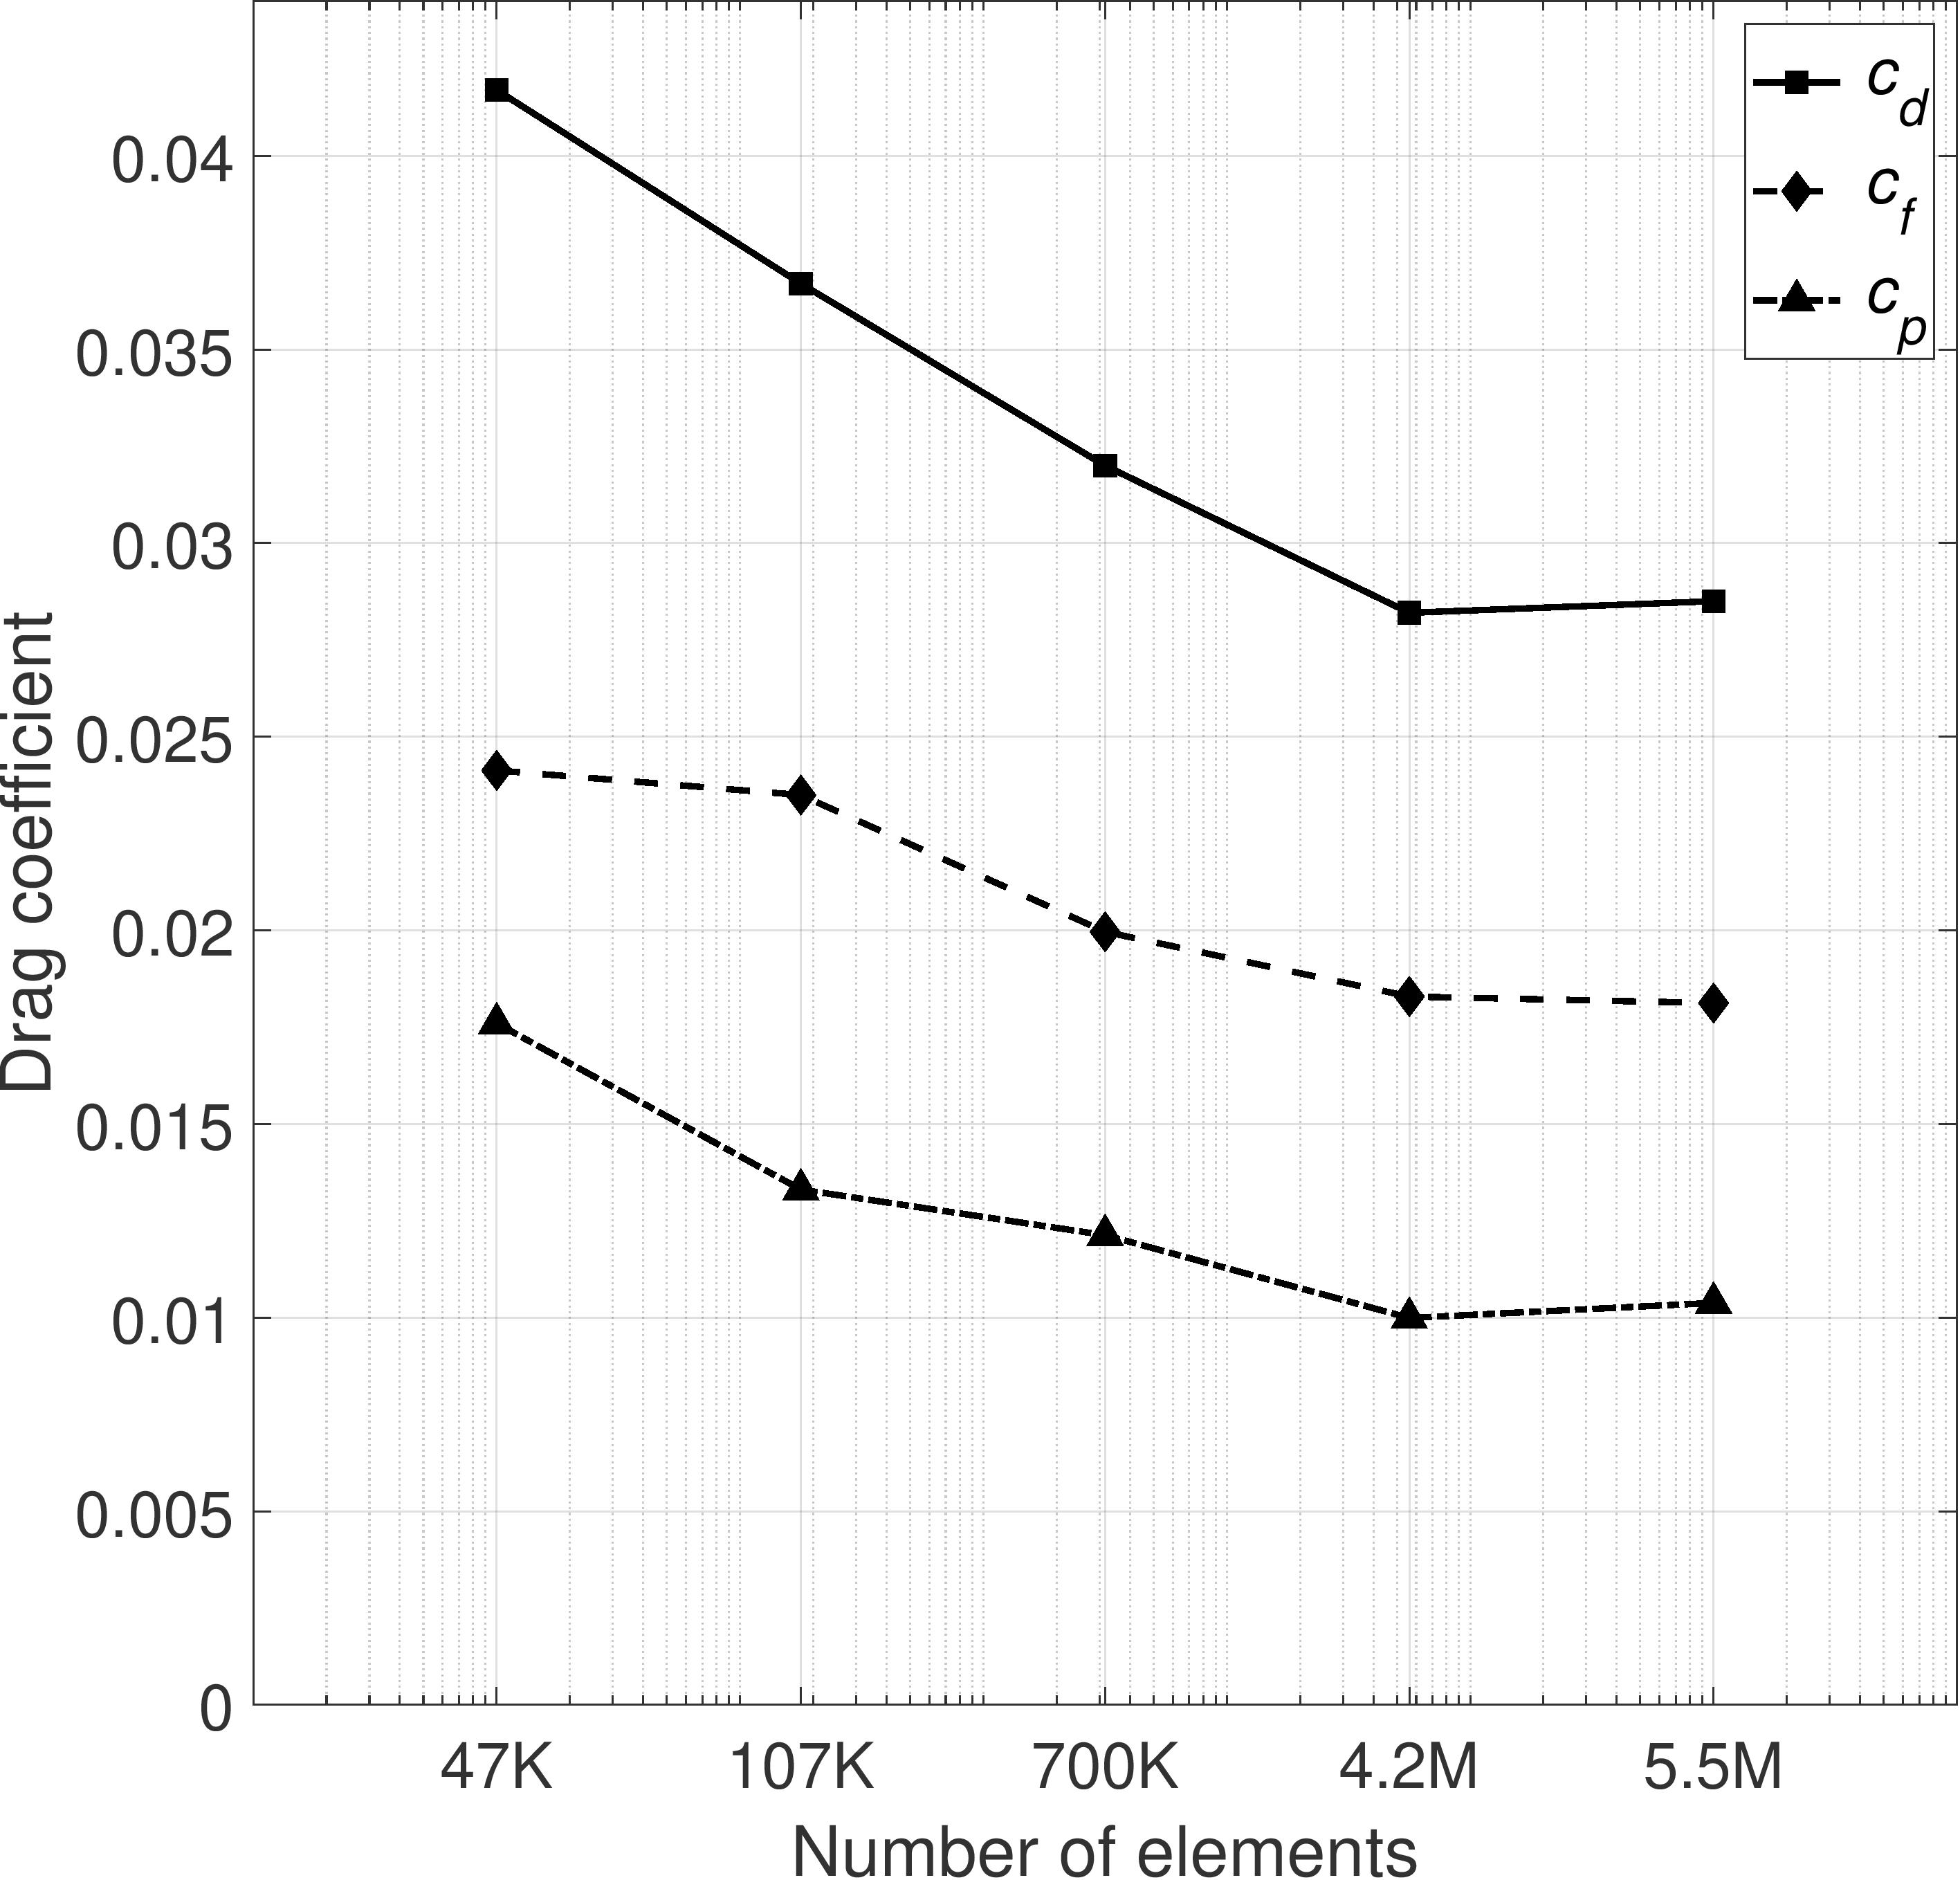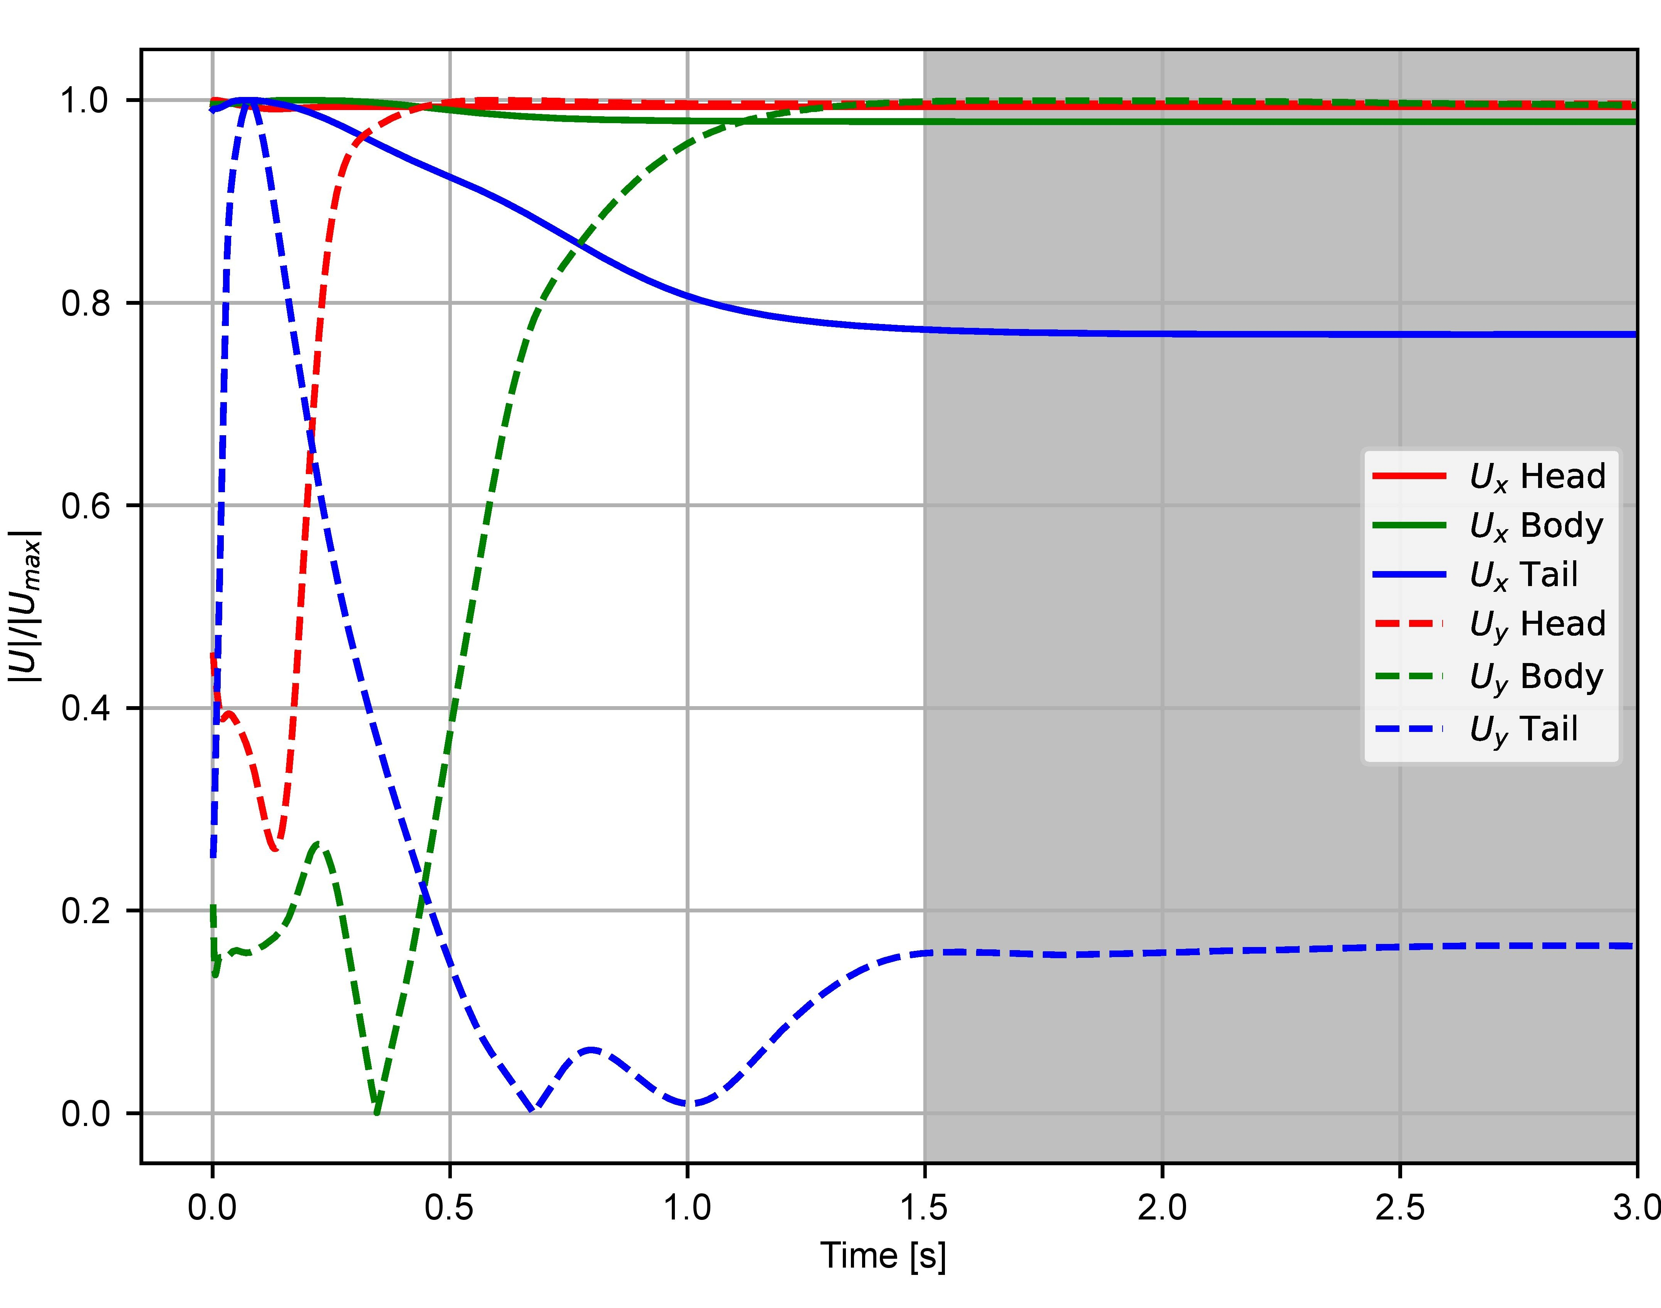
Fig 4. Left: Evolution of drag (cd), friction drag (cf), and pressure drag (cp) coefficients for increasing mesh number of cells (abscissa in logarithmic scale). Right: Convergence of the streamwise and lateral velocity components within the boundary layer (Fig 3) over a simulation time of 3 s.

The drag coefficient (c_{d}) decreases with the increase in the number of mesh and converges at 4.2M. Thus, the model setup with 4.2M cells was opted for final simulation for validation purposes. A time-sensitivity analysis was performed to analyze the fluctuation of velocities in the vicinity of the fish surface. The total time of simulation was set to 3.0 s but the velocities (streamwise U_{x} and lateral U_{y}) converged after 1.5 s. Therefore, all validations were carried out after 1.5 s of the time interval.

Resolved and modelled boundary layer
Flow characteristics are mainly dependent upon the type of flow. Studies with fluid-low interactions generally require the boundary layer to be resolved with a fine resolution mesh. Different RANS turbulence models have different approaches for model wall-bounded flows. The streamwise and lateral velocity measured through LDA measurements and simulations models for Standard k-ϵ, k-ω SST, and Spalart Allmaras, are compared for probe points within a distance of 0.06 m from the boundary layer. Fig 5. shows a comparison of absolute velocity difference within the boundary layer between the simulated models (both resolved and unresolved) and LDA measurements. From the comparison, we found that the Spalart Allmaras model was capable of simulating the boundary layer effectively with a maximum velocity difference of 0.07m for streamwise velocity (U_{x}). Whereas for lateral velocities, the results did not show a substantive difference across the model setups. Overall, the resolved boundary layer cases showed less absolute difference than the modelled cases.

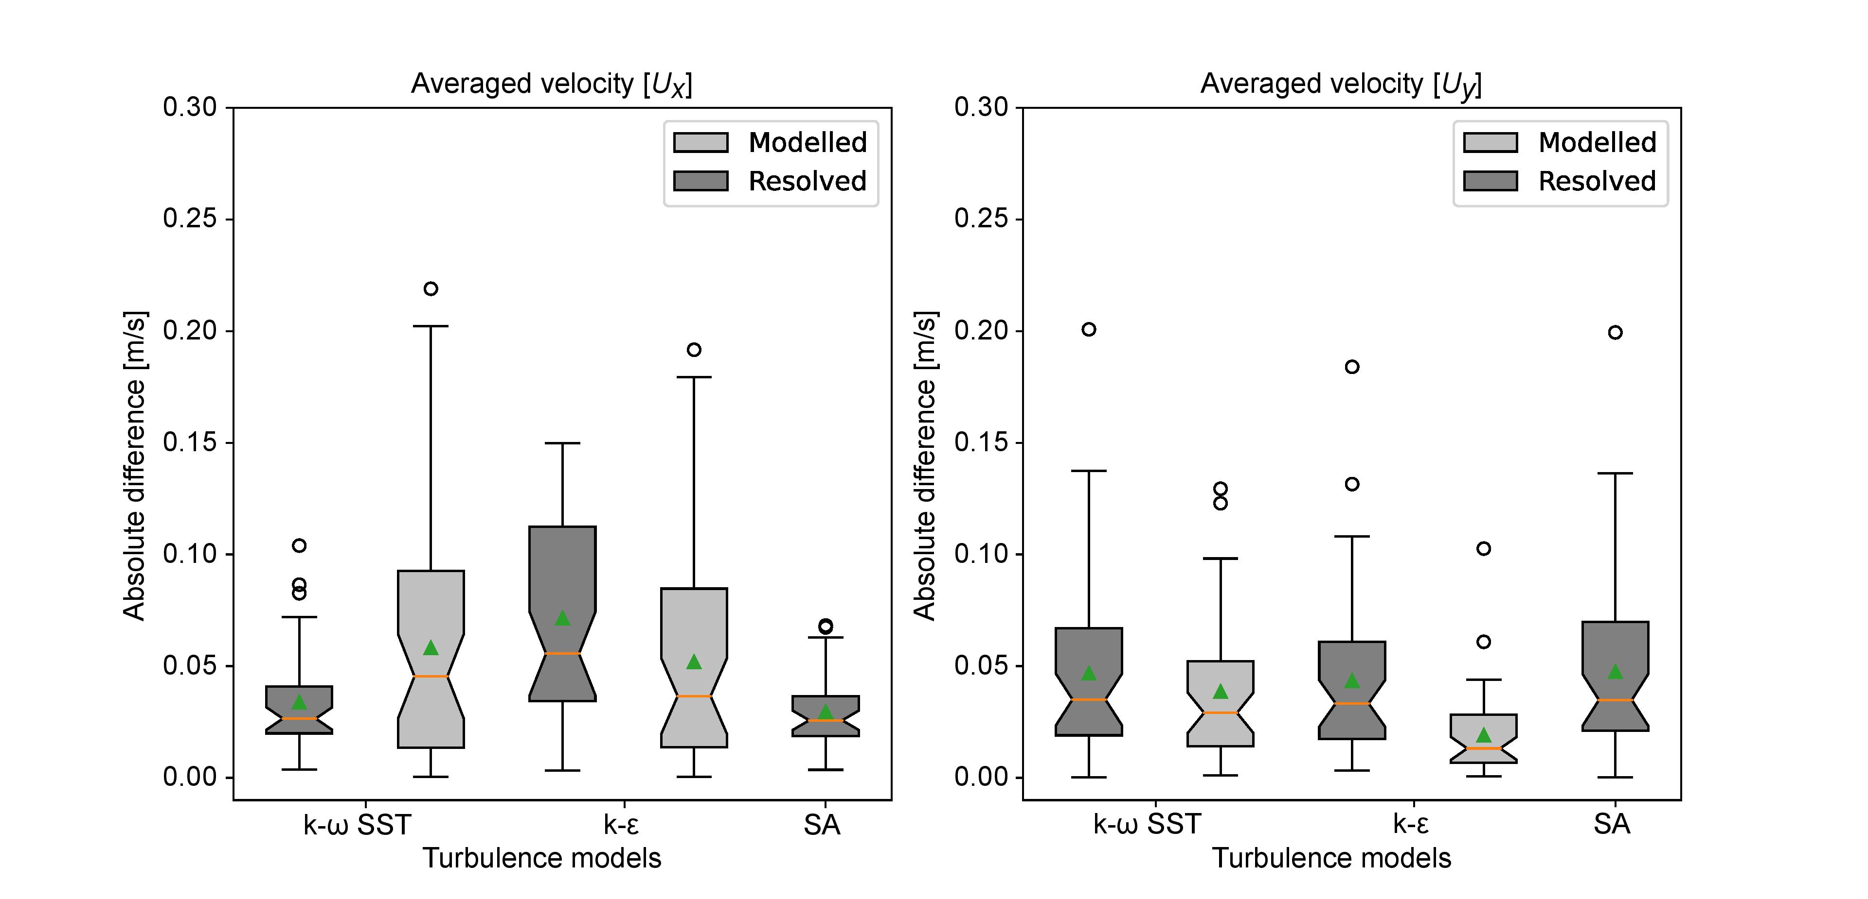
Fig 5. Box plots of the absolute difference between the time-averaged velocities (U_{x} and U_{y}) for the three turbulence models, compared to the LDA measurements. The boxplot indicates the inter-quartile range, mean (green triangle), median (orange line), and outliers are shown as black circles. The fill color indicates either resolved or modelled boundary layers.

Turbulence models and wall modelling
All turbulence models have performed equally in the free stream, but major differences emerge at the surface of fish where k-ω SST and Spalart Allmaras performed better as compared to the Standard k-ϵ model. The k-ω SST and Spalart Allmaras had minor divergence to the LDA measurements between streamwise velocity. Among all three turbulence models, Spalart Allmaras performed best. Fig 6. illustrates the normalized streamwise velocity profiles in three different regions along the body of fish. Within the boundary layer, the performance of the Standard k-ϵ model turbulence model around the head region was not satisfactory.

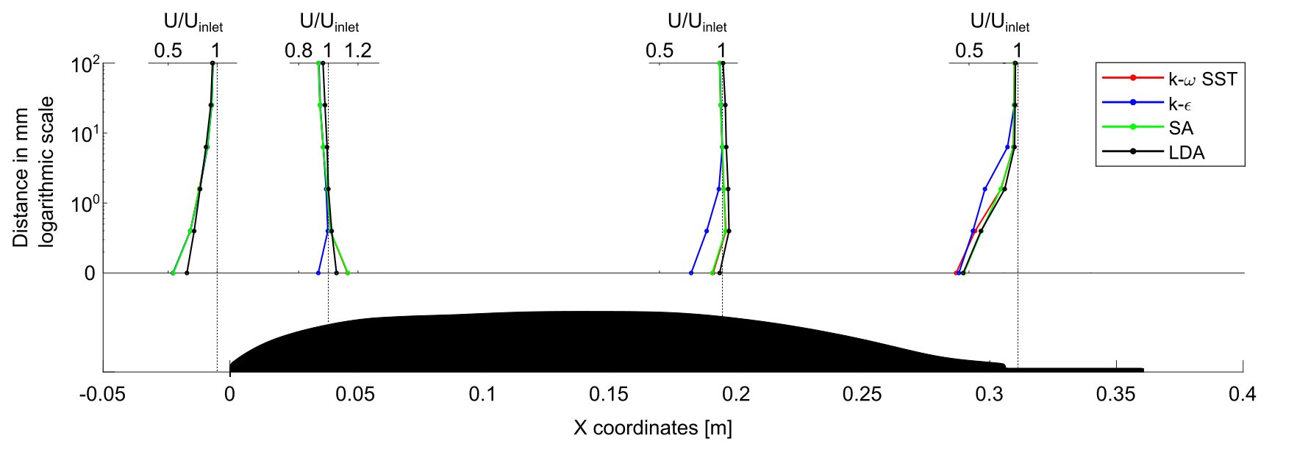
Fig 6. Normalized streamwise velocity profiles at three different regions along the fish-shaped body for all turbulence models and LDA measurements. At some locations, the k-ω SST model overlaps the Spalart Allmaras model and is not visible.

Conclusion
Modelling turbulent flows around fish-shaped bodies require special care in handling the boundary layer. Using wall functions to modify the wall shear stress empirically and satisfy the physics of flow across the boundary layer, adeptly bridges the flow between the inner region and the fully turbulent flow. An alternative way to determine the wall shear stress is by resolving the gradient near the wall by fine resolution of the mesh. In turbulent flows with a high Reynolds number, the boundary layer gets thinner resulting in a gradient at the wall steeper which needs smaller cells to resolve the gradient. In this study, a fine resolution of mesh with mesh size up to 1mm at the surface of fish was generated to get the first mesh node inside the viscous layer (y⁺<1) with additional layers at a thickness ratio of 1.15. Subsequently, a coarser mesh with the first node (30<y⁺<300) in the logarithmic layer was generated for the modelled boundary layer case. Simulation results for streamwise and lateral velocity for both modelled and resolved cases support the argument that resolving the boundary layer provides better results in analyzing flow characteristics for all turbulence models. It is worth mentioning that the Spalart Allmaras model can only be applied for the resolved cases. The modelled cases in general show more divergence from the LDA measurements as compared to resolved cases. Thus, for future studies, we recommend resolving the boundary layer while simulating turbulent flow around fish-shaped bodies.
Among the tested RANS turbulence models, the Spalart Allmaras model performance was the best. The k-ω SST model also performed well, except in the tail region where it did not accurately estimate the position of flow separation. The Standard k-ϵ model performance was substandard in the regions of high-pressure gradients.
This research is significant because it spotlights the implication of resolving the boundary layer for simulating fish in a highly turbulent environment. Fish senses minute fluctuations inside the boundary layer through superficial neuromasts and studies show that they are predominantly concentrated inside the head region [19]. Thus, it is important to simulate the flow across the boundary layer by resolving it and deploying the Spalart Allmaras turbulence model for modelling turbulent flows around fish-shaped bodies [20].
Future studies can implement these modalities on more diverse species of fish with inclusion of fish undulatory motion to explore the flow parameters of the fish body. Understanding flow characteristics velocity or pressure on the 3D complex surface of fish would help us to find how fish perceive its environment in nature.

Acknowledgments
The research work presented in this paper has received funding from European Union Horizon 2020 Research and Innovation Programme under the Marie Sklodowska-Curie Actions, Grant Agreement No. 860800. Laboratory measurements were conducted as part of the RETERO project, sponsored by the German Federal Ministry of Education and Research Grant no. 161L0152A. Jeffrey A. Tuhtan’s contribution was funded by the Estonian Research Council Grant PRG1243 and Maarja Kruusmaa was funded by EXCITE supported by the Estonian Centre of Excellence in IT, funded by the European Regional Development Fund Project nr 2014 2020.4.01.15-0018. The authors are grateful to M. Yanneck Kiiski for the design and 3D printing of the fish geometry and the CAD model of the laboratory flume.

REFERENCES

[1] A. Marion et al., “Aquatic interfaces: a hydrodynamic and ecological perspective,” http://dx.doi.org/10.1080/00221686.2014.968887, vol. 52, no. 6, pp. 744–758, Nov. 2014, doi: 10.1080/00221686.2014.968887.
[2] D. L. Smith, R. A. Goodwin, J. M. Nestler, and R. Andrew Goodwin, “Relating Turbulence and Fish Habitat: A New Approach for Management and Research,” Rev. Fish. Sci. Aquac., vol. 22, no. 2, pp. 123–130, 2014, doi: 10.1080/10641262.2013.803516.
[3] J. F. Fuentes-Pérez et al., “Current velocity estimation using a lateral line probe,” Ecol. Eng., vol. 85, pp. 296–300, Dec. 2015, doi: 10.1016/J.ECOLENG.2015.10.008.
[4] S. P. Windsor, S. E. Norris, S. M. Cameron, G. D. Mallinson, and J. C. Montgomery, “The flow fields involved in hydrodynamic imaging by blind Mexican cave fish (Astyanax fasciatus). Part II: gliding parallel to a wall,” J. Exp. Biol., vol. 213, no. 22, pp. 3832–3842, Nov. 2010, doi: 10.1242/JEB.040790.
[5] R. W. J. Lacey, V. S. Neary, J. C. Liao, E. C. Enders, and H. M. Tritico, “The ipos framework: Linking fish swimming performance in altered flows from laboratory experiments to rivers,” River Res. Appl., vol. 28, no. 4, pp. 429–443, May 2012, doi: 10.1002/RRA.1584.
[6] J. B. Allen and D. L. Smith, “Characterizing the Impact of Geometric Simplification on Large Woody Debris Using CFD,” Int. J. Hydraul. Eng., vol. 2012, no. 2, pp. 1–14, 2012, doi: 10.5923/j.ijhe.20120102.01.
[7] D. W. Crowder and P. Diplas, “Vorticity and circulation: spatial metrics for evaluating flow complexity in stream habitats,” https://doi.org/10.1139/f02-037, vol. 59, no. 4, pp. 633–645, 2011, doi: 10.1139/F02-037.
[8] A. I. Lupandin, “Effect of Flow Turbulence on Swimming Speed of Fish,” Biol. Bull. 2005 325, vol. 32, no. 5, pp. 461–466, Sep. 2005, doi: 10.1007/S10525-005-0125-Z.
[9] J. C. Liao, “A review of fish swimming mechanics and behaviour in altered flows,” Philos. Trans. R. Soc. B Biol. Sci., vol. 362, no. 1487, pp. 1973–1993, Nov. 2007, doi: 10.1098/RSTB.2007.2082.
[10] G. Trinci, G. L. Harvey, A. J. Henshaw, W. Bertoldi, and F. Hölker, “Turbulence, instream wood and fish: Ecohydraulic interactions under field conditions,” Ecohydrology, vol. 13, no. 5, p. e2211, Jul. 2020, doi: 10.1002/ECO.2211.
[11] M. Nones, M. Guerrero, N. Ruther, and S. Baranya, “CFD modelling of Po River morphodynamics affected by bridge piers,” Geophys. Res. Abstr., vol. 19, pp. 2017–2269, 2017.
[12] M. A. Rapo, H. Jiang, M. A. Grosenbaugh, and S. Coombs, “Using computational fluid dynamics to calculate the stimulus to the lateral line of a fish in still water,” J. Exp. Biol., vol. 212, no. 10, pp. 1494–1505, May 2009, doi: 10.1242/JEB.026732.
[13] D. Adkins and Y. Y. Yan, “CFD Simulation of Fish-like Body Moving in Viscous Liquid,” J. Bionic Eng., vol. 3, no. 3, pp. 147–153, Sep. 2006, doi: 10.1016/S1672-6529(06)60018-8.
[14] N. Thekkethil, A. Sharma, and A. Agrawal, “Unified hydrodynamics study for various types of fishes-like undulating rigid hydrofoil in a free stream flow,” Phys. Fluids, vol. 30, no. 7, p. 077107, Jul. 2018, doi: 10.1063/1.5041358.
[15] M. M. Macias, I. F. Souza, A. C. P. Brasil Junior, and T. F. Oliveira, “Three-dimensional viscous wake flow in fish swimming - A CFD study,” Mech. Res. Commun., vol. 107, p. 103547, Jul. 2020, doi: 10.1016/J.MECHRESCOM.2020.103547.
[16] S. P. Windsor, S. E. Norris, S. M. Cameron, G. D. Mallinson, and J. C. Montgomery, “The flow fields involved in hydrodynamic imaging by blind Mexican cave fish (Astyanax fasciatus). Part I: open water and heading towards a wall,” J. Exp. Biol., vol. 213, no. 22, pp. 3819–3831, Nov. 2010, doi: 10.1242/JEB.040741.
[17] A. Outhwaite, “Numerical Solutions for Pressure-Velocity Coupling in Steady Flow Systems using the SIMPLE Algorithm,” pp. 1–24, 2007.
[18] I. B. Celik, U. Ghia, P. J. Roache, C. J. Freitas, H. Coleman, and P. E. Raad, “Procedure for estimation and reporting of uncertainty due to discretization in CFD applications,” J. Fluids Eng. Trans. ASME, vol. 130, no. 7, pp. 0780011–0780014, Jul. 2008, doi: 10.1115/1.2960953/444689.
[19] L. Ristroph, J. C. Liao, and J. Zhang, “Lateral line layout correlates with the differential hydrodynamic pressure on swimming fish,” Phys. Rev. Lett., vol. 114, no. 1, p. 018102, Jun. 2015, doi: 10.1103/PHYSREVLETT.114.018102/FIGURES/4/MEDIUM.
[20] A. H. Khan, K. Ruiz Hussmann, D. Powalla, S. Hoerner, M. Kruusmaa, and J. A. Tuhtan, “An open 3D CFD model for the investigation of flow environments experienced by freshwater fish,” Ecol. Inform., vol. 69, p. 101652, Jul. 2022, doi: 10.1016/J.ECOINF.2022.101652.

