Development of PIV-based techniques for measurements of instantaneous drag and fish-flow energy exchanges

miriam castagna
School of Engineering, University of Aberdeen, Fraser Noble Building
Aberdeen, AB24 3UE, Scotland, UK

Stuart cameron
School of Engineering, University of Aberdeen, Fraser Noble Building
Aberdeen, AB24 3UE, Scotland, UK

beth scott
School of Biological Sciences, University of Aberdeen, Zoology Building
Aberdeen, AB24 2TZ, Scotland, UK

Samuel martin
School of Biological Sciences, University of Aberdeen, Zoology Building
Aberdeen, AB24 2TZ, Scotland, UK

vladimir nikora
School of Engineering, University of Aberdeen, Fraser Noble Building
Aberdeen, AB24 3UE, Scotland, UK

The understanding of fish-flow interactions is of primary importance to the design of interventions aimed at restoring freshwater fish habitats. We propose a dual plane particle image velocimetry (PIV) based method for indirect assessment of instantaneous drag forces experienced by live fish. Preliminary experiments have been carried out on fish models combining drag measurements with acoustic velocimetry measurements to explore the performance of developed instrumentation and also optimise upcoming PIV experiments.

introduction
Advances in the understanding of fish hydrodynamics may help in interpreting fish behaviour in open-channel flows, eventually leading to the design and implementation of engineering solutions with improved effectiveness in preventing river fragmentation. In particular, evaluation of drag forces acting on fish while they swim would play a key role in expanding knowledge on fish-flow interactions, shedding light on fish hydraulic preferences and locomotion strategies. However, direct measurements of drag force on live swimming fish are not possible at present. In recent years, indirect estimates of fluid resistance of robotic fish (e.g., Leftwich et al. [1]) have been successfully achieved through evaluation of flow-field quantities only. However, the extension to instantaneous forces acting on live fish has not yet been attempted. We propose an approach to obtain reliable and non-intrusive estimations of instantaneous drag on free swimming fish through stereoscopic PIV measurements.

PROPOSED MOMENTUM INTEGRAL APPROACH
We have developed a momentum integral approach for non-invasive instantaneous drag force estimation based solely on the evaluation of the momentum deficit between upstream and downstream cross-sections of a control volume enclosing a fish. The proposed simplified equation

${F_{d}}^{*}\left(t\right)=ρ\int_{S_{\text{front}}}{u}\left(u-u_{s}\right) dA-ρ\int_{S_{\text{rear}}}{u\left(u-u_{s}\right) dA},$ (1)

has been derived from the integral form of the momentum conservation law, where F_{d}*(t) is the instantaneous drag force, ρ is fluid density, u is the instantaneous streamwise velocity component, u_{s} is the control volume (or fish) velocity, and S_{front} and S_{rear} are the respective upstream and downstream control volume surfaces. The validity of Eq. (1) relies on the assumptions that (i) pressure is recovered between upstream and downstream surfaces, (ii) viscous stresses at control surface are negligible, and (iii) combined momentum fluxes through the streamwise sides of control volume are close to zero. Before applying the technique to live fish with dual PIV light sheets, we perform a preliminary investigation of the method with model fish and a drag force sensor.

PRELIMINARY TESTS
A set of experiments were carried out using a drag measurement device and two acoustic Doppler velocimeters (ADV) in an open-channel facility in order to (1) test performances of the drag measurement device and fish models, (2) gain information about fish wake structure for optimization of PIV light sheet positions, and (3) test the proposed momentum integral approach for mean drag force estimation.

Experimental facility
Experiments were conducted in the Fluid Mechanics Laboratory of the University of Aberdeen (UK) using the Armfield Flume facility. The flume is 12.5 m long, 0.3 m wide (B) and supports a maximum flowrate of 40 l/s. The bed slope can be adjusted by screw jacks, while the tail water depth is regulated by a weir at the downstream end of the flume to ensure quasi-uniform flow conditions.

Drag measurement device and fish models
Digital fish models mimicking rainbow trout (Oncorhynchus Mykiss) morphometrics were obtained from the Online Toucan Virtual Museum of the Toucan Corporation Japan (e.g., Kogan et al. [2]). The geometry of the models was refined by closing the gill openings and the mouth, the pectoral and pelvic fins were removed, and finally the model was hollowed to reduce mass. The models were scaled to represent different fish sizes and 3D printed in a nylon material using selective laser sintering (SLS) technology. A drag measurement device (DMD), developed as part of this study, was used to measure the instantaneous drag forces acting on fish models under different hydraulic conditions. The DMD is composed of an aluminium flexible beam element and a capacitive displacement sensor. The fish model is attached to the sensor via a 5 mm diameter stainless steel rod with the nose facing upstream (Figure 1). A static calibration procedure was used to relate measured beam deflection to drag forces imposed by the flow.

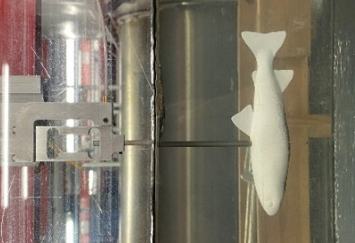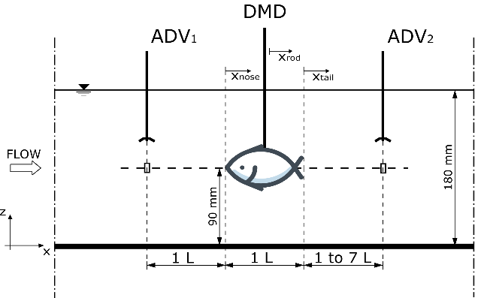
Figure 1. Drag measurement device (left) and experimental set-up (right).

Experiment scenarios
The laboratory flume was operated at a flow depth of H = 180 mm with two different flow velocities U₁ and U₄, and for each velocity, three fish model sizes (L₁, L₃, and L₅) were tested resulting in six scenarios (Table 1). Two types of experiments were carried out for each scenario: (1) short-term (3-minute recording duration) and (2) long-term (2 hours) synchronous measurements of drag and flow velocities. During short-term measurements, the position of the upstream ADV was fixed while the downstream probe was moved across and along the channel to get information about the flow structure in the wake of the fish. The long-term measurements were conducted with both ADVs fixed and aligned to the fish nose in the vertical and transverse directions to obtain highly converged statistics of drag force and velocity fluctuations. In all cases the fish models were placed 9 m (approximately 50 flow depths, H) from the flume entrance.

results

Wake structure
Figure 2 shows streamwise velocity profiles in the wake of the fish as a function of the normalised transverse direction. An asymmetry of the profiles likely results from a single cell secondary current associated with the narrow aspect ratio of the channel. The drop in velocity near the channel centreline is caused by the fish presence and it can be noticed that the velocity defect is larger near the fish (x_{tail}/L = 1) and recovers towards undisturbed flow conditions at larger x_{tail} coordinates, while the width of the disturbed flow simultaneously grows. It is evident from Figure 3, that by x_{rod}/L = 4 the streamwise velocity has recovered to within 2.5% of the upstream velocity. Both normalised mean velocity $\overline{u}/{\overline{u}}_{up}$ and variance $σ_{u}^{2}/{σ_{u}^{2}}_{up}$ collapse on a single curve indicating that the development of the normalised wake is independent of fish size and studied hydraulic conditions.

Table 1. Summary of experiments: H is flow depth, Q is flowrate, U = Q/BH is bulk velocity, S₀ is bed surface slope, Re_{H} = UH/ν is bulk Reynolds number, Fr = U(gH)^{-0.5} is Froude number, L is fish body length, H_{fish} is fish body depth, Re_{L} = UL/ν is fish Reynolds number, ν is fluid kinematic viscosity, and g is gravity acceleration.

RUN | H | Q | U | S₀ | Re_{H} | Fr | L | H_{fish} | Re_{L}
 | (mm) | (m³ s⁻¹) | (m s⁻¹) |  |  |  | (mm) | (mm)
“U1-L1” | 180 | 0.0208 | 0.386 | 0.0004 | 69 000 | 0.29 | 150 | 33.1 | 58 000
“U4-L1” | 180 | 0.0355 | 0.658 | 0.0010 | 118 000 | 0.50 | 150 | 33.1 | 98 000
“U1-L3” | 180 | 0.0208 | 0.386 | 0.0004 | 69 000 | 0.29 | 210 | 45.9 | 81 000
“U4-L3” | 180 | 0.0355 | 0.658 | 0.0010 | 118 000 | 0.50 | 210 | 45.9 | 140 000
“U1-L5” | 180 | 0.0208 | 0.386 | 0.0004 | 69 000 | 0.29 | 270 | 58.7 | 100 000
“U4-L5” | 180 | 0.0355 | 0.658 | 0.0010 | 118 000 | 0.50 | 270 | 58.7 | 180 000

Application of the momentum integral approach
Mean values of drag force experienced by the fish model F_{d} were calculated from direct instantaneous drag measurements and corrected for the contribution of the support strut (Table 2). It can be noted that mean drag increases with increasing flow velocity and fish model size. Fish drag coefficients C_{d} were then calculated from F_{d} values and found to be almost constant and equal to 0.02, thus being within the range of C_{d} values for rainbow trout reported by Webb [3]. An independent estimate of the mean drag force acting on the fish model was computed by applying an approximate implementation of a time-averaged version of Eq. (1):

$F_{d}^{*}≈ρ H_{\text{fish}}\int_{-0.33b}^{+0.33b}{{\overline{u}}_{\text{up}}^{2}}dy-ρ H_{\text{fish}}\int_{-0.33b}^{+0.33b}{{\overline{u}}_{\text{down}}^{2}}dy,$ (2)

where the integral over the vertical coordinate has been approximated by multiplication with H_{fish}, ${\overline{u}}_{\text{up}}$ is the mean velocity 1L upstream of the fish and ${\overline{u}}_{\text{down}}$ is the mean velocity downstream. For each experimental scenario Eq. (2) was evaluated with downstream velocities located at x_{tail}/L = 1, x_{tail}/L = 2, and x_{tail}/L = 3 for comparison (Table 2). Estimated drag values F_{d}* were found on average to be within around 40% of measured drag F_{d} despite a significant simplification of the proposed methodology. No consistent effect of the streamwise coordinate of ${\overline{u}}_{\text{down}}$ can be detected in the data.

Table 2. Mean measured drag force F_{d} and drag coefficient C_{d} = 2F_{d}/(ρA_{wetted}U²), A_{wetted} is wetted area of the fish model, and mean drag force estimates F_{d}* from the momentum integral approach applied at different x_{tail}/L.

RUN | U | F_{d} | C_{d} | F_{d} * (x_{tail}/L = 1) | F_{d} * (x_{tail}/L = 2) | F_{d} * (x_{tail}/L = 3)
 | (m s⁻¹) | (N) |  | (N) | (N) | (N)
“U1-L1” | 0.386 | 0.0163 | 0.0203 | 0.0199 | 0.0184 | 0.0206
“U4-L1” | 0.658 | 0.0394 | 0.0169 | 0.0644 | 0.0350 | 0.0626
“U1-L3” | 0.386 | 0.0402 | 0.0255 | 0.0216 | 0.0150 | 0.0166
“U4-L3” | 0.658 | 0.0854 | 0.0186 | 0.0377 | 0.0931 | 0.1062
“U1-L5” | 0.386 | 0.0551 | 0.0211 | 0.0406 | 0.0358 | 0.0335
“U4-L5” | 0.658 | 0.1329 | 0.0176 | 0.1707 | 0.0962 | 0.0867

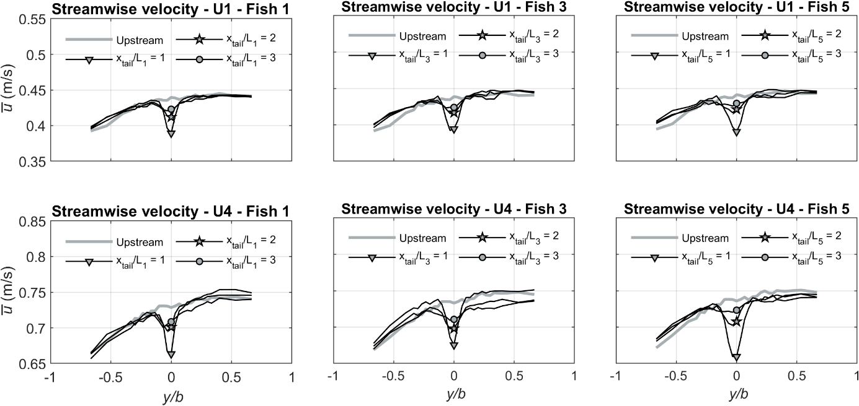
Figure 2. Transverse distribution of time-averaged streamwise velocity at elevation z = 90 mm. The origin of the spanwise coordinate y is the channel centreline, and b = 150 mm is half channel width; x_{tail} is defined in Figure 1.

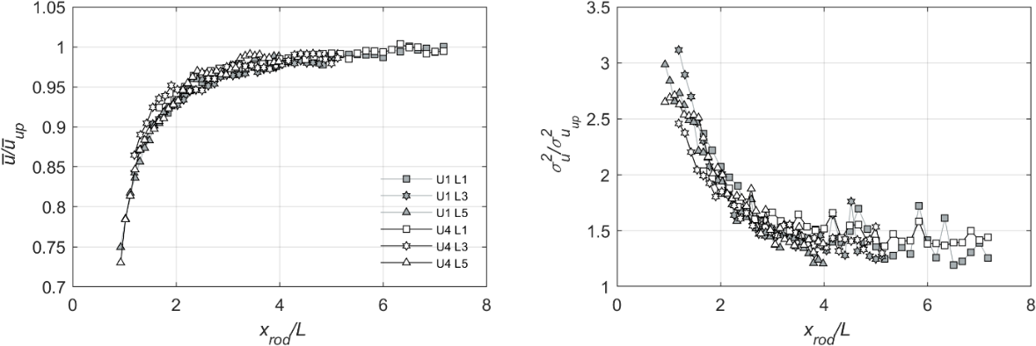
Figure 3. Longitudinal distribution of normalised time-averaged streamwise velocities (left) and normalised streamwise velocity variance (right); x_{rod} is defined in Figure 1.

conclusions
Experiments with model fish in an open channel flume showed that the mean velocities in the wake of the fish recover to their upstream values within around 4 fish body lengths downstream of the fish tail. An implementation of a momentum integral approach to estimating mean drag forces from the velocity field gave values of the same order of magnitude as drag forces measured with a drag force sensor, even with significant simplification of the approach. We plan to expand the method to capture instantaneous drag forces acting on live fish, and to generalise the approach to the integral form of the energy conservation law for fish-flow energy exchanges estimation based solely on kinetic energy transfer from fish to water, and vice versa.

acknowledgements
This study has been funded by the RIBES (River flow regulation, fish BEhaviour and Status) project under the European Union Horizon 2020 Research and Innovation Programme, Grant Agreement No. 860800.

REFERENCES

- Leftwich M.C., Tytell E.D., Cohen A.H. and Smits A.J., “Wake structures behind a swimming robotic lamprey with a passively flexible tail”, J Exp Biol., Vol. 215, No. 3, (2012), pp 416-425.
- Kogan I., Pacholak S., Licht M., Schneider J.W., Brücker C. and Brandt S., “The invisible fish: hydrodynamic constraints for predator-prey interaction in fossil fish Saurichthys compared to recent actinopterygians”, Biology Open, Vol. 4, No. 12, (2015), pp.1715-1726.
[3] Webb P.W., “Hydrodynamics and energetics of fish propulsion”, Bulletin of the Fisheries Research Board of Canada, (1975).

