Smart Fish Counter for Monitoring Species, Size, Migration Behaviour and Environmental Conditions

Jeffrey A. tuhtan, Elizaveta Dubrovinskaya, Lizaveta Miasayedava, Vishwajeet Pattanaik, Jürgen Soom
Department of Computer Systems, Tallinn University of Technology, Ehitajate tee 5
Tallinn, 12616, Estonia

bernd mockenhaupt, Cornelia Schütz
German Federal Institute of Hydrology (BfG), Department Fauna and Ecology, Am Mainzer Tor 1
Koblenz, D-56068, Germany

Christian haas and philipp thumser
I AM HYDRO GmbH, Leopoldstrasse 1
St. Georgen, D-78112, Germany

Here we present a new multi-stage computer vision system for automatically processing underwater fish counter videos. The camera-agnostic system consists of four separate software modules. Module 1 classifies seven typical environmental conditions: clear water, turbidity, debris, aerated flows, low-lighting, lighting overexposure and biofouling. Module 2 then automatically sorts fish and no-fish videos. Module 3 will rely on convolutional neural networks to detect fish species, family and size class in 5 cm increments. Finally, Module 4 will track individual fish during their passage through the counter to assess migration direction relative to the flow, and distinguishes between fish which remain for long periods inside of the counter, those which migrate up or downstream through the counter, and those which enter and exit without migrating through the fish counter.

introduction
Automated digital environmental monitoring technologies encompass a broad range of fields spanning ecological genomics to citizen science [1]. Considering fish migration across barriers including dams and weirs, camera-based fish counters can provide a cost-effective and accurate method to identify individual species and their migration behavior [2]. We propose a “smart fish counter”, based on four software modules.
The smart fish counter software includes a custom web application to upload, annotate, train and validate the model on a site-by-site basis, and the code base will be released incrementally as open source to the ecohydraulics community over the next two years. In this work, we present each of the four modules with examples of challenging environmental conditions, taken from sites across Europe, with special focus on navigable German waterways where more than 30 different fish species. In addition to the species, the size class in 5 cm increments and differentiated migration patterns are to be accurately identified and counted. As the project is open source, we believe it offers a new and broadly useful computer vision toolkit for ecohydraulics practitioners to study fish behaviour. Although designed originally for video fish counters, the modules can be reprogrammed for cameras used in field, laboratory and hybrid studies, thus improving our fundamental understanding of multi-species fish migration behavior in rivers.

methods

Module 1: Environmental Classification
Sorting the videos into those with and without fish is the fundamental and most time-saving task of the smart fish counter software. As a first step, it was necessary to classify six different environmental conditions which commonly occur in order to sort the underwater videos for further processing. Metrics used to evaluate the performance of the convolutional neural network included the precision, recall and F1 score.

The precision is given as the ratio of all correctly classified videos (true positives) to all positives (true and false):

$Precision = \frac{True Positives}{True Positives + False Positives}$ (1)

The recall is the ratio of correct predictions from all those predictions which could have been positively classified:

$Recall = \frac{True Positives}{True Positives + False Negatives}$ (2)

The final performance evaluation in this work uses the F1-score, which represents a balanced measure between precision and recall, and is calculated as their harmonic mean:

$F1 = \frac{Precision *Recall}{Precision + Recall}$ (3)

Module 2: Automated Sorting of Fish and No-Fish Videos
The automated sorting of fish and no fish videos was carried out after each video was assigned an environmental classification, and an overview is provided in Figure 1. Depending on the environmental condition, Gaussian blur or Contrast Limited Adaptive Histogram Equalization (CLAHE) was applied to enhance each video frame. These adjustments are needed to improve the overall contrast between the fish and the background, for example, under low light conditions it is beneficial to increase the overall pixel intensity values in order to bring out the difference between the fish body shape and the darkly illuminated flow tunnel [3].
Standard framewise motion detection was applied by subtracting the pixelwise intensities of two consecutive frames. Bounding boxes for regions in which motion had occurred were then filtered by their length and height, where small boxes less than 20 pixels in size were considered as being non-fish objects. In a parallel data processing pipeline, scanlines of the vertical pixel intensities were taken from each frame and the variance of the intensity over each line was compared between consecutive frames. If the variance was found to be greater than the threshold value for that particular environmental condition, the scanline was registered as containing a fish. Each frame after processing with both motion detection and scanlines was assigned a binary “0” for no object and “1” for detected object. A binary classifier aggregated both sets of binary data sets from each fish / no-fish detection method and a final vote was then made for each video as either “fish” or “no fish”.
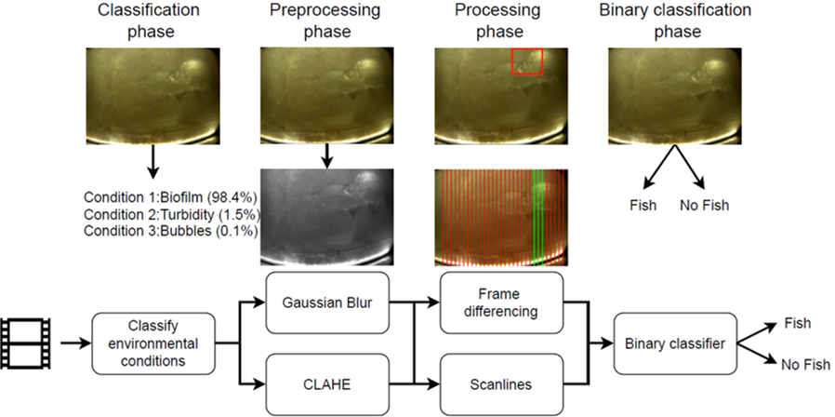
Figure 1. Overview of the fish and no-fish video sorting pipeline. After videos are classified, image enhancement is applied depending on the environmental classification. Next, motion detection using frame differencing and scanlines are applied independently and are used to vote for each frame as to whether a fish is present or not. Finally, the results of each frame-wise vote are aggregated, and a binary classifier is applied to make the final decision as to whether the entire video has fish or not.

Module 3: Family, Species and Size Classification
A custom web interface is shown in Figure 2, which allows for the user to select and filter videos for manual processing and verification after the automated fish detection and counting algorithms have run. Currently, the environmental conditions are automatically detected, and the user defines the fish size, migration behaviour and size class. The next step is to integrate, test and validate computer vision algorithms for the automated detection of these parameters. Current models being tested for fish species classification include YOLO v.3 and YOLO-compact [4].

Module 4: Fish Tracking and Migration Behaviour Classification
The most challenging tasks in the Smart Fish Counter project are in module 4, in which individual fish must be tracked and assigned individual swimming behaviours. As an example, a fish may swim in and out of view multiple times over the course of a single three-minute video. The algorithms must be able not only to track the fish while it remains in view, but also label the migration behaviour of the fish as it leaves the video. In a final step, the cumulative swimming behaviours will be processed using a series of logical operations in order to assign the final migration behaviour for each fish.

results
As the project is in the first year of development and testing, results are presented for the first two modules. The environmental conditions module resulted in a F1 = 0.98, which exceeds the project objective of F1 = 0.95. Further validation on independent data sets will show if the final performance is similar at new fish counter sites.
Considering the fish and no fish video sorting performance, the results from the first round testing of 3,000 balanced data sets, with identical number of fish and no fish videos in each environmental class are as follows: frame differencing had a precision of 87%, recall of 90% and F1 score of 89% whereas scanlines had a precision of 79%, recall of 83% and F1 score of 83%. When combined together with a binary classifier, the overall correct classifications were 91%. Continued optimization is therefore needed for the fish and no fish sorting algorithms in order to reach the objective of 95% correct classifications for all sites and environmental conditions.
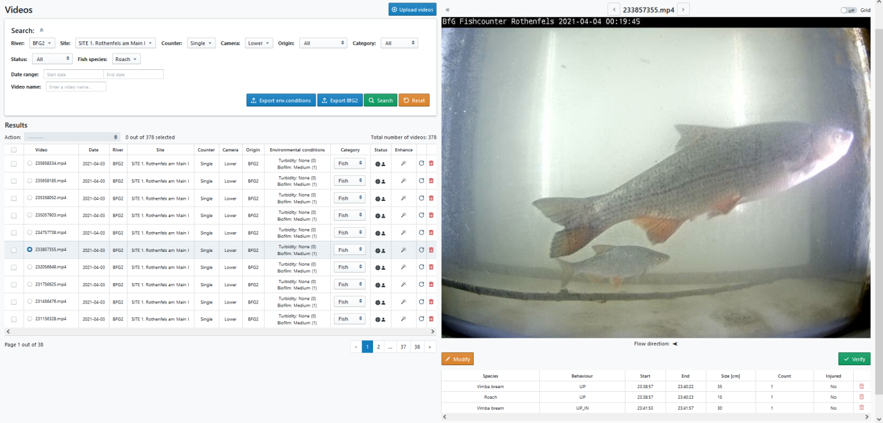
Figure 2. Web application of the automated smart fish counter. The left panel of the user interface allows for the filtering of fish by site, camera, date, fish species and category (not started, in progress, completed and verified). In addition, information is provided on the environmental conditions, fish species, migration behaviour, size class, count and whether or not the fish has visible injuries.

discussion and conclusions
Underwater cameras can be installed where suitable physical and economic conditions exist to accurately count fish migrating through fishways. In this work, a modular software platform with a custom web interface to automate fish detection, species classification, size estimation and migration behaviour was presented. Results from validation data sets not used in training AI models will be used next to assess the performance of sorting fish and no-fish videos, as well as for the classification of six different commonly occurring environmental conditions.
Challenging environmental conditions which reduce the overall effectiveness of the video-based fish counter are flows with high turbidity, and biofilm growth on the glass viewport. In addition, fish in the smallest size classes of 5 to 10 cm total body length can be difficult for fish experts to classify due to their high visual similarity. Addressing these challenges may require the use of more advanced lighting (e.g. ultraviolet, green and blue), the inclusion of stereo cameras calibrated to estimate fish body length and the complimentary use of lidar and possibly sonar imaging systems, where physical conditions allow for their installation and long-term use.
Future developments to the smart fish counter software will include its ability to detect fish family and species, as well as the size class in 5 cm increments and the migration behaviour. These open source software modules will provide the ecohydraulics community with powerful new software tools which can be used in laboratory and field studies of wild fish in their natural environments. Advances in embedded computing hardware will further allow for low-powered smart fish counter software to be deployed directly in the field alongside the camera, opening new opportunities for daily, hourly and eventually real-time analysis of fish species, size and migration behaviour. Such advanced systems could feasibly be linked with actuated hydraulic structures which adaptively change the flow rate, water depth and other physical variables in order to improve migratory success for endemic fish species and to actively hinder migration for exotic species.

acknowledgements
The work of Jürgen Soom in the project "ICT programme" was supported by the European Union through the European Social Fund.

REFERENCES

- Dwivedi, A., “Role of digital technology in freshwater biodiversity monitoring through citizen science during covid-19 pandemic”, River Research and Applications, Vol. 37, No. 7, (2021), pp 1025–1031. https://doi.org/10.1002/rra.3820
- Li, D., Hao, Y. and Duan, Y., “Nonintrusive methods for biomass estimation in aquaculture with emphasis on fish: a review”, Reviews in Aquaculture, Vol. 12 No. 3, (2020), pp 1390–1411. https://doi.org/10.1111/raq.12388.
- Salman, A., Maqbool, S., Khan, A.H., Jalal, A. and Shafait, F., “Real-time fish detection in complex backgrounds using probabilistic background modelling”, Ecological Informatics, Vol. 51, (2019) pp 44–51. https://doi.org/10.1016/j.ecoinf.2019.02.011
- Jiang, P., Ergu, D., Liu, F., Cai, Y., and Ma, B. “A Review of Yolo Algorithm Developments“, Procedia Computer Science, No. 199, (2022), pp 1066-1073. https://doi.org/10.1016/j.procs.2022.01.135

