YOLOv5 analysis for juvenile Ayu detection in underwater images of fishway

Shijun PAN
Graduate School of Environmental and Life Science, Okayama University
Tsushima-naka 3-1-1, Kita-ku, Okayama 700-8530, Japan

RYO furutani
Graduate School of Environmental and Life Science, Okayama University
Tsushima-naka 3-1-1, Kita-ku, Okayama 700-8530, Japan

keisuke yoshida
Graduate School of Environmental and Life Science, Okayama University
Tsushima-naka 3-1-1, Kita-ku, Okayama 700-8530, Japan

These years, Okayama Prefecture is advancing in releasing juvenile Ayus, building spawning grounds, and establishing a fishing ban to achieve the goal of increasing Ayu production. At present, in order to observe the activity status of the juvenile Ayus, the Fisheries Research Institute of the Okayama Prefecture Agriculture, Forestry and Fisheries Research Institute has installed an underwater camera at the Kamogoshi Weir of the Yoshii River. The purpose of setting under water camera is to measure the amount of juvenile Ayus running up the fish way through video for qualitative evaluation by visual counting. Nevertheless, visual counting is a labour-intensive task, and technicians with professional experience are required to distinguish Ayus from other fishes quickly and accurately. Therefore, in order to finish this kind of observation without intensive labour, automatic counting is imperative. Currently, the object detection technologies in the field of artificial intelligence has become matured. Based on the above situation, we created a juvenile Ayu dataset derived from Yoshii River camera and used the YOLOv5 model to automatically identify and calculate the number of juvenile Ayus. In this study, the videos taken by the underwater camera are segmented at 2-second intervals as a segmented image, and the segmented images are divided into two groups (training group and validation group). The dataset is marked by the professional personnel with relative experience. At last, the YOLOv5s model detected juvenile Ayus in the 86400 images derived from 4-days long video with the recognition accuracy of 0.74. Recognition accuracy is based on the F1 score with value from 0.0 (0%) ~1.0 (100%), that is a kind of index derived from confusion matrix.

Introduction
Juvenile Ayu is an important target specie in inland fisheries, nevertheless its catch is declining nationwide. Natural factors, such as damage by cormorants and cold water disease, and social factors, such as a decrease in the number of fishermen, are said to be the main reasons for the decline in catches. In Okayama Prefecture, measurements such as releasing juvenile Ayu, creating spawning grounds, and establishing a closed season for fishing are being implemented. Additionally, the Fisheries Laboratory of the Okayama Prefectural Agriculture, Forestry and Fisheries Research Center installed an underwater camera in the fish way of the Kamogoshi weir located in the lower reaches of the Yoshii River system, a first-class water system in Okayama Prefecture, to visually count the number of juvenile Ayu returning to the fish-way. Nevertheless, visual counting of the number of juvenile Ayu returning to the fish way is time-consuming and labor-intensive, and requires experience in distinguishing between juvenile Ayu and other fish species. In 2013, the researchers released juvenile Ayu without adipose-fins in the Yoshii River, and conducted a gill net test and a follow-up survey of the juvenile Ayu based on anglers' reports of recaptures.
As for other methods of stock assessment, conducted a study using environmental DNA in the Asahi River [1], a first-class river in Okayama Prefecture. Notwithstanding, the environmental DNA method has the problems of high survey cost and difficulty in localized surveys. On the other hand, development of algorithms for object detection using deep learning is progressing, and representative examples include the YOLO series [2], including YOLOv5 used in this study. In the previous studies, the other researchers have tried to apply the YOLOv5 model to detect fish under the water [3]. If we can create a model for detecting juvenile Ayu running up the fish way using images only from an underwater camera, stock assessment of juvenile Ayu becomes much easier and cheaper than visual count by professional personnel. Nevertheless, due to the difficulties in preparing a large number of datasets for deep learning in this study, we aimed to improve accuracy not by increasing the number of datasets, also by changing the way datasets are labeled. By comparing the accuracy of different amounts of datasets, we can provide an indication of the minimum amount of datasets that should be prepared for similar attempts in the future. In conclusion, we propose a practical application of the trained model and discuss its effectiveness.

Study site and method

Targeted river
The Yoshii River as shown in Figure 1 (left-side), is located in the eastern part of Okayama Prefecture. It is a first-class river with a main stem of 133 km and a basin area of 2,110 km². The main spawning ground for juvenile Ayu is located downstream of Sakane-weir, which is upstream of Kamogoshi-weir as shown in Figure 1 (right-side). The Fisheries Laboratory conducts surveys at Kamogoshi weir, a tidal barrage on the Yoshii River, in order to understand the situation of juvenile Ayu. An underwater camera was installed at the upstream end of a stairway fish-way on the right bank from early April to early June to count the number of juvenile Ayu returning to the fish-way. Figure 2 shows the location of the underwater cameras that are installed along the fish way. In order to ensure the stability of the underwater camera, counterweight block was installed underneath the camera and connected using the steel cable to the anchorages located in the concrete.
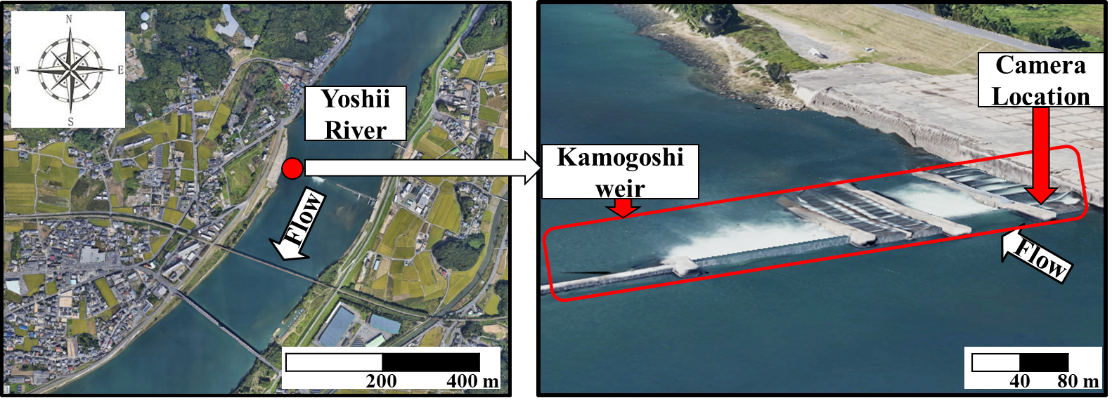

Figure 1 Location of study site (left-side: The Yoshii River; right-side: Kamogoshi weir) (Images from Google
Earth).
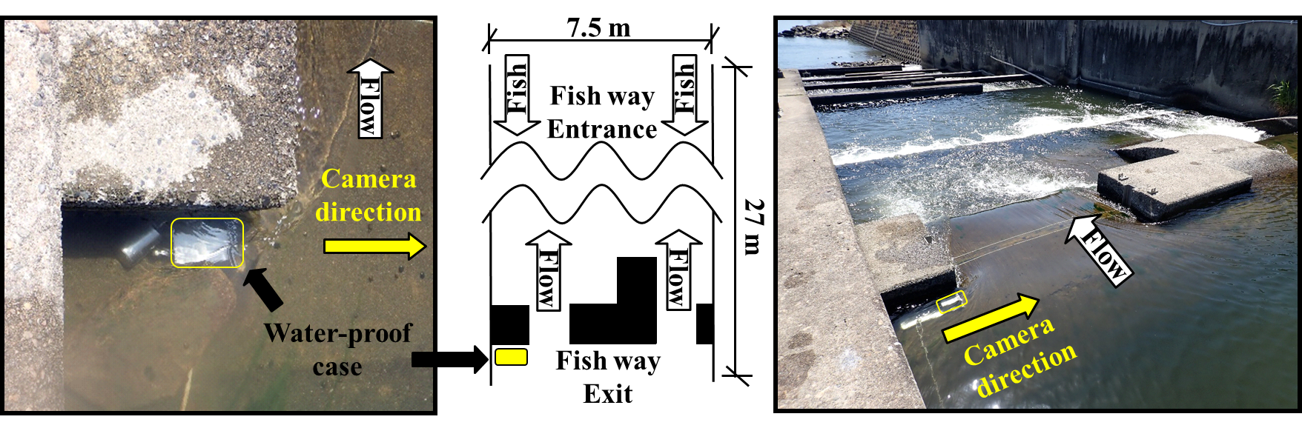

Figure 2 Field images of camera setting in the fish way.

Underwater camera specifications and conventional survey method
The images used for deep learning and detection were taken by a Brinno TLC200Pro time-lapse camera in a waterproof case as shown in Figure 3. The images were taken at 2-second intervals and from 6:00 to 18:00 (period that provides sufficient sunlight for underwater observation). After the images were taken, the number of juvenile Ayu running upstream in the fish way was counted by professional personnel, and the results were tabulated as the number of juvenile Ayu per hour. The counting requires 1,800 images per hour, or 21,600 images per day, which is a time-consuming and labor-intensive task.
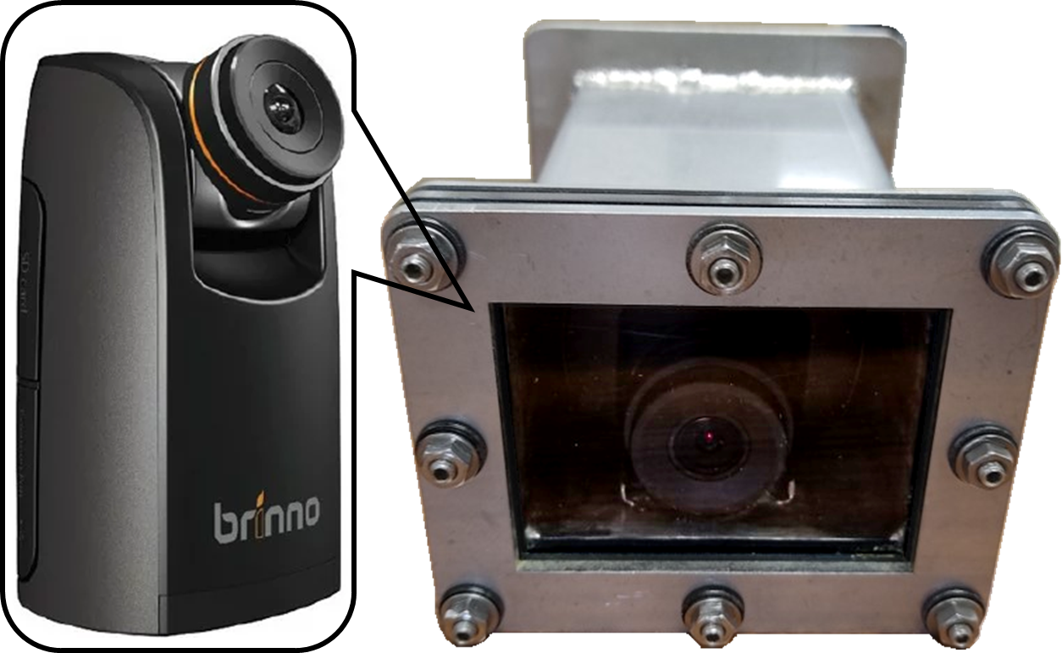

Figure 3 Waterproof case and time-lapse camera.

YOLOv5 model
The raw dataset in this study as shown in Figure 4, consists of 264 images from the underwater camera installed at Kamogoshi weir from April 18th to June 9th, 2021. The raw dataset was divided into Train- (208 images) and Valid- (56 images) dataset for deep learning. Labeling is the process of creating a file that describes the location and type of fish in the image, and using them as the input dataset. The created dataset was checked by professional personnel. On the other hand, the Precision, Recall, and F1 score were used to evaluate the accuracy of object detection results. The model for this study was YOLOv5s using PyTorch version. As the deep learning environment, NVIDIA GeForce RTX3090 GPU with 24 GB memory and 10496 CUDA cores was used. The training process for each time was about 50 minutes.
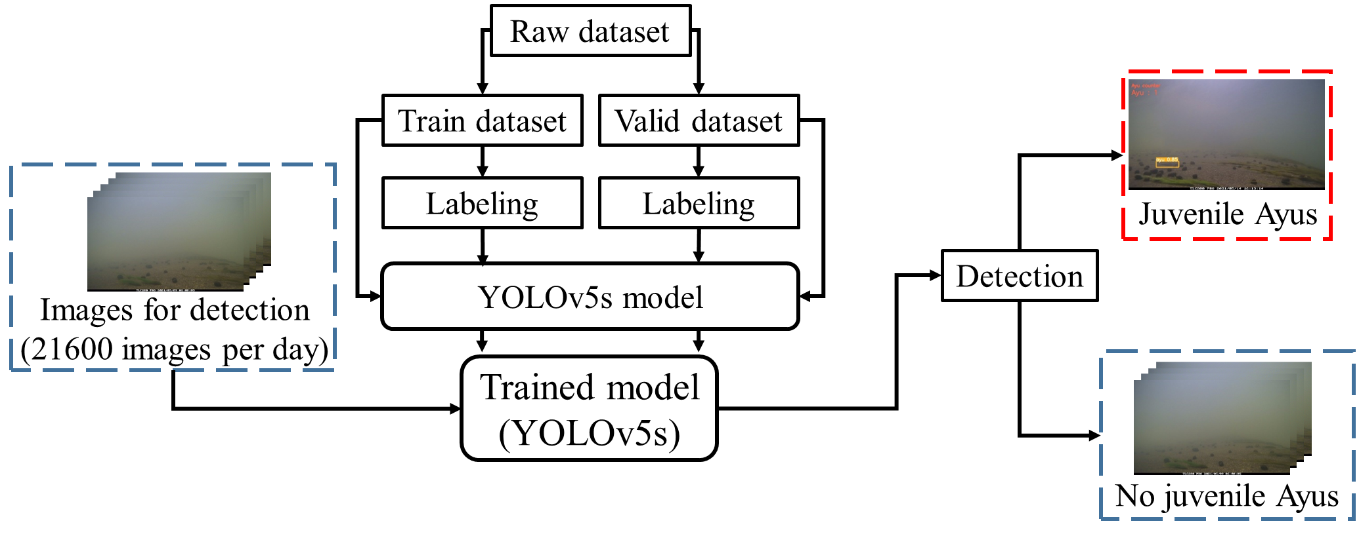

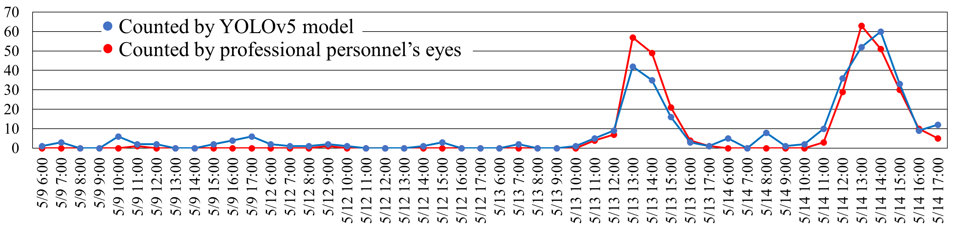
Figure 4 Process of training YOLOv5s model and counting the juvenile Ayu using YOLOv5s model per day.

Figure 5 Comparison of YOLOv5s model-derived and visual juvenile Ayu counting amounts. Visual juvenile Ayu amounts are counted by the professional personnel.

Table 1 Precision, Recall and F1 score of detecting the juvenile Ayus from 86400 images using YOLOv5 model.
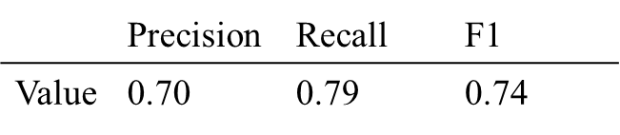

Results

The number of images for searching juvenile Ayu at the Fisheries Laboratory is 21,600 per day, including 4-days data. During this process as shown in Figure 4, the counting work can be finished by using this detection model. As displayed in Figure 5, the red curve-based juvenile Ayu amounts were counted by the professional personnel visually, and the blue curve-based detection results were derived from YOLOv5s model. Finally, using professional personnel visual-derived results as standard to attain precision, recall and F1 score. As performed in Table 1, the YOLOv5s model has correctly detected the objects with recognition accuracy of 0.74.

Conclusion
In conclusion, the detection process using YOLOv5 model can support the professional personnel of counting juvenile Ayu with relative high recognition accuracy, and it also improved the effectiveness of measuring the juvenile Ayu stock without intensive-labor work.

REFERENCES

- Yoshida, K., Inui, R., Udagawa, R., Maeno, S., Akamatsu, Y., Nigo, S., ... & Nagata, K. (2019). Spawning Habitat Potential Evaluation for Ayu Based on AN Environmental DNA Analysis and Field Works of Physical Environment Factors in the Lower Asahi River. Journal of Japan Society of Civil Engineers, Ser. B1 (Hydraulic Engineering), 75(2), I_529-I_534. https://doi.org/10.2208/jscejhe.75.2_I_529
- Ultralytics：YOLOv5，https://github.com/ultralytics/yolov5.
- Wang, H., Zhang, S., Zhao, S., Wang, Q., Li, D., & Zhao, R. (2022). Real-time detection and tracking of fish abnormal behavior based on improved YOLOV5 and SiamRPN++. Computers and Electronics in Agriculture, 192, 106512. https://doi.org/10.1016/j.compag.2021.106512

