Smart Fishways: Real-time sensorization of fishways for autonomous assessment and management of their performance

Juan Francisco FUENTES-Pérez, Francisco Javier Sanz-Ronda
Grupo de Ecohidráulica Aplicada, ETSIIAA, University of Valladolid,
Av. de Madrid 44, 34004 Palencia, Spain

Ana García-Vega, Francisco Javier Bravo-Córdoba
Grupo de Ecohidráulica Aplicada, Centro Tecnológico Agrario y Agroalimentario - Itagra.ct
Av. de Madrid 44, 34004 Palencia, Spain

Modern society requires large volumes of fresh water. The result is the installation of multiple river barriers, causing the fragmentation of riverine habitats as well as changes in the ecology of freshwater ecosystems. When it comes to fish, stepped fishways are the most common solution to allow them to move freely through river barriers and complete their life cycles. However, the natural variability of rivers (e.g., discharge, floating debris, etc.) modifies the hydraulic conditions within these structures, directly affecting fish passage, and thus, it becomes vital for fish a real-time assessment and management of the fishway.
Smart Fishways is an EU-funded project which aims to assess the effect of hydrological variability on fishways and to develop a low-cost technological and methodological framework to monitor fishways' performance in real-time. The main objective of this project is to combine fish biology, hydraulics, and sensor networks to create a new generation of smart fishways capable of self-deciding their optimal management and configuration.
The present paper describes the first steps followed to develop the sensor network and the online platform for the Smart Fishways project, together with the results of a fish migration campaign in a fishway in the Iberian Peninsula. The network follows a star architecture with independent custom-made ultrasonic water level nodes and environmental sensors distributed through the fishway together with a fish detection system for fish movement assessment, both remotely and autonomously managed by a central gateway.
This work demonstrates how the network is able to optimize the timing of maintenance on a fishway in real-time as well as to help on detecting those hydraulic configurations and times that maximize the fish passage.

INTRODUCTION
A stepped fishway consists of a succession of cross-walls with connections (notches, slots, or orifices) in a stepped pattern that divide the total height of an obstacle (e.g. a weir or a dam) in a succession of pools with small drops between them to allow (or facilitate) fish movements through the obstacle [1]. Fishways are designed to provide hydraulic conditions compatible with fish (e.g. turbulence levels or velocity), therefore, they are sensitive to any change in discharge or morphology of the river. Considering rivers’ variability over time, fishways efficiency can be often (or periodically) far from acceptable.
The biological equilibrium in fishways can be disrupted by multiple reasons, some avoidable: an incorrect design or deviations during construction, and others manageable: the natural variability of rivers (which alter the boundary conditions upstream and downstream of the structure) [2] or incorrect maintenance [3]. Any situation altering their design-performance balance affects biological response inside them [4,5] and has the potential of hindering the free movement of fish.
Despite some malfunctions in fishways are difficult to solve (mainly those related to the incorrect design and construction), others are easily avoidable with the continuous monitoring of their performance (such as obstructions or discharge regulation). Moreover, the continuous monitoring can allow the optimization of the structure by promoting those hydraulic conditions that maximize the fish passage. This is where it comes into play the European Union's Horizon 2020 research project Smart Fishways (www.smartfishways.org), which aims to assess the effect of hydrological variability on stepped fishways and to develop a technological and methodological framework to monitor fishways' performance in real-time.
This paper describes the first phase of the cost-effective software and hardware architecture developed for the remote and near real-time monitoring of fishways, environmental variables, and fish. Likewise, in this work, the obtained field results since its installation (01/04/22) for Iberian barbel (Luciobarbus bocagei, Steindachner 1864) in one of the study cases (Vadocondes Fishway) in the Iberian Peninsula are analyzed.
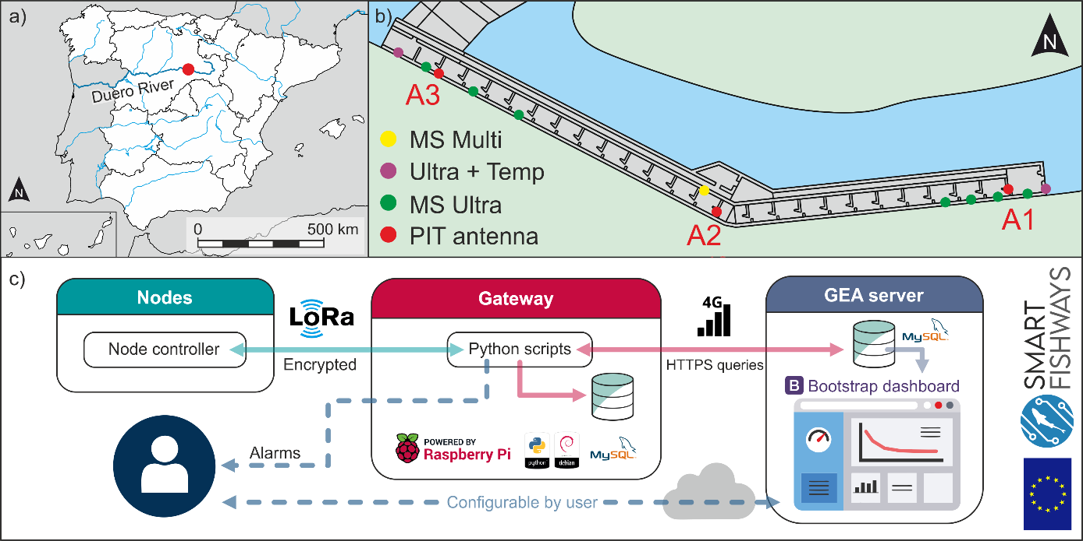
Figure 1. Study case and architecture. a) and b) Location. c) Summarized architecture of Smart Fishways

MATERIAL AND METHODS

Hardware and software architecture
Up to day the Smart Fishways network is composed of 1) multiple water level monitoring nodes (MS Ultra by Grupo de Ecohidráulica Aplicada [6]) installed over the different pools of a fishway (some with water temperature sensors), 2) a multiparameter node (MS Multy by Grupo de Ecohidráulica Aplicada) able to measure the water depth, air and water temperature, luminosity, humidity, and barometric pressure, 3) a pit-tag monitoring system with 3 antennas in the target study site (Half Duplex multiplexer reader, ORFID®, Portland, Oregon, USA) and 4) a central gateway (Raspberry Pi + LoRa Radio + WiFi modem by Grupo de Ecohidráulica Aplicada). The sensor network has a start architecture, which means that the nodes only communicate with the gateway and it is the gateway that controls the nodes (by means of scheduled python scripts), runs the algorithms (by means of scheduled python scripts), collects the data (MySQL database), triggers the alarms, and transmits the information to an online server (HTTPS queries and MySQL database) (Figure 1.c). Currently, the most interesting developed algorithms to improve the fishway management are “the real-time PIT-tag data processing algorithm” (under evaluation) and “the real-time obstruction detection algorithm” [6].

Study site
To date, there are 3 fishways with the Smart Fishway architecture. The one presented here is located in the mainstem of the Duero River, in Vadocondes village (Burgos) in the northwest part of Spain (41°38’16 ″ N, 3°34’17″ W) (Figure 1.a and 1.b) [7]. It is a vertical slot fishway composed of 26 cross‐walls (slot width (b_{s}) = 0.2 m) and 25 pools (length = 2.1 m; width = 1.6 m; slope = 6.5%) with mean water drops (ΔH) of 0.15 m, mean water depth in the pools (h₀) of 0.92 m, and mean volumetric power dissipation of 122 ± 7 W/m³.
The fish assemblage in the area is composed mainly of native cyprinids (Luciobarbus bocagei, Pseudochondrostoma duriense, Squalius carolitertii, and Gobio lozanoi) and the increasing presence of the invasive alien Alburnus alburnus. Iberian barbell is the selected for the analysis The Iberian babel is the selected species for the analysis due to its high proportion in the area and its ecological importance in the area.

Fish sampling
In order to relate physical variables with biological responses, fish monitoring is necessary. One of the goals of Smart Fishways is to achieve a non-contact monitoring system. However, this is planned for the second year of the project (2022-2023), when custom-made fish counters will substitute PIT-tag systems. Most of Smart Fishways study sites were part of the FIThydro H2020 EU project (2014-2019), thus, there is a high proportion of tagged fish in the studied river reaches (from the year 2018, 1130 barbels have been tagged), and to sustain the number of tagged fish in the river tagging campaigns are still performed yearly. In these campaigns, fish are captured by electrofishing (Hans-Grassl ELT60II backpack; 180-250 V and 1.5-2.5 A), after anesthetized with eugenol (50 mg/L diluted in ethanol in proportion 1:10), measured (fork length, ± 0.1 cm), and intraperitoneally tagged with an HDX PIT-tag by an incision posterior to the left pectoral fin (respecting the relationship of tag weight lower than 2% of fish weight). All experiments and procedures were performed following European Union ethical guidelines (Directive 2010/63/UE) and Spanish Act RD 53/2013, with the approval of the competent authorities (Regional Government on Natural Resources and Water Management Authority).

Data treatment and processing
The analyses of collected data and the evaluation of the overall performances were performed using Python and Matlab R2019a, downloading data from the online server (http://www.smartfishways.com/realtime.html).

Results and discussion
Figure 2 shows part of the collected data by the Smart Fishways from its installation (01/04/22) until the writing of this work (01/06/22). Despite the short period, it is possible to see the potential of the technology and developed algorithms, and its benefits for monitoring and decision-making on the management of fishways. In the top part of the figure, the results from the PIT-tag data processing algorithm are displayed in form of a contour plot, where key events in the fishway are easily identifiable: 1) a period with many natural fish movements associated with an increase in the river discharge greater than the manageable by the hydropower plant, and thus, directly affecting the fishway discharge and water levels, as well as, with noticeable change in atmospheric pressure in previous days, 2) a translocation of fish for experimental reasons (fish sampling in the fishway), and 3) fish without a movement assigned, i.e. fish inside the fishway and not classified yet. Data classification is daily made by the processing algorithm. Despite the promising result, the algorithm is currently been assessed comparing its results with those obtained by an experienced technician on PIT data interpretation.
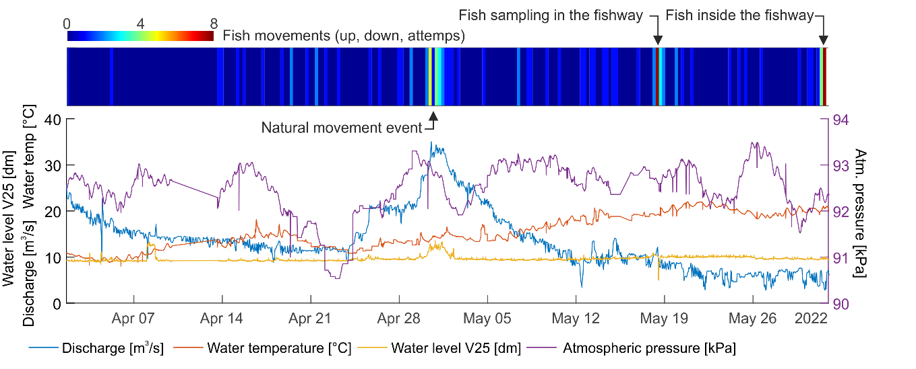
Figure 2. Raw output of some variables of Smart Fishways system, together with river discharge monitored by Duero River authorities (www.saihduero.es). V25 means water level in cross-wall #25. The sensor network also measures luminosity, humidity or air temperature. MS Multi was out of communication from 10 to 13 of April.

The sensors of Smart Fishways are able to collect physical variables on-site and near real-time with a configurable frequency. In addition, the gateway stores and sends to an online server all the data. In contrast to other works where biological data is related to distant weather stations data, smart Fishways allows instantaneous data analysis and makes more relevant data interpretation. Likewise, it allows real-time hydraulic analysis to ensure that ongoing fishway scenarios are compatible with fish. As an example, Figure 3 shows the water level and water drop distributions in the cross-walls at the entrance and the exit of the fishway (V1 corresponds to most upstream cross-wall) for three different time periods: the 1st and the 3rd periods correspond to the beginning and the end of the time series while the 2nd to the high discharge event at the end of April (Figure 2). As expected, the increase in discharge directly affects the water levels of the fishway. Moreover, it dramatically increases the water drop in the most upstream cross-wall, increasing the velocity in the fish exit [1], and thus, making the exit of fish from the fishway more challenging. The connection in the first cross-wall is a sluice gate and its opening during this period could have avoided this limiting water drop. The high drop in V25 is permanent and mainly related to the difference in discharge with the connection in V26.
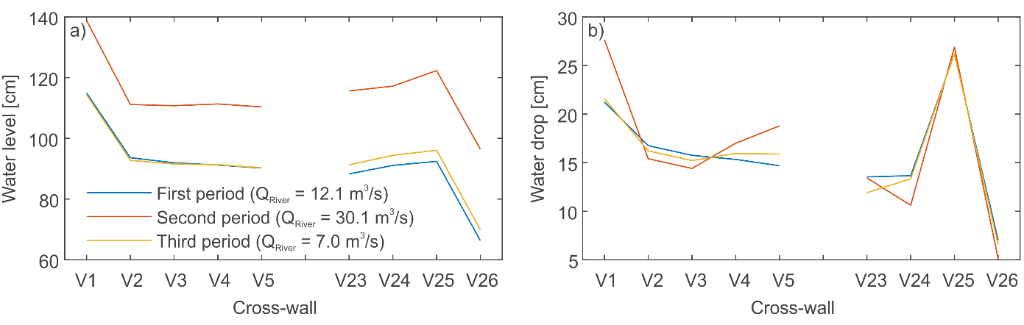
Figure 3. Water level and water drop distribution in the fishway during the three studied periods. First period: 13/04/22-23/04/22; Second period: 30/04/22-01/05/22; Third period: 28/05/22-01/06/22.

The observation and analysis of the data in real-time are of vital interest to achieve an adaptive management of biological processes using hydraulic structures, as once we know the current state it is possible to change it modifying some of the variables affecting the process. For instance, in the case of fishways associated to any anthropic water abstraction (e.g. hydropower plants, irrigation weirs, fish farms, drinking water supply, etc.), it is possible to modify its operation to trigger scenarios that could increase the number of fish passages during the target season (e.g. reproductive season) and/or ascend time/hours. Designing those scenarios is a difficult task due to the caustics of each site and the limited references [8]. In this sense, by observing the historical trends of a site and the events of interest, we can try to reproduce them. This is where Smart Fishways comes handily as it allows to easily and visually track historical events, reproduce them, make controlled tests, and immediately observe the biological responses.
More worldly application of the developed architecture include the detection of maintenance needs in the fishways by using the obstruction detection algorithm [6]. This allows the comparison of typical scenarios with ongoing ones to detect anomalies, and consequently, optimizing the timing of maintenance on fishways, thus, with the potential of automatizing, reducing operational cost, and augmenting the service of fishways. In addition, a direct application of Smart Fishways is the planning of hydropower operations and actuations in the river by the direct observation of the number of fish using the fishway.

Acknowledgments
The research leading to these results has received funding from the European Research Council (ERC) under the European Union's Horizon 2020 research and innovation program (Smart fishways - grant agreement n° 101032024), from the research project “Elaboración de una red sensorial para la monitorización y seguimiento de eventos hidrológicos” funded by Webge Global and LANZADERA Fish Track project (NT20 67/217791) funded by Junta de Castilla y León.

References

- Larinier, M., et al. "Fishways: biological basis, design criteria and monitoring", Bull. Français la Pêche la Piscic., (2002), 364.
- Fuentes-Pérez, J.F. et al. "Non-uniform hydraulic behavior of pool-weir fishways: A tool to optimize its design and performance", Ecol. Eng., (2016), 86, 5–12.
- Valbuena-Castro, J. et al. "Coarse fishway assessment to prioritize retrofitting efforts: a case study in the Duero River basin", Ecol. Eng. (2020), 155, 105946.
- Fuentes-Pérez, J.F., et al. "Spatial preferences of Iberian barbel in a vertical slot fishway under variable hydrodynamic scenarios". Ecol. Eng., (2018), 125, 131–142.
- Clay, C.H. "Design of fishways and other fish facilities", CRC Press, Ottawa, Canada, (1995).
- Fuentes-Pérez, J.F., et al. "A step to Smart Fishways: an autonomous obstruction detection system using hydraulic modelling and sensor networks", Sensors, (2021), 21, 6909.
- Bravo-Córdoba, F.J., et al. "Vertical slot versus submerged notch with bottom orifice: Looking for the best technical fishway type for Mediterranean barbels", Ecol. Eng., (2018), 122, 120–125.
- García-Vega, A., et al. "Pre-reproductive movements of potamodromous cyprinids in the Iberian Peninsula: when environmental variability meets semipermeable barriers", Hydrobiologia, (2022), 849, 1338.

