Turbulent eddies as potential migration obstacles in fishway constructions

Márcio S. Roth, Jürgen Stamm
Dep. Civil Engineering, IWD- Institute of Hydraulic Engineering and Technical Hydromechanics, University of Dresden
Dresden, Germany

Abstract: Fishways are an important link for restoring river continuity, interrupted by transverse structures, such as weirs, dams and hydropower plants. The Meander Fishway and Vertical Slot Fishway are two common types of construction in Germany that create distinctive flow regimes to allow upstream passage. Nevertheless, minor environmental or structural alterations lead to unforeseen flow regimes, whose impact on fish are still uncertain. An approach that is rarely used due to its complexity is to obtain different flow aspects for fish by evaluating numerous parameters with the IPOS-framework in laboratory and field experiments stated by Lacey et. al. (2012).
The IPOS-framework categorizes the prevalent flow into four main categories: intensity (I), periodicity (P), orientation (O) and scale (S). It offers various objective identification parameters and methods related to the behavior and swimming capacity of fish. The challenge so far is the extensive laboratory measurements, that are required to obtain some of the parameters and also to establish a connection between the fish swimming efficiency using the frameworks procedures. The presented research links the IPOS-framework with turbulent numerical simulations and proposes an approach to subsequently identify relevant turbulent eddy structures (Figure 1). In addition to the hydraulic evaluation, a hybrid approach to capture the imposed strain by pressure signatures on the fish´s lateral-line is done. Starting from a fish surrogate in a laboratory experiment, equipped with pressure-sensor, this method is transferred to the already existing hydraulic simulations to obtain the fish´s strain during migration in the fishway (Figure 2).
The evaluation made it possible to objectively compare and identify turbulent flow structures in the numerical models. They show evident pros and cons of each fishway when taking the swimming capacity and body measurements of different species and age into account. The numerical evaluation of fishways using the IPOS-framework is a novelty and can be used to improve current and future structures towards better ecohydraulic conditions. Finally, the numerical implementation of a fish´s body and its simplified lateral-line organ allows for a individual species-fitted quality-assessment of fishways, instead of the current solely hydraulic approach.

Keywords: fishways, river continuity, turbulence, Detached Eddy Simulation, OpenFOAM

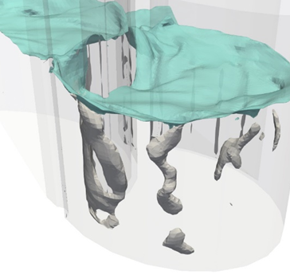 | 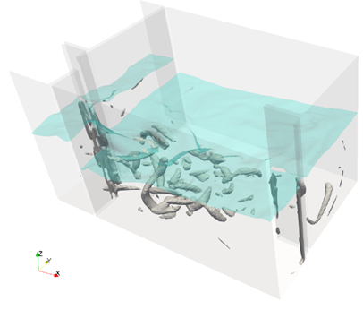

Figure 1. Two fishway constructions (left: meander-fishway; right vertical-slot-fishway) in similar fishway region are shown. The turbulent eddies (grey) below the water surface (light blue) show distinctive appearances.

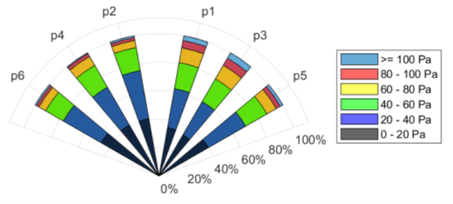 | 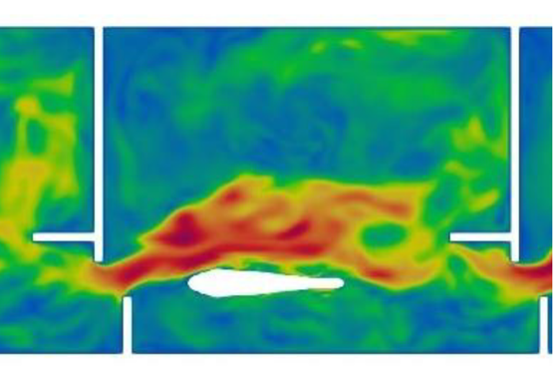

Figure 2. The hydraulic signature of a fish in a vertical-slot-fishway (left) and a slice of the fish´s location in the simulation is shown (right). (Values are exemplary).

