Optical and molecular signatures of sedimentary organic matter in the Three Gorges Reservoir: Spatial dynamics and carbon cycling implications

Kai Wang
State Key Laboratory of Hydro-science and Engineering, Department of Hydraulic Engineering, Tsinghua University
Beijing 100084, China

Abstract: Damming exerts a significant modification on the function of natural river networks, and influences sediment dynamics with reservoir operation. However, underlying mechanism influencing the deposition and burial of sedimentary organic matter (SOM) in reservoir, and its influence on the river carbon cycle, remain elusive for the the complex reservoir construction influenced environmental processes. Here we show that hydrological condition and land use of watershed constrain the dynamic of SOM in the world's largest Three Gorges Reservoir (TGR) through the application of a series of bulk and molecular techniques including stable carbon isotope, optical spectroscopy, and Fourier transform ion cyclotron resonance mass spectrometry (FT-ICR MS). Relatively higher terrestrial input of SOM was observed in upstream than that in downstream of TGR mainstream. The results indicated that hydrological condition and land use of watershed might be the key factors influencing SOM dynamic. This study investigated the SOM dynamic from bulk to molecular level and provided a subtly new insight into the underlying mechanism of carbon burial in reservoir, which would help to better constrain the carbon budget in inland waters, especially in the context of the global blooming of reservoirs.

Keywords: Carbon burial; FT-ICR MS; Hydrological variations; Sedimentary organic matter

Introduction
Sedimentary organic matter (SOM) is an important form of organic matter in the aquatic system and plays a crucial role in the sequestration of organic carbon (OC) [1]. Clarifying the dynamic of the sedimentation and transformation of SOM in watersheds is critical to understand carbon cycling mechanism in the biosphere. Since the significant influence of hydrological conditions variation (e.g., discharge and water level) in natural aquatic ecosystems (e.g., rivers and lakes) on the quantity and quality of SOM has been uncovered, reservoir, the most far-reaching human interruption of aquatic ecosystems and has a complicated semi-lake (in tributary) / semi-river (in mainstream) system of hydrological conditions, has been brought into focus on SOM dynamics [2-6]. For instance, the dispersal and distribution of mineral matrix of sediments, which have been considered to play a critical role in the accumulation of OC (e.g., quantity and quality) by adsorption [7], have been proved to be influenced by the complex hydrodynamic processes in reservoirs [8, 9], which should alter the balance between the fixation, mineralization, and burial of SOC and change the river carbon cycle [10]. Furthermore, the bio-resistant component of OC adsorpted by mineral matrix, which could not be degraded by microorganisms in sediments, should devote significantly to the carbon sequestration. However, limited studies to date focused on the man-made reservoir-induced SOM dynamics and its influence on the biogeochemical process, especially considering the spatial complexity of hydrologic conditions across a large-scale reservoir [11].
Reservoir construction and management have significantly altered the natural hydrological regime of about 70% of global rivers and partly blocked these reactive conduits connecting the land and oceanic carbon cycles [12, 13]. Three Gorges Reservoir (TGR), the largest man-made reservoir in the world, is the typical interference of the riverine ecosystem. TGR, located at the upper reach of the Yangtze River, has a total storage capacity of ca. 39.3 billion cubic meters and a flood control capacity of ca. 22.2 billion cubic meters with a watershed area of 1080 km² [14]. The operation of TGR altered the hydrological regime (e.g., timing, magnitude, frequency, duration, and rate of flows, water temperature, water levels, and sediment load) of the Yangtze River from Chongqing to Yichang (about 660km) and exerted a significant influence on biogeochemical processes [15, 16]. For instance, the lentic aquatic environments (lake-like) in tributaries are propitious to nutrients induced seasonal algae blooms with increasing primary productivity [17, 18], while the lotic aquatic environments (river-like) in the mainstream are subjected to sediment accumulation with lower greenhouse gas emission compared to tributary [14, 19, 20]. Thus, the semi-lake/semi-river hydrological conditions result in the complex regional biogeochemical cycle in TGR [21]. However, it still remains unclear whether and how the TGR construction influences the quantity and quality of SOM, and further influences the biogeochemical and carbon cycle in TGR.
In this study, TGR was selected to assess the SOM chemistry dynamics in reservoir. The objectives of this study are to (a) characterize the properties of SOM in TGR; (b) explore the potential mechanisms of SOM dynamic in TGR.

Materials and methods

Sample collection
We selected 6 sampling sites to investigate the variability in SOM chemistry in mainstream of TGR (Fig. 1). Surface sediments (ca. 0-2 cm) were obtained based on the topography and wrapped with a pre-combusted alumina foil and placed in an icebox during the transport back to the lab.

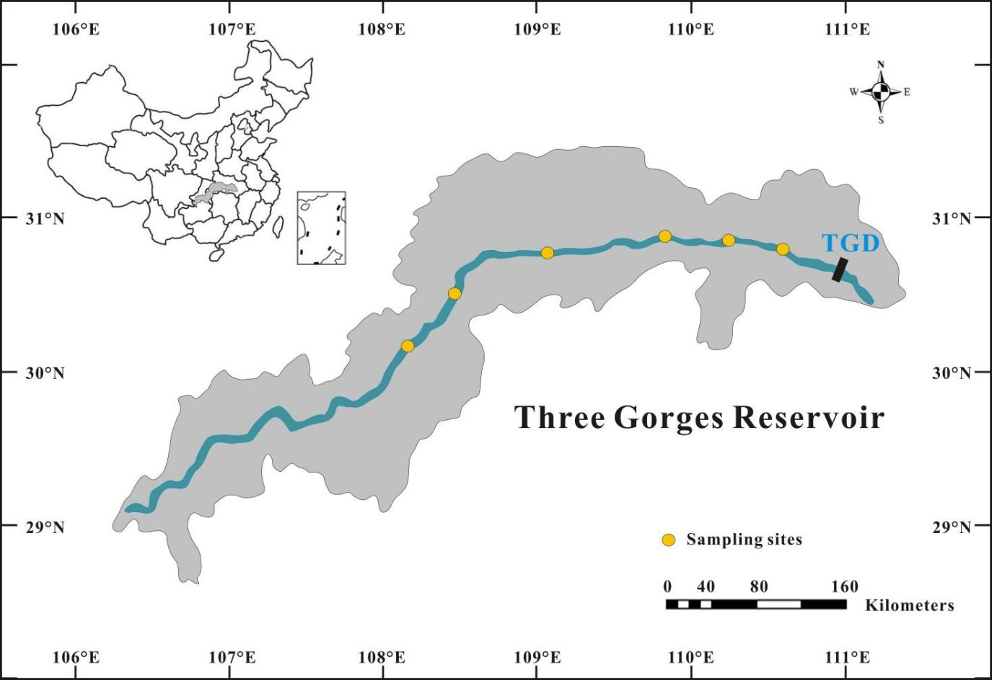

Fig. 1 Study area and sampling sites

Comprehensive analysis of SOM
Sedimentary organic carbon (SOC) and total nitrogen (TN) in sediments were obtained by a Thermo Scientific FLASH2000 Series CNS Elemental Analyzer [22]. Before SOC analysis, sieved samples (ca. 1 g) were pretreated by using 0.1 M HCL to remove carbonates, followed by repeated washing with deionized water and then dried at 60 °C. Acid‐treated carbonate‐free samples were analyzed for δ¹³C by a FLASH 2000 Elemental Analyzer connected to a MAT‐253 Isotope Ratio Mass Spectrometer.
Optical and molecular analysis of SOM was based on the extraction of water-extractable organic matter (WEOM) with a detailed procedure followed [23]. To be specific, excitation-emission matrixes (EEMs) was analysis by Aqualog absorption-fluorescence spectrometer (Horiba) according to [24]. Fourier transform ion cyclotron resonance mass spectrometry (FT-ICR MS) was analysis by Bruker SolariX FT-ICR MS (15.0 T) with an electrospray ionization (ESI) source (Research Center for Eco-Environmental Sciences, Chinese Academy of Sciences).

Results and discussions

Characteristics of SOM in TGR
OC and C/N exhibit a decreasing trend from upstream to downstream of mainstream, while δ¹³C value increases from upstream to downstream (Fig. 2). SOM in riverine sediments can be from allochthonous input as well as autochthonous input [4]. Considering the low carbon content of soil and phytoplankton relative to terrestrial plants with C/N values ranging from 5 to 15 [25], the C/N ratios ranging from 7.0 to 12.2 indicates the organic matter (OM) input of soil and plankton, which would result from reservoir operation induced soil submerging and alga bloom (Fig. 2b) [26]. δ¹³C values of SOM in TGR were similar to that in other reservoirs [27] and covered the range of rivers and lakes in previous studies [28], corresponding with the semi-lake/semi-river characteristic of reservoir. Considering the range of δ¹³C values of OC from various sources (e.g., C3 plants, C4 plants, and phytoplankton), the δ¹³C values of SOM in mainstream (-26.9‰ to -25.6‰) further supported the mixture of allochthonous (terrestrial plants and soils) and autochthonous (phytoplankton) sources [29] (Fig. 2c).

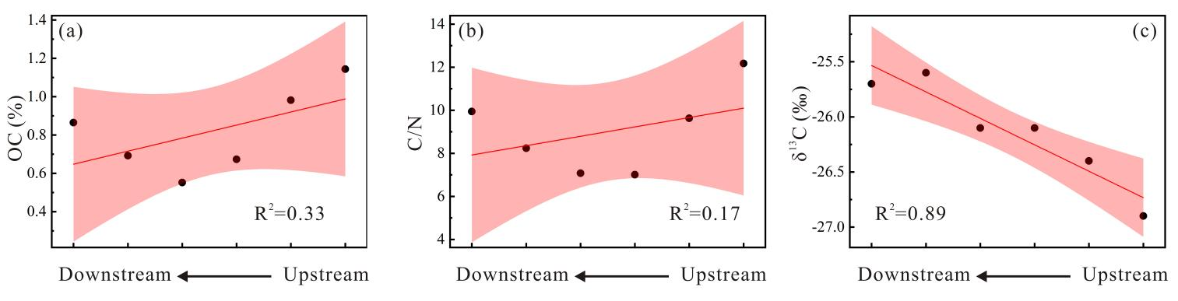

Fig. 2 Bulk characteristics variation of SOM. (a) OC, (b) C/N, (c) δ¹³C.

The range of Flourescence index (FI) (1.50 to 1.57), parameter for the contribution assessment of terrestrial and microbial sources [30], indicates the mixture of terrestrial and microbial OM in WEOM (Fig. 2a). Biological index (BIX, indicator of autotrophic productivity) and Freshness index (FrI, indicator of fresh produced OM) present an increasing trend from upstream to downstream (Fig. 3b,c), indicating that SOM in downstream might involve more severely in autochthonous productivity than that in upstream [31, 32].

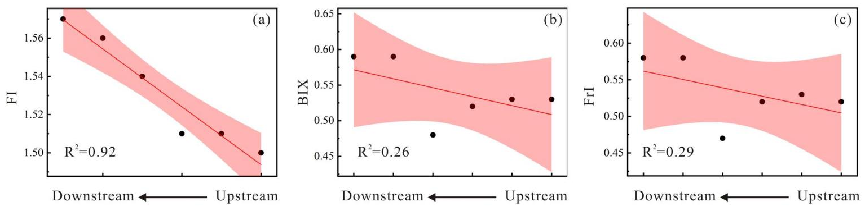

Fig. 3 Optical characteristics variation of SOM. (a) FI, (b) BIX, (c) FrI

Molecular analysis of WEOM further demonstrated the property of SOM (Fig. 4). Comparing to downstream, higher double bond equivalent (DBE), indicator of unsaturation degree of molecules [33], was observed in upstream (Fig. 4a). In terms of SOM composition, heteroatomic compounds exhibited complex variation behaviors that S containing compounds (CHOS) decreased from upstream to downstream, while N containing compounds (CHON) increased (Fig.4b, c). For the molecular source identification, various molecular groups categorization were introduced [34]. Compounds such as polycyclic aromatics (PCAs, AI ≥ 0.67), polyphenols (0.66 ≥ AI ≥ 0.50), highly unsaturated compounds, which include soil-derived products of lignin degradation (AI < 0.50, H/C < 1.5), unsaturated aliphatic compounds (2.0 ≥ H/C > 1.5, N = 0), and peptides (2.0 > H/C ≥ 1.5, N > 0) were identified and hinted the allochthonous and autochthonous sources of SOM (Fig. 5).

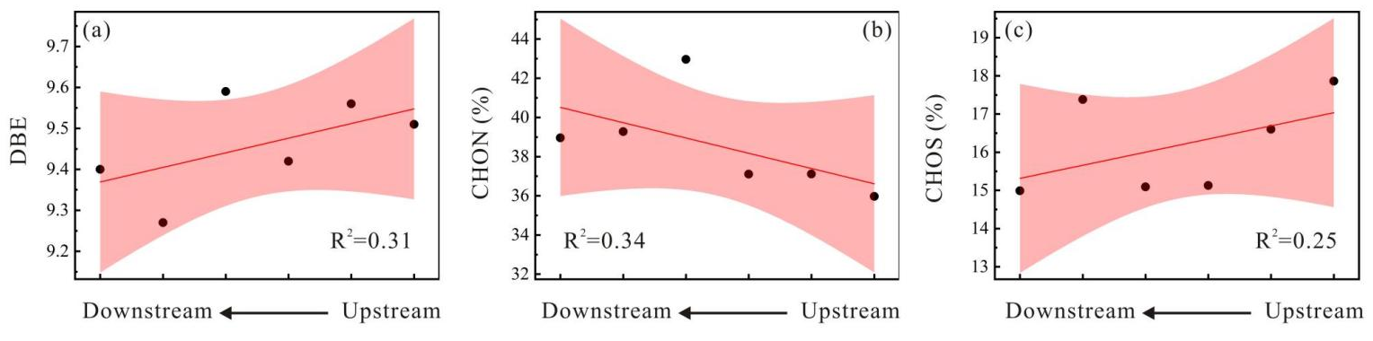

Fig. 4 Molecular characteristics variation of SOM. (a) DBE, (b) CHON, (c) CHOS.

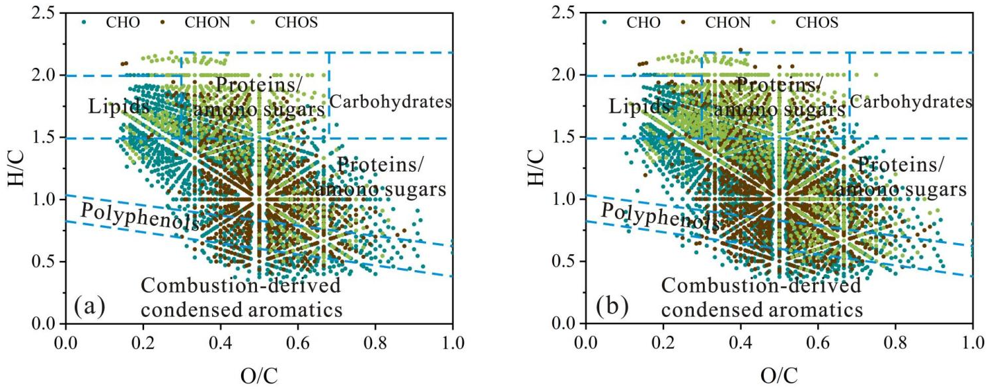

Fig. 5 Van Krevelen distributions of molecular formulae. (a) common formulae in all samples, (b) all formulae in all samples.

Potential dynamic of SOM
Based on comprehensive analysis of SOM properties from bulk to molecular level, relatively higher terrestrial OM input in upstream and autochthonous OM input in downstream of TGR were uncovered. Considering the significant influence of watershed land use and hydrological condition on OM dynamic [35, 36], we proposed the variation regime of SOM in TGR.
With TGR construction, hydrological conditions (e.g., water residence time and flux) were regulated by reservoir operation [37]. There were relatively higher water residence time and lower flux in downstream than those in upstream [38], which might devote to primary productivity enhancement and result in autochthonous OM production, especially in tributaries of downstream [39, 40]. This hydrological variation induced primary productivity heterogeneity would involve in biogeochemical processes in aquatic ecosystem and higher autochthonous OM deposition in downstream than upstream. In terms of allochthonous OM, land use could exert a significant constrain on OM cycling between terrestrial and aquatic ecosystems [41, 42]. In TGR watershed, there was a decreasing trend of agricultural and grassland proportion, while an increasing trend of forest from upstream to downstream watershed [43]. Previous studies have demonstrated the increasing of humic-like OM in agricultural streams [44, 45]. Higher proportion of agricultural and grassland in upstream might lead to more allochthonous OM input, which was further supported by the variation of FI (Fig. 3a). Therefore, hydrological heterogeneity regulated primary productivity and land use constrained OM input might be the main factors influencing SOM dynamic.
The estimation of annual burial fluxes of OC in globally surveyed reservoirs demonstrates an increasing trend in world reservoirs, especially in Africa and Asia [46], which hints the importance of carbon burial in reservoir. The autochthonous SOM enhanced in downstream of TGR demonstrating that although primary productivity is primed with reservoir operation, CO₂ sequestrated by algal bloom could devote to carbon burial in reservoir.

Conclusion
This study preliminarily demonstrates the variation of SOM in TGR mainstream through the comprehensive survey of SOM properties from bulk to molecular level. The spatial heterogeneity of SOM characteristics was uncovered. Relatively higher autochthonous signature and lower allochthonous signature of SOM were observed in downstream than those in upstream, which might be mainly regulated by watershed land use type and hydrological condition. This work emphasizes the influence of SOM dynamic on carbon burial in reservoir, although assessment of the quantitative contribution of allochthonous and autochthonous SOM to carbon burial of the whole reservoir needs further efforts. The comprehensive investigation of SOM dynamics under hydrological variations of reservoirs should be further pursued for a better understanding of carbon cycling in the fluvial ecosystem, especially with the reservoir booming worldwide.

Acknowledgements

This study was supported by China Postdoctoral Science Foundation (2021M701931).

REFERENCES

- Bao, R., Mcintyre, C., Zhao, M., Zhu, C., Kao, S.-J., Eglinton, T. I. (2016). Widespread dispersal and aging of organic carbon in shallow marginal seas. Geology, 44(10), 791-794.
- Walling, D. E., Fang, D. (2003). Recent trends in the suspended sediment loads of the world's rivers. Global and Planetary Change, 39(1), 111-126.
- Dalzell, B. J., Filley, T. R., Harbor, J. M. (2007). The role of hydrology in annual organic carbon loads and terrestrial organic matter export from a midwestern agricultural watershed. Geochimica et Cosmochimica Acta, 71(6), 1448-1462.
- Galy, V., France-Lanord, C., Lartiges, B. (2008). Loading and fate of particulate organic carbon from the Himalaya to the Ganga-Brahmaputra delta. Geochimica et Cosmochimica Acta, 72(7), 1767-1787.
- Draut, A. E., Logan, J. B., Mastin, M. C. (2011). Channel evolution on the dammed Elwha River, Washington, USA. Geomorphology, 15(3), 71-87.
- Fernandes, D., Wu, Y., Shirodkar, P. V., Pradhan, U. K., Limbu, S. M. (2019). Sources and preservation dynamics of organic matter in surface sediments of narmada river, india - illustrated by amino acids. Journal of Marine Systems, 201, 1-10.
- Kennedy, M. J., Wagner, T. (2011). Clay mineral continental amplifier for marine carbon sequestration in a greenhouse ocean. Proceedings of the National Academy of Sciences, 108(24), 9776-9781.
- Mzuza, M. K., Weiguo, Z., Chapola, L. S., Tembo, M., Kapute, F. (2017). Determining sources of sediments at Nkula Dam in the Middle Shire River, Malawi, using mineral magnetic approach. Journal of African Earth Sciences, 126, 23-32.
- Gourfi, A., Daoudi, L., Rhoujjati, A., Benkaddour, A., Fagel, N. (2020). Use of bathymetry and clay mineralogy of reservoir sediment to reconstruct the recent changes in sediment yields from a mountain catchment in the Western High Atlas region, Morocco. Catena, 191, 104560.
- He, D., Wang, K., Pang, Y., He, C., Li, P., Li, Y., … Sun, Y. (2020). Hydrological management constraints on the chemistry of dissolved organic matter in the Three Gorges Reservoir. Water Research, 187, 116413.
- Baran, A., Mierzwa-Hersztek, M., Gondek, K., Szara, M., Tarnawski, M. (2018). The content and composition of organic matter in bottom sediments of the Rybnik reservoir - preliminary studies. Geology, Geophysics and Environment, 44(3), 309.
- Regnier, P., Friedlingstein, P., Ciais, P., Mackenzie, F. T., Gruber, N., Janssens, I. A., … Andersson, A. J. (2013). Anthropogenic perturbation of the carbon fluxes from land to ocean. Nature Geoscience, 6(8), 597-607.
- Grill, G., Lehner, B., Thieme, M., Geenen, B., Tickner, D., Antonelli, F., ... Macedo, H. E. (2019). Mapping the world’s free-flowing rivers. Nature, 569(7755), 215-221.
- Dai, Z., Liu, J. (2013). Impacts of large dams on downstream fluvial sedimentation: An example of the Three Gorges Dam (TGD) on the Changjiang (Yangtze River). Journal of Hydrology, 480, 10-18.
- Yang, Z., Wang, H., Saito, Y., Milliman, J. D., Xu, K., Qiao, S., Shi, G. (2006). Dam impacts on the Changjiang (Yangtze) River sediment discharge to the sea: The past 55 years and after the Three Gorges Dam. Water Resources Research, 42(4), 1-10.
- Guo, H., Hu, Q., Zhang, Q., Feng, S. (2012). Effects of the Three Gorges Dam on Yangtze River flow and river interaction with Poyang Lake, China: 2003-2008. Journal of Hydrology, 511, 19-27.
- Cai, Q, Hu, Z. (2006). Studies on eutrophication problem and control strategy in the Three Gorges Reservoir. Acta Hydrobiologica Sinica, 30(1), 7-11.
- Ji, D., Wells, S. A., Yang, Z., Liu, D., Huang, Y., Ma, J., Berger, C. J. (2017). Impacts of water level rise on algal bloom prevention in the tributary of Three Gorges Reservoir, China. Ecological Engineering, 98, 70-81.
- Hu, B., Yang, Z., Wang, H., Sun, X., Bi, N., Li, G. (2009). Sedimentation in the Three Gorges Dam and the future trend of Changjiang (Yangtze River) sediment flux to the sea. Hydrology and Earth System Sciences, 13(11), 2253-2264.
- Li, Z., Lu, L., Lv, P., Zhang, Z., Guo, J. (2020). Imbalanced Stoichiometric Reservoir Sedimentation Regulates Methane Accumulation in China’s Three Gorges Reservoir. Water Resources Research, 56(9).
- Zhao, P., Tang, X., Tang, J., Wang, C. (2013). Assessing water quality of Three Gorges Reservoir, China, Over a five-year period from 2006 to 2011. Water Resources Management, 27(13), 4545-4558.
- He, D., Zhang, K., Cui, X., Tang, J., Sun, Y. (2018). Spatiotemporal variability of hydrocarbons in surface sediments from an intensively human-impacted Xiaoqing River-Laizhou Bay system in the eastern China: Occurrence, compositional profile and source apportionment. Science of the Total Environment, 645, 1172-1182.
- Hur, J., Lee, B., Shin, K. (2014). Spectroscopic characterization of dissolved organic matter isolates from sediments and the association with phenanthrene binding affinity. Chemosphere, 111, 450-457.
- Wang, K., Pang, Y., He, C., Li, P., Xiao, S., Sun, Y., Zhang, Y., Shi, Q., He, D. (2019). Optical and Molecular Signatures of Dissolved Organic Matter in Xiangxi Bay and Mainstream of Three Gorges Reservoir, China: Spatial Variations and Environmental Implications, Science of the Total Environment, 657, 1274-1284.
- Kendall, C., Silva, S. R., Kelly, V. J. (2001). Carbon and nitrogen isotopic compositions of particulate organic matter in four large river systems across the United States. Hydrological Processes, 15(7), 1301-1346.
- Jiang, T., Kaal, J., Liang, J., Zhang, Y., Wei, S., Wang, D., Green, N. W. (2017). Composition of dissolved organic matter (DOM) from periodically submerged soils in the Three Gorges Reservoir areas as determined by elemental and optical analysis, infrared spectroscopy, pyrolysis-GC-MS and thermally assisted hydrolysis and methylation. Science of The Total Environment, 603, 461-471.
- Zheng, L., Li, D., Ding, X., Lee, T., Zheng, Z., Shiah, F., … Kao, S. (2020). Isotope constraints on the sources of particulate organic carbon in a subtropical deep reservoir. Journal of Geophysical Research, 125(1), 1-15.
- Zigah, P. K., Minor, E. C., Werne, J. P. (2012). Radiocarbon and stable‐isotope geochemistry of organic and inorganic carbon in Lake Superior. Global Biogeochemical Cycles, 26(1), 1-20.
- Lamb, A. L., Wilson, G. P., Leng, M. J. (2006). A review of coastal palaeoclimate and relative sea-level reconstructions using δ13C and C/N ratios in organic material. Earth-Science Reviews, 75(1), 29-57.
- McKnight, D. M., Boyer, E. W., Westerhoff, P. K., Doran, P. T., Kulbe, T., Andersen, D. T. (2001). Spectrofluorometric characterization of dissolved organic matter for indication of precursor organic material and aromaticity. Limnology and Oceanography, 46(1), 38-48.
- Parlanti, E., Wörz, K., Geoffroy, L., Lamotte, M. (2000). Dissolved organic matter fluorescence spectroscopy as a tool to estimate biological activity in a coastal zone submitted to anthropogenic inputs. Organic geochemistry, 31(12), 1765-1781.
- Huguet, A., Vacher, L., Relexans, S., Saubusse, S., Froidefond, J. M., Parlanti, E. (2009). Properties of fluorescent dissolved organic matter in the Gironde Estuary. Organic Geochemistry, 40(6), 706-719.
- Hawkes, J. A., D’Andrilli, J., Agar, J. N., Barrow, M. P., Berg, S. M., Catalán, N., … Dittmar, T. (2020). An International Laboratory Comparison of Dissolved Organic Matter Composition by High Resolution Mass Spectrometry: Are We Getting the Same Answer? Limnology and Oceanography-Methods, 18(6), 235-258.
- Seidel, M., Yager, P.L., Ward, N.D., Carpenter, E.J., Gomes, H.R., Krusche, A.V., Richey, J.E., Ditmar, T., Medeiros, P.M. (2015). Molecular-level changes of dissolved organic matter along the Amazon River-to-Ocean continuum. Marine Chemistry, 177, 218-231.
- Wilson, H. F., Xenopoulos, M. A. (2009). Effects of agricultural land use on the composition of fluvial dissolved organic matter. Nature Geoscience, 2(1), 37-41.
- Loginova, A. N., Thomsen, S., Engel, A. (2016). Chromophoric and fluorescent dissolved organic matter in and above the oxygen minimum zone off P eru. Journal of Geophysical Research: Oceans, 121(11), 7973-7990.
- Li, Q., Yu, M., Lu, G., Cai, T., Bai, X., Xia, Z. (2011). Impacts of the Gezhouba and Three Gorges reservoirs on the sediment regime in the Yangtze River, China. Journal of Hydrology, 403(3-4), 224-233.
- Xiang, R., Wang, L., Li, H., Tian, Z., Zheng, B. (2021). Water quality variation in tributaries of the Three Gorges Reservoir from 2000 to 2015. Water Research, 195, 116993.
- Villacorte, L. O., Ekowati, Y., Neu, T. R., Kleijn, J. M., Winters, H., Amy, G., ... Kennedy, M. D. (2015). Characterisation of algal organic matter produced by bloom-forming marine and freshwater algae. Water Research, 73, 216-230.
- Zhang, J., Ye, D., Zhu, H., Hu, S., Wang, Y., Tang, J., Zhou, Z. (2019). Characteristics of spring algal blooms under different impounded levels in tributaries of the Three Gorges Reservoir. ACTA HYDROBIOLOGICA SINICA, 43(4), 884-891.
- Young, R. G., Huryn, A. D. (1999). Effects of land use on stream metabolism and organic matter turnover. Ecological Applications, 9(4), 1359-1376.
- Williams, C. J., Yamashita, Y., Wilson, H. F., Jaffé, R., Xenopoulos, M. A. (2010). Unraveling the role of land use and microbial activity in shaping dissolved organic matter characteristics in stream ecosystems. Limnology and Oceanography, 55(3), 1159-1171.
- Hao, B., Ma, M., Li, S., Li, Q., Hao, D., Huang, J., ... Han, X. (2019). Land use change and climate variation in the three gorges reservoir catchment from 2000 to 2015 based on the Google Earth Engine. Sensors, 19(9), 2118.
- Graeber, D., Gelbrecht, J., Pusch, M.T., Anlanger, C., Schiller, D.V. (2012). Agriculture has changed the amount and composition of dissolved organic matter in Central European headwater streams. Science of the Total Environment, 438(3), 435-446.
- Singh, S., Dash, P., Silwal, S., Feng, G., Adeli, A., & Moorhead, R. J. (2017). Influence of land use and land cover on the spatial variability of dissolved organic matter in multiple aquatic environments. Environmental Science and Pollution Research, 24(16), 14124-14141.
- Maavara, T., Lauerwald, R., Regnier, P., Van Cappellen, P. (2017). Global perturbation of organic carbon cycling by river damming. Nature Communications, 8, 1-10.

