MORPHOLOGICAL QUALITY AND MACROINVERTEBRATE DIVERSITY OF THE GRAVEL-BED SHITING RIVER, SICHUAN PROVINCE

SONGYI LI
State Key Laboratory of Water Resources and Hydropower Engineering Science, Wuhan University, Hubei 430072 China

SHAN ZHENG
State Key Laboratory of Water Resources and Hydropower Engineering Science, Wuhan University, Hubei 430072 China

Abstract: Dramatic undercutting of the Shiting River, a gravel-bed river draining from the Longmen Mountains, has taken place since the 2008 Wenchuan Earthquake. The morphological conditions of the Shiting River have changed due to natural factors and anthropogenic impacts after the earthquake. In this study, we measured the river morphology using drone, and surveyed the macroinvertebrate communities at 18 sampling sites along a channel reach of ~25-km-long at the Shiting River in 2021. We divided the channel reaches into six segments and assessed the morphological quality of the segments using the Morphological Quality Index (MQI), a method recommended in the EU Water Framework Directive to assess and restore rivers. The results showed that, the MQI scores for the six segments varied between 0.45 to 0.7, which indicates poor to good morphological quality. Two segments are in poor condition and need to be restored first. The low MQI scores at the two segments are mainly because of poor longitudinal continuity and strong cross-section configuration by bank protection. A total of 54 species of macroinvertebrates were found in the channel reaches, and they belong to 3 phylum, 6 classes and 33 families. The diversity of macroinvertebrates is positively related with the MQI scores. This study may help to provide reference for the morphological and ecological restoration of rivers impacted by earthquakes or degradation.
Keywords: Gravel-bed river; Morphological Quality Index; Macroinvertebrates; River restoration

INTRODUCTION
The rivers in basins affected the Wenchuan Ms 8.0 Earthquake have been reported to change from a relatively stable state pre-earthquake to obvious erosion or aggradation after 2008. The supply of sediment increased dramatically as a result of the earthquake and they excessed the transport capacity by the hydrodynamic condition, leading to channel aggradation in mountainous reaches. Nevertheless, rapid degradation was reported in the plain reaches of channels, especially in Shiting River [1].
Both natural factors and human activities can impact the river morphology and the aquatic environment. Reconstruction after the earthquake may have gave rise to massive sediment mining [2-4]. Thus far, consensus has not been reached regarding the relationship between the morphological diversity of river channel and the diversity of macroinvertebrates. Benthic macroinvertebrates are good indicator species for the health of the aquatic environment. The constitution and the diversity of the macroinvertebrate communities have been widely used to evaluate the degree of river pollution and the quality of aquatic ecosystems.
The morphological quality and aquatic environment need to be assessed at the Shiting River as it has been experiencing dramatic undercutting since the earthquake and restoration may be needed. In this study, the Shiting River was evaluated using a stream morphological quality assessment method called the Morphological Quality Index (MQI), which was recommended by the EU Water Framework. The macroinvertebrates were surveyed at 18 sites in 2021. The relationship between the scores of MQI and the diversity of macroinvertebrates was analyzed.

STUDY AREA
The Shiting River drains from the Longmen Mountain and flows to the Chengdu Plain. The climate is subtropical humid monsoon and the mean annual precipitation is 850–1700 mm. Gaojingguan hydrological station is located at a transition reach of the Shiting River between the Longmen Mountain and the Chengdu Plain. The river basin area upstream of the station is 701 km2 with a river length of ~52.7 km [1].
The study channel reaches extend ~25 km from Gaojingguan to the upstream of the junction of a tributary of the Shiting River, named the Sheshui River (Fig. 1). The average longitudinal slope of the reach is 7.6‰. The channel reaches are featured by the morphological units of cascades, step-pools, and riffle-pools, and the bed sediment is predominantly sand and gravel.

After the Wenchuan earthquake in 2008, many floods occurred in the Shiting River, resulting in severe bed undercutting and dramatic channel morphology. Intense human activities, such as sand mining, the construction of bank revetments, weirs and bridges, have also altered the channel morphology. The channel reaches can be divided into six consecutive segments, to which the MQI method will later be applied. The boundaries of the six segments were mainly determined by the location of weirs, bridges and tributary conjunction. There are three weirs and several bridges at the channel reach. The three weirs are herein called the First Weir, the Hongyan Canal Weir, and the Renmin Canal Weir from the upstream to the downstream (Fig. 2). The heights of the three weirs are approximately 2 m, 25 m and 20 m, respectively. As shown in Fig. 2, there are three bridges in river segment 5 (S5). The piers of one of the bridges, Cheng-Mian Highway Bridge, were under reconstruction in 2021 (Fig. 2a). The banks near the bridges have been protected by concrete and revetments, e.g., at the 105th Provincial Highway Bridge (Fig. 2b).
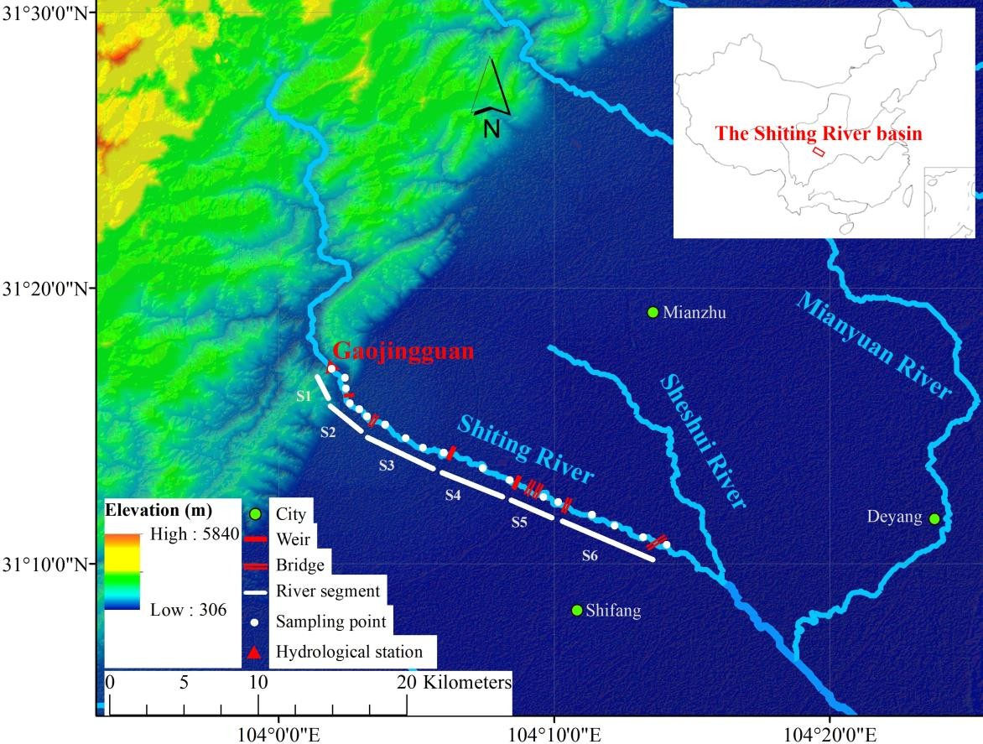

Figure 1. Location and the study channel reaches of the Shiting River.
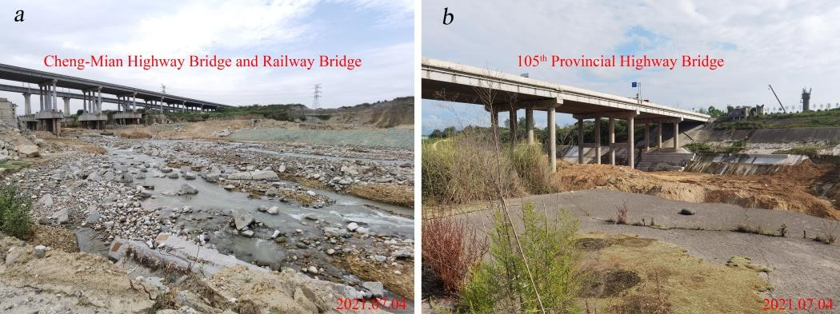
Figure 2. Bridges at S5 (a) Cheng-Mian Highway Bridge and Railway Bridge, and (b) the 105th Provincial Highway Bridge.

METHODS

  - The Morphological Quality Index (MQI)
The MQI was initially developed to assess the hydromorphological condition of Italian streams, as described in detail in Rinaldi et al. [5], and thus far it has been applied in many European rivers [6]. The MQI considers conditions of three aspects, including the morphological functionality, artificial disturbance, and the amount of channel adjustments (Table 1). There are a total of 28 indicators in the evaluation procedure. These indicators can be used to assess the channel longitudinal and lateral continuity, cross-section configuration, change in channel pattern, substrate and bed structure, and vegetation in the riparian corridor at river segments [5]. Three classes are typically defined for each indicator (except for a limited number with two classes or more than three classes): (A) undisturbed conditions or negligible alternations; (B) intermediate alternations; (C) very altered conditions [7]. A score is given for each class, and the score for class C is the greatest while that for class A is the smallest. The overall assessments of the indicators are carried out by field surveys and GIS generated by drone maps and RTK measurements.
As for the three indicators of channel adjustments, the period of assessment and amount of bed-level adjustments were modified according to the studied time in this paper. The assessment period of channel adjustments indicators changed from 1930s – 1960s to 2008 – 2021. There are four classes of indicator CA3: (A) negligible bed-level changes (≤ 0.5 m); (B) limited to moderate bed-level changes (0.5 ÷ 3 m); (C1) intense bed-
level changes (＞ 3 m); (C2) very intense bed-level changes (> 6 m). Accordingly, the four classes were divided
into new four levels based on the incision depth of each segment in the Shiting River since 2008: (A) negligible bed-level changes (≤ 5 m); (B) limited to moderate bed-level changes (5 ÷ 15 m); (C1) intense bed-level changes (15 ÷ 25 m); (C2) very intense bed-level changes (> 25 m).
The Morphological Quality Index is calculated as follows:
MQI = 1 – Stot/Smax (1)
where Stot is the sum of the scores for all the indicators, and Smax is the maximum score that can be got when all indicators are in class C. The value of MQI is proportional to the quality of the river and inversely proportional to the alternations. Five classes of the morphological quality were defined: (I)very good or high, 0.85 ≤ MQI ≤ 1;
(II) good, 0.7 ≤ MQI ≤ 0.85; (III) moderate, 0.5 ≤ MQI ≤ 0.7; (IV) poor, 0.3 ≤ MQI ≤ 0.5; (V) very poor or
bad, 0≤ MQI ≤ 0.3 [8-10]. Additionally, a series of sub-indices of the MQI can be calculated according to the guidebook [8].

Macroinvertebrate surveys and analysis
We surveyed the macroinvertebrate communities at 18 sampling sites along the channel reaches at the Shiting River using the Surber net (mesh 250μm) during Oct. 28 and Nov. 2, 2021. The number of sampling sites at each segment varied between 2 and 4. A Surber net covers an area of 0.09 m2 (per sample). The sediment covered by the Surber net was rinsed for 5 min before collecting the macroinvertebrates caught in the net [11]. This procedure was repeated 3 times at different locations at each sampling site. Specimens were sorted and preserved in 95% ethanol in the field [12-13]. All macroinvertebrate samples were identified to the genus level by the Institute of Hydrobiology, Chinese Academy of Sciences.
Biodiversity indexes, including the Shannon-Wiener, Simpson, and Evenness indexes, were calculated to assess the macroinvertebrate assemblage structures. The Shannon-Wiener index reflects the proportion of taxa abundances in comparison to the total number of taxa. The Simpson index were calculated as the proportion of taxa abundances relative to the total number of taxa and squared, and this indicates diversity through a relative dominance for each species. Additionally, the Evenness index reflects the proportion of richness in comparison to abundance [11]. The Shannon-Wiener Index, H, is given by:

𝐻 = − ∑^{𝑆}
(𝑛𝑖/𝑁) 𝑙𝑛(𝑛𝑖/𝑁)
(2)

𝑖=1
where N is the total number of individuals in a sampling point (ind. m⁻²), S is the taxa richness, and ni is the number of individuals of the i-th taxon.
The Simpon Index, D, and Evenness Index, J, are calculated by the following two equations, respectively:

𝐷 = 1 − ∑^{𝑆}
𝑖=1
(𝑛𝑖/𝑁)²
(3)

= 𝐻/ ln 𝑆 (4)

RESULTS

  - Application results of the MQI
The MQI was applied to the six segments S1-S6 at the Shiting River, and the results showed that the scores of MQI varied between 0.45 (at S5, poor) to 0.7 (at S6, good) (Fig. 3).
The morphological quality at S3 and S5 is poor among the six segments. The lowest MQI score exists at S5 (Table 1), and this may mainly due to the intense artificial disturbances (e.g., bridges, bank revetment, Fig. 2), poor longitudinal continuity of river flow and sediment transport, and evident channel adjustments. For example, there are 3 bridges in S5, which results in the indicator crossing structures A5 in class C (>1 every 1000 m in average in the reach) (Table 1). The percentage of protected banks over total length (sum of both banks) is nearly 33%, and the indicator bank protections A6 in class B. The channel was degraded most dramatically near the 105th Provincial Highway Bridge at S5 with the bed undercutting depth of ~20.8 m during 2008 to 2015 [1]. The indicator bed-level adjustments CA3 at S5 is in class C2, which has the highest score among the classes. The morphological quality of S3 is poor mainly because of narrow functional vegetation and limited linear extension of riparian vegetation in the fluvial corridor, with both F12 and F13 are in class C (Table 1).

Table 1. Morphological Quality Index (MQI): indicators, assessed parameters and the results for segments S5 and S6.
Aspect | Indicator | Assessed parameter | Class at  S5 | Class at  S6
Geomorphological functionality | F1 – Longitudinal continuity in sediment and  wood flux | Presence of crossing structures altering sediment and wood continuity | B | A
 | F2 – Presence of a modern floodplain | Width and longitudinal length of a modern floodplain | B2 | A
 | F3 – Hillslope–river corridor connectivity | Presence and length of elements of disconnection on river sides | / | /
 | F4 – Processes of bank retreat | Presence/absence of retreating banks | C | C
 | F5 – Presence of a potentially erodible corridor | Width and longitudinal length of an erodible corridor | A | A
 | F6 – Bed configuration–valley slope | Identification of bed configuration and comparison with expected bed configuration based on  valley slope | / | /
 | F7 – Planform pattern | Percentage of the reach length with alteration of planform pattern | B | A
 | F8 – Presence of typical fluvial forms in the  floodplain | Presence/absence of fluvial forms in the alluvial plain | C | B
 | F9 – Variability of the cross section | Percentage of the reach length with alteration of the natural heterogeneity of cross section | B | B
 | F10 – Structure of the channel bed | Presence/absence of alterations of bed sediment | B | A
 | F11 – Presence of in-channel large wood | Presence/absence of large wood | B | B
 | F12 – Width of functional vegetation | Mean width of functional vegetation in the fluvial corridor | A | B
 | F13 – Linear extension of functional vegetation | Longitudinal length of functional vegetation along the banks | B | B
Artificiality | A1 – Upstream alteration of flows | Amount of changes in discharge caused by interventions upstream | A | A
 | A2 – Upstream alteration of sediment  discharges | Presence, type, and position (drainage area) of relevant structures responsible for bedload  interception (dams, check-dams, weirs) | B1 | A
 | A3 – Alteration of flows in the reach | Amount of changes in discharge within the reach | B | A
 | A4 – Alteration of sediment discharge in the  reach | Type and density of structures intercepting bedload along the reach | B | A
 | A5 – Crossing structures | Spatial density of crossing structures | C | B
 | A6 – Bank protections | Length of protected banks | B | B
 | A7 – Artificial levées | Length and distance from the channel of artificial levees | B | B
 | A8 – Artificial changes of river course | Percentage of the reach length with artificial modifications of the river course | C | A
 | A9 – Other bed stabilisation structures | Presence, spatial density and typology of other bed-stabilizing structures and revetments | B | A
 | A10 – Sediment removal | Existence of past and/or recent sediment mining activity | C | C
 | A11 – Wood removal | Existence and relative intensity of in-channel wood removal | B | B
 | A12 – Vegetation management | Existence and relative intensity of riparian vegetation cuts or aquatic vegetation removal | B | B
Channel adjustments | CA1 – Adjustments in channel pattern | Changes in channel pattern from 2008 to 2021 | B | B
 | CA2 – Adjustments in channel width | Changes in channel width from 2008 to 2021 | B | B
 | CA3 – Bed-level adjustments | Bed-level changes from 2008 to 2021 | C2 | B
MQI/MQI class |  |  | 0.45/poor | 0.7/good
Note: / means not applicable to the partly or not confined segments.

The morphological quality of S4 is moderate (MQI = 0.61) and the indicators concerning with vegetation show the best quality among the six segments. The width of functional vegetation in the fluvial corridor is twice as great as the channel width and the indicator F12 is in class A. The linear extension of the riparian vegetation is lower than 90% but higher than 33% and the indicator F13 is in class B. The sediment behind the weirs almost reached the top of the weirs, making a slight alternation in the continuity of sediment and wood flux and forming a wide and long modern floodplain upstream of the Renmin Weir at S4.
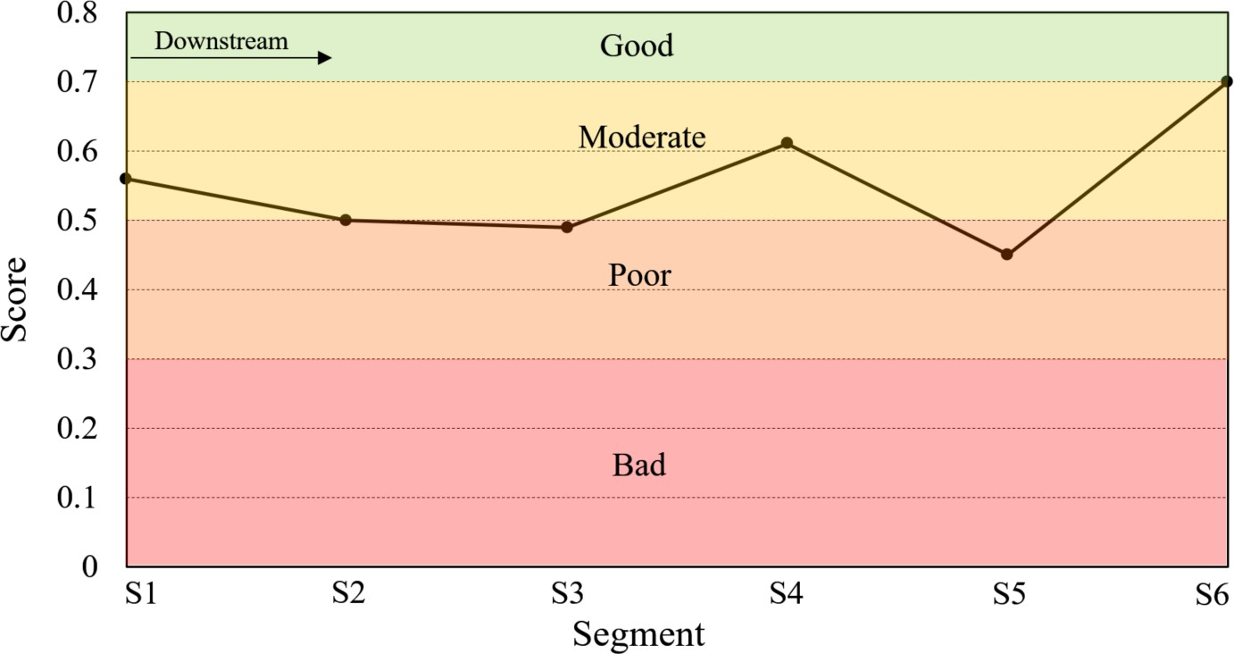

Figure 3. The MQI scores at the segments S1-S6 at Shiting River.

Relationships between the macroinvertebrate diversity and the morphological quality
Results showed that the MQI scores are positively related with the biological diversity indexes of the benthic macroinvertebrates. Specifically, the correlation coefficient between the MQI scores and the Shannon-Weiner, Simpson and Evenness indexes is r=0.76, 0.64 and 0.83, respectively (p<0.01) (Fig. 4). Scores of the indicators representing the role played by the geomorphological functionality and artificiality, compared to those representing channel adjustments, had a stronger correlation with the diversity indexes. This may be related to the different weight of the three aspects considered by the MQI: artificiality has the highest weight on the overall scoring, followed by geomorphological functionality and channel adjustments. The diversity indexes of macroinvertebrates showed stronger correlation with the lateral continuity than those with the longitudinal continuity (Fig. 5). In addition, there was a negative correlation between the channel adjustment and the diversity indexes. Although the correlation is not significant in statistics, the greater channel adjustment (e.g., class C for indicators CA1-CA3) may be associated with lower diversity indexes. Vegetation in fluvial corridors showed a positive relationship with the diversity indexes, especially for the Simpson index (r=0.75, p<0.01).
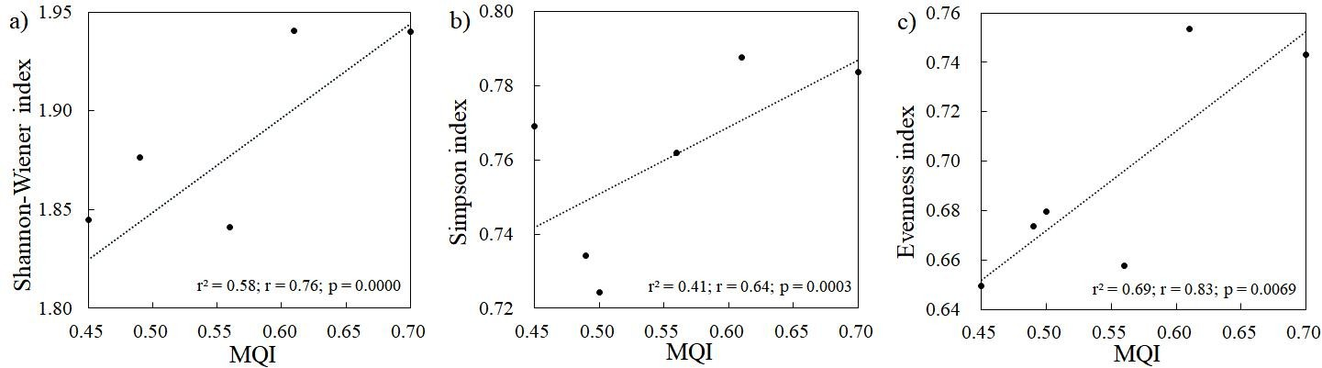

Figure 4. Correlations between MQI and the indexes for the macroinvertebrate community: a) Shannon-Wiener vs MQI; b) Simpson vs MQI; c) Evenness vs MQI.

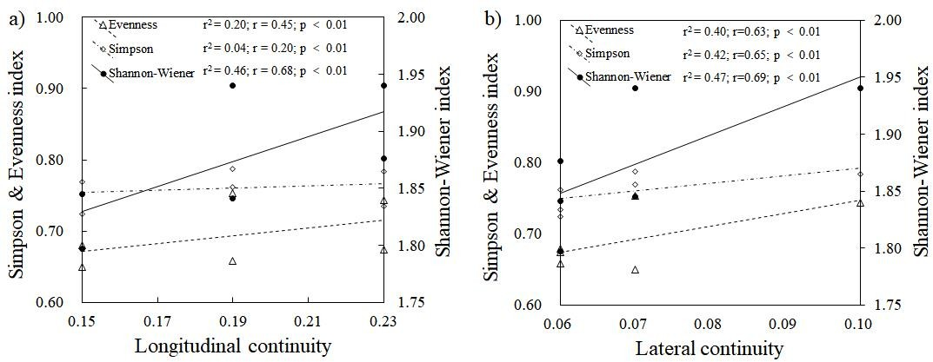

Figure 5. Correlations between longitudinal or lateral indexes and the indexes for the macroinvertebrate community: a) longitudinal indexes vs. Shannon-Wiener, Simpson and Evenness; b) lateral indexes vs. Shannon- Wiener, Simpson and Evenness.

CONCLUSIONS
The MQI scores ranged from poor (0.45) to good (0.7) at the segments of the Shiting River. The segments with low scores were generally subject to intense artificial disturbance, and the channel bed has been eroded significantly. The MQI scores showed a significant positive relationship with the Shannon, Simpson and Evenness indexes of macroinvertebrate, which implies that a stream with good morphological quality defined by MQI is tended to have more diverse macroinvertebrate communities than those with lower MQI scores. Some sub-indices that compose the MQI also showed correlation with the diversity indexes of macroinvertebrate. Vegetation in fluvial corridors showed a positive relationship with the diversity indexes.

ACKNOWLEGEMENT
This study was supported by the National Natural Science Foundation of China (52079095). We thank professor Niannian Fan at Sichuan University for his guidance during fieldtrip. We are grateful for the assistance of Wei Liu, Hualin Wang, Juan He and Min Liu in the field work.

REFERENCES
- Fan N., Nie R., Wang Q., et al., “Dramatic undercutting of piedmont rivers after the 2008 Wenchuan Ms 8.0 Earthquake”, Scientific Reports, Vol. 6, No. 1, (2016), pp 37108.
- Yu H., Xia Y., Wang Z., et al., “Numerical Simulation Study on Effect of Different Longitudinal Profile Dimensions of Sandpit on Riverbed Evolution of Pebble Channel——A Case of Shuangsheng Section of Shiting River”, Advanced Engineering Sciences, Vol. 49, No. Z2, (2017), pp 83-91.
- Wang Z., Xia Y., Yu H., et al., “Impacts of Changed Base Level of Erosion on the Riverbed Evolution in Shuangsheng Section of Shiting River”, Advanced Engineering Sciences, Vol. 49, No. Z2, (2017), pp 67-73.
- Nie R., Wang X., Liu F., et al., “Study on fluvial processes of piedmont rivers damaged by strong earthquakes”,
Advanced Engineering Sciences, Vol. 50, No. 3, (2018), pp 105-111.
- Rinaldi M., Surian N., Comiti F., et al., “A method for the assessment and analysis of the hydromorphological condition of Italian streams: The Morphological Quality Index (MQI)”, Geomorphology, Vol. 180-181, No. 1, (2013), pp 96-108.
- Belletti B., Nardi L., Rinaldi M., et al., “Assessing Restoration Effects on River Hydromorphology Using the Process-based Morphological Quality Index in Eight European River Reaches”, Environmental Management, Vol. 61, No. 1, (2018), pp 69-84.
- Rinaldi M., Surian N., Comiti F., et al., “A methodological framework for hydromorphological assessment, analysis and monitoring (IDRAIM) aimed at promoting integrated river management”, Geomorphology, Vol. 251, No. DECa15, (2015), pp 122-136.
- Rinaldi M., Bussettini M., Surian N., et al., “Guidebook for the evaluation of stream morphological conditions by the Morphological Quality Index (MQI) Version 2”, Istituto Superiore per la Protezione e la Ricerca

Ambientale, https://www.isprambiente.gov.it/pre_meteo/idro/idromorfologia/MQI_final_Aug16_revOct16.pdf
- Rinaldi M., Belletti B., Bussettini M., et al., “New tools for the hydromorphological assessment and monitoring of European streams”, Journal of Environmental Management, Vol. 202, No. PTA2, (2017), pp 363-378.
- Rinaldi M., Belletti B., Bussettini M., et al., “An assessment of the hydromorphological conditions of the middle and lower Guadalquivir River (southern Spain)”, Physical Geography, Vol. 41, No. 3, (2019), pp 1- 18.
- Mendonca B., Mao L. and Belletti B., “Spatial scale determines how the morphological diversity relates with river biological diversity. Evidence from a mountain river in the central Chilean Andes”, Geomorphology, Vol. 372, (2020).
- Zhou X., Wang Z., Xu M., et al., “Stream power as a predictor of aquatic macroinvertebrate assemblages in the Yarlung Tsangpo River Basin (Tibetan Plateau)”, Hydrobiologia, Vol. 797, No. 1, (2016), pp 215-230.
- Zhou X., Xu M., Wang Z., et al., “Debris-flow deposits on a major river influence aquatic habitats and benthic macroinvertebrate assemblages”, Freshwater science, Vol. 38, No. 4, (2019), pp 000-000.

