Quantity analysis the channel habitat quality using an ecohydraulic model

Yike Li
State Key Laboratory of Hydraulics and Mountain River Engineering, Sichuan University
Chengdu 610065, China

Pengcheng Li
Department of Civil and Environmental Engineering, University of Alberta
Edmonton, AB, Canada T6G 2G7

Meixia Bao
State Key Laboratory of Hydraulics and Mountain River Engineering, Sichuan University
Chengdu 610065, China

Qianqian Wang
State Key Laboratory of Hydraulics and Mountain River Engineering, Sichuan University
Chengdu 610065, China

Weiwei Yao*
State Key Laboratory of Hydraulics and Mountain River Engineering, Sichuan University
Chengdu 610065, China
*Author to whom correspondence should be addressed; E-Mail: science_research@126.com

Abstract:Anthropogenic channel reconstruction and flow discharge influence the composition and configuration of habitat patches in stream and channel ecosystems. Flow velocity, water depth and substrates composed of a unique physical habitat in channel ecosystems. This paper proposed a model which composed of hydrodynamic, sediment transport, and habitat module. This model were used to evaluate five types of channel habitat quality and evaluate the impacts of two types of dike installation. A rectangular channel with 180 m in width and 1800 m in length was chosen as computational domain and Schizothorax (Schizothorax) was selected as target fish species. Fish preference curves were obtained from literature and scientific report. Model results indicate that the fish habitat quality were showed an increase trend from 50 to 2000 m3/s, and then showed a decreased trends, after that it remained stable. The highest habitat quality were happened at hydrological conditions with flow rate at 950 m3/s with the high HSI value located at the middle of the main channel. The long-term effects for the dike installation were also simulated. The analysis indicates that there are a significantly erosion happened at the channel when the dike was installed at both sides. The habitat quality was also decrease along with the erosion happened.
Keywords:Ecohydraulic modelling, Dike installation, Channel habitat quality, sediment transport.

1 Introduction
River restoration and riverbank reconstruction are attempts to increase the shipping volume and protect river banks from direct erosion. Although river reconstructions can enhance the channel navigation condition and protect river banks, the constructions may substantially change the flow conditions and thus threaten the ecosystem^{[1]}. In this case, river restoration planning and strategies have been widely implemented to recoup the ecosystem services losses due to changes in physical conditions. For instance, plenty of river restoration projects has been conducted in the United States for protecting endangered species in rivers. Similarly, China has also spent billions of dollars on restoring river ecosystem in the Yangtze River basin^{[2]}. Stream restoration projects, e.g. riverbank stabilization and riparian management projects, have been extensively developed in Australia^{[3]}. Hydrodynamic conditions and riverbed evolution are crucial parameters for evaluating the influence of river reconstruction on fish habitat. Therefore, to determine the optimized river reconstruction strategies, coupling physical characteristics (e.g. hydrodynamic, sediment characteristics, etc.) of the stream system and habitat model is essential to evaluate the influence of riverbank reconstruction.
The goal of this study is to investigate the influence of riverbank reconstruction on fish habitats and find out the optimized riverbank reconstruction strategies. The fish habitat quality in a natural stream along with four riverbank reconstruction strategies were evaluated. Installing straight or T-shaped spur dikes (groynes) on a single riverbank or both riverbanks were selected as the proposed riverbank reconstruction strategies in this study to investigate their impacts on the habitat suitability level of Schizothorax (Schizothorax). Flow velocity and water depth in various riverbank reconstruction strategies were simulated using the hydrodynamic module. Subsequently, sediment transport, substrates distribution, and river bed evolution were calculated. Fish habitat qualities, such as habitat suitability index (HSI), weighted usable area (WUA), and the overall habitat suitability index (OSI), was quantified using the habitat module. Eventually, post effects of these four riverbank reconstruction strategies can be explored in both short term and long term to potentially improve fish habitat quality.

2 Materials and method

2.1 Study areas
The computation domain is an 1800 meter long straight stream, with a width of 180 m and the discharge ranging from 50 and 2500 m³/s (Figure 1). Four riverbank reconstruction strategies were tested in this study: straight or T-shaped spur dikes constructed on the left bank or both banks of the river as shown in Figure 1 (Case 2-4). Schizothorax (Schizothorax) was selected to evaluate its ecological status.
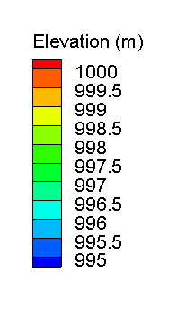
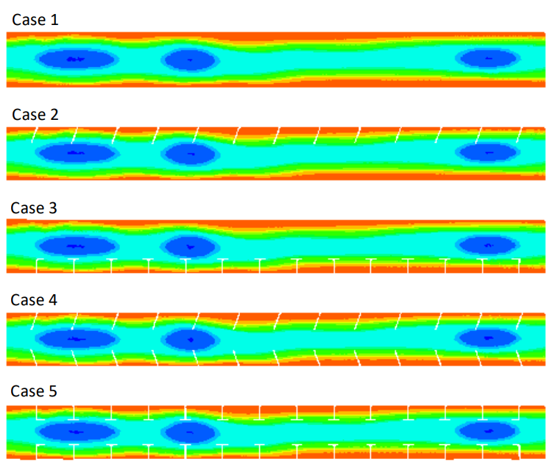
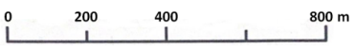
Figure 1. The computation domain of the five types of channel

2.2 Mathematical description of ecohydraulic model
The ecohydraulic model was composed by hydrodynamic module, sediment transport, and habitat module (Figure 2).
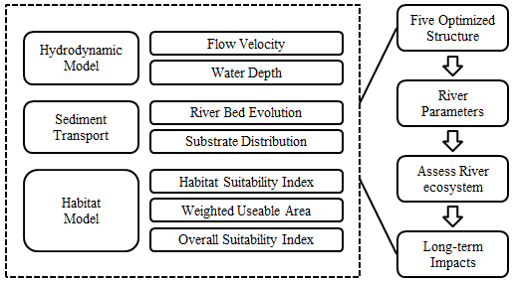
Figure 2.Flow charts for evaluating fish adaptive ecological hydrodynamic model systems for different restoration options.

The hydrodynamic module was used to calculate the flow velocity and water depth in the computational domain based on the two-dimensional continuity equation and Reynolds-averaged Navier-Stokes (RANS) equations:
Continuity equation

(1)

Momentum equation

(2)
(3)

where u and v are depth integrate velocity components in x and y directions respectively (m/s); t is time (s); g is gravitational acceleration (m/s²); η is the water surface elevation (m); h is the water depth (m); χ_{u} and χ_{v} are heat transfer diffusivity ; f_{Cor} is archimedes number ; is water density(kg/m³). The standard k–ε turbulence model, consisting of the turbulence kinetic energy (k) and its dissipation rate (ɛ), was adopted for closing the RANS equations.
The riverbed deformation can be obtained from the sediment continuity equation^{[4]}:

(4)

where p’ is the non-cohesive bed porosity; Z_{b} is channel elevation (m); Q_{bs} and Q_{bn} are the bed-load flux, which is calculated by bed load equations.
The bed load calculation is based on the following equation^{[5,6]}.

(5)
(6)

where C is the bottom fraction; C₉₀ is the quadratic fraction;θ is the shields number (-); θ_{cr} is critical shields value; τ_{b} is bed shear stresses; ρ_{s} is sediment density (kg/m³); ; d₅₀ is particle size parameter in 50 percent (mm). The riverbed substrate distribution was calculated by the following equation:

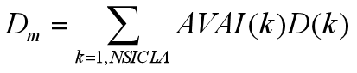 (7)

where AVI(k) is the volume fraction k of sediment; D(k) is the mean diameter of sediment fraction k (m); D_{m} is the mean diameter of the active layer (m). Suitability parameters including HSI (habitat suitability index), WUA (weighted usable area), and the OSI (overall suitability index) are calculated as follows:

(8)

where HSI is affected by suitability indexes (SI) which can influence fish growth, survival, and abundance. In this study, flow velocity (SI_{v}), river depth (SI_{d}), substrates (SI_{s}) were selected for HSI estimation. Habitat suitability quality levels (low, middle, or high) can be indicated by the value of HSI (Table 1). Weighted usable area (WUA) and overall suitability index (OSI) are described as:

(9)
(10)

where A_{i} is the horizon surface of mesh cell i (m²), HSIi is the habitat suitability index of mesh cell i and M the number of meshes in the studied river stretch. The OSI is defined as the ratio of the weighted useable area and total computational domain area in the horizontal plane.

3.4 Model system and boundary condition setup
Five cases, including the current nature river without any riverbank reconstructions (Case 1), straight spur dikes installed on the left bank (Case 2), T-shaped spur dikes installed on the right bank (Case 3), straight spur dikes installed on both riverbanks (Case 4), and T-shaped spur dikes installed on both riverbanks (Case 5), were simulated to evaluate their fish habitat suitability quality.

4 Results

4.1 Hydrodynamic simulation
Flow velocity distributions with and without different riverbank reconstructions are illustrated in Figure 3(a). In the case 1, the flow velocity is very slow (less than 0.1 m/s) near riverbanks and reaches to the maximum (more than 0.3 m/s) in the middle of the river. In case 2 and 3, the change of the maximum flow velocity near the river center is not significant. However, the area with slow velocity near the reconstructed bank expands substantially until the end of the spur dikes. Similarly, dead zones appear on case 4 and 5, while the flow velocity in the middle of the river is larger at the river upstream compared to case 2 and3. The change of dead zone area and maximum velocity will magnify with an increasing flow rate. A similar trend is found in the river depth (Figure 3b). Case 2 and 3 have limited influence on water depth, white installing spur dikes on both riverbanks may raise the water level at the river downstream. Riverbank reconstruction and flow discharges also have a limited influence on grain size and small grain size of 2-4 mm was observed in the middle of the river.
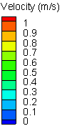
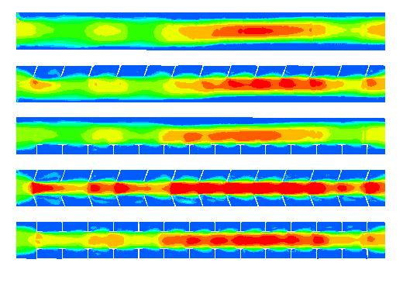
a
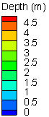
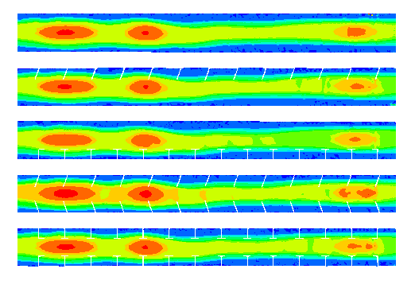
b
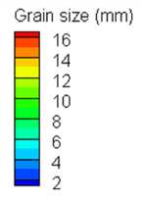
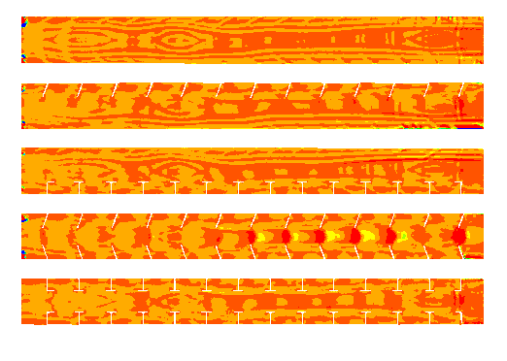
c
Figure 3.The flow velocity, water depth and grain size distribution of five schemes.

4.2 Habitat suitability distribution
Simulated water depth, flow velocity, and substrates are used to estimate the fish suitability index. The fish habitat suitability index distribution before and after riverbank reconstructions at different flow rates is illustrated in Figure 4. The HSI is about 1 in the middle of the river. The WUA and OSI for Schizothorax (Schizothorax) in the nature river without any riverbank reconstructions are 1403 m2 and 43%, respectively, with the high, middle, and low habitat suitability are 50%, 8%, and 42%, respectively.
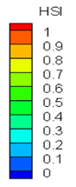
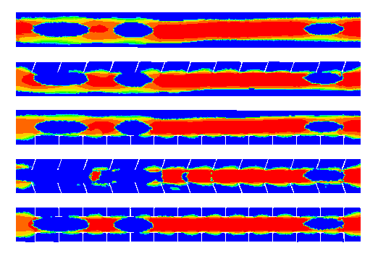
Figure 4.Habitat suitability index distribution of five schemes.

After installing the straight or T-shaped spur dikes on the left (Case 2) or right bank (Case 3), the habitat suitability is not impacted compared with that in the natural river. Note that the low HSI area near the reconstructed riverbank expands slightly after the spur dikes installation. The high, middle, and low habitat suitability proportions with spur dikes installation on a single river bank are also close to that in the nature river without riverbank reconstructions. For Case 2, WUA and OSI decrease slightly to 1164 m² and 36%, respectively. As for Case 3, WUA and OSI decrease to 1183 m2 and 37%, respectively. Installing straight spur dikes on a single riverbank has similar habitat suitability to the T-shaped, and both riverbank reconstruction strategies have limited influence on the fish habitat of the natural river.
When straight or T-shaped spur dikes are installed on both riverbanks (Case 4-5), the fish habitat suitability index decreases, as shown in Figure 4. HSI in the area between installed spur dikes decreases to about zero. Compared with the natural river without any riverbank reconstructions , the WUA with straight and T-shaped spur dikes installed on both riverbanks shrinks significantly, which are 663 m² and 912 m², respectively. OSI for Cases 4 and 5 also dramatically decreased to 21% and 29%, respectively.

4.3 Habitat sensitivity analysis
Both WUA and OSI at various flow rates are used for habitat sensitivity analysis of the Schizothorax (Schizothorax). The case 1) has more OSI (up to 43%) compared to those with riverbank reconstructions (Case 2-4). With respect to installing spur dikes on a single riverbank (Case 2-3), OSI is 36%. For riverbank constructions on both banks (Case 4-5), OSI is about 30%, indicating low suitability compared to the single riverbank reconstruction. The same trend occurs on WUA at various discharges under different tested cases, in which nature river has the highest WUA, compared to riverbank reconstructions on a single bank and both banks.

4.4 Post effects of restoration strategies
It is noted that installing spur dikes on a single riverbank has less negative influence on fish habitat and ecological conditions than that on both sides, long term impacts for riverbank reconstruction strategies are needed for better evaluating their influences. Hydrodynamics, sediment transport, river bed evolution, and habitat suitability in a four-year period were simulated.
After installing spur dikes on a single riverbank, river bottom elevations have limited changes in all tested time series. However, installing spur dikes on both riverbanks would lower the river bottom elevation and the degree of reduction is enhanced with time. Specifically, the average elevations of Case 4 and 5 were reduced by about 3.5 m and 2.5 m in a four-year term, respectively. Therefore, installing spur dikes on a single riverbank has little influence on the riverbed, whereas installing spur dikes on both riverbanks can potentially scour the riverbed in more than two years.
Grain size distribution can also support the evolution of the riverbed as shown in Figure 5(a). When spur dikes are installed on a single riverbank, the grain size near the riverbank without any reconstruction increases with time, indicating small sediments would be washed away. On the other hand, substrates in the middle of the river increase with time if spur dikes are installed on both riverbanks. Riverbed evolutions for all tested cases are shown in Figure 5(b), which can also suggest installing spur dikes on both riverbanks leads to serious erosion of the riverbed in the middle of the river in the fourth year. Although installing spur dikes on a single riverbank also causes riverbed scouring, it only appears near the riverbank without reconstructions and the affected area is not large.
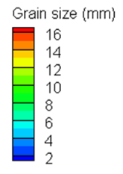
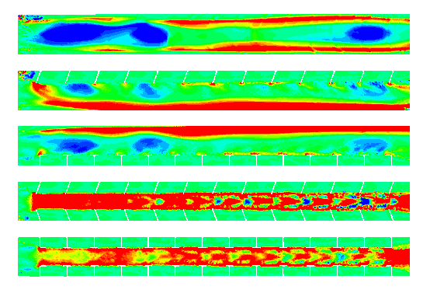
a
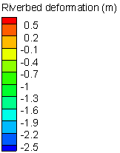
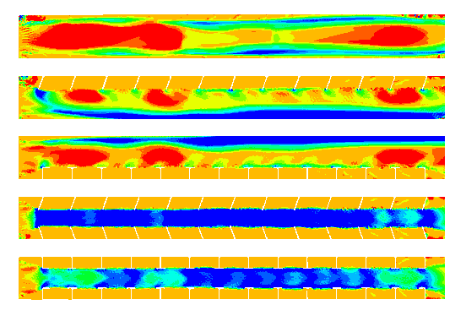
b
Figure 5.The riverbed substrate distribution prediction (a) and river bed evolution (b) in two and four years.

After the riverbank reconstruction restoration strategy has been applied in two and four years, HSI distribution for all tested cases is shown in Figure 6. HSI in the natural river and the river with a single-side river bank reconstruction decreases slightly during the long-term time series simulation. However, HSI of Case 4-5 in the middle of the river decreases significantly. Similarly, OSI and WUA for all five cases shrink with time period as shown in Figure 7. OSI for Cases 2 and 3 are 0.28 and 0.29 in 4 years, respectively. For Case 4 and 5, OSI is both close to 0.17. WUA also has the same trend for a single and two riverbanks reconstruction. For single riverbank reconstructions, HSP also keeps around 50% for Cases 2 and 3. HSP for river reconstructions on both banks is significantly lower than other cases, which are 13% and 16% for Cases 4 and 5, respectively. Therefore, installing spur dikes on a single riverbank is better than both banks, which can mitigate the negative influence of the river reconstruction and protect fish habitat.
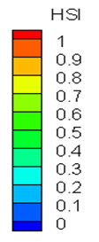
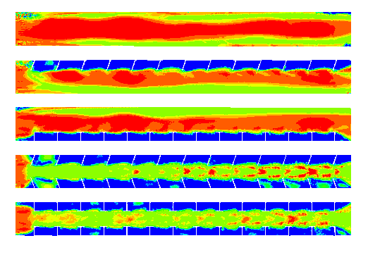
Figure 6.The habitat suitability index distribution of Chinese Sailfin Sucker (Myxocyprinus asiaticus) after the riverbank reconstruction restoration strategy has been applied.

0  1  2  3  4 | 4  0  1  2  3
Figure 7.The post-restoration effects of OSI and WUA after the riverbank reconstruction restoration strategy has been applied.

5 Conclusions
Modeled results indicate that by installing straight or T-shaped spur dikes on a single riverbank, habitat suitability level decreases slightly compared to that without riverbank reconstructions. Installing spur dikes on both riverbanks can substantially change the physical conditions of the river and reduce the habitat suitability level. The difference in fish habitat suitability level between the straight spur dikes and T-shaped spur dikes is tiny enough to be neglected. Installing spur dikes on both riverbanks for a long-term period can severely scour riverbed and degenerate the fish habitat suitability level. Installing spur dikes on a single riverbank has negligible influence on fish habitat suitability level which meets the ecological requirement of fishes.

References
- Chittoor Viswanathan, V. and Schirmer, M., “Water quality deterioration as a driver for river restoration: a review of case studies from Asia, Europe and North America”, Environmental Earth Sciences, Vol. 74, No. 4, (2015), pp 3145-3158.
- An, R., Li, J., Yi, W. M. and Mao, X., “Hydraulics and swimming behavior of schizothorax prenanti in vertical slot fishways”, Journal of Hydrodynamics, Vol. 31, No. 1, (2019), pp 169-176.
- Liedermann, M., Gmeiner, P., Glas, M., Tritthart, M. and Habersack, H., “Functionality of the tested river engineering measures within the pilot project Bad Deutsch-Altenburg at the Austrian Danube River”, Österr Wasser-und Abfallw, (2016).
- Hamilton, M., Nelson, S. V., Fernandez, D. P. and Hunt, K. D., “Detecting riparian habitat preferences in “savanna” chimpanzees and associated Fauna with strontium isotope ratios: Implications for reconstructing habitat use by the chimpanzee‐human last common ancestor”, American Journal of Physical Anthropology, Vol. 170, No. 4, (2019), pp 551-564.
- Yang, J. Q. and Nepf, H. M., “A turbulence‐based bed‐load transport model for bare and vegetated channels”, Geophysical Research Letters, Vol. 45, No. 19, (2018), pp 10-428.
- Massey, W., Biron, P. M. and Choné, G., “Impacts of river bank stabilization using riprap on fish habitat in two contrasting environments”, Earth Surface Processes and Landforms, Vol. 42, No. 4, (2017), pp 635-646.

tables:
Table 1 The optimal river ecological index values among all scenarios.
 | LSP | MSP | HSP | WUA (m²) | OSI
Case 1 | 50% | 8% | 42% | 1403 | 0.43
Case 2 | 58% | 6% | 36% | 1164 | 0.36
Case 3 | 57% | 6% | 37% | 1183 | 0.37
Case 4 | 76% | 4% | 20% | 663 | 0.21
Case 5 | 67% | 5% | 28% | 912 | 0.29
* LSP is the percentage of low HSI value; MSP is the percentage of middle HSI value; HSP is the percentage of high HSI value; WUA is the weighted usable area; OSI is overall suitability index.

Table 2 The river ecological index values among all scenarios with long-term effects.
 |  | LSP | MSP | HSP | WUA (m²) | OSI
2 years | Case 1 | 43% | 14% | 43% | 1340 | 0.41
 | Case 2 | 54% | 19% | 27% | 915 | 0.29
 | Case 3 | 53% | 18% | 29% | 974 | 0.30
 | Case 4 | 60% | 27% | 13% | 578 | 0.18
 | Case 5 | 61% | 23% | 16% | 627 | 0.19
4 years | Case 1 | 37% | 27% | 36% | 1317 | 0.40
 | Case 2 | 49% | 29% | 22% | 870 | 0.27
 | Case 3 | 49% | 26% | 25% | 940 | 0.30
 | Case 4 | 55% | 40% | 5% | 500 | 0.17
 | Case 5 | 54% | 40% | 6% | 526 | 0.18
* LSP is the percentage of low HSI value; MSP is the percentage of middle HSI value; HSP is the percentage of high HSI value; WUA is the weighted usable area; OSI is overall suitability index.

