THE EFFECTS OF ANTHROPOGENIC STRUCTURES ON THE ECOHYDRAULIC CHARACTERISTICS FOR MORTONAGRION HIROSEI HABITATING IN ESTUARINE WETLAND

GWO-WEN HWANG
Hydrotech Research Institute, National Taiwan University, No. 1, Sec. 4, Roosevelt Rd.
Taipei City 106, China

Hsin-Hua Yang
Hydrotech Research Institute, National Taiwan University, No. 1, Sec. 4, Roosevelt Rd.
Taipei City 106, China

The aim of this study is to explore the characteristics of flow and salinity affected by tidal gates for Mortonagrion hirosei habitating. The population of Mortonagrion hirosei, one species of Odonata emerging in brackish water area, living in the reeds of the tidal wetland. In 2005, it is the first time to find Mortonagrion hirosei which is near threatened species in the International Union for Conservation of Nature (IUCN) Red List in Wu-ku wetland of Tanshui River, Taiwan. The Society of Wilderness incessantly monitor the species and then detect that the number of Mortonagrion hirosei rapidly decreased from 2006 to 2014. Flow condition and salinity are considered the crucial factor of the habitat destruction and responsible for the loss of species. Therefore, this study conducted a tidal current investigation on January 4, 2022, from 7 o'clock to 19 o'clock (about one tidal cycle), using Acoustic Doppler Current Profiler (ADCP)-River Surveyor M9 for velocity and flow measurements. According to the results of tidal current investigation, the tidal cycle of the Wu-ku wetland is similar to the mouth of the Er-chong floodway. The variations of tidal range and salinity are affected by tidal gates of the Er-chong floodway. According to this study, the ecohydraulic characteristics of the habitat of Mortonagrion hirosei are analyzed, and the regulation mechanism of the tidal gates was established. The results of this study may enhance the comprehensive understanding of the tidal gates effects on flow and salinity characteristics and may also provide some guidance for restoration of Mortonagrion hirosei.

Introdution
Mortonagrion hirosei Asahina was listed as Endangered in the 1996 IUCN Red Book, and is now listed as Near Threatened [5]. Since Mortonagrion hirosei is only distributed in Guangdong, Japan, Hong Kong and Taiwan, etc., conservation and restoration are urgently needed. In 2005, after Taiwan's first discovery of the Mortonagrion hirosei in the Wu-ku Wetland of the Erchung Floodway, the Wilderness Conservation Association began monitoring the Mortonagrion hirosei. According to the monitoring data, the number of Mortonagrion hirosei has decreased significantly in recent years. According to the on-site observation of the monitoring personnel, the habitat of the Mortonagrion hirosei has undergone dramatic changes of siltation and drying up.
Since the adult period of the Mortonagrion hirosei is about 35 days, and it often inhabits the reeds above 20 cm high, the adult flight distance is less than 110m in its lifetime. The regeneration of the Mortonagrion hirosei requires high-salinity water and a puddle with a water depth of about 10 cm. and high density of reeds [4], it can be seen that the Mortonagrion hirosei is quite sensitive to the environment and has poor mobility. In early 2014, the sluice gate of the sluice was repaired, which prevented the tide water from flowing into the sluice by means of piping, which also caused the habitat of the Mortonagrion hirosei to gradually dry out, and the water depth of about 10cm could not be maintained.
In the renovation plan of the outlet weir, 4 new vertical gates will be installed. The main purpose is to introduce the tidal water of the Tanshui River into the Swamp Canal and provide the salty water body of the Wu-ku Wetland. Therefore, this study uses the method of on-site investigation to understand the characteristics of water flow and salinity changes outside the gates of the Erchung floodway and in Swamp Canal during the full tide survey. In the future, the simulation reference of hydraulic model and salinity model can be provided to facilitate the research and simulation of ladder rods. The gate operation mode is adopted to maintain the environmental quality of the habitat of the Mortonagrion hirosei.

Materials and Methods

Study Area
The Erchung Floodway, one of the most important measures of Taipei Flood Prevention System, was established to divide floodwaters. The specific goal of the Erchung Floodway is to divide 9,200 m3/s of floodwater from the Tanshui River under a 200-year recurrence flood event. This allows the Q200- Tanshui River to decrease from 23,500 to 14,300 m3/s. Since its completion, the Erchung Floodway has functioned successfully during ten flood events. [6]
The outlet weir (Figure 1) of the Erchung floodway was completed in December 1971, and 35 tidal gates were rebuilt in 1997. The main function is to prevent the backflow of the tidal water from the Danshui River, to protect the farmland around the upper reaches of the Swamp Canal, and to avoid the suffering of salt damage. In recent years, the basic plate of the outlet weir has been damaged to form a piping trough that runs through the upstream and downstream. This piping phenomenon allows the salty water body of the Tanshui River to enter the Wu-ku wetland of the Erchung Floodway at high tide, thus forming a habitat condition that the Mortonagrion hirosei prefers.
In 2013, both the inner and outer basic plates of the gate were damaged, and the erosion size was estimated to be 2,000m3, which may pose a hidden concern to the structural safety. Although the chutes at the bottom of the gate were repaired, piping continued to occur soon after. Since the piping provides the salty water body required by the Mortonagrion hirosei, if the piping is repaired, the habitat will be degraded. Therefore, the repair of the gate and the provision of the salty water body need to be considered at the same time.

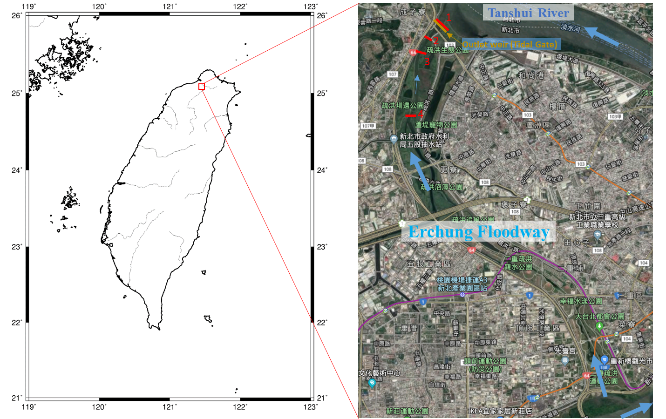

Figure 1. The map of the Erchung Floodway and the position of tidal current investigation

Field Investigation
In this study, the Acoustic Doppler Current Profile (ADCP) was used for the flow measurement of the full tide survey. The characteristic of ADCP is that when the ADCP is placed on the water surface, three-dimensional flow velocity data at multiple points on the vertical line below the water surface can be obtained at the same time. Due to the light weight of the ADCP, the vehicle can choose its size according to the needs. Therefore, even in shallow water areas, smaller hulls can be used for measurement, and in smaller rivers or shallow water areas, the method of pulling ropes by manpower is used. By moving ADCP, you can quickly obtain the real-time water depth, flow velocity, and bottom topography of the section, and with the flow velocity area method, the section flow information can be obtained [1]. For the survey of salinity, the method of artificial water intake is adopted. After the water body is taken ashore, the salinity measurement and analysis are carried out with a water quality meter. Carry out full tide surveys according to the following specifications:
- Select 4 sections for simultaneous total tide observation (including 1 outside the exit weir gate, and 3 upstream at Swamp Canal, as shown in stations 1, 2, 3, and 4 in Figure 1.

- Measurement content: Measurement items include cross-sectional area, cross-sectional stratified velocity, water level, flow, and salinity.
- Measurement frequency: 1 measurement per hour, at least 13 hours during the full tide survey.

Results and discussion
Figure 2 shows the water level changes at each station during the full tide survey of the Erchung Floodway. On January 4, 2022, the full-tide survey day was from 7:00 to 19:00 (including 7:00 and 19:00). Figure 2 shows that the outside of the gate changed greatly, and the water level was the lowest at 8:30 in the morning, about EL. -0.985 m, and then gradually increased. The water level rose to the highest at 13:00, about EL. 1.589 m, and at 19:00 at night, the water level was the lowest, about EL. -0.884 m.
According to the rainfall data during the 13-hour observation period (7 to 19:00 on January 4, 2022) of the full tide survey in the Erchung Floodway is 0 mm, so the effect of surface runoff on the actual flow caused by rainfall is not considered. influence. Figure 3 shows the full tide survey results of the Erchung Floodway. According to the general trend of tidal flow, it is related to the principle of tidal transmission. The closer it is to the Tanshui River, the greater the tidal flow. From the observation results, it can be seen that there is little difference in the change trend of the flow of the Erchung Floodway, so this trend cannot be seen. The maximum flow outside the gate (station 1) is 47.13 m3/s, the maximum flow of the station 2 is 34.14 m3/s, the maximum flow of the station 3 is 37.97 m3/s, and the maximum flow of the station 4 is 25.81 m3/s. The relevant flow information of each station is arranged as Figure 3. There is a correlation between tide level, flow velocity and tidal flow. From the arrangement of the average flow velocity of each station in Figure 4, it can be seen that the average flow velocity of each station increases significantly at 9:00 when the tide is high, and then gradually decreases with time, and the highest at the tide level The flow velocity is the smallest at the time of the tide, and the flow velocity is the fastest when the tide ebbs, until the next tide rises again. The salinity changes of each station are arranged as shown in Figure 5. The salinity of each station in the full tide survey of the Erchung Floodway is about 1.1 to 24.8 ppt, which is 33 to 35ppt lower than the seawater salinity. It can be seen from the figure 5 that the salinity of each station increases with the higher the tide level, and the salinity decreases significantly after the ebb tide.
The tidal hydrology and salinity characteristics of the outside of the weir gate and swamp canal can be known from the results of this full tide survey, which can be used as the basic data for subsequent hydraulic and salinity simulations.
Considering the public's needs for traffic, recreation and landscape of the Erchung Floodway, the authority agency plans to renovate the gate in 2020, add a vertical gate and adjust the terrain next to the road. The vertical gate can moderately regulate the introduction of tide water, and avoid road flooding affecting traffic during high tide. Among them, the renovation of the gate and the newly added operation part of the vertical gate will affect the ecological environment of Wu-ku Wetland. Therefore, it is necessary to conduct a hydrological environment and ecological survey, and establish the basic background information of hydrology and ecology before the renovation of the gate, so as to facilitate the water flow Analysis of physical model verification, salinity simulation and ecological impact assessment, evaluation of the changes in the habitat characteristics of Wu-ku wetland after the renovation of the planned outlet weir gate, and the zoning of the future habitat characteristics of Wu-ku wetland and the development of management strategies. [2] [3]

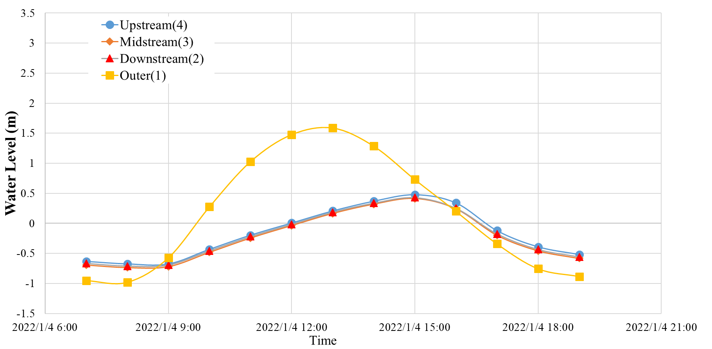
Figure 2. The measurement results of water level in the full tide survey.

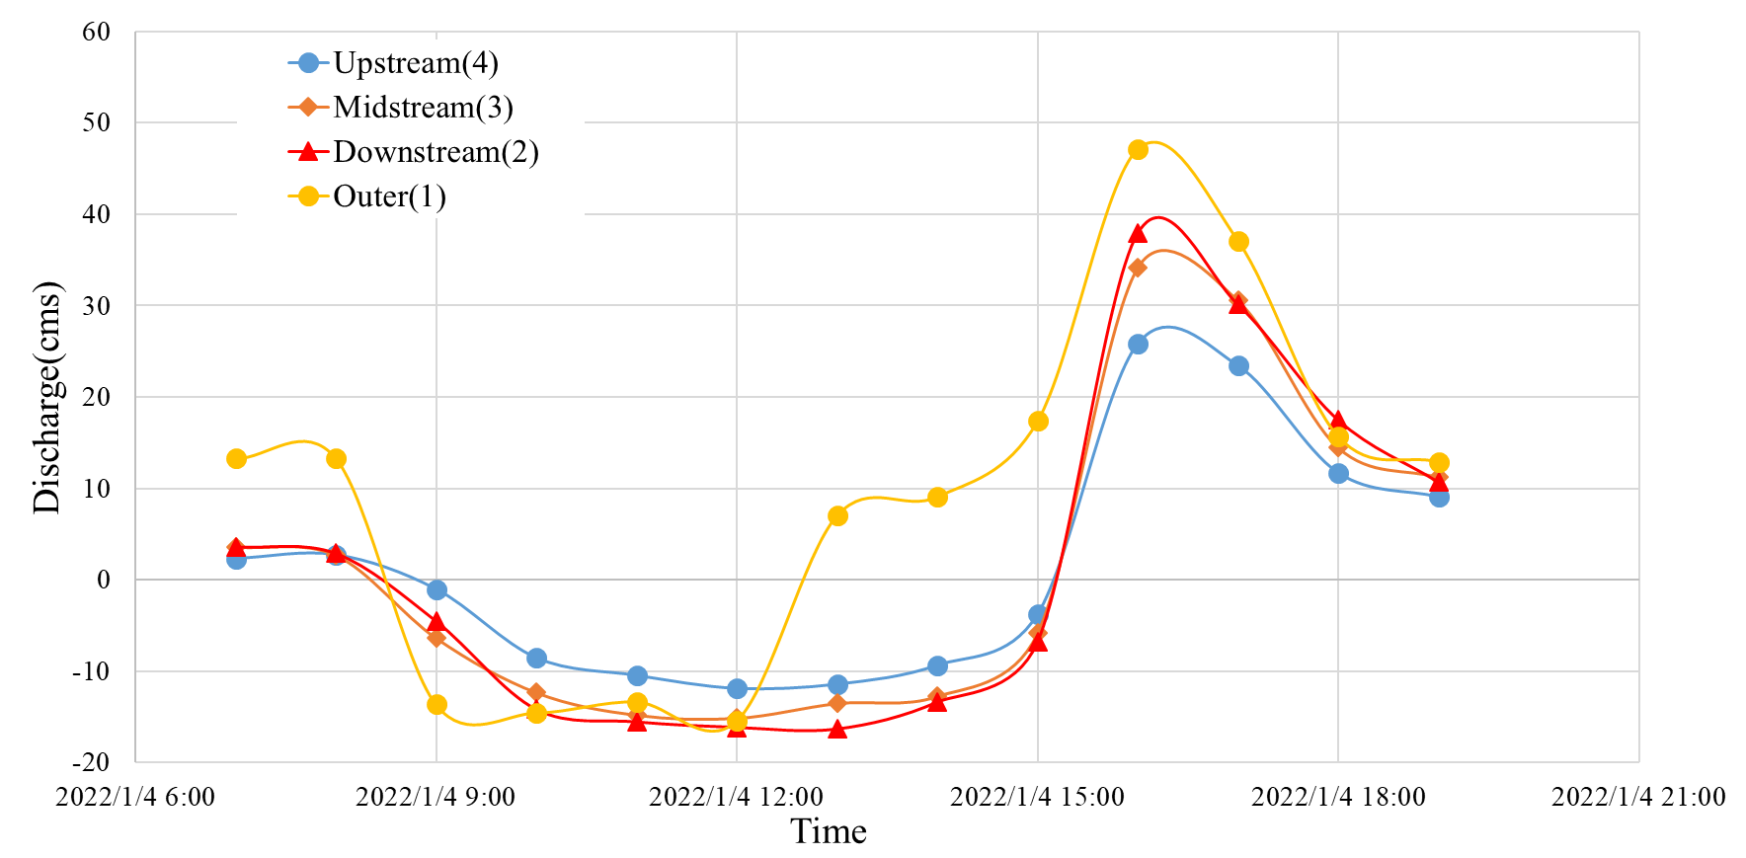

Figure 3. The measurement results of discharge in the full tide survey.

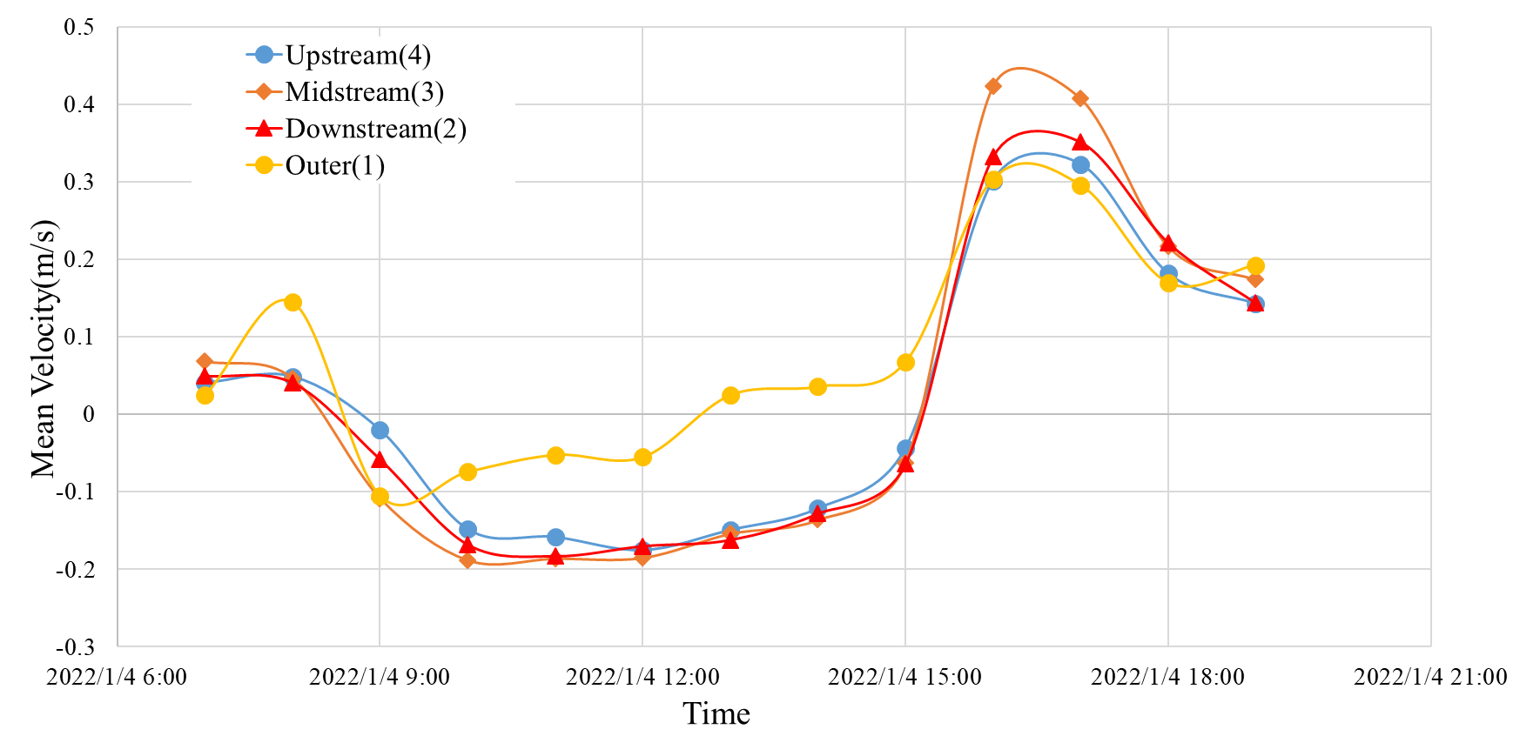

Figure 4. The measurement results of mean velocity in the full tide survey.

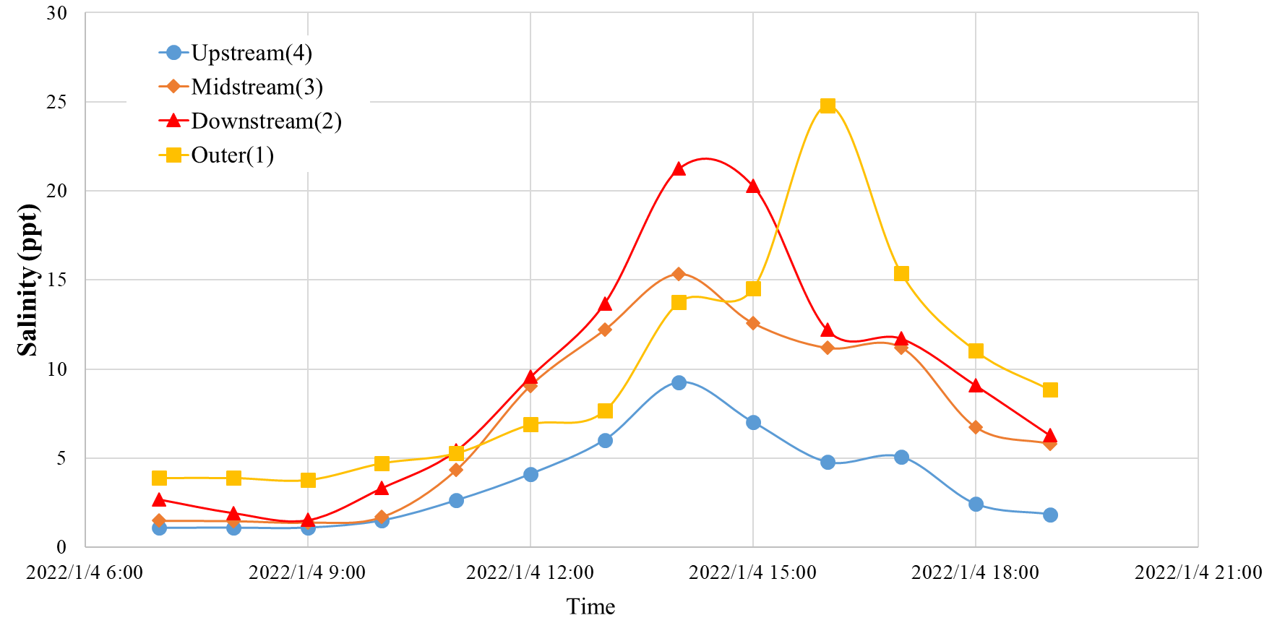

Figure 5. The measurement results of salinity in the full tide survey.

Acknowledgments
First and foremost, we would like to appreciate all the contributors, in particular the Society of Wilderness for investigation activity. Thank you to New Taipei City Government and Ministry of Science and Technology for the funding spent on projects.

REFERENCES

- Chow, V. T., Open-channel hydraulics. McGraw-Hill Book Co. (1959), New York.
- Freeman, G. E., W, J. Rahmeyer and R. R. Copeland. Determination of Resistance Due to Shrubs and Woody Vegetation (2000), US Army Corps of Engineering.
- Huang, S.C., S.S. Shih, Y.S. Ho, C.P. Chen, H.L. Hsieh. Restoration of Shorebird-roosting Mudflats by Partial Removal of Estuarine Mangroves in Northern Taiwan, Restoration Ecology 20(1), (2012),pp 76-84.
- Watanabe M. and Y. Mimura. Population dynamics of Mortonagrion hirosei(Odonata: Coenagrionidae). International Journal of Odonatology 6(1) , (2003) pp65-78.
- Wilson, K.D.P. & Reels, G. 2013. Mortonagrion hirosei. The IUCN Red List of Threatened Species. Version 2014.3. <www.iucnredlist.org>. Downloaded on 15 April 2015.
- Shih, S.-S., S.-C. Yang, H.-T. Ouyang, Anthropogenic effects and climate change threats on the flood diversion of Erchung Floodway in Tanshui River, northern Taiwan, Natural Hazards 73(3), (2014), pp 1733-1747.

