EVALUATION OF THE IMPACT OF DRAINAGE CHANNEL ON FLOOD FLOW IN THE URBAN-RURAL LANDSCAPE

KAZUAKI OHTSUKI
Graduate Faculty of Interdisciplinary Research, University of Yamanashi, 4-3-11 Takada Kofu-shi, Yamanashi 400-8511, Japan

JUN NISHIHIRO
Center for Climate Change Adaptation（Climate Change Impacts Monitoring Research Section）, National Institute for Environmental Studies, 16-2 Onogawa
Tsukuba-shi, Ibaraki 305-8506, Japan

HIROKI KATO
Graduate School of Science, Toho University, 2-2-1 Miyama Funabashi-shi, Chiba 247-8510, Japan

KEIGO NAKAMURA
Japan RiverFront research Center, 1-17-24 Shinkawa Chuo-ku, Tokyo 104-0033, Japan

Wetlands are not only the most ecologically important habitat, but also a typical green infrastructure with multi-purpose functions such as flood mitigation and water purification. However, the channelization of watersheds for agricultural development has accelerated flood runoff and increased the vulnerability of watersheds due to the urbanization of low-lying areas that has occurred at the same time. In recent years, however, agricultural lands have been seriously abandoned, and waterways remain as a negative legacy. In this study, the potential of abandoned farmland for flood mitigation was examined by clarifying channel development and flood runoff acceleration in a rural watershed in the suburbs of Tokyo. The results showed that the peak flood discharge in 1975 was more than 10% lower than that in the current channel condition, and the estimated damage in a medium to large flood could be about 3% lower than that in the current condition.

INTRODUCTION
Wetlands is one of a typical green infrastructure with multipurpose functions such as flood mitigation and water purification [1]. Monsoon wetlands are developed by humans into rice paddies and serve as important production sites, as well as play a role in flood mitigation [2] the process of increasing productivity to satisfy the historical need for food production, wetlands were channelized to dry out. In Japan, the conversion of wetlands into drylands has been progressing at an extremely rapid rate since around the 1970s. However, due to production adjustments caused by food imports and a declining population, much of the farmland that has been developed is being abandoned. The development of watershed channels has resulted in increased peak flood flows and faster arrival times [3], but abandoned farmland has not been blocked despite years of abandonment, and the existence of waterways has become a major negative legacy (Figure 1). As a result, the ecosystem services provided by wetlands, such as biological ecology, flood control, and water purification, cannot be properly enjoyed. Abandonment of cultivation is a nationwide issue [2].
This study aims to quantify the flood control effect of wetland restoration by reverse development of waterways as a nature-positive flood control measure in a watershed with valleys, which is a representative natural landscape of rural areas in the suburbs of the Tokyo metropolitan area. The characteristics and distribution of developed channels were clarified through field surveys, and the runoff-inundation process was reproduced by an integrated model of runoff, channel flow, and inundation flow. The runoff and inundation volumes generated for each chronological condition of the watershed were estimated.
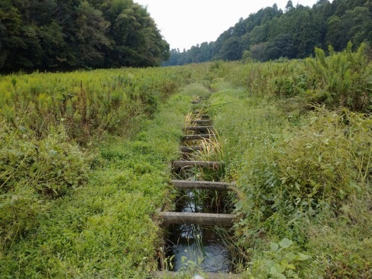

Figure 1. Channel in abundant paddy field.

METHODS

Site descriptions
Takasaki River (Basin area: 85.71 km2, Figure 2) flowing into Lake Inbanuma is chosen as a study site. Its watershed consists of higher flat plateaus and low- lying narrow dendritic valleys called Yatsu. The plateau is mainly used for field cultivation and the valley for rice paddies, while urban areas and industrial complexes have been develope. The current land use ratio in the watershed is 33.4% cropland, 22.7% forest, 15.7% building lots, 9.0% paddy fields, 6.6% urban areas, and 12.8% road. Lake inbanuma has an issue on eutrophication due to the discharge of high concentrations of nutrients derived from fertilizer application to cropland.
Traditional rice paddies were in the Yatsu landscape and were fed by spring water from the slope toes. The drainage channels were shallow to pass the water from paddy to paddy. They were improved by land consolidation around 1970s burned well-developed drainage channels. Later, due to production adjustments and low production efficiency, cultivation was gradually abandoned from the valley head area.

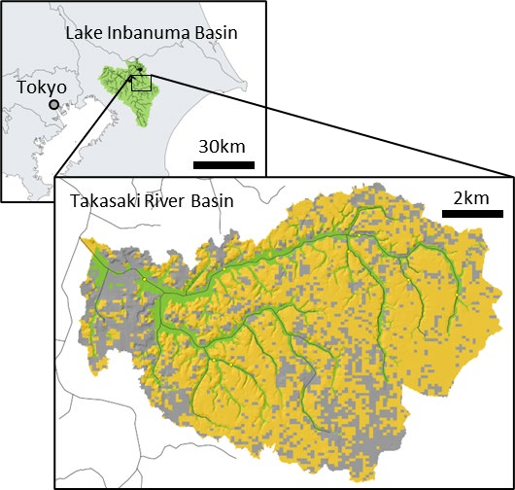

Figure 2. Maps and current land use of study site, Takasaki River basin.

Investigations of field data
Channel geometry (width, depth and bank height) and type (treated and untreated cover) were investigated at 99 points in the target basin. The relationship between channel size and basin area was formulated by power expression. The distribution of channel and land use on the valley bottom were spatially identified using aerial photographs of different periods in 1940s, 1970s, 1980s and 2019. The existence of channels were determined by their visibility from the photographs obtained by GSI website.
Water level was observed continuously at 9 stations in the three target catchments since 2020. Time-laps video camera were also set to measure velocity and H-Q relation were developed with the data. Obtained hydrograph were used for model validation.

Model descriptions
The Rainfall-Runoff-Inundation (RRI) model was applied to the site. The model a 2D grid cell-based hydrodynamic model capable of simulating for both rainfall runoff and flood inundation processes [4] (Figure 3). All model grid cells receive rainfall, and the model tracks the flow. This 2D model also simulates vertical infiltration based on the Green-Ampt model. The flow inside a river channel is computed with the built-in 1D diffusive wave model, whose lateral inflow and outflow or overbank flow are estimated by coupling with the 2D land model. The flow interaction between the river channel and slope is estimated at each time step depending on water-level and levee-height conditions.
In this study, the land was divided into 30m-interval grids and applied ground height from 5m-mesh LiDAR- based digital elevation model by GSI. Model parameters of RRI model are mainly related to roughness, channel dimension and infiltration. Roughness and infiltration parameters were obtained by plateau (cropland), valley bottom (paddies) and urban area. Impervious conditions were applied to the urban areas, and slope roughness was lowered in the rice paddies in the flooded areas. The channel parameters and distribution were set based on the in-situ relation described 2.2.

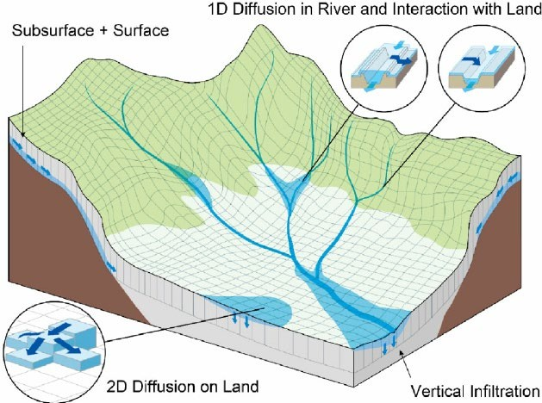

Figure 3. Model illustration (Sayama et al., 2012)

Evaluation of flood mitigation
To evaluate the flood mitigation function of the dechannelizing for different rainfall events, the design storms for 5-year to 200-year return periods were generated using the alternating block method from intensity–duration– frequency (IDF) curves.
For the channel distribution conditions, the information for the three ages (1947, 1975, and 1986) shown in Figure 4 was applied. Case-1947b, which includes tributaries flowing through the urban area downstream of the watershed, was also added.
For an objective comparison of damage, the maximum inundation depths for each mesh were organized by thresholds in all the conducted cases. The potential damage costs for residential, paddy, and cropland areas were estimated by a simplified method proposed by Kazama et al. (2009) [5] based on the official manual. For simplicity, only house damage was treated for residential area damage, and the building occupancy rate was assumed to be 10%.

RESULTS AND DISCUTTIONS

Land consolidation, channelization, and field abandonment progress
As shown in Figure 4, in 1948, almost all the valley floor was occupied by traditional fine rice paddies; in 1975, about half of the downstream area had been improved; in 1986, rice paddies deeper in the valley that had not been improved were being abandoned. As land improvement progressed, the waterway was extended.
The channel width is underestimated, and the water depth (channel height) is overestimated compared to the relationship between flow rate, river width, and water depth in natural rivers. The total length of the channel doubled from the 1940s to the 1970s due to field development.

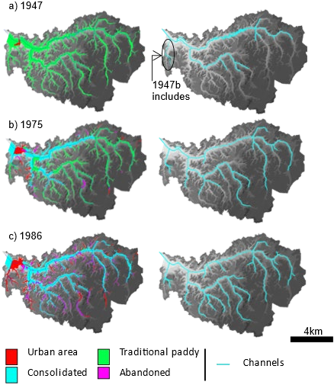
Figure 4. Historical changing in land use (left) and channels in Yatsu small valley landscape (right).

Model validation
The hydrograph was estimated from the H-Q equation at nine water level observation points, and the parameters were adjusted to fit the hydrograph. The Nash coefficient at the outlet was 0.7, which indicates the validity of the model.

Impact of channelization on flood mitigation effects

Peak flow rate
Figure 5 shows rate of maximum flow reduction at outlet point in each simulation. The water level dropped quickly in the abandoned and culverted catchment, just like in the urban catchment. On the other hand, the water level in the abandoned but untreated channel decreased more slowly than in the other basins, suggesting a temporary storage effect in the basin. In case of extreme flood (200y), flow rate is significantly decrease because of increasing riverine flood inundation.

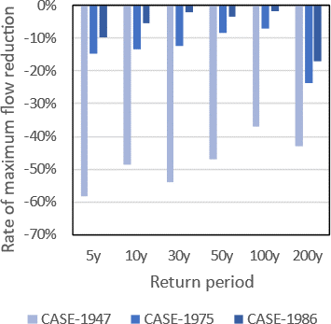

Figure 5. Rate of maximum flow reduction for each flood levels.

Potential damage costs
Figure 6 shows estimated potential damage difference against no measure situation in each level of floods. Because the differences based on the current land use and simulated inundation depth, they tend to be high in case of old channel condition. They decrease in conditions of case-1975 compared to case-1947.
Figure 7 shows changes in potential damage cost in residential area on Yatsu valley bottom. The black line indicates baseline data for current channel and land use condition. The graph shows result for case- 1975 (yellow) is lower than case-2019 in case of middle (return period >30 years) and extreme levels of flood. This result was caused by the channelization and urbanization of the lowlands. Therefore, wetland restoration by reverse engineering of channelization has a potential for flood mitigation.

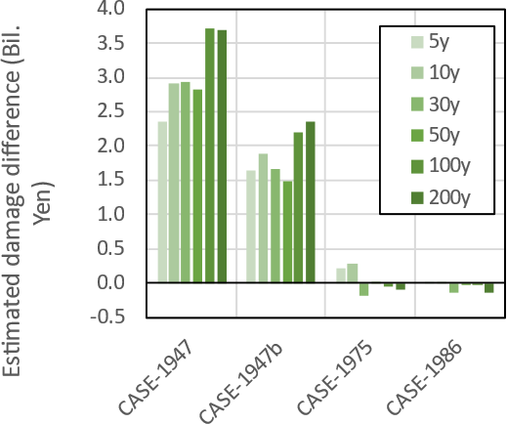

Figure 6. Estimated damage cost for each level of flood extent.

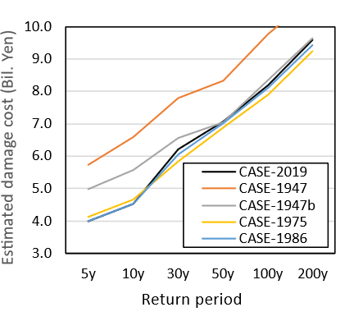

Figure 7. Estimated damage in residential area in Yatsu small valley bottom

ACKNOULEDGEMENT
This research was performed by the Environment Research and Technology Development Fund JPMEERF20202001 of the Environmental Restoration and Conservation Agency of Japan.

REFERENCES

- Stefanakis, A. I. (2019). The role of constructed wetlands as green infrastructure for sustainable urban water management. Sustainability, 11(24), 6981.
- Osawa, T., Nishida, T., & Oka, T. (2021). Potential of mitigating floodwater damage to residential areas using paddy fields in water storage zones. International Journal of Disaster Risk Reduction, 62, 102410.
- Yoshikawa, N., Nagao, N., & Misawa, S. (2010). Evaluation of the flood mitigation effect of a Paddy Field Dam project. Agricultural Water Management, 97(2), 259-270.
- Sayama, T., Tatebe, Y., & Tanaka, S. (2017). An emergency response‐type rainfall‐runoff‐inundation simulation for 2011 Thailand floods. Journal of Flood Risk Management, 10(1), 65-78.
- Kazama, S., Sato, A., & Kawagoe, S. (2010). Evaluating the cost of flood damage based on changes in extreme rainfall in Japan. In Adaptation and mitigation strategies for climate change (pp. 3-17). Springer, Tokyo.

