ecological risk assessment of TOXIC METALS in water of PERAI RIVER, MALAYSIA

MUHAMMAD FITRI MOHD AKHIR
River Engineering and Urban Drainage Research Centre, Universiti Sains Malaysia
Nibong Tebal, 14300 Penang, Malaysia

DANIAL NAKHAIE MOHD SOUKHRI
River Engineering and Urban Drainage Research Centre, Universiti Sains Malaysia
Nibong Tebal, 14300 Penang, Malaysia

MUHAMMAD ZAKI MOHD KASIM
River Engineering and Urban Drainage Research Centre, Universiti Sains Malaysia
Nibong Tebal, 14300 Penang, Malaysia

NOR AZAZI ZAKARIA
River Engineering and Urban Drainage Research Centre, Universiti Sains Malaysia
Nibong Tebal, 14300 Penang, Malaysia

NOOR AIDA SAAD
River Engineering and Urban Drainage Research Centre, Universiti Sains Malaysia
Nibong Tebal, 14300 Penang, Malaysia

Perai River has been recognized as an additional raw water resource for Penang state. Inadequate waste management can lead to river pollution. River water contamination with metals such as light and heavy metals and metalloid is a global concern that negatively impacts human, plant and aquatic life. Therefore, this paper aims to evaluate the potential sources and impacts of toxic metals at downstream of the Perai River basin. There were 15 sampling points located at possible pollution sources and a sample at the river outfall. In the dry season, samples were taken in two different tidal: low and high tide. According to spatial distribution analysis, Al and Hg levels were observed to be higher than the standard limits during low tide. Meanwhile, Al, As, Hg and Se were significant during high tide. Significant contamination of Al was noticeable upstream during low and even high tide. Pollution of Al and Hg may have started beyond the research zone, as the concentrations were highest upstream during low tide. Low tide causes many pollutants to be flushed into the sea, followed by a backflow force into the river during high tide. As, Hg, and Se concentrations started high at the downstream and gradually decreased as they moved upward. Overall, the Perai River is severely polluted with Al and Hg. Al and Hg have a significant negative impact on the ecological system. Government authorities must take steps to resolve this issue in order to protect the river ecosystem and prevent human health problems.

INTRODUCTION
Toxic metal contamination has increased dramatically due to industrialization, urbanization, population growth, and technological advancements. The sources occur through natural/geogenic/lithogenic and anthropogenic activities [1]. Furthermore, natural events such as soil erosion, air deposition, earthquakes, tornadoes, weathering of metal-bearing rock, and volcanic eruption can result in heavy metal dispersion in groundwater and surface water. Most cases of heavy metal pollution come from industrial effluent. In limited amounts, some heavy metals are necessary for the human body. It is termed micronutrient trace elements. The elements are vanadium (V), manganese (Mn), iron (Fe), cobalt (Co), copper (Cu), zinc (Zn), selenium (Se), strontium (Sr) and molybdenum (Mo).
On the other hand, some heavy metals [lead (Pb), chromium (Cr), cadmium (Cd), and mercury (Hg)] and metalloid [arsenic (As)] can lead to biological toxicity even in part per billion concentrations [2]. It is even worse when heavy metals accumulate in human food sources like animals and plants, posing a silent threat to consumers. Heavy metals are the most persistent pollutants in the aquatic system because they are non-destructive and non-biodegradable [3]. On the one hand, light metal such as aluminum (Al) is high biologically reactive and toxic to human, plant, and aquatic life [4]. Metals are not the same as organic matter, which degrades spontaneously. It cannot be destroyed in the environment and only change its form or become attached or separated from particles. River impairment is caused by the accumulation of toxic metals in the river's water column, sediment, and aquatic species.
Perai river is the largest and longest river in Penang, Malaysia, with a surface area of 447.824 km2 and a length of 45 km long. This river is categorized as a preserved water catchment since the raw water supply of this state primarily depends on the Muda River [5]. The headwater of the Muda River is in the neighboring state, Kedah and flows downstream to the state of Penang. Since 2010, there have been significant political disagreements about water intake authority and charges between the two states [6]. Therefore, as an alternate water source for Penang, the river should be protected against contamination as a future resource. This paper aimed to evaluate the potential pollution sources and impacts of metals at the tributaries and main drainage in the downstream area of the Perai River.

methods

Study area and sampling
In the Perai River, sixteen sampling points with fifteen potential sources (PS) of metals pollution and an outfall were examined, as shown in Figure 1. The fifteen PS consisted of 3 tributaries and 12 significant drains directly draining into the main river. The sampling was conducted during the dry season with different tides: low and high tides.

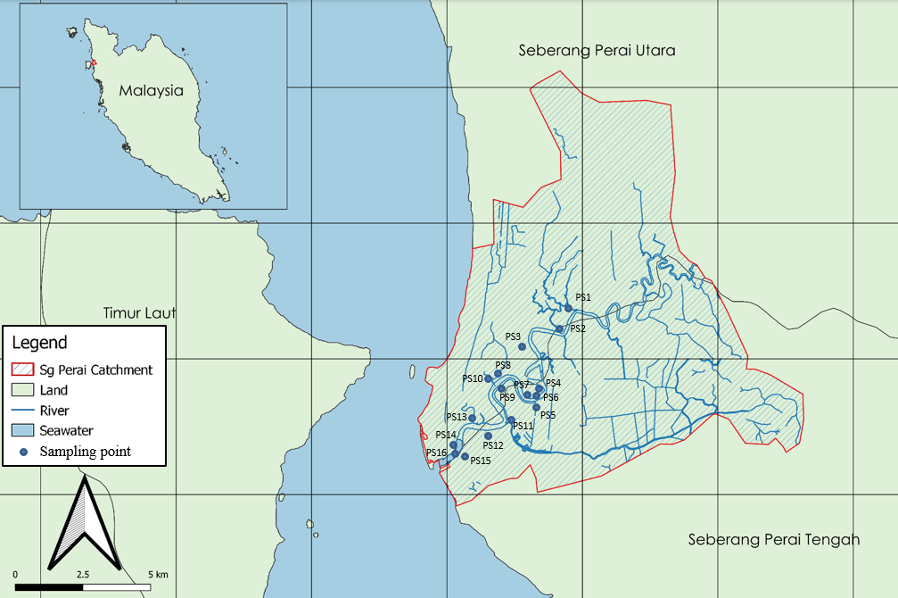

Figure 1. Potential sources of toxic metals.

Spatial distribution analysis of metals
The samples taken from the 16 sampling points were put into 50 ml centrifuge tubes and kept in an icebox before being transported to the lab. The samples were immediately preserved using 2% of nitric acid. Then all samples were filtered via 0.45-micron microfiber syringe filters for coupled plasma optical emission spectroscopy (ICP-OES) analysis. The ICP analysis was conducted within two days. ICP-multi element standard solution IV 23 standard elements were used as a standard to analyze the toxic metals. The results from the analysis were compared to the National River Water Quality Standard (NRWQS) (as in Table 1) for determining the significant toxic metals in the river.

Table 1. NRWQS for Malaysia.

Elements | Permissible concentration limit (ppm)
Al | 0.06
As | 0.05
Hg | 0.001
Se | 0.01

The concentration results were then used as input data for spatial distribution analysis using ArcGIS Pro. The analysis process was followed via this method: import data from excel to csv format → join and relates with the sampling location → spatial analyst tools → kringing. The data classification was used geometrical interval method for classifying symbology interval.

RESULTS AND DISCUSSION

Toxic metals distribution during low tide
All the sampling points were detected during the low tide containing toxic metals that exceeded the permissible limit NRWQS except for PS11, as shown in Figure 2. Al mainly was found at the potential sources. The highest value was 1.026 ppm at PS3 and the permissible limit in rivers based on NRWQS is 0.06 ppm. Al is the most abundant metal in the Earth's crust, approximately 8.1% but is rarely found uncombined in nature. It is also one of the lightest metals in the world. It can be found in igneous rocks as aluminosilicates in feldspars, feldspathoids, and micas; in the soil as clay; and as bauxite and iron-rich laterite after further weathering. According to the Malaysia geological map, the study region is clay and silt marine. It is not possible for Al to naturally occur in marine geological.
In addition, several complaints about releasing alum sludge from water treatment plants into the Perai River were addressed [7]. Alum sludge is a by-product of the coagulation process in water treatment plants, where aluminum sulphate or poly-aluminum chloride is utilized. The water treatment residue has been released since 1973 and undoubtedly increased the Al concentration in the Perai River. Al also was detected a high concentration at the outfall due to the legal dumping in the river. Based on the spatial distribution analysis of the Al contamination in Figure 3, it was concentrated at the PS3. Theoretically, the river flows from upstream to downstream during low tide. Yet, the pattern revealed that the source of Al pollution might be further upstream than the research region, as the concentration remained high at over 0.248 ppm in the most upstream area. Therefore, it was believed that Al pollution was done by the water treatment.
Apart from the Al contamination, the most severe worry is that significant mercury (Hg) quantities were discovered at eight sampling points. Hg is one of the most severe contaminants in river water because it is a potent neurological poison in fish, wildlife, and humans. Even in small amounts, mercury may cause serious health problems. The NRWQS for mercury is 0.001 ppm. Despite this, the maximum mercury concentration was discovered in the middle of the research area (PS10), at 1.104 ppm. The difference between the standard limit and the actual value was too significant. PS8 and PS10 are the most densely populated areas in terms of industrial activity. According to the spatial analysis of Hg distribution, Hg was distributed from the most upstream, began to dilute until the middle of the research region, and then began to increase again. However, Hg was diluted until below the standard at the outfall. In conclusion, the potential source of Hg may be found in the indicated area upstream, downstream, and even beyond the research zone. Even though it was diluted before flushing out to the sea, the concentration of Hg may accumulate in the sea and can return to the river during high tide.

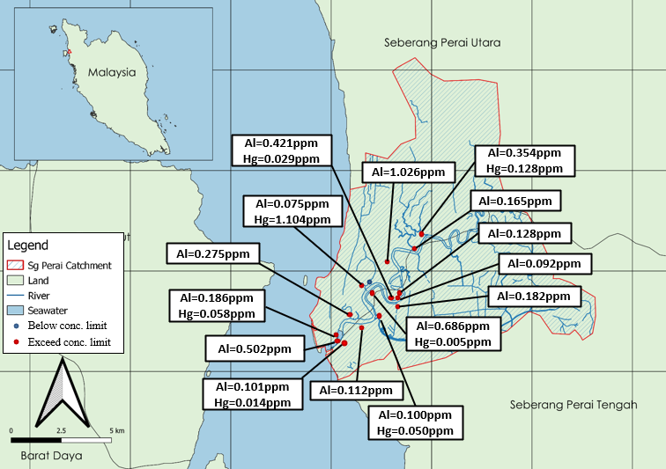

Figure 2. Exceed concentration limit of toxic metals in certain areas during low tide.

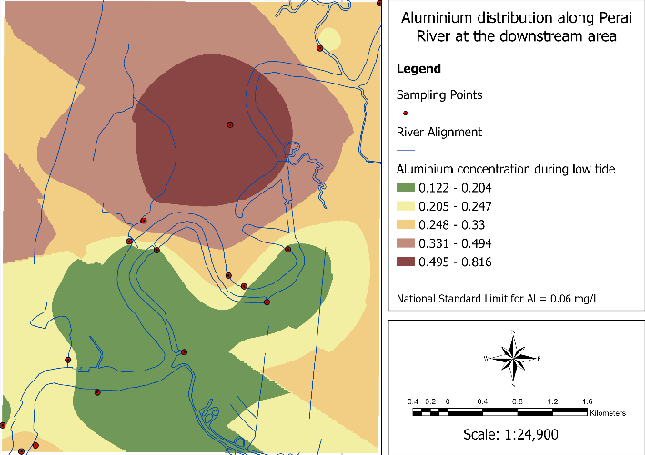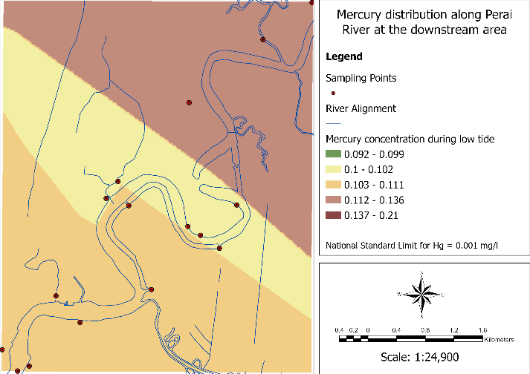

Figure 3. Al and Hg distribution in Perai River during low tide.

Toxic metals distribution during high tide
All probable sources had metal pollution exceeding the NRWQS acceptable limit during the high tide, as shown in Figure 4, except for PS11. As was the case at the low tide, Al was mostly discovered near probable sources. During high tide, as in Figure 5, river water flowed backwards from downstream to upstream, causing Al pollution in the upstream area to worsen. Because Al is frequently released at the upstream location during low tide and possible during high tide, as previously stated, the pollutant was not flushed out into the sea and remained concentrated at the upstream area.
From the As and Se spatial distribution pattern, the pollutants began in the downstream area and were then spread upstream due to backflow. Referring to the concentration of As in Figure 4, only two sampling points exceeded the permissible limit and the cause of the As dispersed upstream. On the other hand, most of the downstream area was affected by Se pollution and distributed to the upstream. The spatial distribution pattern of Se illustrated that the pollution was concentrated in the outfall area and dispersed upstream. Moreover, Se pollution was also not found during the low tide season. Therefore, the possibility of Se from the seawater invaded into the river during the high tide was strongly significant.
During the hide tide, mercury was the second most prevalent contaminant. According to the spatial distribution of Hg in Figure 5, Hg from the sea entered the river and was diluted until it reached the upstream. This was due to the fact that during low tide, river water washed out the pollution and dispersed back into the river during high tide. It was not the same circumstance as Al, where the distribution began upstream due to alum sludge discharge during high tide. The Hg discharge, on the other hand, occurred at low tide only.

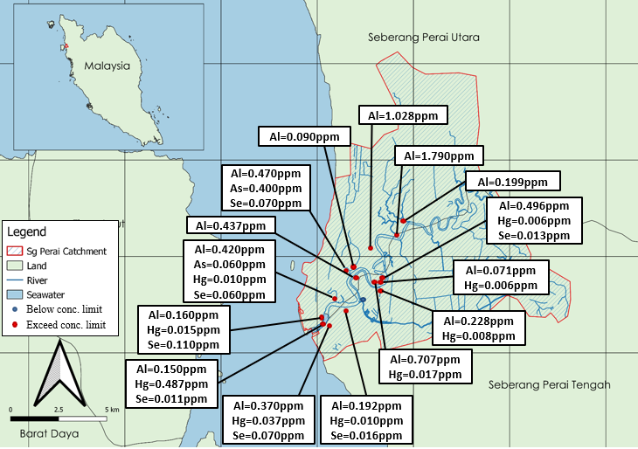

Figure 4. Exceed concentration limit of toxic metals in certain areas during high tide.

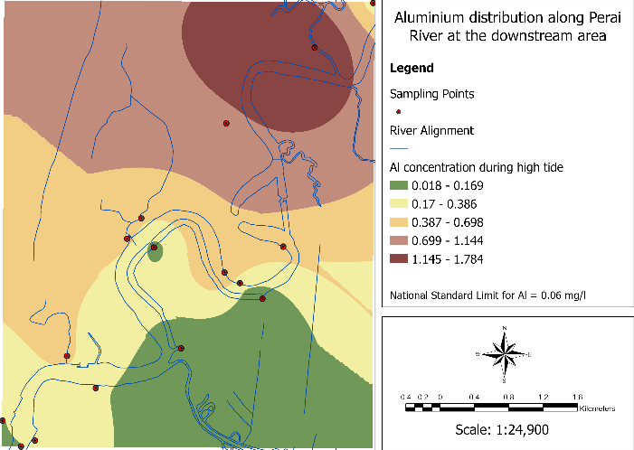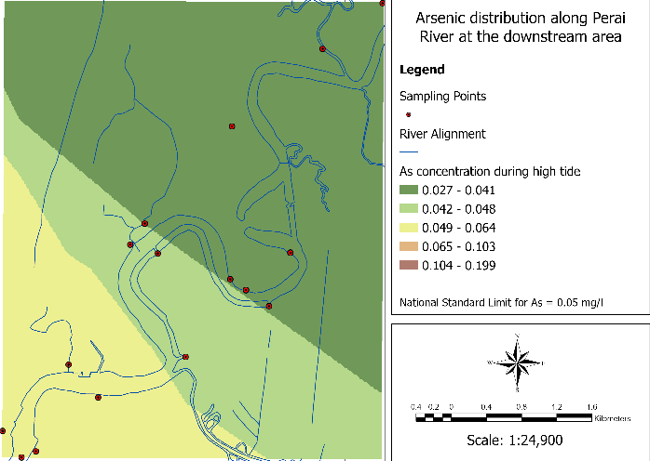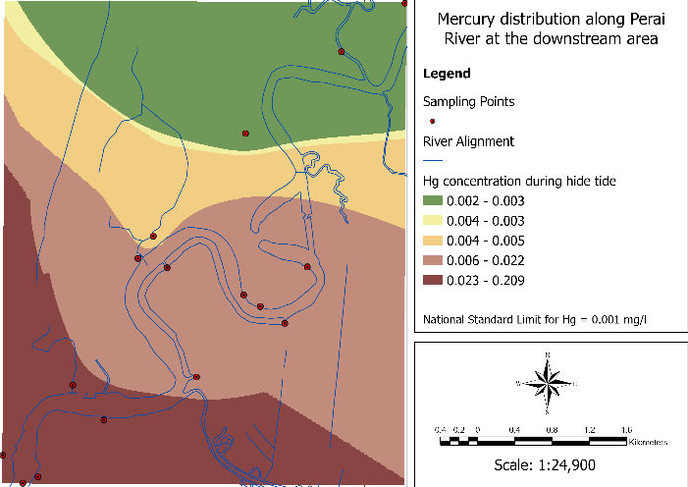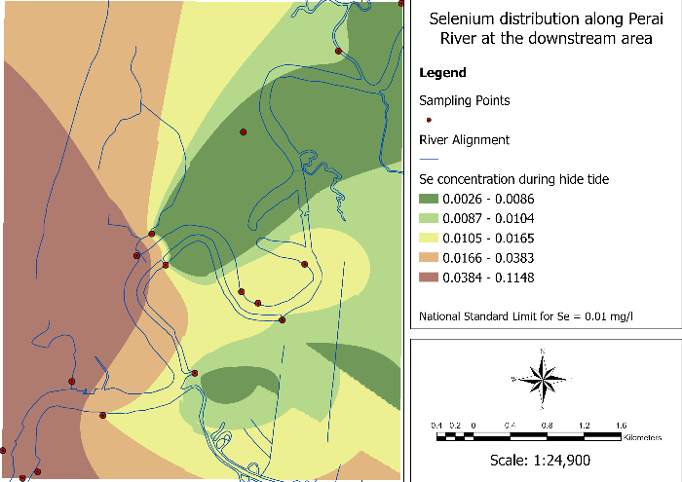

Figure 5. Al, As, Hg, and Se distribution in Perai River during low tide.

Risk assessment of aluminium, arsenic, mercury and selenium toward the human, plant, and aquatic life
Based on the significant pollutants during low and hide tide, it concluded Al, As, and Hg distribution came from the anthropogenic activities at Perai River. Some plants and aquatic life can tolerate those toxic metals at a certain concentration value. Commonly aquatic plants are generally less sensitive than fish and other aquatic life to toxic metals. Table 2 shows the compilation of the threshold limit of Al, As and Hg. Exceeding these limits may harm or, even worse, can cause fatal.
(As) concentration in the Perai River was below the critical for plant and chronic value for aquatic life. On the other hand, Al was over the chronic value for aquatic life at locations PS3 and PS9 during low tide, while high tide at locations PS2, PS3, and PS7. Hg, the most toxic heavy metal in the environment, was found to exceed the limit of plant and aquatic life in certain areas.

Table 2. Acute value and concentration limit of metals for low tolerance plant and aquatic life.

Elements | Acute value and concentration limit for low tolerance plant | References | Chronic value and concentration limit (total recoverable) for aquatic life | References
Al | 2.0 | [8] | 0.63-3.2 | [9]
As | 5.0 | [10] | 0.34 | [11]
Hg | 0.08-2.6 | [12] | 0.0014 | [11]
Se | 1.0 | [13] | 0.0031 | [13]

Al toxicity in freshwater species has been extensively researched in aquatic vertebrates. Adverse respiratory effects predominate at pH values between 6.0 and 8.0, which could be attributed to the deposition of precipitated Al on the gill surface [14]. Al polymerization on the fish gills most likely generates a physical clogging effect, resulting in hypoxia and osmoregulation failure [15]. As the interlamellar gaps get clogged and mucus secretion increases, water flow over the respiratory surface decreases, and the diffusion barrier for gases and ions thickens [16].
From the mechanisms above, Raj et al. [17] found freshwater fish Clarias Batrachus exposed to Al pollution at neutral condition pH 7.0 promotes histopathological alterations in the liver (loss of cytoplasm, loss of centrilobular, loss of central canal, loss of hepatic cell, cytoplasmic vacuolation, necrosis of hepatic cells) and kidney (expansion of Bowman's loss of renal tubules, narrowing of tubular lumen, damage of hematopoietic cells, clustering of hemosiderin pigments, clustering of kidney cells, and glomerulus vacuolation). Al also can accumulate in the nervous system of aquatic vertebrates, leading to neurotoxic [15]. It can be responsible for oxidative stress [18]. This is as well the critical adverse effect of Al exposure on humans in terms of neurotoxicity. In a review on the health effects of Al exposure provided by Klotz et al. [19], patients with high Al levels in their plasma and brain tissue proved disorientation, memory problems, and dementia in advanced stages.
Hg has no beneficiary effects on plants and organisms, yet it gives toxicity even at low concentrations. The most serious health hazard of Hg exposure is neurotoxicity [20]. Methylation is the most crucial step in the mercury cycle because it considerably enhances toxicity and the potential for accumulation in aquatic organisms [21]. Methylmercury makes up most of the Hg detected in fish tissue [22]. Methylmercury is easily absorbed into the bloodstream and dispersed throughout all tissues, as well as crossing the ordinarily protective blood-brain barrier to enter the brain. It can also easily pass via the placenta to growing foetuses and their developing brains. Thus, pregnant women and women of childbearing age should be particularly concerned. Low-level exposure has been associated with learning problems in children and reproductive issues in fish-eating animals. Hg poisoning can cause a wide range of health problems in humans, including neurological, renal, gastrointestinal, genetic, cardiovascular, and developmental abnormalities, as well as mortality [23].
Increased Hg levels in the soil have a number of detrimental consequences for plant growth and metabolism [24]. Reduced photosynthesis, transpiration, water intake, chlorophyll synthesis, and lipid peroxidation are some of the effects [25]. The prominent toxic effect of Hg on plants is the generation of reactive oxygen species such as superoxide anion radicals (H₂O₂) and hydroxyl radicals (OH) [24]. Enzymatic antioxidants and some nonenzymatic antioxidants, such as glutathione, phytochelatin, salicylic acids, ascorbic acid, selenium, proline, and tocopherols, are among the detoxification processes used to counteract Hg-induced oxidative stress [26]. Based on the previous discussion of toxic metals in the Perai River, Se was dispersed into the river because of seawater intrusion via high tidal. Because selenium acts as an enzymatic antioxidant to protect plants from Hg-induced oxidative stress, it's possible that therefore plants along the Perai River's banks can tolerate high levels of Hg.

CONCLUSION
Perai River is highly polluted with Al and Hg even during low tide or hide tide. Pollution of Al and Hg may have started beyond the research zone, as the concentrations were highest upstream. Hg is one of the most severe contaminants in river water because it is a potent neurological poison in fish, wildlife, and humans. The highest concentration of Hg was found at 1.104ppm and exceeded the limit of NRWQS, critical value for low tolerance plants and acute value for aquatic life. Al pollution from the release of the water treatment sludge can accumulate into the sediment and severely affect the river's water quality. Al was found to exceed the NRWQS limit for most of the probable sources. Even the plants at the Perai River could survive the Al concentration condition, but not for aquatic life. Al polymerization on the fish gills most likely generates a physical clogging effect, resulting in hypoxia, osmoregulation failure, neurotoxicity, and oxidative stress. Human toxicity on Al exposure also experiences neurotoxicity that leads to disorientation, memory problems, and dementia in advanced stages.
Hg has no beneficiary effects on human, plant, and aquatic life, yet it gives toxicity even at low concentrations. Mercury poisoning can cause a wide range of health problems in humans and aquatic life, including neurological, oxidative stress, and developmental abnormalities. Meanwhile, increased mercury concentration in the soil has several detrimental consequences for plant growth and metabolism. Ignorance of the increase of Al and Hg may be worsening the river ecosystem and leading to human health problems. Therefore, the authorities should immediately take prevention, rehabilitation, and remediation actions for future water resources as the Perai River is an alternative source for the Penang water supply.

ACKNOWLEDGEMENT
Ministry of Higher Education Malaysia fully funded this project under grant FRGS/1/2019/TK01/USM/03/1.

REFERENCES

- H. Ali, E. Khan, and I. Ilahi, "Environmental chemistry and ecotoxicology of hazardous heavy metals: Environmental persistence, toxicity, and bioaccumulation," Journal of Chemistry, vol. 6730305. Hindawi Limited, pp. 1–14, 2019. doi: 10.1155/2019/6730305.
- M. Balali-Mood, K. Naseri, Z. Tahergorabi, M. R. Khazdair, and M. Sadeghi, "Toxic Mechanisms of Five Heavy Metals: Mercury, Lead, Chromium, Cadmium, and Arsenic," Frontiers in Pharmacology, vol. 12. Frontiers Media S.A., p. 643972, Apr. 13, 2021. doi: 10.3389/fphar.2021.643972.
- J. Briffa, E. Sinagra, and R. Blundell, "Heavy metal pollution in the environment and their toxicological effects on humans," Heliyon, vol. 6, no. 9. Elsevier Ltd, p. e04691, Sep. 01, 2020. doi: 10.1016/j.heliyon.2020.e04691.
- I. O. Igbokwe, E. Igwenagu, and N. A. Igbokwe, “Aluminium toxicosis: A review of toxic actions and effects,” Interdisciplinary Toxicology, vol. 12, no. 2, pp. 45–70, 2020, doi: 10.2478/intox-2019-0007.
- S. N. Syed Feisal Barakbah, “PBAPP has contingency plans following the latest SPRWTS Scenario,” PBAPP Media Release, Jul. 03, 2022. https://pba.com.my/pdf/news/2022/7-3-2022_PBAPP_SPRWTS_Contingency.pdf (accessed Jul. 17, 2022).
- A. Dermawan, "Federal govt hopes for understanding in Penang raw water issue," News Strait Times, Mar. 22, 2022. Accessed: Jul. 15, 2022. [Online]. Available: https://www.nst.com.my/news/nation/2022/03/782157/federal-govt-hopes-understanding-penang-raw-water-issue
- P. Nambiar, “Alarm over ‘alum sludge’ from water treatment plant,” Free Malaysia Today News, George Town, May 07, 2021. [Online]. Available: https://www.freemalaysiatoday.com/category/nation/2021/05/07/alarm-over-alum-sludge-from-water-treatment-plant/
- Office of Solid Waste and Emergency Response, "Ecological Soil Screening Level for Aluminum Interim Final," Pennsylvania Avenue, 2003.
- A. J. Wildeman, "Final aquatic life criteria for aluminum in freshwater," Federal Register, vol. 83, no. 245, pp. 65663–65665, Dec. 2018, [Online]. Available: http://www.epa.gov/dockets.
- [7] R. bhadauria, "Arsenic toxicity: an overview," Horticulture International Journal, vol. 3, no. 1, pp. 20–22, Jan. 2019, doi: 10.15406/hij.2019.03.00106.
- U.S. Environmental Protection Agency, "National Recommended Aquatic Life Criteria table," National Recommended Water Quality Criteria, May 20, 2022. https://www.epa.gov/wqc/national-recommended-water-quality-criteria-aquatic-life-criteria-table (accessed Jul. 15, 2022).
- Office of Water Regulation and Standards Criteria and Standards Division, "Ambient Water Quality Criteria for Mercury," Washington, Oct. 1980.
- Office of Water, "Aquatic Life Ambient Water Quality Criterion for Selenium-Freshwater 2016," Washington, Aug. 2021.
- R. W. Gensemer et al., "Evaluating the effects of pH, hardness, and dissolved organic carbon on the toxicity of aluminum to freshwater aquatic organisms under circumneutral conditions," Environmental Toxicology and Chemistry, vol. 37, no. 1, pp. 49–60, Jan. 2018, doi: 10.1002/etc.3920.
- A. Botté, M. Zaidi, J. Guery, D. Fichet, and V. Leignel, "Aluminium in aquatic environments: abundance and ecotoxicological impacts," Aquatic Ecology, Jan. 2022, doi: 10.1007/s10452-021-09936-4.
- K. Rani, Aluminium induced physiological and biochemical changes in freshwater fish Cyprinus Carpio Var. Communis," Doctor of Philosophy, Bharathiar University, Coimbatore, 1999. Accessed: Jun. 03, 2022. [Online]. Available: http://eprints.cmfri.org.in/7416/1/B154_Rani_Palaniswamy_Thesis_Aluminium_induced_physiological....pdf
- A. Raj, R. Panchal, and S. Rani, "Histopathological changes in liver and kidney of catfish, clarias batrachus exposed to aluminium," International Journal of Zoology and Applied Biosciences, vol. 3, no. 2, pp. 220–223, 2018, doi: 10.5281/zenodo.1314258.
- S. M. Cantanhêde et al., "Evaluation of cardiotoxicity in Amazonian fish Bryconops caudomaculatus by acute exposure to aluminium in an acidic environment," Aquatic Toxicology, vol. 242, Jan. 2022, doi: 10.1016/j.aquatox.2021.106044.
- K. Klotz, W. Weistenhöfer, F. Neff, A. Hartwig, C. van Thriel, and H. Drexler, “The health effects of aluminum exposure,” Deutsches Arzteblatt International, vol. 114, no. 39, pp. 653–659, Sep. 2017, doi: 10.3238/arztebl.2017.0653.
- U. Okereafor, M. Makhatha, L. Mekuto, N. Uche-Okereafor, T. Sebola, and V. Mavumengwana, "Toxic metal implications on agricultural soils, plants, animals, aquatic life and human health," International Journal of Environmental Research and Public Health, vol. 17, no. 7, Apr. 2020, doi: 10.3390/ijerph17072204.
- Water School Science, "Mercury Contamination of Aquatic Environments |," U.S. Geological Survey Official Website, Nov. 13, 2018. https://www.usgs.gov/special-topics/water-science-school/science/mercury-contamination-aquatic-environments (accessed Jun. 01, 2022).
- S. Romero-Romero, E. García-Ordiales, N. Roqueñí, and J. L. Acuña, "Increase in mercury and methylmercury levels with depth in a fish assemblage," Chemosphere, vol. 292, p. 133445, Apr. 2022, doi: 10.1016/j.chemosphere.2021.133445.
- New Hampshire Department of Environmental Services, "Mercury: Sources, Transport, Deposition and Impacts," New Hampshire, 2019. Accessed: Jun. 02, 2022. [Online]. Available: https://www.des.nh.gov/sites/g/files/ehbemt341/files/documents/2020-01/ard-28.pdf
- R. Azevedo and E. Rodriguez, "Phytotoxicity of Mercury in Plants: A Review," Journal of Botany, vol. 2012, pp. 1–6, May 2012, doi: 10.1155/2012/848614.
- A. Asati, M. Pichhode, and K. Nikhil, "Effect of Heavy Metals on Plants: An Overview," International Journal of Application or Innovation in Engineering & Management (IJAIEM), vol. 5, no. 3, pp. 56–66, 2016, [Online]. Available: www.ijaiem.org
- R. S. Dubey, "Reactive Oxygen Species and Antioxidants in Higher Plants," in Reactive Oxygen Species and Antioxidants in Higher Plants, S. Dutta Gupta, Ed. New Hampshire: CRC Press, 2012, pp. 177–202. Accessed: Jun. 02, 2022. [Online]. Available: https://books.google.com.my/books?hl=en&lr=&id=C4HRBQAAQBAJ&oi=fnd&pg=PA177&dq=The+prominent+toxic+effect+of+Hg+on+plants+is+the+generation+of+reactive+oxygen+species+such+as+superoxide+anion+radicals+(H2O2)+and+hydroxyl+radicals+(OH)&ots=sikVOCidCz&sig=zFIh8vBQ-UlZtFGLrzgChND8BgQ&redir_esc=y#v=onepage&q&f=false

