Using Airborne LiDAR Bathymetry-aided transfer learning method in riverine land cover classification

Shijun PAN
Graduate School of Environmental and Life Science, Okayama University
Tsushima-naka 3-1-1, Kita-ku, Okayama 700-8530, Japan

Keisuke YOSHIDA
Graduate School of Environmental and Life Science, Okayama University
Tsushima-naka 3-1-1, Kita-ku, Okayama 700-8530, Japan

Takashi KOJIMA
TOKEN C. E. E. Consultants Co., Ltd.
Kitaotsuka 1-15-6, Toshima-ku, Tokyo 170-0004, Japan

In recent years, due to the increase of flooding caused by global climate change and the rapid development of artificial intelligence (AI) technology, hydraulic researchers have started to try to cope with the land cover classification (LCC) problem aided by deep learning (DL) techniques. To clarify the vegetation distribution in Asahi River, Japan, this study firstly utilized a DL-based DeepLabV3+ model for semantic segmentation of aerial plane-derived orthophoto. Although this orthophoto-based (RGB-based) method has advantages in producing LCC mapping, how to create reliable true label (TL) mapping efficiently is still a complex issue that this method is confronting with. Especially, in the process of creating TL maps, facing certain parts where fieldwork by labors is not possible, like hazardous field observation environments. And at the same time, maybe aerial photographs are not enough to extract the feature of the land cover, like grass and bamboo. Based on this mentioned situation, airborne laser bathymetry (ALB) datasets including voxel-based laser points (n) and digital surface model data minus digital terrain model data (l), can be reference of creating TL maps. Except of the TL map reference, we also modified the existing DeepLabV3+ model by connecting data at its result output port to access ALB datasets, including n and l, is named as RGBnl-based method. This paper mainly concentrates on how to classify riverine land cover using orthophoto with the aid of the ALB dataset. In this study, an orthophoto of the corresponding area needs to be selected in advance, an orthophoto is synthesized by the corresponding coordinates (middle of the first pixel in the upper left corner), and finally the redundant part of this aerial photograph is whitened. As an experience of distributing DL dataset, this orthophoto needs to be divided into three parts (pixel ratio of 8:1:1): train-, valid- and test-part. The results show that the RGB-based and RGBnl-based methods are 0.89, 0.84 and 0.88, 0.84 in terms of overall accuracy and macro F1 scores derived from test-part confusion matrix, respectively. Therefore, this also concludes that our TL map is more plausible for both methods.

Introduction
In recent years, the global warming crisis has caused frequent extreme and record-breaking flooding events worldwide. One of these challenges, in the lower Asahi River, Okayama Prefecture, Japan, our target study site, which was hit by extreme flooding with a discharge of approximately 4,500 m³ s⁻¹ in early July 2018. The target river reached record water levels due to riparian vegetation, such as dense woody and bamboo forests [1]. Therefore, proper LCC mapping is necessary to estimate the flow resistance parameters attributed to riparian vegetation in the flood model. In view of the previously described problems, we have tried the DeepLabV3+ model [2] to predict the LCC utilizing the RGB information only, is RGB-based method, and we got relatively good result. Simultaneously, the procedure of generating the LCC mapping is with the assist of training model under supervised by TL mapping. Incidentally, TL mapping was made by the researchers who have the experience of field work and observing the aerial photographs [3]. This study was conducted to investigate a transfer learning method related on RGB-based method for LCC mapping in riparian areas considering ALB-based voxel laser points (n) and vegetation heights (l), is RGBnl-based method.

In the current study, ALB measurements include over land and under water bed elevation measurements using Near-Infrared (NIR) and green lasers. Futhermore, during the LiDAR campaign, aerial photographs were also taken, and combined as one orthophoto after the flight for measurement. Eventually, this study uses the RGB from orthophoto for RGB-attached method, both orthophoto and LiDAR data for RGBnl-based method to assess the LCC, respectively.

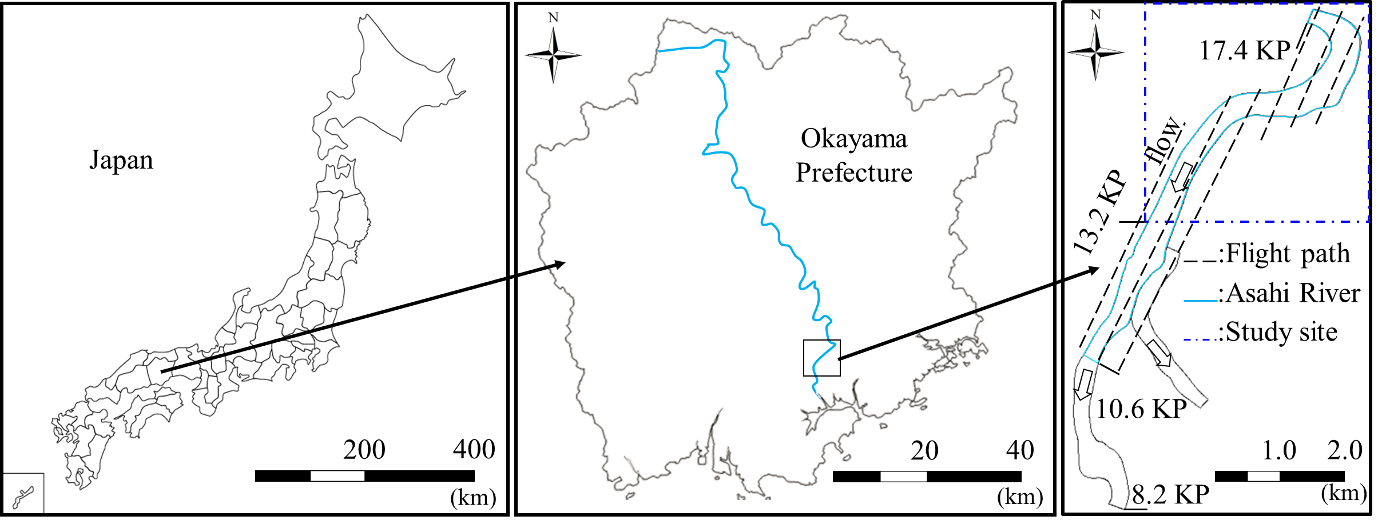

Figure 1. Perspective of targeted research area, location of the Asahi River in Japan with the kilometer post (KP) values representing the longitudinal distance (km) from the river mouth.
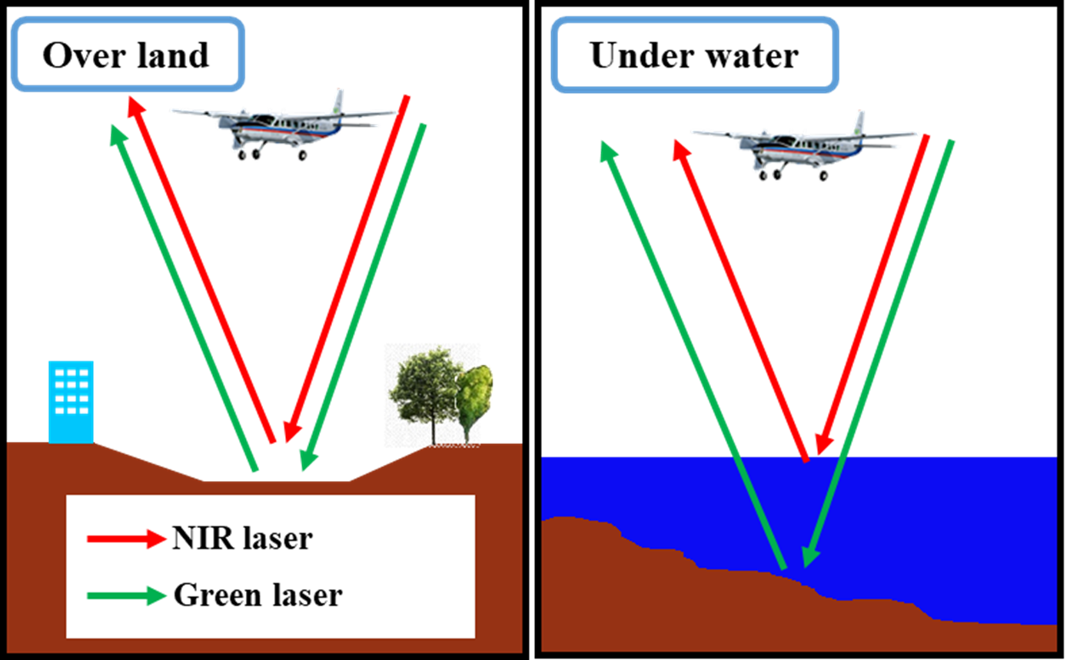

Figure 2. Airborne laser bathymetry system using a Near-Infrared (NIR) laser for overland surveys and a green pulsed laser for underwater surveys.

study site and methods

Study site
In this study, we conducted ALB (Leica Chiroptera II; Leica Corporation) surveys in March 2017 along a 4.5-km reach of the lower Asahi River (13.2 to 17.4 KP) controlled by the national government. Figure 1 shows that multiple flight operations were carried out in leaf-off (March 2017) condition to achieve overlapping coverage of the target area.

Data collection
Figure 2 performs that, the current system scanned the river channel for LCC using aircraft-mounted near-infrared and green lasers. The device commonly uses the green laser to detect underwater (bottom) surfaces, as greenlight can penetrate the water column to some extent. By contrast, the NIR laser is used to detect terrain surfaces, including vegetation, because it is easily reflected by the air-water interface. Additionally, during each ALB measurement, a digital camera mounted directly beneath the aircraft took aerial photographs of the target river. It is important to note that the brightness of aerial photographs can vary due to cloud movement, solar radiation, and time differences in flight paths. Post-processing by increasing the contrast value can reduce the brightness difference of the images.

Table 1 Specifications of the present ALB system and measurement conditions in the targeted river reach.

Item |  |  | Measurement dates of  ALB and Aerial photographs
 |  |  | Mar. 2017
Equipment  specifications | Laser wavelength  range (nm) | NIR¹⁾ | 1,064
Equipment  specifications | Laser wavelength  range (nm) | Green | 515
Measurement specifications | Number of laser beams (s⁻¹) | NIR | 148,000
Measurement specifications | Number of laser beams (s⁻¹) | Green | 35,000
Measurement specifications | Ground altitude (m) |  | 500
Measurement specifications | Flight speed (km h⁻¹) |  | 220
Measurement specifications | Density of measurement points (m⁻²) | NIR | 9.0
Measurement specifications | Density of measurement points (m⁻²) | Green | 2.0
Photograph  specifications | Resolution  (cm pixel⁻¹) |  | 10
Water quality | Turbidity²⁾ (degree³⁾) |  | 2.9
1). Near-Infrared;
2). Ministry of Land, Infrastructure, Transport and Tourism hydrological water quality database (Asahi River, Otoide Weir);
3). One degree of Japan Industrial Standard (JIS K0101) is the same as when 1 mg of standard substance (kaolin or formazine) is contained in 1 L of purified water.
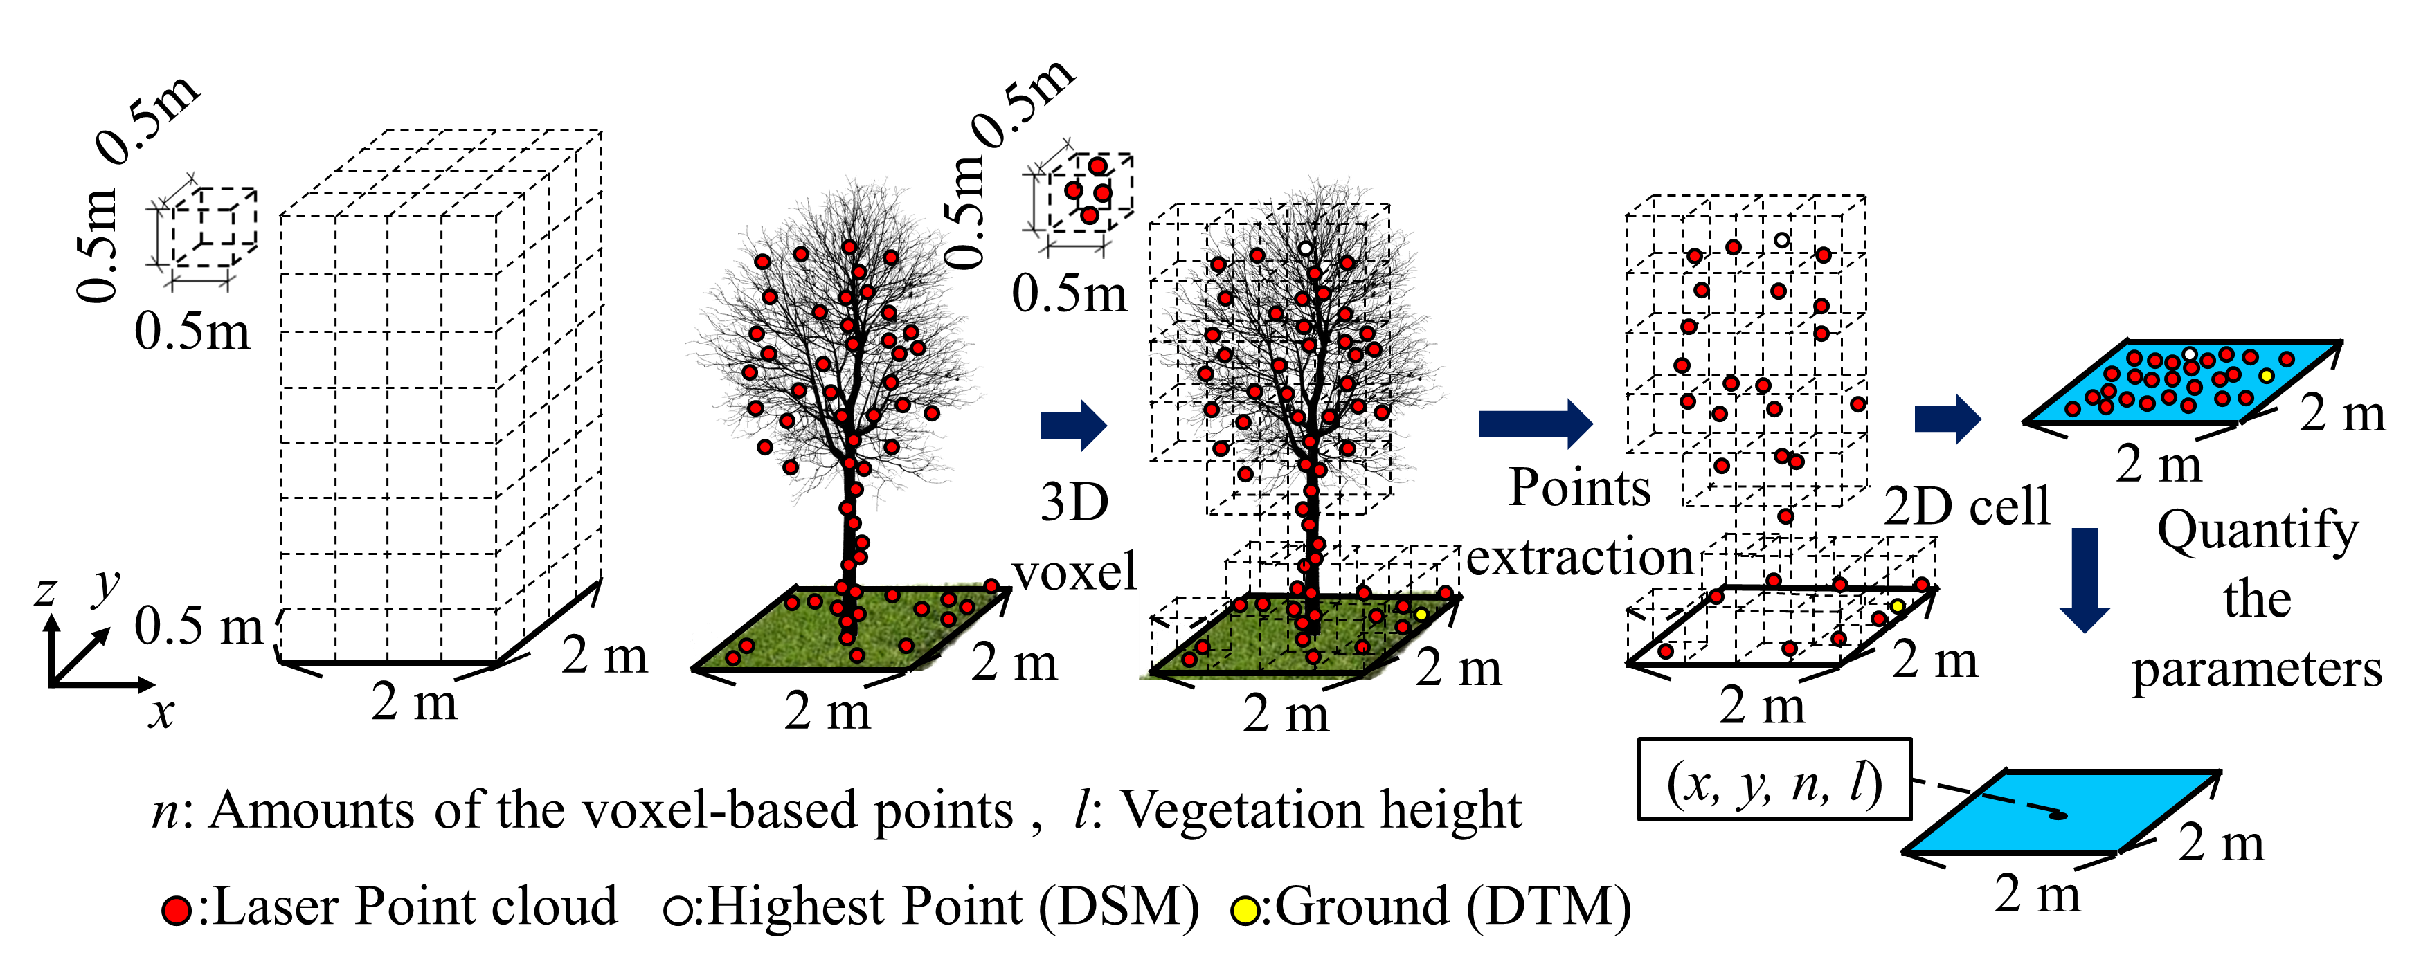

Figure 3. Airborne laser bathymetry system using a NIR laser for overland surveys and a green pulsed laser for
underwater surveys.

Table 1 shows the specifications of the equipment, measurement parameters, and river water quality at the time of the measurements. Because the magnitude of turbidity in a river can significantly impact the amount of light incident into the water column, its value was confirmed before each ALB measurement, and the water quality was enough for measuring the surface of underwater terrain.

Data processing
Subsequently, Figure 3 depicts the ALB data processing, beginning with establishing a Cartesian grid in the target domain comprised of three-dimensional (3-D) voxels. Each voxel has a side length of 0.5 m and can only hold one laser point. Then, instead of using all of the points in each voxel, we only keep the highest ones (to reduce the impact of overlapping and side-lapping). To be used as a parameter in subsequent two dimensional (2-D) flood simulations, a horizontal 2-D cell that could contain all of the laser points in the processed 3-D voxel was created. The points in each 2-D cell are referred to as n. We found the ground (riverbed or digital terrain model, DTM) after such processing by filtering the point cloud data near the lower part of the 2-D cell.
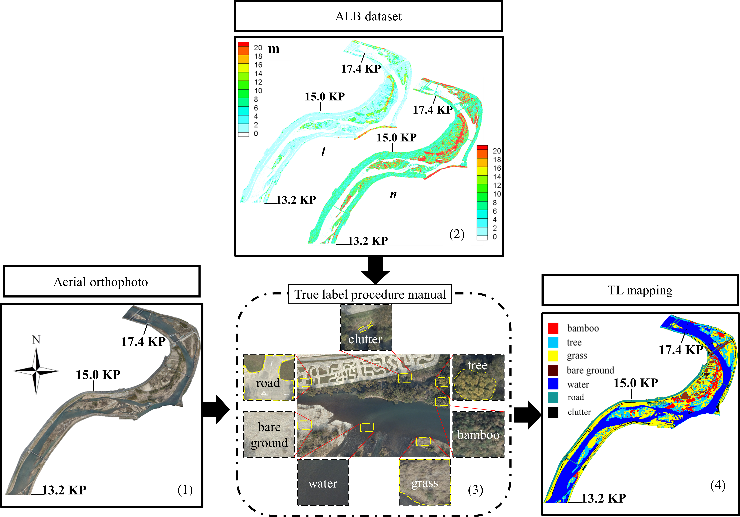

Figure 4. Process of producing TL mapping with following 4 steps, (1) combine multiple aerial photographs as
one orthophoto and whiten the excess part; (2) observe the orthophoto by personnel with field inspection experience and compare it with the ALB data, including n and l for checking the uncertain part; (3) make a TL mapping procedure manual; (4) produce TL mapping with the aid of the manual.

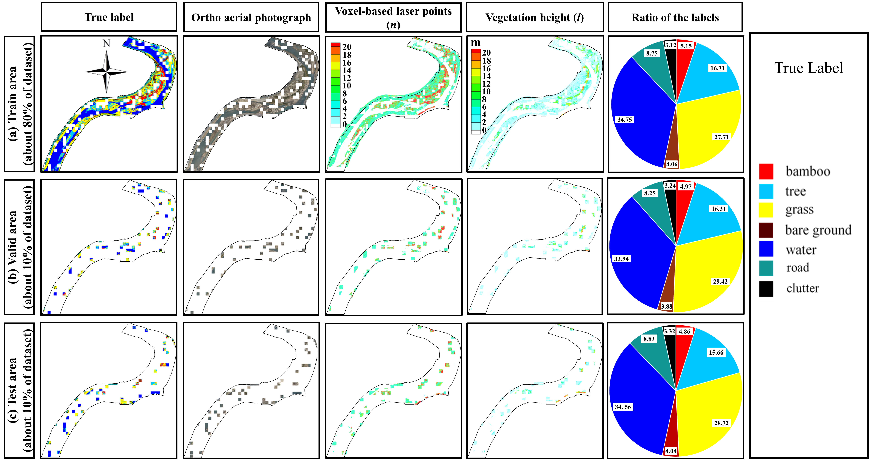
Figure 5. Spatial distribution of the dataset in the (a) training, (b) valid, and (c) test areas (March 2017 dataset as
example).

Afterwards, we calculated l by locating the highest point in each 2D cell (or Digital Surface Model, DSM) minus the DTM.

Because of the stability from LiDAR-derived data, as shown in Figure 4, it can be reference of producing TL mapping, especially when the orthophoto is not clear enough to judge the difference between the similar land cover (i.e., bamboo and tree; tree and grass; grass and bare ground). Figure 5 depicts the true labels, orthophoto, and ALB dataset, were divided into three parts: (a) 80% for training, (b) 10% for validation, and (c) 10% for testing. For this study, the modified module chose spatial resolution ratio of 1:10 between the orthophoto and the ALB datasets based on DeepLabV3+ model specifications and data resolution. Accordingly, we set the spatial resolution for the orthophoto to 0.2 m pixel⁻¹ and for the ALB data to 2 m pixel⁻¹.
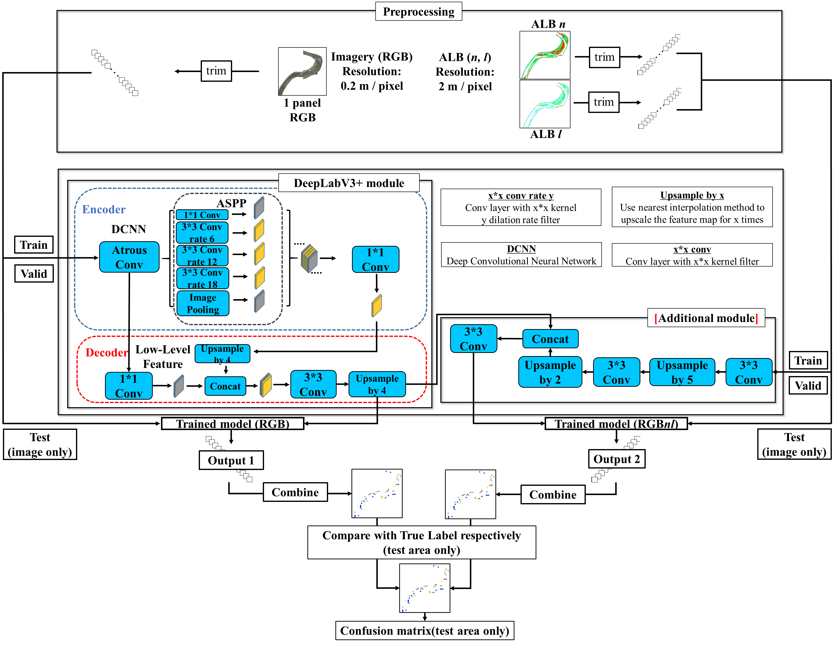
Figure 6. Processing of mapping LCC with two DL methods.

Models
The DeepLabV3+ module in Figure 6 extracts feature from orthophoto using an ‘Encoder–Decoder’ structure. The model’s parameters are then optimized with assist of TL. Subsequently, these parameters are saved as a ‘Trained model’. This training procedure determines the relations among input data, such as photographs, and the TL. Throughout this study, this processing was designated as the RGB-based method. Later, this technique was upgraded by including an additional module with a ‘Decoder’ function using the ALB dataset. To combine with the RGB-based ‘Trained model’, the ALB dataset was expanded twice by factors of 2 and 5 in the additional module. Consequently, we performed upsampling using an imaging technique called ‘nearest-neighbor interpolation’. Then, we chose n and l as input data for the additional module for the ALB dataset. The parameters were optimized with the same TL as the RGB-based method. This processing was designated for this study as the RGBnl-based method. The upgraded method’s goal is to incorporate ALB data into the model to improve the accuracy of the inference results. Notwithstanding, the RGBnl-based method is also a reasonable way to confirm the correctness of TL mapping, because of using the stable ALB data.

Figure 6 depicts the workflows used for the processing of LCC mapping with the modified DeepLabV3+ module, in which orthophoto and ALB datasets, as shown in Figure 5, are cut into small panels using the above scales for pre-processing. The RGB-based method used for this processing is traced roughly as (a) training phase – [RGB imagery as input] → [DeepLabV3+ model] → [Trained model (RGB)] and (b) inference phase – [RGB imagery as input] → [Trained model (RGB)] → [Output 1]. By contrast, the RGBnl-based method image processing is represented as (a) training phase – [RGB imagery and ALB dataset as input] → [upgraded model] → [Trained model (RGBnl)] and (b) inference phase – [RGB image and ALB dataset as input] → [Trained model (RGBnl)] → [Output 2]. Finally, Table 4 presents a summary of the all training environment parameters used for programming.

Results
Table 1 Specifications of the present ALB system and measurement conditions in the targeted river reach; RC, recall value; PR, precision.

 | Case 1 (2 m resolution test area RGB-based result)
 | Bamboo | Tree | Grass | Bare-land | Water | Road | Clutter | Total | RC(%)
Bamboo | 199972 | 21107 | 12728 | 258 | 0 | 61 | 92 | 234218 | 85.38
Tree | 27745 | 582370 | 123393 | 2693 | 20971 | 861 | 9411 | 767444 | 75.88
Grass | 19632 | 128550 | 1262665 | 31170 | 4366 | 8958 | 28725 | 1484066 | 85.08
Bare-land | 560 | 367 | 46527 | 178830 | 1775 | 207 | 1621 | 229887 | 77.79
Water | 880 | 19500 | 4705 | 2336 | 1723609 | 858 | 7636 | 1759524 | 97.96
Road | 0 | 189 | 5989 | 2741 | 468 | 447099 | 7711 | 464197 | 96.32
Clutter | 231 | 3726 | 19369 | 2784 | 4022 | 4858 | 119278 | 154268 | 77.32
Total | 249020 | 755809 | 1475376 | 220812 | 1755211 | 462902 | 174474
PR (%) | 80.30 | 77.05 | 85.58 | 80.99 | 98.20 | 96.59 | 68.36
OA = 0.89, Macro-F1 = 0.84

 | Case 2 (2 m resolution test area RGBnl-based result)
 | Bamboo | Tree | Grass | Bare-land | Water | Road | Clutter | Total |  | RC(%)
Bamboo | 199381 | 15911 | 18609 | 279 | 0 | 32 | 6 | 234218 |  | 85.13
Tree | 38387 | 551674 | 142119 | 2458 | 22560 | 910 | 9361 | 767469 |  | 71.88
Grass | 13344 | 138339 | 1255417 | 30169 | 5563 | 9441 | 31813 | 1484086 |  | 84.59
Bare-land | 666 | 1848 | 34770 | 188364 | 1349 | 283 | 2639 | 229919 |  | 81.93
Water | 413 | 24849 | 4257 | 1116 | 1719712 | 1316 | 8021 | 1759684 |  | 97.73
Road | 0 | 372 | 5723 | 1901 | 580 | 448996 | 6662 | 464234 |  | 96.72
Clutter | 28 | 2898 | 15791 | 4390 | 6695 | 6735 | 117774 | 154311 |  | 76.32
Total | 252219 | 735891 | 1476686 | 228677 | 1756459 | 467713 | 176276
PR (%) | 79.05 | 74.97 | 85.02 | 82.37 | 97.91 | 96.00 | 66.81
OA = 0.88, Macro-F1 = 0.84

Case1 from Table 1 showed the confusion matrix relevant evaluation indices, including OA and Macro F1-score as the results of the RGB-based method. The indices are relatively more prominent when the data from the same period are trained and inferred. Furthermore, compared to the RGB-based method, Case 2 in Table 1 performed that the RGBnl-based method attained almost the same accuracy, including OA and macro F1-score. The findings imply that the accuracy of TL mapping have been proved by both RGB- and RGBnl-based methods.

Conclusion
Results revealed that the RGB- and RGBnl-based methods outperformed in terms of overall accuracy and Macro F1-score. Despite the fact that the RGBnl-based method includes ALB-derived voxel-based laser points (n) and vegetation height information (l), the accuracy of LCC mapping has not been influenced significantly over the RGB-based method. The correctness of the TL mapping has been proved by both of these methods. Overall, due to recent advancements in remotely sensed technologies, it is recommended to employ unmanned aerial vehicle borne LiDAR-derived data in future relevant research with a more detailed point density and concurrently captured high spatial resolution aerial images.

REFERENCES

- Yoshida, K., Nagata, K., Maeno, S., Mano, K., Nigo, S., Nishiyama, S., & Islam, M. T. (2021). Flood risk assessment in vegetated lower Asahi River of Okayama Prefecture in Japan using airborne topo-bathymetric LiDAR and depth-averaged flow model. Journal of Hydro-Environment Research, 39, pp 39-59.
https://doi.org/10.1016/j.jher.2021.06.005
- Chen, L. C., Zhu, Y., Papandreou, G., Schroff, F., & Adam, H. (2018). Encoder-Decoder with Atrous Separable Convolution for Semantic Image Segmentation. arXiv preprint arXiv:1802.02611.
https://doi.org/10.48550/arXiv.1802.02611
- Yoshida, K., Pan, S., Taniguchi, J., Nishiyama, S., Kojima, T., & Islam, T. (2022). Airborne LiDAR-assisted deep learning methodology for riparian land cover classification using aerial photographs and its application for flood modelling. Journal of Hydroinformatics. 1 January 2022; 24 (1), pp 179–201. https://doi.org/10.2166/hydro.2022.134

