Concurring Indications of HSI and HMID for Assessing the Success of River Restoration Actions

Maximilian Kunz
Institute for Modelling Hydraulics and Environmental Systems, University of Stuttgart,
Pfaffenwaldring 61, 70569 Stuttgart, Germany

Markus Noack
Institute of Applied Research, Karlsruhe University of Applied Sciences,
Moltkestrasse 30, 76133 Karlsruhe, Germany

Sebastian Schwindt
Institute for Modelling Hydraulics and Environmental Systems, University of Stuttgart,
Pfaffenwaldring 61, 70569 Stuttgart, Germany

Stefan Haun
Institute for Modelling Hydraulics and Environmental Systems, University of Stuttgart,
Pfaffenwaldring 61, 70569 Stuttgart, Germany

Silke Wieprecht
Institute for Modelling Hydraulics and Environmental Systems, University of Stuttgart,
Pfaffenwaldring 61, 70569 Stuttgart, Germany

The Hydro-Morphological Index of Diversity (HMID) and the Habitat Suitability Index (HSI) are two metrics used to assess the ecomorphological state of rivers. Both the HMID and the HSI imply, among others, water depth and flow velocity data. The HSI rates physical habitat suitability based on a comparison between present abiotic data and habitat requirements of target aquatic species. The HMID calculates statistics to provide a measure of morphological diversity. This study compares both metrics based on the results of two-dimensional hydro- and morphodynamic models for a current and future state in the light of multiple restoration actions, such as partial removal of sills. The study reach is located at the Inn River (Germany), which is characterized by residual flows as a consequence of upstream damming and water diversion. The results show that no direct correlation between the HMID and the HSI can be found for specific target species in the considered reach, namely the grayling and the common nase.

Introduction
River ecosystems are often marked by legacies such as channelization for navigation purposes or the generation of hydropower. Today, thousands of river restoration projects worldwide attempt to repair damage to river ecosystems, where many of them aim at increasing hydro-morphological diversity and maximizing physical habitat suitability for target aquatic species and specific life-stages. Tools that enable us to predict the success of restoration actions are vital to effectively designing particular measures. While two-dimensional (2d) hydro-morphodynamic (numerical) models are applied to predict morphological changes in bed elevation and grain size distribution over time, additional metrics, such as the Habitat Suitability Index (HSI) or the Hydro-Morphological Index of Diversity (HMID), are required to link river morphology and habitat suitability. In this study, both the HSI and HMID are calculated and compared with each other, based on the results of a 2d hydro- and morphodynamic model to evaluate possible restoration actions at the Inn River in Southern Germany.

Methods and Materials

Study Site: Current State and (Partial) Removal of Angled Sills
The most downstream reach of the Inn River is located in Bavaria, Germany, and is longitudinally divided by a series of 19 dams for run-of-river hydropower generation [1]. An exception is the diversion hydropower plant in Toeging, which was built in 1924 in connection with the Jettenbach weir and an artificial diversion channel [2]. The diversion channel bypasses the original riverbed at the diversion weir to convey water to the Toeging hydropower station. In the current state, only residual flows pass through the original riverbed and bedload transport is completely cut off, which leads to considerable ecological deficits in the river reach, evidenced by a pronounced armor layer and clogging of the gravel riverbed in large parts of the residual water stretch. The lack of bedload supply led to riverbed incisions in the past, which could be stopped by the installation of several inclined ground sills between 2000 and 2012 [3]. Beyond their main goal of channel stabilization, the angled sills also aimed at promoting lateral erosion, which only worked out partially and temporarily. For this reason, modifications of a chain of six sills (see Figure 1) are hypothetically under consideration in this study. The average distance between the six sills is 290 m. The options at hand include a partial removal by one-third and two-thirds as well as complete removal of these six angled sills. The one-third and two-thirds removals of the sills intend to force a meandering flow pattern (see Figure 2) that simultaneously creates favorable aquatic habitat heterogeneity.

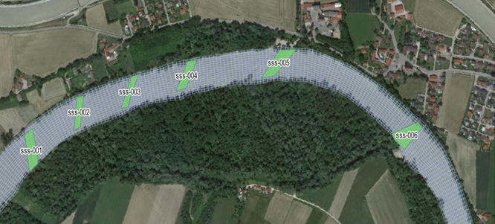

Figure 1. Chain of six angled sills in the residual water stretch of the Inn River between Jettenbach and Toeging (Map data ©2015 Google).

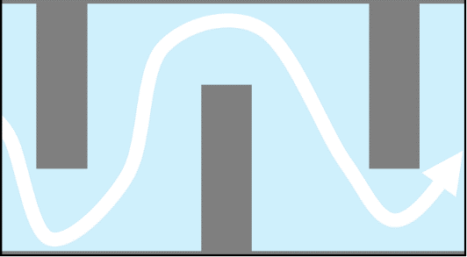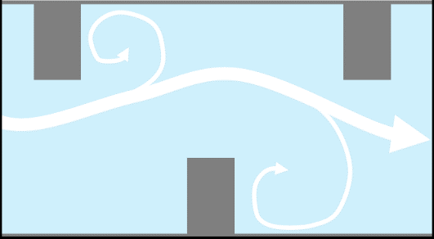

Figure 2. Expected flow pattern for the removal of one-third (left) and two-thirds (right) of the angled sills.

2d Hydro- and Morphodynamic Modelling
A two-dimensional (2d) hydro- and morphodynamic numerical model of the river reach was set up to evaluate the current state and the potential long-term (10-year) effects of restoration actions, such as the (partial) removal of the angled sills, on sediment dynamics. The simulations were performed with the Hydro_FT-2D software version 3.1.6 [4].
The numerical model was calibrated by comparing observed and simulated topographic changes and sediment budgets between 2007 and 2014. The long-term morphodynamic model experiments built on the calibrated model and started with an airborne lidar-derived digital elevation model from 2019. An average instream cell is 12-m long and 7-m wide. An artificial 10-years long hydrograph was created by adapting the flood pattern of the ten previous years, re-ordering flood stages and cutting of flows less than 200 m³/s, which by previous investigations do not affect the morphological river pattern [5]. The implementation of the angled sills in the numerical model can be seen in Figure 3. On the left side, the constructed sill, the (partial) removal (one- and two third), as well as the complete removal are shown for one sill, where only the z-coordinates of the respective nodes were changed. The right side shows the alternating partial removal of the sills to create a meandering flow pattern. For every sill scenario, one long-term morphodynamic model run was performed.

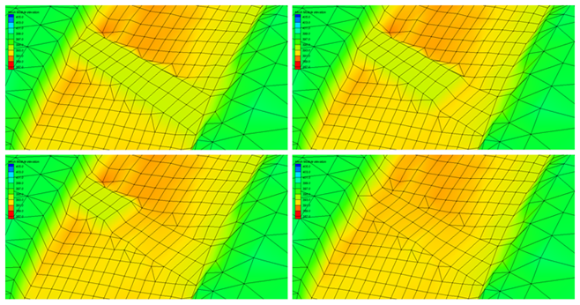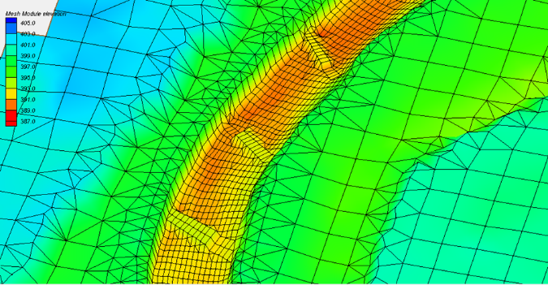

Figure 3. Implementation of the angled sills in the numerical model: example of the (partial) removal at one sill (left) and alternating removal to create a meandering flow pattern (right).
Numerous hydrodynamic steady-state simulations were conducted for the current state and the future state (after 10 years) of the sill scenarios. Discharges of 40 m³/s (i.e., the minimum discharge during the spawning season of graylings and nases) and 101 m³/s (i.e., the mean discharge of the residual water stretch) were evaluated in this study.

The Habitat Suitability Index (HSI)
Because physical habitat is a key factor for evaluating the ecological condition of rivers [6], a commonly used approach to quantifying habitat is to calculate habitat indices for a range of abiotic conditions for indicator species [7]. Based on a comparison of existing abiotic conditions (e.g. water depth, flow velocity, and substrate size) with the preferred conditions of aquatic organisms, habitat quality is determined for a particular site. Particular preferences of fish species and their life-stages are implemented by an expert assessment of either univariate HSI curves or multivariate fuzzy sets. The most commonly used index used to describe biological responses is the habitat suitability index (HSI), which ranges from 0.0 (unsuitable) to 1.0 (very suitable) [8]. In this study, the habitat modeling system CASiMiR [8, 9] is used with a multivariate fuzzy-logic approach.
Based on the HSI, pixel sizes $A_{i}$ and the total wetted area $A_{total}$ of the region of interest, a hydraulic habitat suitability (HHS) can be calculated:

$HHS= \frac{1}{A_{total}}\sum_{i=1}^{n}{A_{i}∙{HSI}_{i}=f(Q)}$ (1)

The Hydro-Morphological Index of Diversity (HMID)
The HMID is presented as a tool for describing habitat heterogeneity of a river reach for pre-alpine gravel-bed streams [10]. In contrast to the HSI, the HMID has no reference to specific fish species or life-stages. Calculating the HMID notably builds on statistic distributions of flow velocity and water depth using squared values of partial diversity and multiplication of squared values of partial diversity [11]:

${HMID}_{Site}=\prod_{i}{V{(i)}^{2}=V{(v)}^{2}∙V{\left(d\right)}^{2}={(1+\frac{σ_{v}}{μ_{v}})}^{2}}∙{(1+\frac{σ_{d}}{μ_{d}})}^{2}$ (2)

The HMID only uses hydraulic parameters resulting from 2d hydrodynamic numerical modeling to indirectly account for morphological parameters, which is justified by correlation analysis and the conclusion of a strong interaction between channel form and hydraulic attributes. HMID values below 5 represent a channelized and morphologically heavily altered site. Values in the medium range (5 < HMID < 9) represent sites with limited variability of hydraulic units up to sites that approach natural morphology. Sites with an HMID > 9 can be considered as reference sites where spatial dynamics are fully developed [10].

Evaluation Approach
Both the HSI and HMID are computed for the current and future (10-year) state to assess the effect of the (partial) removal of sills from the riverbed. Based on morphological changes observed in the 10-year time frame, an area of influence is determined, which represents the part of the river reach influenced by the restoration actions. The area stretches from 2.6 km upstream of the first sill to 300 m downstream of the last sill and covers the riverbed as well as the banks. For the calculation of the HSI and HMID, flow velocities and water depths are extracted for every mesh node from the results of the hydrodynamic simulations of the current and future states. Additionally, information on the substrate (percentage of fine sediments and grain size distribution) is extracted from the morphodynamic modeling results for the calculation of the HSI.
For the determination of the HMID in the area of interest, the number of wetted nodes, depending on the discharge, represents the statistical sample size. The HMID is calculated according to equation 2 for the two discharges of 40 m³/s and 101 m³/s, for the current state (t=0) including the sills and the future state (t=10) for all four scenarios (sills remain, removal of 1/3, removal of 2/3 and complete removal).
While the HMID can only be calculated for the entire area of interest, HSI values are computed for each node in the area, which enables to display maps of habitat suitability. Furthermore, HSI values are computed for different fish species and life-stages depending on their habitat requirements. In this study, the species grayling (Thymallus thymallus) and nase (Chondrostoma nasus) are considered representative for the observed river reach. The life-stages considered for the grayling are adults, resting, spawning, juveniles and hatching. For the nase, the life-stages resting, spawning, hatching as well as the larval habitat are considered. The HSI values are computed for the same discharges and states as mentioned above. In order to make the HSI results comparable to the HMID results, the hydraulic-habitat-indices (HHS) are computed for the area of interest.

Results

HMID
Figure 4 shows the HMID values in the area of influence for discharges of 40 m³/s and 101 m³/s for the current and future states and for the four different scenarios.

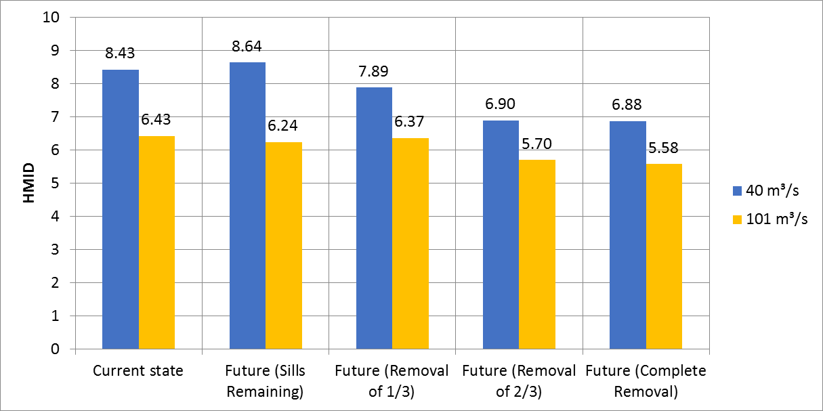

Figure 4. HMID values for the current state and future states.

While it can be seen that the HMID is generally higher for a discharge of 40 m³/s than for a discharge of 101 m³/s, it tends to decrease with the rate of sill removal for both discharges. This is evident when considering the four future states, where the model case with the remaining sills reaches the highest HMID of 8.64 and the case of complete removal leads to an HMID of 6.88 for a discharge of 40 m³/s. The HMID values for a removal of one-third (7.89) and two-thirds (6.90) are in between. A similar trend can be observed for the mean discharge of 101 m³/s, with the exception that the removal of one-third leads to the highest HMID (6.37).
The high HMID values of the cases that include the sills stem from the fact that the flow velocities are very low in the backwater of the sills and very high on the sills themselves. The opposite is true for the water depth, which results in a high diversity according to the HMID formula.

HSI
Figures 5, 6 and 7 show the hydraulic habitat indices in the area of interest for adult graylings, spawning graylings and spawning nases for the previously mentioned current and future states. All three figures show that even though the HMID values (see Figure 4) for the current state and future state with the remaining sills are lower for the discharge of 101 m³/s than for 40 m³/s, the HHS values are higher for the discharge of 101 m³/s. For the three other future cases in Figure 5, both the HMID value and the HHS decrease with increasing discharge. This leads to the assumption that the hydro-morphological diversity is not able to predict habitat suitability, because decreasing diversity does not necessarily come along with a decrease in habitat quality. A reason for that could be the neglecting of sedimentological parameters such as grain sizes, which do not influence the HMID, but are included in the HSI calculation.
This can also be seen in Figure 6 showing the HHS for spawning graylings. Considering only the future scenarios with a discharge of 40 m³/s, an increase of the hydraulic habitat index can be observed with increasing ratio of sill removal. However, the opposite can be said for a discharge of 101 m³/s. In contrast, Figure 7 shows an increase of the hydraulic habitat index with increasing ratio of sill removal for spawning nases for both discharges. The comparison of the spawning graylings and spawning nases shows that the characteristic habitat requirements of the individual target species have to be considered when evaluating the effects of river restoration actions.
Especially for the spawning nases, a contrary trend between the HMID and HHS can be observed. The effect of the sill removal on their habitat suitability can be seen in Figure 8, which shows HSI maps for spawning nases for the future state with remaining sills (left) and the future state with complete removal of the sills (right) at a discharge of 40 m³/s. While only the remaining sills themselves represent suitable spawning habitats for nases, the backwater reaches show almost no suitable habitat due to their high water depths and low flow velocities. In contrast, the removal of the sills leads to an increase in suitable habitat, especially in the medium ranges (HSI values of 0.3 to 0.8). This, again, is contrary to the decreasing HMID, which drops from 8.64 to 6.88 for a discharge of 40 m³/s.

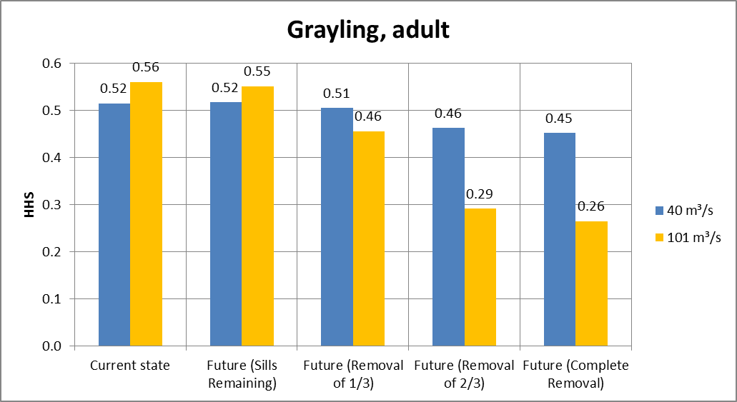

Figure 5. HHS values for adult graylings for the current state and future states.

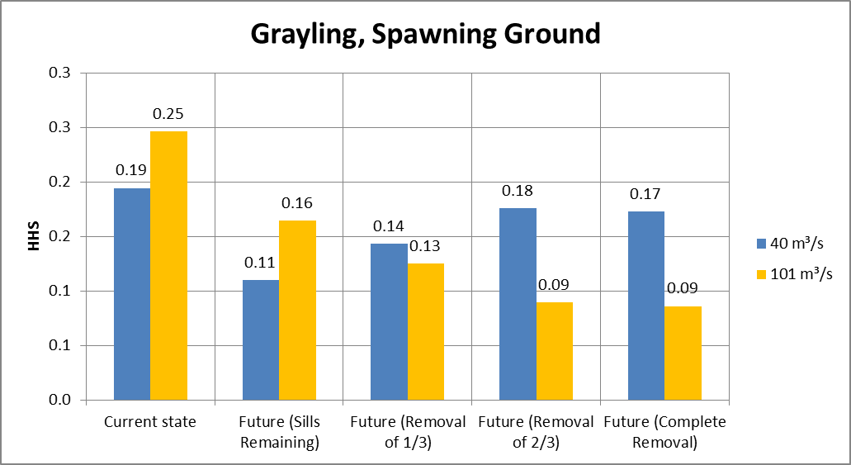

Figure 6. HHS values for spawning graylings for the current state and future states.

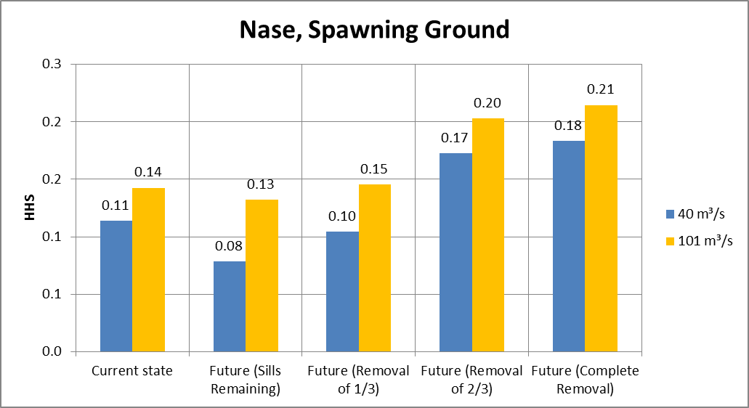

Figure 7. HHS values for spawning nases for the current state and future states.

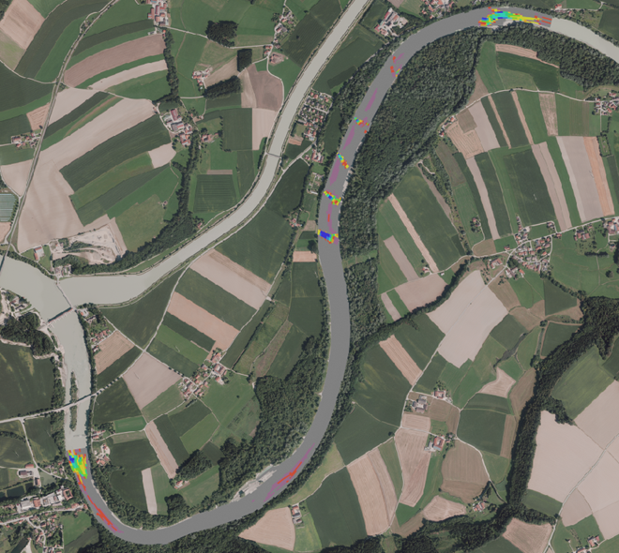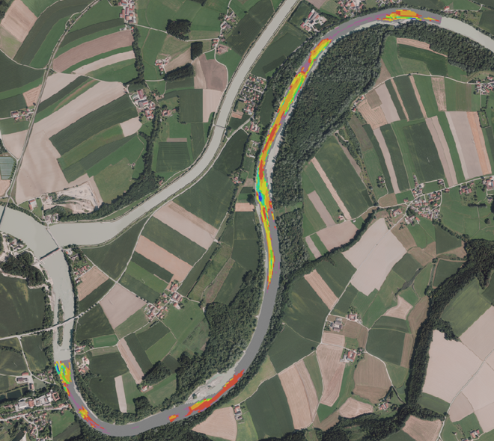

Figure 8. HSI maps for spawning nases for the future state with remaining sills (left) and the future state with a complete removal of the sills (right) at a discharge of 40 m³/s.

Conclusions
This study shows concurring indications of the HMID and HSI for different restoration scenarios considering the (partial) removal of angled sills. The HMID predicts a decrease in hydro-morphological diversity with increasing removal ratio of sills for the discharge in the spawning season and the mean discharge, which suggest that the conditions worsen when the sills are removed. However, the HSI increases for some species and life-stages, especially for spawning nases and spawning graylings. The HSI values for adult graylings also do not suggest good agreement with the HMID. Consequently, the assessment of river restoration actions using the HMID may characterize the hydraulic diversity in a river reach, but this procedure is not representative for the physical habitat quality for gravel-spawning fish. While there may be a correlation between hydro-morphological diversity and general habitat conditions, a more distinguished approach like the habitat suitability is recommended. The habitat suitability index (HSI) accounts for abiotic parameters and preferences of aquatic species at different lifestages and proved to be suitable to evaluate restoration actions. In general, no direct correlation between HSI and HMID was found here.

REFERENCES

- Innsieme c/o WWF Oesterreich, “Der Inn in Deutschland“, (2021). https://www.innsieme.org/drei-laender-fluss/der-inn-in-deutschland/ (Retrieved August 8, 2021).
- Verbund AG, “Toeging Run-of-River Plant”, (2021). https://www.verbund.com/en-at/about-verbund/power-plants/our-power-plants/toeging (Retrieved August 8, 2021).
- Aquasoli, “Flussmorphologische Untersuchung Inn Ausleitungsstrecke Jettenbach bis Toeging“, Traunstein, (2015).
- Nujic M. et al., “Benutzerhandbuch Hydro_FT-2D. Erweiterung zu Hydro_AS-2D zur Simulation des Stofftransports“, Aachen, (2015).
- Kunz et al., “Inn-ovative Morphological Restoration Efforts”, Proceedings of the International Symposium on Bedload Management 2021, Interlaken, (2021), pp 52-55, https://doi.org/10.3929/ethz-b-000513098.
- Maddock I., “The importance of physical habitat assessment for evaluating river health“, Freshwater Biology, Vol. 41, (1999), pp 373-379.
- Leclerc M.A., St-Hilaire A., Bechara J.A., “State-of-the-art and perspectives on habitat modelling”, Canadian Water Resources Journal, Vol. 28, No. 2, (2003), pp 153-172.
- Schneider M., “Habitat- und Abflussmodellierung fuer Fliessgewaesser mit unscharfen Berechnungsansaetzen“, PhD Thesis, Institute of Hydraulic Engineering, University of Stuttgart, (2001).
- Noack M., Schneider M., Wieprecht S., “The Habitat Modelling System CASiMiR: A Multivariate Fuzzy Approach and its Applications“. Ecohydraulics: An Integrated Approach, (2013), pp 75-91.
- Gostner et al., “The hydro-morphological index of diversity: a tool for describing habitat heterogeneity in river engineering projects”, Hydrobiologia, Vol. 712, No. 1, (2013), pp 43-60.
- Schleiss A.J., “Flussbauliche Hochwasserschutzmassnahmen und Verbesserung der Gewaesseroekologie – Vorschlag eines hydraulisch – morphologischen Vielfaeltigkeitsndexes“, Wasser, Energie, Luft, Vol. 97, (2005), pp 195-199.

