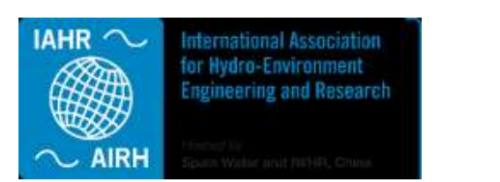
IAHR/IWA Joint Specialist Group on Outfall Systems

Chair: Dr Majid Mohammadian, University of Ottawa, Canada

Activities of 2023
- ISOS 2023
https://www.space4water.org/events/international-symposium-outfall-systems-isos-2023
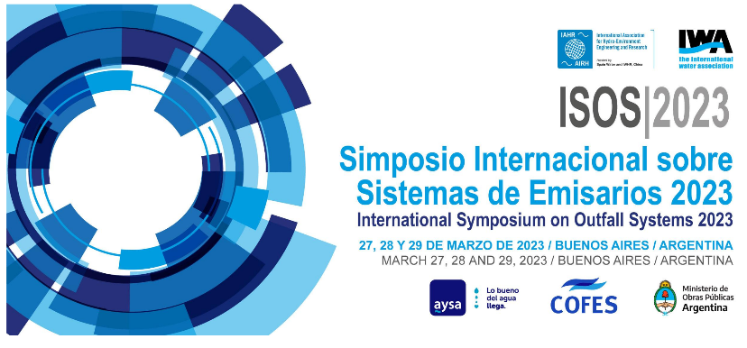
https://www.iahr.org/index/detail/1086

The International Symposium on Outfall systems (ISOS 2023) was successfully organized in Buenos Aires from March 27 to March 29. Over 250 participants attended the conference, which was exceptional compared to previous ISOS events. Eight keynote speeches and 12 technical presentations were delivered as well as several panel discussions. A very interesting and impressive site visit was also organized.

- Special session in the 2023 IAHR Congress
The committee organized a special session with six presentations and about 35 attendees covering experimental, numerical and analytical subjects presenting recent advances in the subject.

- Expanding the scope of the committee
In order to expand the committee's scope of work, attract more people, and further involve IWA, the committee decided to broaden its focus by changing its name from “IAHR/IWA joint committee on marine outfall systems” to “IAHR/IWA joint committee on outfall systems”. That is, the scope was expanded from marine outfalls to all outfalls.

- Request for proposals for the organization of ISOS 2026
An RFP was developed and posted for the organization of ISOS 2026
https://www.iahr.org/index/detail/1185

- Working group
A working group was formed focusing on numerical simulation of outfall systems and organized a webinar and a short course as outlined below.

- Webinar
A webinar was organized on Numerical Simulation of Effluent Discharges on Tuesday 16 May 2023.
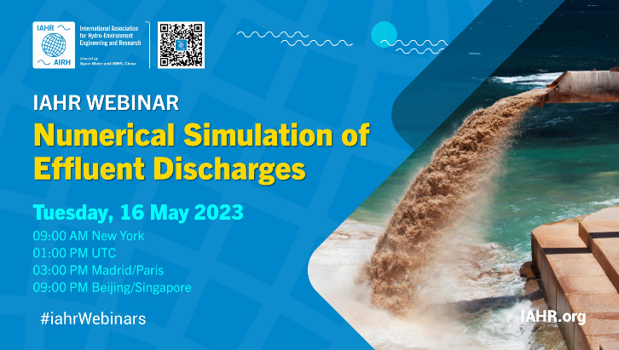
https://www.iahr.org/index/detail/930
The webinar briefly introduced the application and configuration of outfalls, the basic principles of numerical simulation and various methods of turbulence modeling. In addition, the simulation case of OpenFOAM for sewage discharge modeling, and the improvement in the numerical model was further discussed.

- Short course
A short course was organized on outfall discharge modeling and analysis during Oct 30th to Nov 1st 2023.

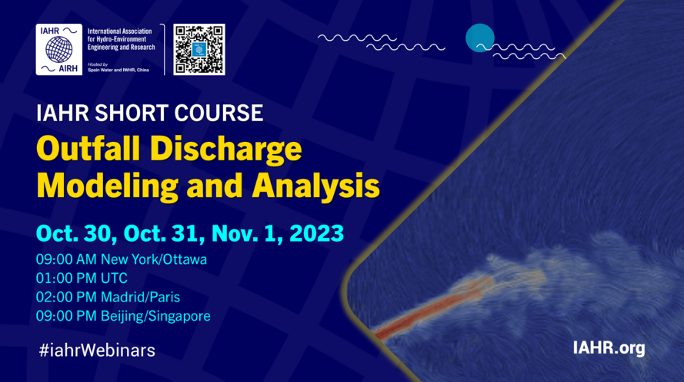
https://www.iahr.org/index/detail/1189
The short course, organized as part of the activities of the IAHR Technical Committee on Marine Outfall Systems aimed to present an introduction to the design and modelling methods and the latest selected research results related to outfall systems and the mixing of effluents in water bodies.
Nearly 400 registrations were received.

- Book
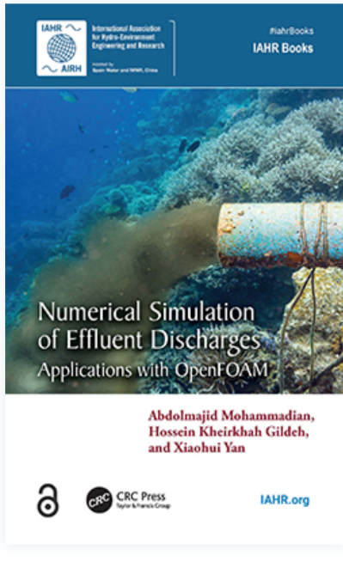
https://www.iahr.org/index/detail/845

A book was published entitled “Numerical Simulation of Effluent Discharges: Applications with OpenFOAM” by Abdolmajid Mohammadian, Hossein Kheirkhah Gildeh, Xiaohui Yan.
The book provides a resource for understanding the effluent discharge mechanisms and the approaches for modeling them. It bridges the gap between academia and industry with a focused approach in CFD modeling and providing practical examples and applications. With a detailed discussion on performing numerical modeling of effluent discharges in various ambient waters and with different discharge configurations, the book covers the application of OpenFOAM in effluent discharge modeling.

- Committee meeting
A committee meeting was organized during ISOS 2023 in which various items were discussed, such as the possibility of organizing webinars, working groups and the next ISOS. For the next ISOS, it was suggested to plan for 2026 to avoid overlap with the IAHR congress.

- Newsletter
A newsletter was published.

- Other activities and news
- Committee webpages on IAHR and IWA websites, as well as Linkedin, were updated.
- Dr Philip Roberts was nominated for IAHR fellowship award and was awarded the IAHR fellow designation by IAHR.

Activities of Future Years
- Organization of ISOS 2026
- Organization of a special session in the next IAHR congress (2025)
- Committee meetings
- Working group activities such as two webinars, a short course focusing on practical aspects of the design of outfalls and development of a short guideline on numerical modeling of outfall systems
- Election of new members
- Newsletters
- Keeping Committee webpages in IAHR and IWA websites as well as Linkedin up to date.

