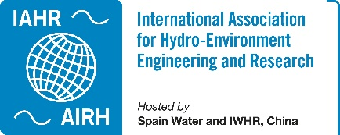 IAHR TC/WG Annual Report 2023

Committee on Ecohydraulics
Collaborating with other international associations working in the field of aquatic ecosystems to bring specialists together in order to discuss, compare and evaluate methods, and also to work on state-of-the-art papers, monographs, guidelines for end users in fields such as hydraulic modelling of aquatic ecosystems, fish passes, and eutrophication in lakes and reservoirs.
Webpage | https://www.iahr.org/index/committe/10
Chair | Michele Mossa, Polytechnic University of Bari DICATECh, Italy
Past Chair | Gregory Pasternack, University of California, United States
Vice Chair | Daniele Tonina, University of Idaho, Centre for Ecohydraulics Research, United States
Primary affiliates | 249
Secondary affiliates | 460
Tertiary affiliates | 1154

Activities of the Year 2023
Including but not limited to conferences, webinars, publications, TC/WG meetings, elections, participation in international processes, etc. Some examples below:

ISE - International Symposium on Ecohydraulics, 15th International Symposium on Ecohydraulics and Fish Passage – ISE-FP 2024 - Contribution to the organization and support of the congress.

May 5-9, 2024. Québec City, Canada.
Launched in 1994, the International Symposium on Ecohydraulics (ISE) aim to provide a platform for scientists and engineers worldwide to discuss cutting-edge scientific progress, compare and evaluate state-of-the-art technical methods, and recommend them to the end-users.
Dating back to 2011, the annual Fish Passage Conference has brought together experts, managers, stakeholders, and companies from around the world with concurrent sessions in engineering, biology, and management and social issues.
The joint ISE – Fish Passage 2024 conference will be held in Québec City, Canada. This event aims at increasing research and professional networking and is an excellent opportunity to connect future partners. The last time ISE was held in Québec City was in 1996.
Web site: https://ise-fp2024.org/
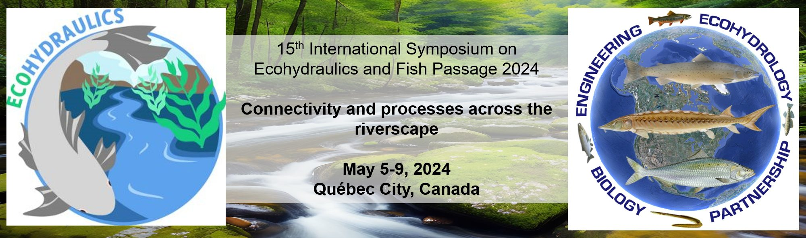

Organizing and Participating in Several Sessions at the 40th IAHR World Congress
August 21-25, 2023. Vienna, Austria.
We had several sessions at the World Congress in Vienna in August, i.e.
Session: From White River to Green River, a New Paradigm of Ecohydraulics_1_S2 Mo, 14:00 – 16:00 Chairperson: Takashi Asaeda
Session: 1a. River processes, monitoring and modelling Tu, 16:30 – 18:00
Chairperson: Donatella Termini

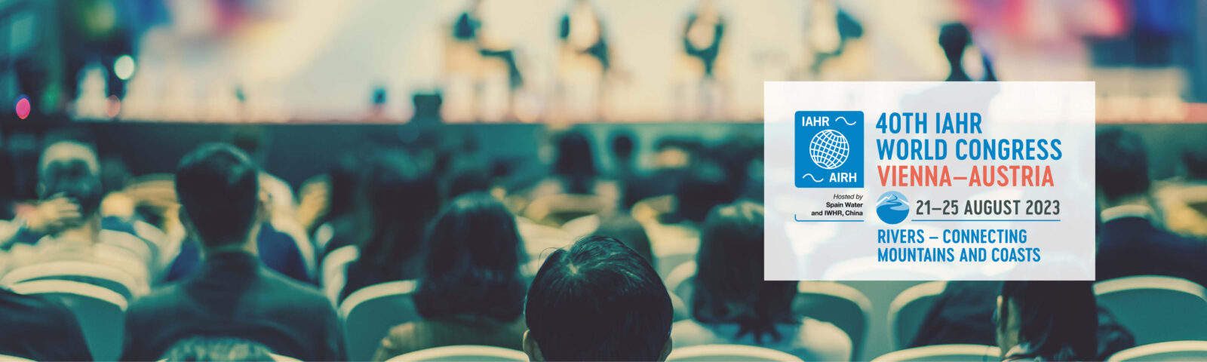

Organizing of key-note lecture and High-Level Panel on Ecohydraulics at the 40th IAHR World Congress
August 23, 2023. Vienna, Austria
Wednesday, 23 August 2023, 9.30-11.00 with keynote by Prof. Maciej Zaleweski,
Hall E
Ecohydraulics – connecting inland flow hydraulics with ecosystems
Worldwide, the blue economy has ample room for growth. However, we must not overlook the strong pressures that this generates on marine, lake, and river ecosystems, compromising their good condition. The concept of “sustainable use of resources” now appears obsolete and not sufficient to guarantee the correct functioning of ecosystems that are also essential to human well-being.
Knowledge, technological innovation and sustainable management of marine, lake, and river ecosystems, typical of eco-hydraulics, represent the areas in which investments are made to redesign the concept of sustainability of water environment, which leads to the creation of functional solutions for the protection and to the integrity of ecosystems in harmony with the presence of man.

Focus for the IAHR World Congress in Vienna
In the context of the scenario indicated above, during the congress in Vienna the focus will be more on identifying the feedback between flow characteristics and biological requirements, which is key understanding for managing sustainably inland waters. Here we aim to discuss the advances, needs and issues facing sustainable management of in-land water resources and how linking flow characteristics, hydraulics, and water quality, impact the surrounding ecosystems from in-channel to floodplain.
After the keynote lecture, the following scientists of the high-level panel delivered their presentations.
1. Prof. Peter Goodwin
2. Prof. Sung-Uk Choi
3. Prof. Qiuwen Chen
4. Prof. Christoph Hauer

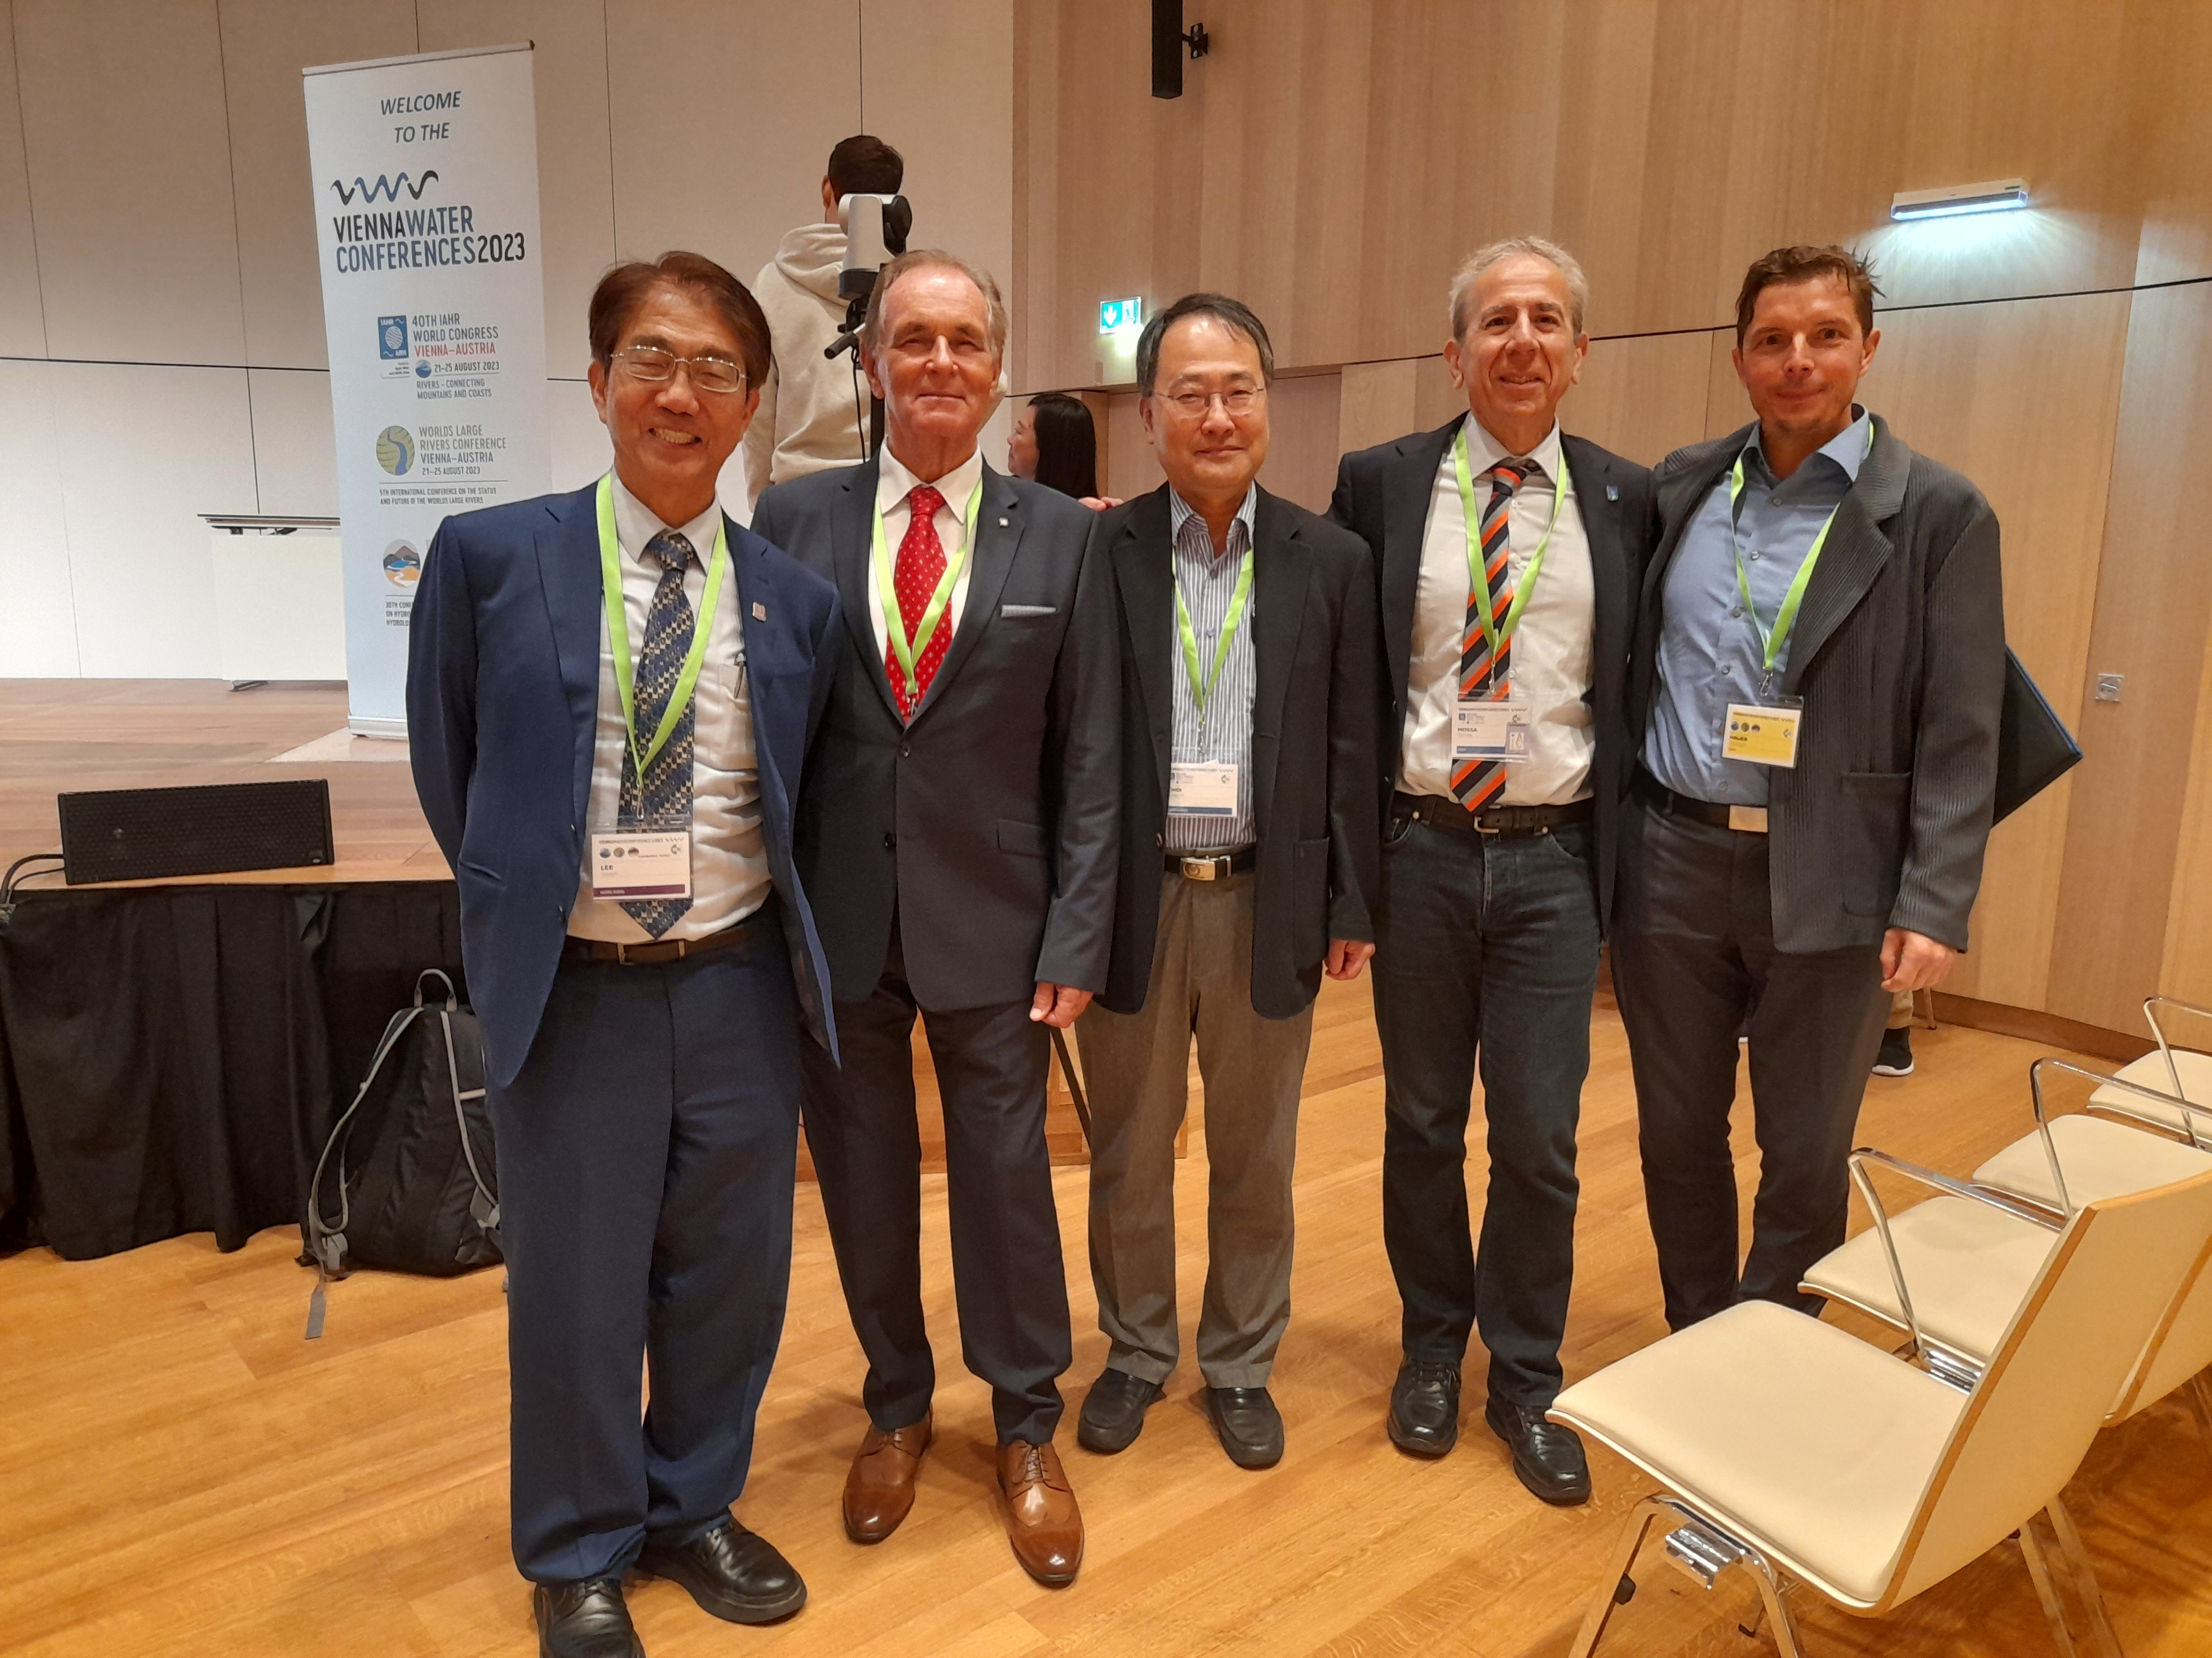

LT Members Participating and Supporting JoE Work
2023
Ecohydraulics LT members participated in conversations about the status and future of journals hosted by IAHR, including the Journal of Ecohydraulics (JoE). The LT regularly advertises the journal to the broad ecohydraulics community and encourages submissions. The LT is committed to supporting the JoE, also with new associate editors of the LT.
More: https://iahr.tandfonline.com/journals/tjoe20
More: https://iahr.tandfonline.com/action/journalInformation?show=editorialBoard&journalCode=tjoe20
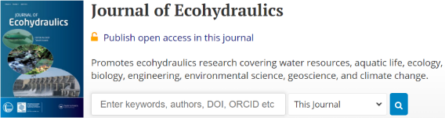

Session on “Hydraulics & Ecohydraulics and Coffee break with mentors” at the 4th IAHR Young Professionals Congress
November 22-24, 2023. Online.

The IAHR Young Professionals Congresses give young professionals, researchers and students the opportunity to present their work and access mentoring from leading global experts. Representing a unique opportunity for networking and promoting their work, the success of previous editions, with over 1,000 participants each, has ensured that the event is now established as an ongoing annual series organised by young professionals and for young professionals.
On November 23, 2023, Professor Michele Mossa chaired the following session.

17:30 - 19:00 | Hydraulics & Ecohydraulics and Coffee break with mentors

Chairs: Michele Mossa, Daniel Hayes and Andre St-Hilaire

Hosts. Emanuele Quaranta

Continuous measurement of river flow and flow direction using a new generation of underwater acoustic tomography system Mohamad Basel ALSAWAF, Kiyosi Kawanisi, Masoud Bahreinimotlagh

Study on Aeration Efficiency of Gabion Weir KM Luxmi, Nand Kumar Tiwari, Subodh Ranjan Vajesnayee

Effect of Hydro-generator Rotor Eccentricity on Unbalanced Magnetic Pull Jiwen Zhang, Huang Xingxing, Wang Zhengwei

Design and Construction of a Cross-Flow Turbine Rotor Fabricated with Recycled Polymers David Aray, Estefania Tineo

An experimental study on the ability of aquatic vegetation to trap plastic in rivers Giovanni Di Lollo, Claudia Adduce, Maria Rita Maggi, Luca Gallitelli, Massimiliano Scalici, Beatrice Trombetta

Effects of fortnightly environmental parameters on Etsu (Coilia nasus) catch in the Chikugo river estuary, Japan Vishal Singh Rawat, Gubash Azhikodan, Katsuhide Yokoyama

Turbulence Distribution in an Open Channel Flow with Submerged Flexible Canopy Harioum Gautam, Zulfequar Ahmad, Pramod Kumar Sharma.
More: https://www.iahr.org/index/detail/992
Video: https://www.youtube.com/watch?v=-SBwUvKrQ8I&list=PLSlAoS8gdfvoNdnMOjc9ui6vDMJRKJe47&index=3&t=16494s

Collection of “Ecohydraulics” in Scientific Reports by SpingerNature Editors: Abul BM Baki & Michele Mossa
2023
Ecohydraulics collection in Scientific Reports of SpringerNature
Submission status: Open
Submission deadline: 20 March 2024
Ecohydraulics - Connecting inland flow hydraulics with ecosystems. Worldwide, the blue economy has ample room for growth. However, we must not overlook the strong pressures that this generates on marine, lake, and river ecosystems, compromising their good condition. The concept of “sustainable use of resources” now appears obsolete and not sufficient to guarantee the correct functioning of ecosystems that are also essential to human well-being. Knowledge, technological innovation and sustainable management of marine, lake, and river ecosystems, typical of eco-hydraulics, represent the areas in which investments are made to redesign the concept of sustainability of water environment, which leads to the creation of functional solutions for the protection and to the integrity of ecosystems in harmony with the presence of man.
With this Collection, we aim to bring together the latest research in Ecohydraulics, from novel engineering solutions for coastal erosion problems, to modeling fluid flows interacting with vegetation, and more.

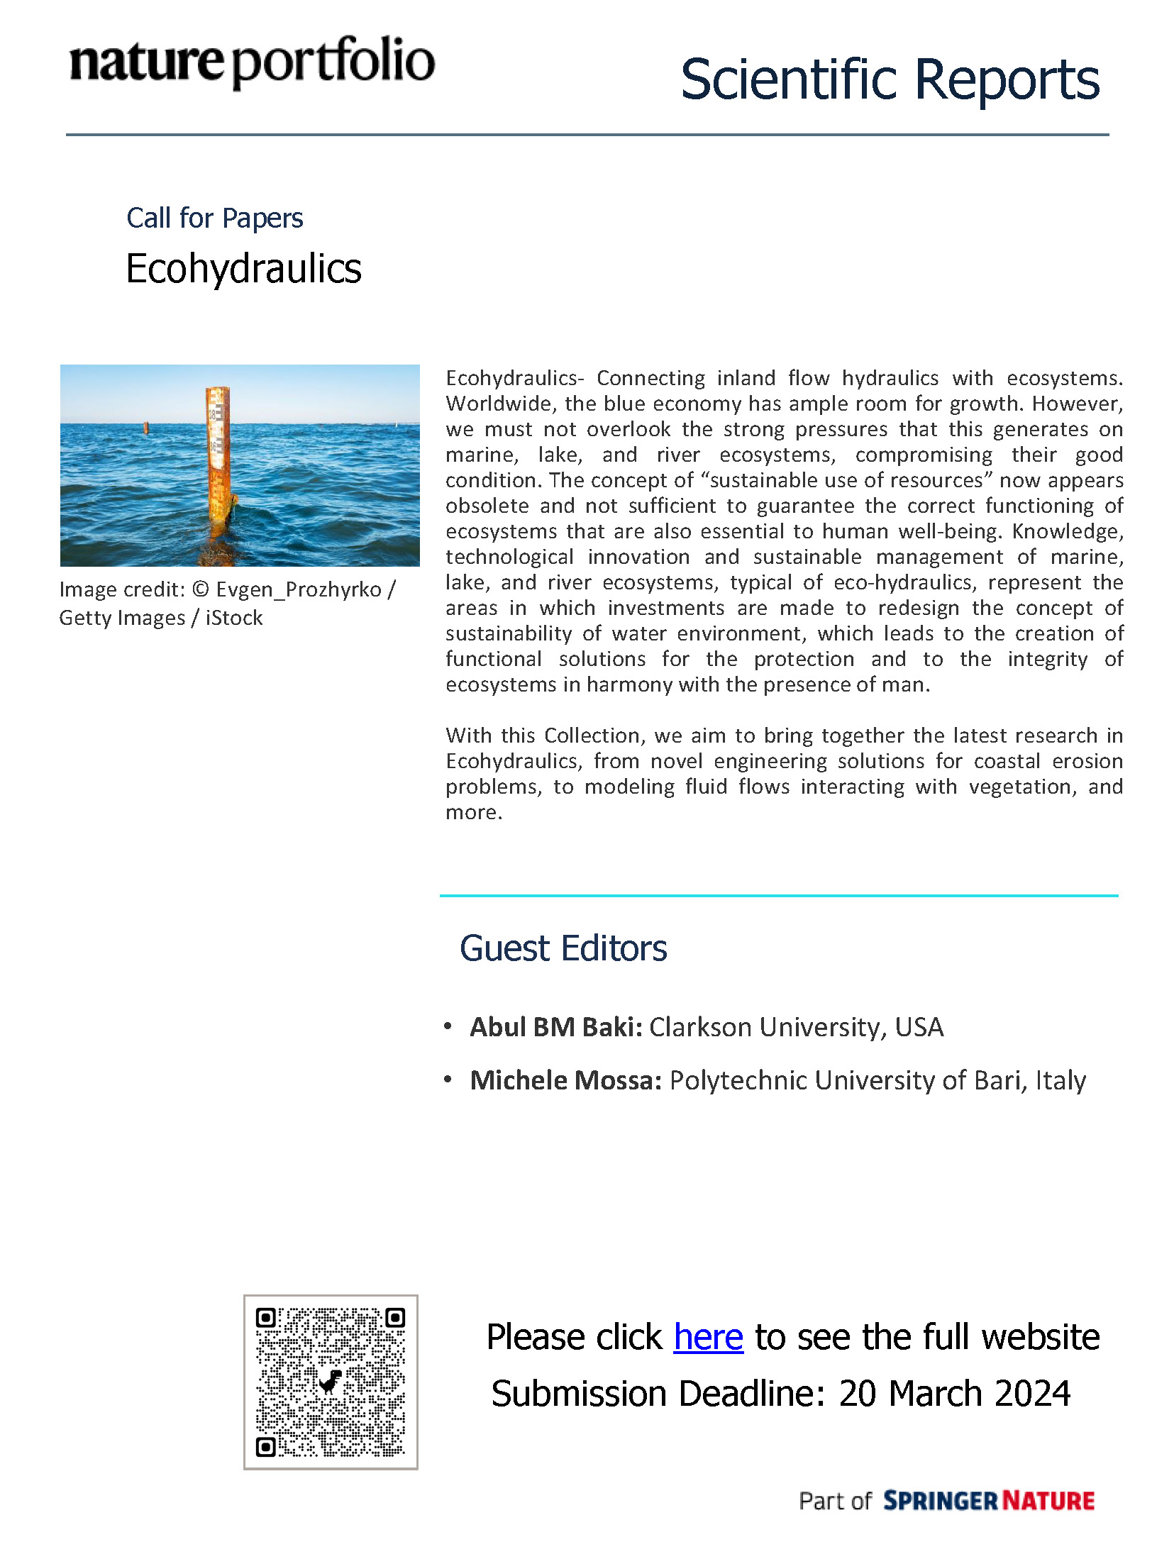

Contribution to UN Water Expert Group on Water and Climate Change
Prof. Michele Mossa was contacted by the UN Water Expert Group on Water and Climate Change, who have invited IAHR to contribute their "TECHNICAL WORKSHOP ON WATER AND CLIMATE INTER-DEPENDENCIES" - especially regarding mitigation (transition to carbon neutrality). The event is taking place in the framework of the Bonn Climate Conference - one of the main preparatory processes for the COP negotiations.
The organizers are seeking to bring together a snapshot of the current state of knowledge on the interdependencies between water and climate mitigation and use this to advise the COP negotiations as well as the topics of the next round of IPCC reports. IAHR, with the chairs of its TCs, is being invited to contribute as a recognized community of global experts.

Activities of Future Years
Including but not limited to conferences, webinars, publications, TC/WG meetings, elections, participation in international processes, etc.

ISE - International Symposium on Ecohydraulics 2026
Call for Letters of Intent from aspiring Local Organizing Committees to host the International Symposium on Ecohydraulics 2026

The IAHR Ecohydraulics Technical Committee leadership team invites letters of intent from the global community to serve as the Local Organizing Committee (LOC) for the 2026 International Symposium on Ecohydraulics. Aspiring LOCs should establish their team and collaborate to produce a Letter of Intent that shall include a brief statement to give a sense of the overall proposal concept for the scientific program and location. Letters will be reviewed by the leadership team on the basis of three criteria:
Favor proposals from continents that have not hosted an ISE in recent years, European counties will be prioritized,
Quality of the scientific idea of the symposium concept, and Likelihood of the symposium to be organized well and contribute to advancing the ecohydraulics community’s goals.
Submit your Letter of Intent to the Chair Prof. Michele Mossa (michele.mossa@poliba.it) cc Vice Chair Prof. Daniele Tonina (dtonina@uidaho.edu) who will return a confirmation email of receipt of the letter. Deadline of letters are extended to December 31, 2023 (11:59pm European Central Time).
Questions about the LOC selection process should be emailed to prof. Michele Mossa michele.mossa@poliba.it and in cc to prof. Daniele Tonina dtonina@uidaho.edu

IAHR Media Library on the topics of Ecohydraulics
https://www.iahrmedialibrary.net/
Now a new and more appealing web site of the IAHR Media Library has been launched. Apart from the graphic design, the new website technologies are:
• Proprietary PHP code
• PHP with MySQL database
• Powerful internal search engine
• home page with random articles divided by categories
• Fully responsive HTML/CSS
• Mobile and tablet compatible
• Registration form to create accounts
• Protected area with password to insert materials.
The LC will work in order to achieve further development of the IAHR Media Library on the topics of Ecohydraulics, encouraging additional contributions from the entire international scientific community.



