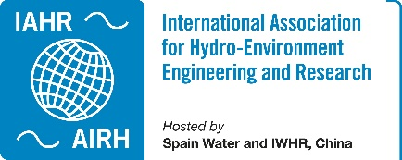 IAHR TC/WG Annual Report 2023

Committee on Flood Risk Management
The committee aims to provide a platform for the members of our community with interest in the current concerns on integrated flood risk management. The FRM TC promotes the exchange of ideas on FRM through the organization of scientific events, such as seminars, workshops, and conferences, and acts as a contact point with sister associations dealing with FRM.
Webpage | https://www.iahr.org/index/committe/11
Chair | Daniela Molinari, Politecnico Di Milano - DICA, Italy
Past Chair | Alastair G. Barnett, HYDRA Software Ltd, New Zealand
Vice Chair | Stefan Haun, University of Stuttgart, Germany
Primary affiliates | 315
Secondary affiliates | 728
Tertiary affiliates | 1148

Activities of the Year 2023
Including but not limited to conferences, webinars, publications, TC/WG meetings, elections, participation in international processes, etc. Some examples below:
White paper: The role of hydraulic engineering in support of flood mitigation and resilience
This important White Paper, co-authored by members of the FRM Technical Committee, provides an overview of principles and ongoing developments in Integrated Flood Risk Management (IFRM), a holistic approach aimed at managing floods properly and effectively.
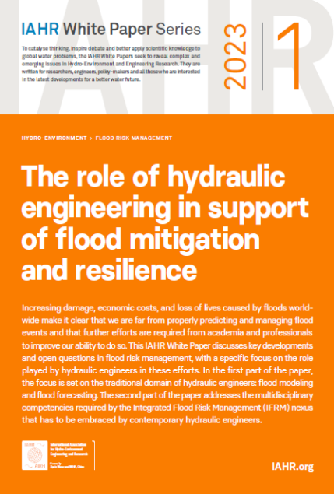
https://www.iahr.org/library/infor?pid=26749

Hydrolink paper: Integrated flood risk management as a tool to achieve UN Sustainable Development Goals
Floods are the most frequent type of hazard around the globe, affecting more people than any other natural hazards. A total of 222 floods were recorded in 2021 with approximately 30 million affected people (www.emdat.be/database). In 2030, this number could rise to 54 million/year according to the World Resources Institute, despite large infrastructure investments made to mitigate disaster risk. Effective practices of Integrated Flood Risk Management (IFRM) are needed to achieve Sustainable Development Goals in the next future.
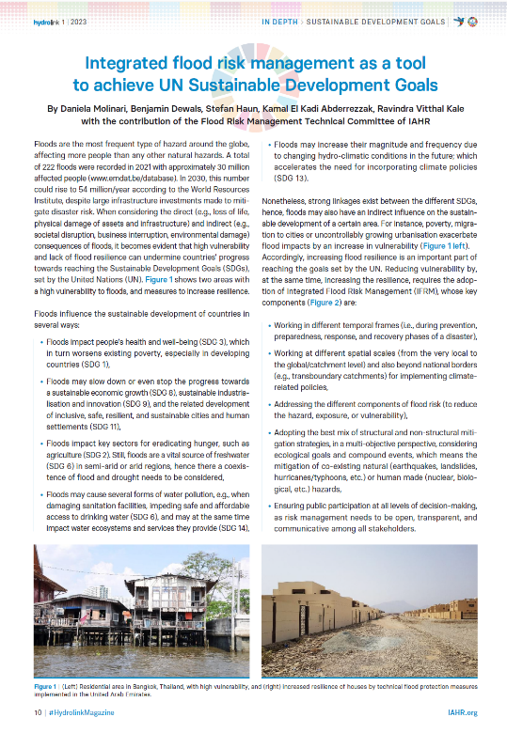
https://www.iahr.org/library/infor?pid=26734
40th IAHR World Congress: “Integrated Flood Risk Management from Science to Practice” special session
August, 2023. Austria.
Intending to bridge the connection between scientific researchers, practitioners, and flood managers for sustainable flood risk planning and implementation, the session collected 11 contributions from 7 countries.
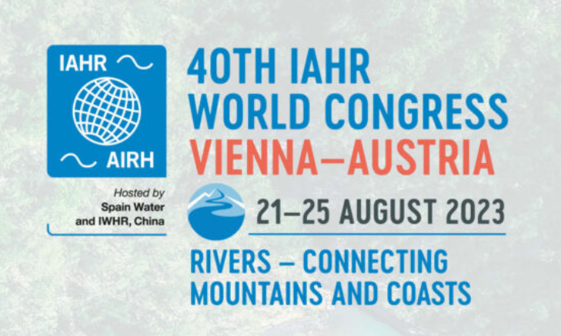
https://rivers.boku.ac.at/iahr/special-sessions-2/integrated-flood-risk-management-from-science-to-practice/

4th IAHR Young Professionals Congress: “Flood Risk Management” session
November 2023, Online
The IAHR Young Professionals Congress is an online, free-of-charge Congress, a wonderful opportunity for early-career scientist from all the world to present their work and get mentoring from leading experts. The session on Flood Risk Management collected 7 contributions from 5 countries and lead to a very fruitful discussions towards future challenges of FRM. https://www.iahr.org/index/detail/992

40th International school of Hydraulics: “Basic Features of HEC-RAS Software” course
May 2023, Poland
The course was held by FRM-TC member Dr. Tomasz Dysarz. The purpose of the course was a short and gentle introduction to HEC-RAS, one of the most powerful tools for hydrodynamic simulation of free-surface flows. The focus is set on the preparation of a hydrodynamic model with and without GIS data. In the course small, but very active and enthusiastic groups of students participated. The course, which was held for the first time can be considered as very successful. Hence, it is possible, that the course will be performed as a standard workshop ahead of the International Schools of Hydraulics in Poland, held every two years.
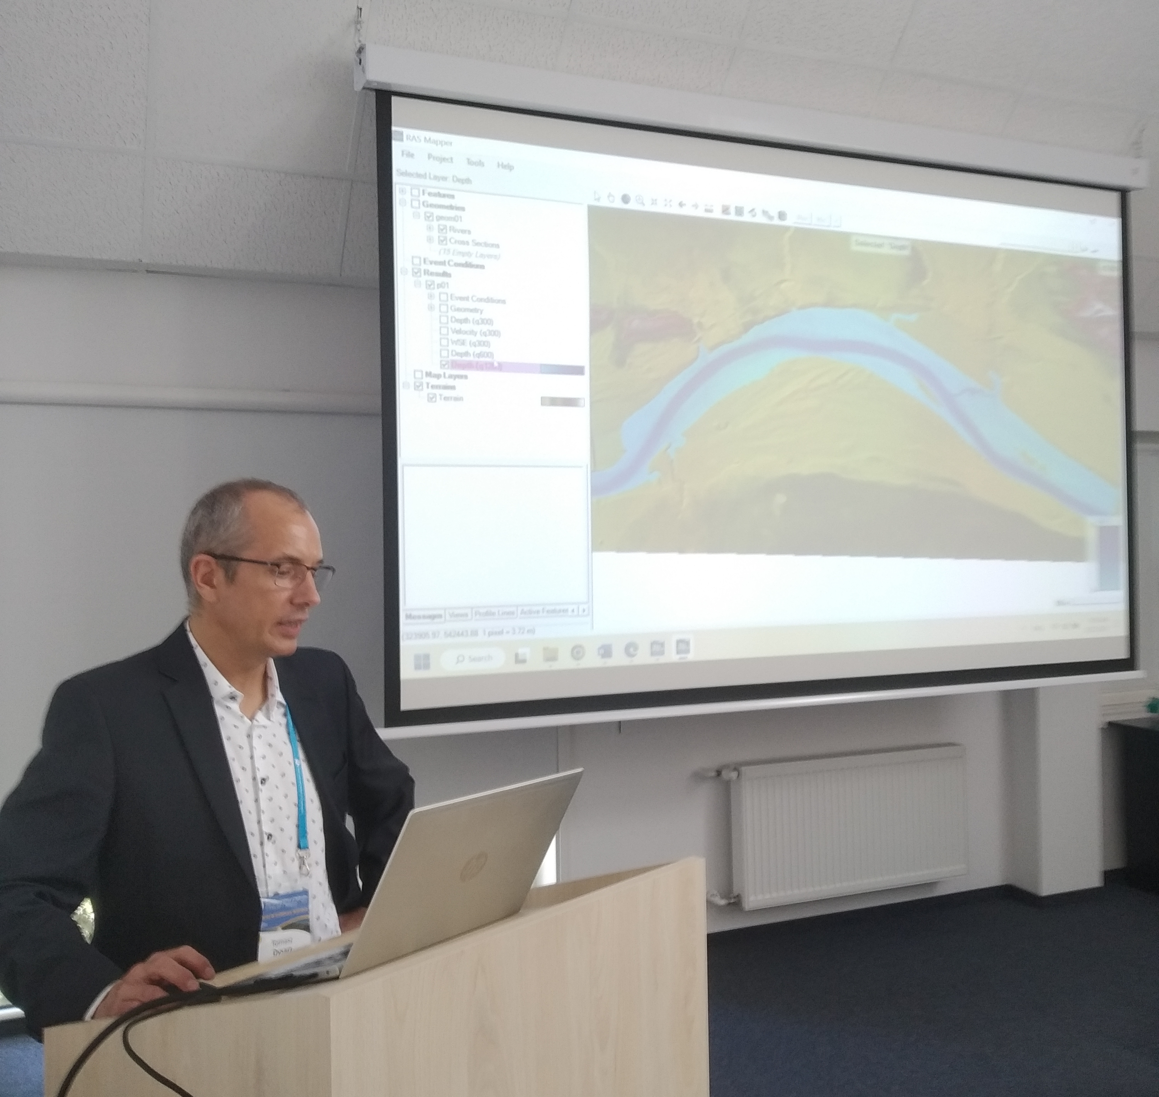
Dr. Tomasz Dysarz, member of the FRM TC during his presentation.

Activities of Future Years
Including but not limited to conferences, webinars, publications, TC/WG meetings, elections, participation in international processes, etc.
8th IAHR Europe Congress: “Flood risk management for El Niño phenomena global impact 2023-2024” special session
June, 2024. Portugal
The special session is co-organized by FRM-TC members and aims at discussing the role of El Niño phenomena, as impacted by climate change, on the recent and future flood events.

https://www.iahr2024.lnec.pt/special-sessions

“Vision paper on the current and the future vision of IFRM”
December 2024 (expected)
The FRM Technical Committee is leading a new initiative aimed at defining a future and shared vision of Integrated Flood Risk Management. More than 15 experts have been already involved by participating in a survey, and we want to include people associated with our committee during the next year. https://www.iahr.org/index/committe/11

