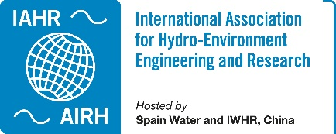 IAHR TC/WG Annual Report 2023

Committee on Fluid Mechanics
Focusing on fundamental and applied environmental fluid mechanics in support of hydraulic research, with particular emphasis on the fundamentals of transport and mixing phenomena in turbulent flows such as contaminant transport processes in rivers, lakes and coastal regions, anthropogenic influences (e.g., heat, dissolved and suspended organic/inorganic material) and sediment dynamics.
Webpage | https://www.iahr.org/index/committe/2
Chair | Claudia Adduce, Roma Tre University, Italy
Past Chair | Vladimir Nikora, University of Aberdeen, United Kingdom
Vice Chair | Thorsten Stoesser, University College London, United Kingdom
Primary affiliates | 347
Secondary affiliates | 616
Tertiary affiliates | 1064

Activities of the Year 2023

Master Class A: Fluid Mechanics for Instrumentation for Fluid Mechanics at the 40th IAHR World Congress.
August 20, 2023. Wien, Austria.
We organized jointly with the Experimental Methods Committee the master class Fluid Mechanics for Instrumentation for Fluid Mechanics at the 40th IAHR World Congress. The master class was convened by Prof. Rui M.L. Ferreira (Ceris, University of Lisboa) and Prof. Rita F. Carvalho (Mare-Arnet, University of Coimbra) and the masters were Prof. Stuart Cameron (University of Aberdeen), Prof. Stefan Felder (University of New South Wales), Prof. Rita Carvalho (Mare-Arnet, University of Coimbra).

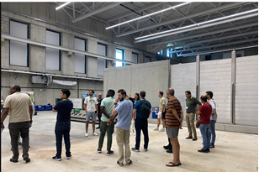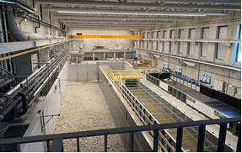
https://rivers.boku.ac.at/iahr/masterclasses-and-workshops/fluid-mechanics-for-instrumentation-for-fluid-mechanics/

Hosting an Open LT Meeting during the 40th IAHR World Congress
August 20, 2023. Wien, Austria
Given the World Congress in Austria, we hosted an open LT meeting on August 20 for all TC members, or anyone else from IAHR who would want to attend. During the meeting there was the leadership transition: Prof Claudia Adduce became Chair and Prof Vladimir Nikora moved to the role of past Chair.

Organizing Special Sessions at the 40th IAHR World Congress
August 21-25, 2023. Wien, Austria.
We organized two special sessions at the World Congress in Wien in August:
- Hydrodynamics of open channel flows: legacy of professor Wlodzimierz Czernuszenko, convened jointly by Prof. Pawel Rowinski (Polish Academy of Sciences) and Vladimir Nikora (University of Aberdeen)
- Turbulence modelling for and simulation of hydro-environmental flows - past, present, future, convened jointly by Prof. Thorsten Stoesser (University College London), Vladimir Nikora (University of Aberdeen).

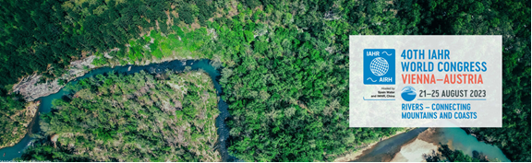
https://rivers.boku.ac.at/iahr/special-sessions-2/hydrodynamics-of-open-channel-flows/
https://rivers.boku.ac.at/iahr/special-sessions-2/turbulence-modelling-for-and-simulation-of-hydro-environmental-flows/

9th Gerhard Jirka Summer School on Environmental Fluid Mechanics
August 28-September 1, 2023. Dresden, Germany
The Gerhard Jirka Summer School on Environmental Fluid Mechanics was organized under leadership of Prof. Bernhard Vowinckel, Technical University of Dresden, Germany. A central objective of the School has been to combine theory, experiments and applications, with an emphasis on basic theoretical principles (and their mathematical description) as well as consideration of examples of engineering design and environmental applications. This objective is realized in the School through formal, in-class lectures as well as informal, out of class excursions and visits.
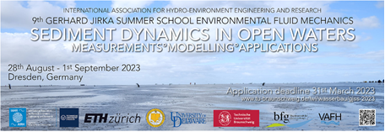
https://www.tu-braunschweig.de/lwi/wasserbau/gjss-2023

4rd IAHR Young Professionals Congress
November 22-24, 2023. Online
The Technical Committee on Fluid Mechanics strongly supported the 4rd IAHR Young Professional congress including:
- Members of the Scientific Committee.
- Session on Fluid Mechanics with 9 presentations, which was chaired by the Fluid Mechanics Committee Chair Prof Claudia Adduce as well as Prof. Rita Carvalho member of the LT of the Fluid Mechanics Committee.
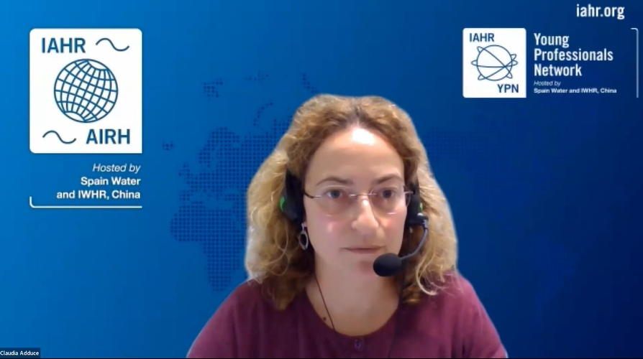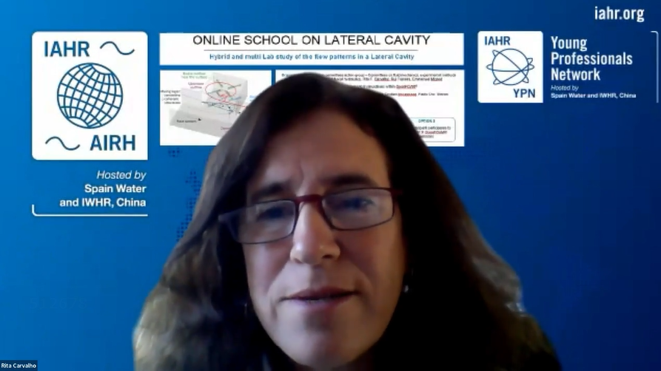
https://www.iahr.org/index/detail/992
Video of the Fluid Mechanics Session https://www.iahr.org/video/clip?id=1615

Contributing to IAHR publications
Members of the LT of the Fluid Mechanics Committee have contributed to IAHR publications through their services to the Journal of Hydraulic Research (Associate Editors: Damien Violeau, Claudia Adduce, Alexander N. Sukhodolov, Thorsten Stoesser, Vladimir Nikora), Journal of Ecohydraulics (Associate Editor: Vladimir Nikora), Environmental Fluid Mechanics (Editor in Chief: Harindra Joseph Fernando; Associate Editor: Claudia Adduce) and IAHR Publication Committee and Task Force on Monograph Series (Damien Violeau, Claudia Adduce, Vladimir Nikora).

Activities of Future Years

Online School on Lateral Cavity: Hybrid and multi Lab study of the flow
February-March, 2024. Online
The online course is organised by an IAHR cross committees action group - Committees on Fluid Mechanics, Experimental Methods and Instrumentation and Fluvial Hydraulics to enhance knowledge on open-channel fluid mechanics, use of advanced tools, instrumentation and numerical modelling, and analysing results in depth. Organizers: Prof. Rita F.Carvalho, Prof. Rui M.L.Ferreira, Prof. Emmanuel Mignot.
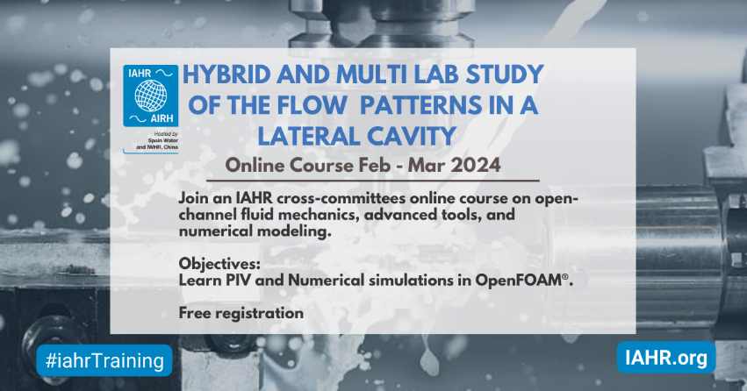
https://www.iahr.org/index/detail/1204

10th International Symposium on Environmental Hydraulics
June, 2024. Aberdeen, UK.
To be organized under leadership of Dr. Dominic Van der A, University of Aberdeen, UK.
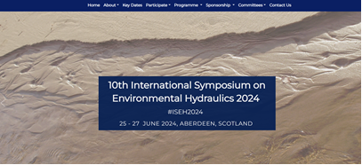
https://abdn.eventsair.com/iseh2024/

6th ISSF - International Symposium on Shallow Flows
September, 2025. Torino, Italy.
To be organized under leadership of Prof. Costantino Manes, Politecnico di Torino, Italy.
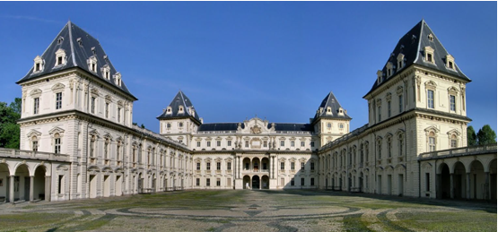

10th Gerhard Jirka Summer School on Environmental Fluid Mechanics
2025, Lima, Peru.
To be organized by Dr Daniel Horna-Munoz, Universidad de Ingeniería y Tecnología, Peru.

11th International Symposium on Environmental Hydraulics
June 2027. USA.
To be organized by Prof. George Constantinescu, University of Iowa, USA.


