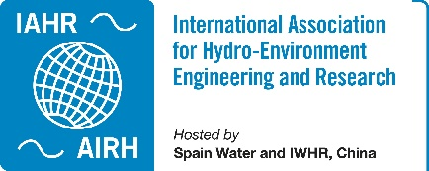 IAHR TC/WG Annual Report 2023

Committee on Water Resources Management
Improving understanding about the linkages between water-related decision-making, society and the environment, promoting the use of advanced technologies to address problems of environmentally sound water resources management, encouraging interdisciplinary approaches in hydraulic engineering with special regard to ecological concerns, and promoting the adoption of appropriate methodologies for developing countries by education and by training.
Webpage | https://www.iahr.org/index/committe/18
Chair | Satoru Oishi, Research Center for Urban Safety and Security, KOBE University, Japan
Past Chair | Elpida Kolokytha, Aristotle University of Thessaloniki, Greece
Vice Chair
Primary affiliates | 544
Secondary affiliates | 830
Tertiary affiliates | 1086

Activities of the Year 2023:

40th IAHR World Congress
August 20, 2023. Vienna, Austria.
During the 40th IAHR World Congress held in Vienna Austria, Committee on Water Resources Management had an in-person meeting at the new laboratory of BOKU on August 20, 2023. There are 7 members in-person, many members attended through remote meeting system. We talked about our past activities, up-coming activities and books that we will publish.
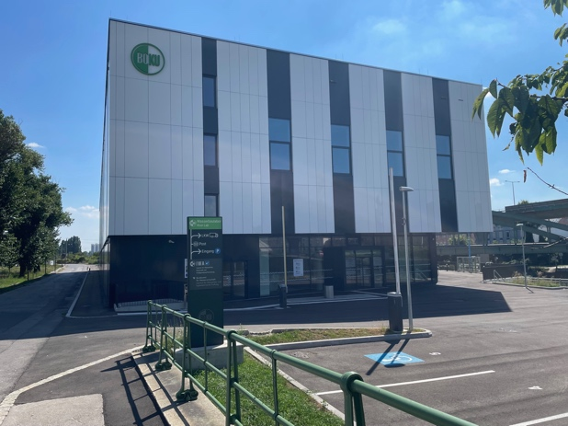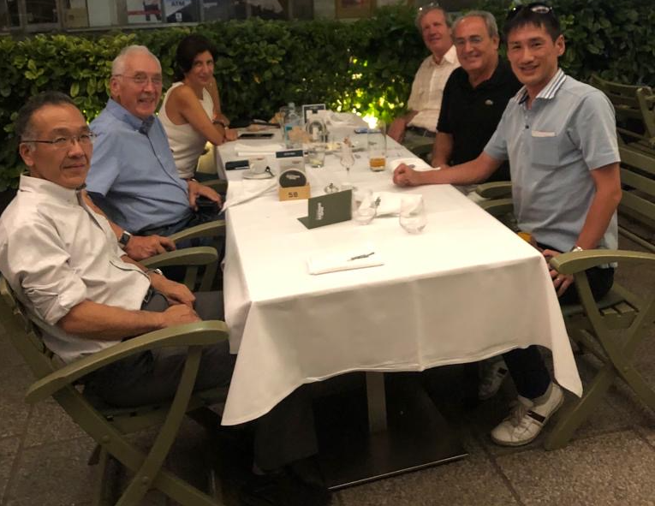
https://www.iahr.org/video/collection?id=98

Activities of Future Years

24th IAHR-APD
October 14-17, 2024. Wuhan, China
The theme of 24th IAHR-APD Congress is “Water for a Changing Future”, emphasizing the urgent need to improve water science and technology to respond to a rapidly changing world and collaborate towards a sustainable future. Seven sub-themes focusing on water disaster risk reduction, integrated water resources management, eco-hydraulics and environment, water-energy-food nexus, adaptation and resilience to climate change, smart water, sediment regulation and management have been proposed under the main theme. We are delightful to provide a platform to share experiences, promote discussion, and to present new knowledge, research results and developments in the field of water sciences and technologies.
Committee on Water Resources Management will have a meeting there as well as we will serve for the meeting as chairs.
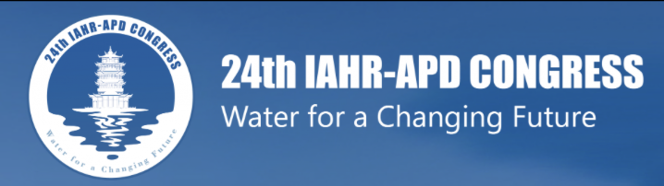
https://iahrapd2024.aconf.cn

