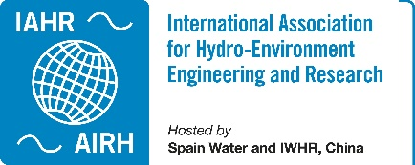 IAHR TC/WG Annual Report 2023

Working Group on Transient Flows
Providing with a framework to the transient group community within IAHR association.
Webpage | https://www.iahr.org/index/committe/115
Chair | Silvia Meniconi, University of Perugia, Italy
Past Chair | Moez LOUATI, The Hong Kong University of Science and Technology, Hong Kong, China
Vice Chair | David Ferras Segura, IHE Delft Institute for Water Education, Netherlands
Primary affiliates | 86
Secondary affiliates | 86
Tertiary affiliates | 371

Activities of the Year 2023
Meetings held during 2023 by the Working Group leading team:
- August 22 2023, face to face meeting.
- September 26 2023, online meeting.

Special session on transient flows during the 40th IAHR World Congress
August 22, 2023. Vienna, Austria.
Convenors: Moez Louati and Silvia Meniconi
The field of hydraulic transients, which is important for system design and recently found to be valuable for system diagnosis, is being studied by over 500 researchers around the world. The session aimed to provide exchange framework among this community. Seventeen research works were presented covering a broad spectrum range within pressurized transient flows theme involving new experimental methods, numerical developments, design, diagnosis and system operation methods, etc. Overall this was a successful session and the WG leading team is now looking forward for the 41st World Congress.
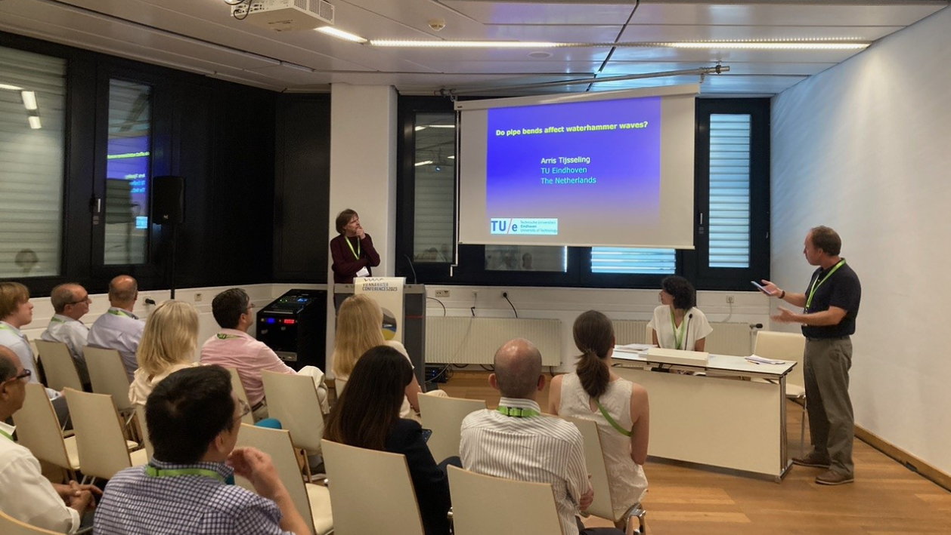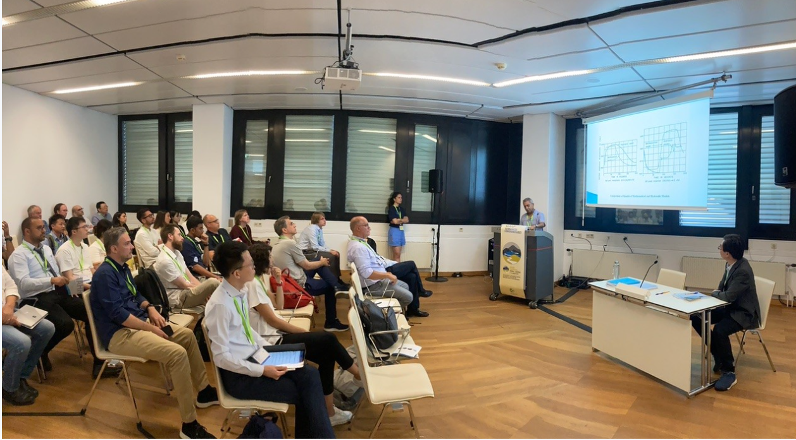
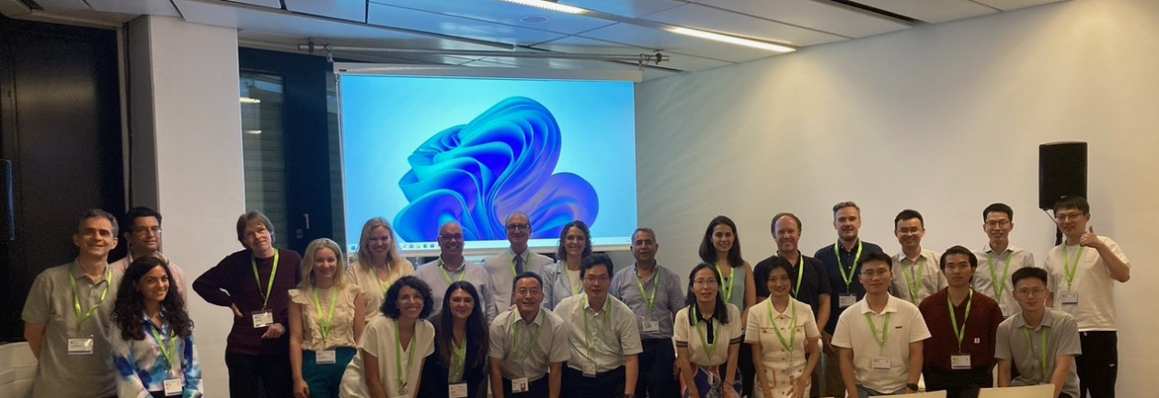

https://rivers.boku.ac.at/iahr/#

After the session there was the face to face meeting of the Working Group on Transient Flows, during this meeting the composition of the leading team was renewed. More information about the WG aims and leading team can be found in: https://www.iahr.org/index/committe/115

IAHR Online Short Course

Perspectives on Two-phase Flows in Urban Water Systems
Date. May 8, 2023 (online)
This course is organised by the IAHR Working Group on Transient Flows in collaboration with the Environmental & Water Resources Institute (EWRI-ASCE). The course sessions are structured to follow the chapters of a monograph on air-water interaction in Urban Water System that is undergoing development by the working group members of EWRI and the IAHR Technical Committee on Hydraulic Structures.
https://www.iahr.org/index/detail/832

Activities of Future Years

Thematic symposium on transient flows
Date. To be determined
The Working Group on Transient Flows would like to launch the 1st Thematic Symposium on Transient Flows. The Symposium is expected to be held during late 2024 or early 2025. Right now, we are at the bidding process stage and currently collecting expressions of interest.

Special session on transient flows during the 8th IAHR Europe Congress
Date. 4-7 June 2024, Lisbon (Portugal)
Considering the good experience of the special sessions organized by the Working Group in the past IAHR World Congresses, now we would like to extend this initiative to regional congresses. A special session for the 8th Europe Congress on Transient Flows has been accepted by the organizing committee and the WG is looking forward to work on its implementation.
https://www.iahr2024.lnec.pt/

IAHR Monograph on transient flows
Date. To be determined
As a result of the online course on transient flows. The working group is now working on the writing of an IAHR monograph including all the course contents, which were presented by top researchers in the field covering its whole spectrum. We expect to come up with a first monograph draft during early 2024.
https://www.iahr.org/index/detail/453

