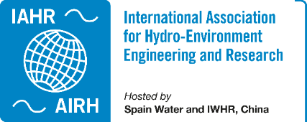

Annual Report 2023

Technical Committee/Working Group
This form is to collect the annual report on the activities of your TC/WG. IAHR Secretariat will compile all the reports received and share them internally with the IAHR Council and all TCs/WGs.
TC/WG | Committee on Global Water Security
Webpage | https://www.iahr.org/index/committe/136
Founding year | 2019
Chair | Roger Falconer, Cardiff University, United Kingdom of Great Britain and Northern Ireland  Arthur Mynett, IHE Delft Institute for Water Education, Netherlands
Past Chair | Nil
Vice Chair | Nil
Primary affiliates | 66
Secondary affiliates | 240
Tertiary affiliates | 770

I. Activities of the year 2023
Please specify what activities have been organized by your TC/WG during the past year, including specialty conferences, activities related to world and regional congresses, educational activities, publications, contacts with other organizations, etc.

Activity 1 | 1st IAHR International Conference on Global Water Security and 4th International Forum on Water Security and Sustainability
Dates and Venue | 29th October – 1st November 2023. Changzhou City, China.
Description | The main activity of the IAHR Global Water Security Technical Committee during 2023 was the highly successful 1st IAHR International Conference on Global Water Security. This event was held jointly with the 4th International Forum on Security and Sustainability, and with the event being sponsored by Hohai University and the Nanjing Hydraulic Research Institute. The programme was organized by Profs. Roger Falconer and Arthur Mynett of the IAHR GWS TC, together with Profs. Yu Ye, Jina Yin and Teng Xu from the Yangtze Institute for Conservation and Development, with the conference development being overseen by Prof. Chunhui Lu, Director of the Institute.  The conference was hosted by Hohai University, at its new campus in Jintan District, Changzhou City. The Organising Committee was chaired by Academician Jianyun Zhang, with much support given by Academician Hongwu Tang (Chair of Hohai University). The conference sponsors included: IAHR, the Chinese Hydraulic Engineering Society, Hohai University and Nanjing Hydraulic Research Institute, and the hosts included: Yangtze Institute for Conservation and Development, The National Key Laboratory of Water Disaster Prevention, JRC Water Science and Water Engineering, MWR Research Center for Climate Change, National Engineering Research Centre for Water Resources Efficient Utilization and Engineering Safety, and IAHR-Hohai Co-Committee on Higher Education and E-Learning.  The conference opening ceremony attracted about 1,200 delegates and was opened by: Academician Jianyun Zhang, Prof. Guishan Yang (President of Hohai University), Prof. Roger Falconer (Co-Chair IAHR TC), Prof. Xuewen Zhou (Secretary General of the National Flood and Drought Control Demand). Keynote presentations were then given by: Prof Zhiya Zhong (Chief Engineer, Ministry of Water Resources), Prof. Annan Wang (Director China South-to-North Water Transfer Group Co.), Prof. Philippe Gourbesville (President of IAHR), and Academician Tandong Yao (Qinghai-Tibet Plateau Research Institute of the Chinese Academy of Sciences). Other keynote speakers included: Dr Mark Fletcher (Arup Fellow), Prof. Dragan Savic (CEO of KWR Water, Netherlands), Dr Harry Seah (Deputy CEO of Public Utilities Board of Singapore), Prof. Eelco van Beek Deltares Research Institute), Prof. Chris Zevenbergen (IHE Delft), Prof. Mohamed Ghidaoui (Vice-President of IAHR), Academician Hongwu Tang (Party Secretary, Hohai University), Prof Dr Rahmah Elfithri (UNESCO, Paris).  Following the keynote presentations delivered on the first day of the conference, over 140 technical papers were presented on the following day from a diverse community of international and national speakers on the 5 key topic themes, including: (i) Integrated River Basin Management; (ii) Climate Change and Risk Management; (iii) Water Engineering and Smart Water Conservancy; (iv) Eco-environmental Protection; and (v) Conservation and High-quality Development of the Yangtze River and Yellow River Basins. All of the parallel sessions were very well attended by delegates and intensive discussions were held in the Question-and-Answer sessions as well as outside the programmed parallel sessions.  On the final day of the conference, two technical site visit tours were organised to: (i) Jintan City Image Pavilion, Hua Luogeng Memorial Hall, Changdang Lake Governance Exhibition Hall, Digital Fishing Farm, or (ii) Jintan City Image Pavilion, German Center, Beehive Energy or China Innovation Aviation, Changbao Pleasant Steel Pipe or Xinwei Communication.  The 1st IAHR conference on Global Water Security was deemed to be an excellent inaugural event by those IAHR Technical Committee members in attendance at the conference, and discussions will soon be commenced on the next international conference to be held in 2027.
Pictures | 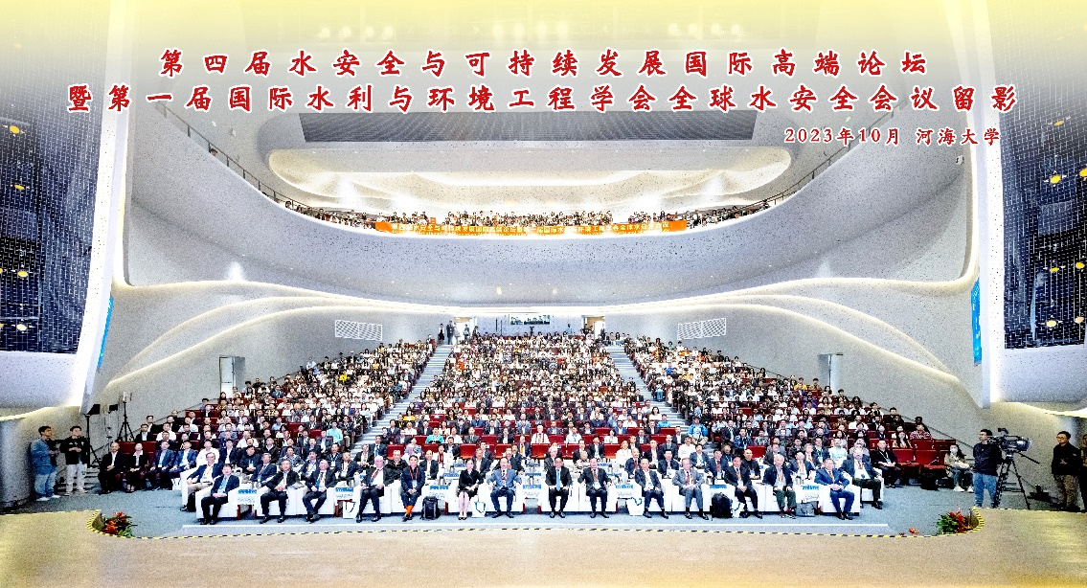  View of the packed auditorium at IAHR’s 1st International Conference on Global Water Security  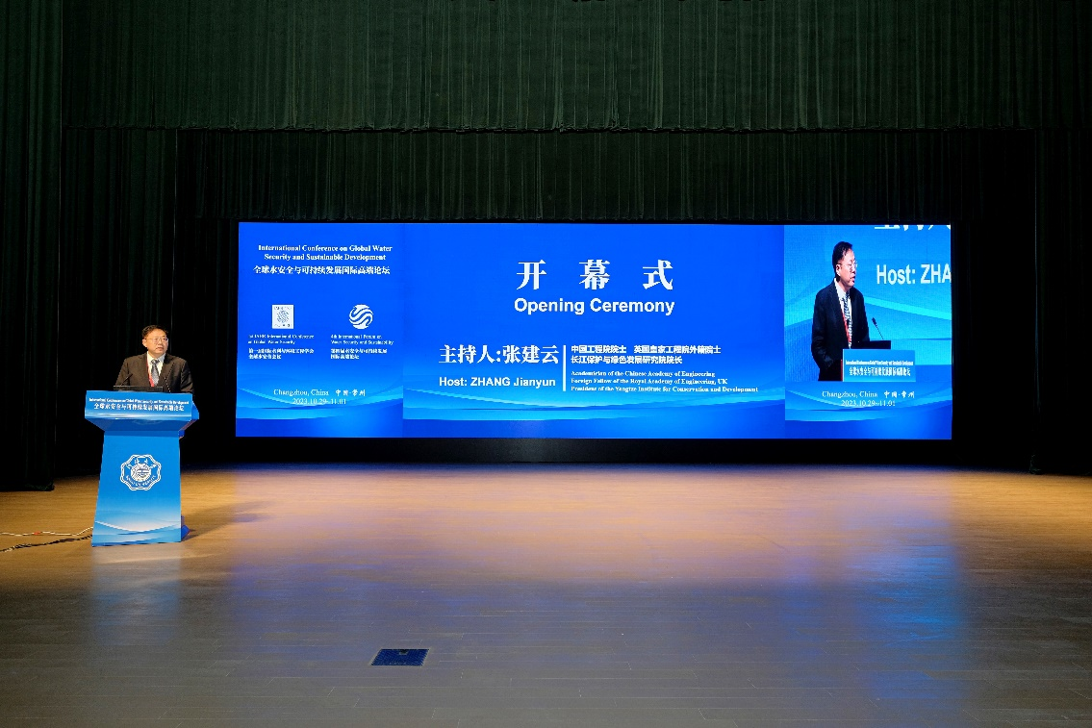  Academician Professor Jianyun Zhang, Past President of Nanjing Hydraulic Research Institute Chairing the Conference Opening Ceremony  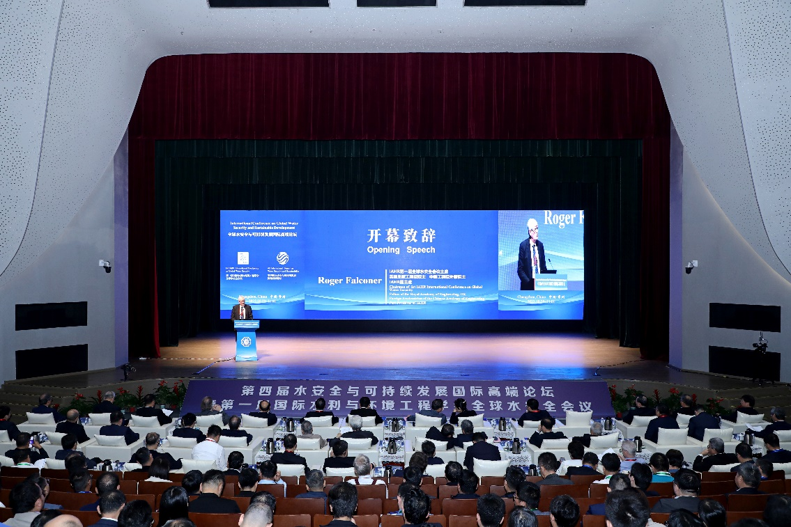  Professor Roger Falconer Introducing IAHR and the Global Water Security Technical Committee at the Conference Opening Ceremony

Activity 2 | Delivery of IAHR Resource Guide on Global Water Security
Dates and Venue | 29th October 2023, via IAHR China Office
Description | The IAHR Technical Committee Co-Chairs worked with Sally Feng at the IAHR China Office to produce a detailed topic-specific catalogue guide to the resources delivered by the Global Water Security Working Group (2019-21) and Technical Committee (2021-date). The GWS TC focuses on all aspects of water resources and quality, with particular focus on the transport of sediments and polluting species (including species dissolved or in suspension within a water body and/or adsorbed on the sediment). This includes processes in catchments, rivers, urban systems, groundwater systems, estuaries, coastal basins and seas. The Co-Chairs are very grateful to the IAHR China Office for the support in producing this valuable document. The document can be accessed here: IAHR Resource Guide on Global Water Security
Picture | 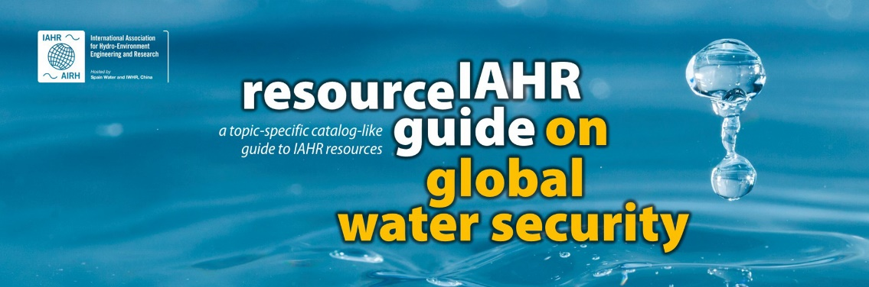

Activity 3 | Informal Meeting of IAHR Global Water Security Technical Meeting at 1st IAHR Conference on Global Water Security
Dates and Venue | 31st October 2023, Marriott Hotel, Changzhou, China
Description | An informal meeting was held during the 1st IAHR Conference on Global Water Security to enable Prof. Falconer to outline the key issue that both he and Prof. Arthur Mynett felt that they should now stand aside as Co-Chairs of the Global Water Security Technical Committee and remain as advisors to new incoming Co-Chairs. It was suggested that the Technical Committee should consider replacing Profs. Falconer and Mynett, ideally with a representative from Europe and another from China – particularly with the strong international reputation of the Water Security and Sustainability Forum, which has been in operation over the past decade. Prof. Reza Ahmadian’s name was suggested for Europe, having been involved in UK IAHR activities for many years and having worked with Prof. Falconer on Global Water Security.
Pictures | Nil

Activity 4 | 2023 International Cooperation & Exchange Week on Integration of Industry, Education, Research and Application (Jiangsu, China)
Dates and Venue | 1st November 2023, Lecture Hall, Hohai University, Changzhou New Campus, Hohai University
Description | At the end of the IAHR International Conference on Global Water Security several GWS TC members present, along with the President of IAHR, Prof. Philippe Gourbesville attended and participated in the Environmental Engineering Sub-Forum of the above event, also held at Changzhou. The Opening Ceremony was addressed by the Vice President of Hohai University, the Leader of Jiangsu Education Department and Prof. Roger Falconer on behalf of IAHR. The speakers focused on environmental engineering challenges and the importance of water security.  The Opening Ceremony was then followed by a series of presentations from Chines faculty along with the following IAHR members: Profs. Philippe Gourbesville (IAHR President), Reza Ahmadian (Cardiff University), Michael Harnett (University of Galway) and Shunqi Pan (Cardiff University). The Forum was attended by over 200 graduate students and engineers, who engaged in a wide-ranging debate on issues relating to engineering training, water security, forestry, environmental management, etc.
Pictures | 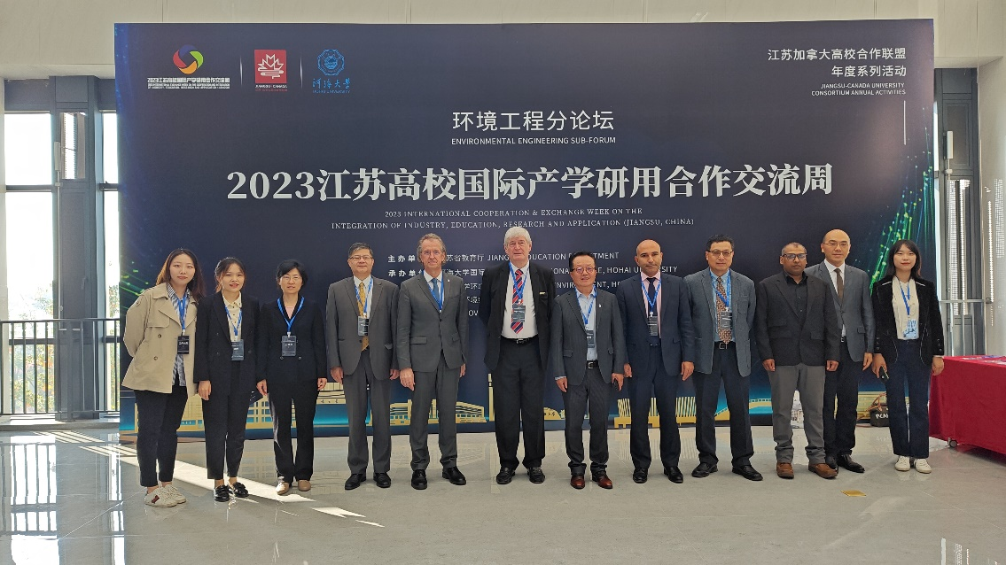  Speakers and organizers at the Environment Engineering Sub-Forum of the Forum on Integration of Industry, Education, Research and Application

II. Activities of future years
Activity 1 | Continue the series of webinars, with this programme of events being driven by the incoming chairs and planning for the 2nd International Conference to be held in 2027.
Dates and Venue | Various
Description | Suggested topics for webinars (typically two per annum and not in order of priority) might include :  1. Hydro-environmental Modelling and Assessment  2. Hydro-biological Processes  3. Hydro-morphological Processes  4. Groundwater Transport Processes  5. Groundwater Transport Processes  6. Nature-Based Solutions  7. Disaster Risk Reduction and Resilience  8. Climate Change and Population Growth Impacts  9. Digital Water Transformation  10. Data Technologies  11. Design of Storage Facilities, Coastal Basins and Desalination Plants  12. Agricultural and Aquaculture Developments  13. Water Pollution and Health Risks in Africa  14. Water Transfer and Governance  15. Externalities of Engineering
Pictures | Nil

III. What are badly needed for your TC/WG?
Please rank the level of importance of the following items for the development of your TC/WG, with 1 indicating the most important. Items not included in the following table can be added to the end.
Rank | Items
5 | Increase the exchange and collaboration between and among different TCs/WGs
4 | Increase the interaction between TC/WG and IAHR members
2 | Increase the participation and visibility of TC/WG in the IAHR World Congress
3 | Increase the involvement of your TC/WG in the international initiatives/processes (e.g., those under the patronage of UN-Water, UNESCO, FAO, UNEP, etc.)
7 | Summarize the latest scientific and academic progress of the research fields in a way (article, report, white paper, etc.) that can be shared with the community
Not needed | Provide software and logistics support for TCs/WGs to organize webinars and online meetings
6 | Seek financial support for the development of the TC/WG
1 | Better recognition of our Technical Committee as it attracts practitioners to IAHR – it should not be listed as part of Hydro-Environment and not part of Professional Development

IV. Level of relevance to agendas
Please rank the level of your TC’s/WG’s relevance to the following technical agendas, with 1 indicating the most relevant and 5 the least.
Rank | Items
4 | Digital water futures: AI, modelling, and data
1 | Engineering global water solutions with nature and ecosystems
2 | Hydraulics for sustainable development
3 | Hydro-environment pathways towards carbon neutrality, adaptation, and resilience
5 | Innovations, capacity building and professional development

+++++++++++++++++++++++++++++++++++++++++++++++++++++++++++++++++++++
Thank you for taking your precious time in completing this report. IAHR wouldn’t be IAHR if without the selfless and generous contributions by our technical committees and working groups.
Thank you very much!
Please contact Ms. Jenny Lu (jenny.lu@iahr.org) whenever you need support from the Secretariat.
+++++++++++++++++++++++++++++++++++++++++++++++++++++++++++++++++++++

