IAHR Experimental Methods and
Instrumentation Committee

Minutes of EMI Technical Committee meeting during IAHR World Congress, Monday 23rd, June 2025, 16:00 Singapore time (10:00 Central Europe time) – EXPO Singapore, Room A

1. Information
The EMI Committee scope, composition and activities were briefly presented by the Chairman, Massimo Guerrero. The activities developed during the period September 2022- June 2025 corresponding to the EMI mandate chaired by Massimo Guerrero were presented.
The scope of EMI is to share instrumental-experimental solutions and data for heterogenous applications in hydraulics. This scope has been targeted by means of specific actions in the aforementioned period:
- Four editions of the W.A.T.E.R. Summer School editions:
- 6th edition at Instituto Superior Técnico of the University of Lisboa, Portugal (July 2022).
- 7th edition at The Oskar von Miller Institute of the Technical University of Munich, Germany (July 2023).
- 8th edition at the ICube laboratory, inStrasbourg, France (July 2024).
- 9th edition at the Institute of Hydro-Engineering of the Polish Academy of Sciences, Gdansk, Poland (scheduled for 1-5 September 2025).
- On-line mentoring in collaboration with YPN Committee (3rd and 4th YPN Congress, including the “Experimental Data Challenge” initiative).
- Through cross- action involving EMI, Fluid Mechanics and Fluvial Hydraulics committees.
- Several special sessions at World and European IAHR congresses and a couple of special issues/paper collections on Acta Geophysica
The need for continuing/fostering cross-actions between different TCs was stressed by Rui Ferreira and Vladimir Nikora.
A discussion followed about the need of renewing/fostering EMI LT commitment around well-defined tasks. Candidates to LT positions should bring their own personal projects, aligned with the strategic plan of IAHR, the strategic plan of EMI and the resulting outcomes from online survey launched in late 2022 within IAHR community: “A portrait of the IAHR Experimental Methods and Instrumentation community”.
To overcome the issue of limited time/resources preparing applications for funding involving IAHR members and external entities should be a priority.
Massimo Guerrero reported about suggested idea by Marian Muste regarding the formation of Working Group on Hysteresis in Rivers Flow (i.e., Q-H relation). A discussion followed about required effort and specific tasks of such a WG. No decision was formulated.
A wider involvement of industry appears relevant both in terms of instrument producers/expertise and water agencies/authorities which might benefit from knowledge transfer promoted within EMI. Concrete actions may follow initiatives of new LT members to be elected and by co-opted members
The new Vice-Chair was announced: Marie Burckbuchler from Ubertone (Strasburg-France) will take the Vice-Chair role following the World Congress in Singapore while Margaret Chen will step up to Chair role and Massimo Guerrero will be the Past-Chair.

2. EMI Initiatives
The 9th W.A.T.E.R. Summer School edition was briefly presented that will take place the first week of September 2025 at IBW-PAN, Rui Aleixo from EMI is leading the local organization
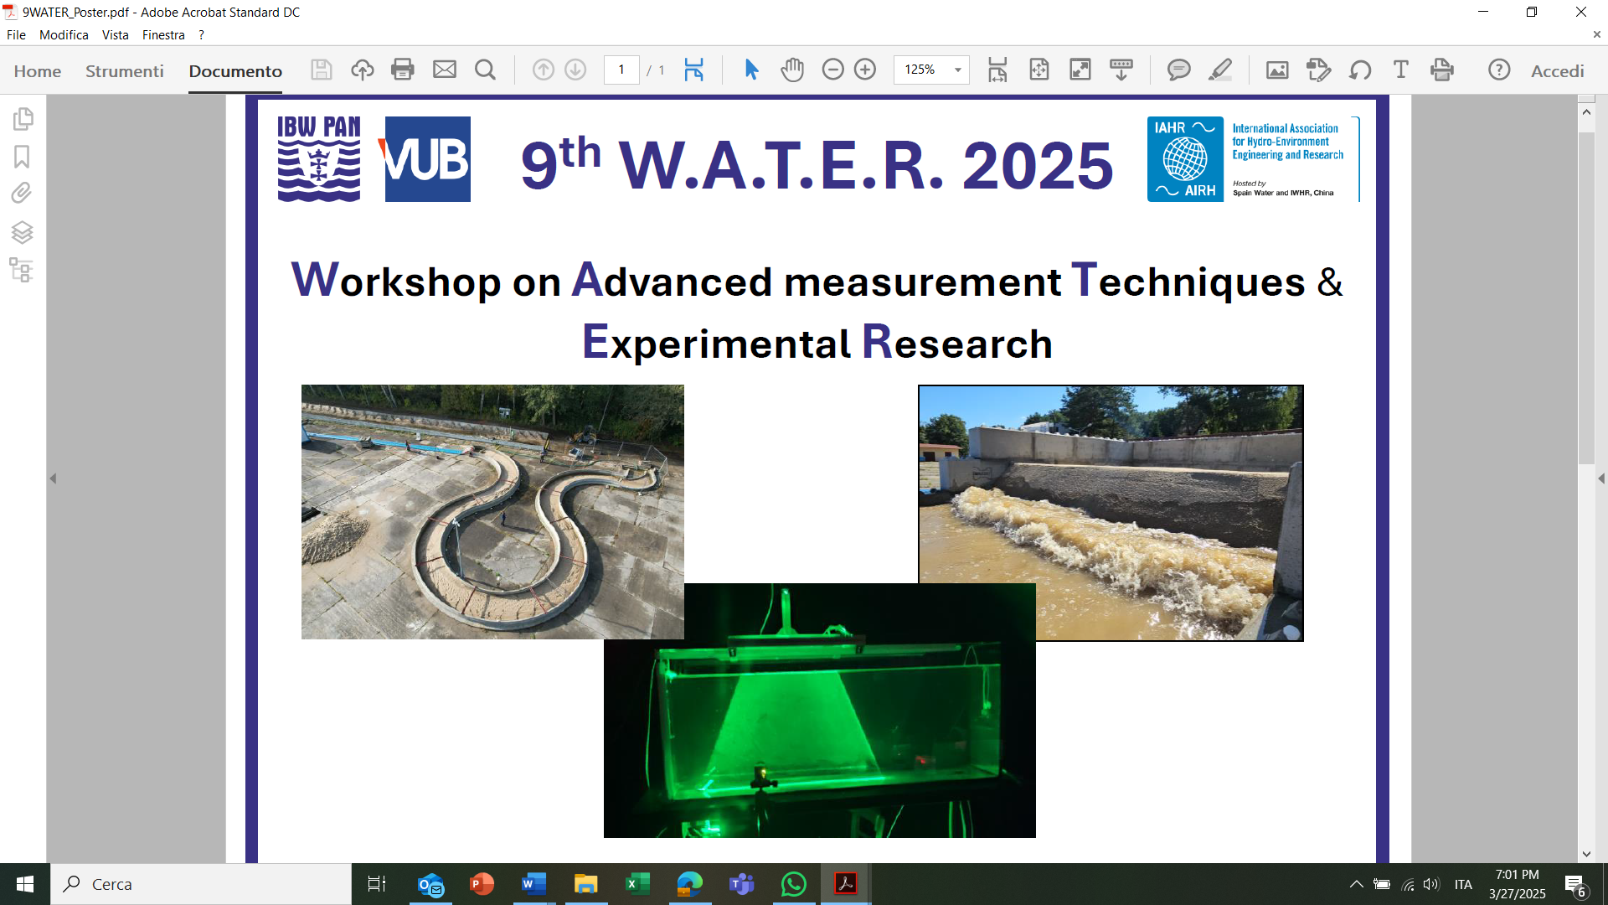
Figure 1: 9th W.A.T.E.R. edition Flyer
The 10th edition host is still to be decided. a call for possible candidates will be opened soon.

3. IAHR events and initiatives
EMI will contribute to WATER Monograph Series by developing the Monograph:
“Sediment fluxes investigation by means of the Acoustic Doppler Current Profiler (ADCP)”
Slaven Conevski, Dan Haught, Massimo Guerrero, Jeremy G. Venditti, Colin Rennie, Nils Ruther
Massimo Guerrero reported about the advancement of this work that should be published in 2026. This will in addition include/share Matlab scripts for ADCP output analysis and data for testing.
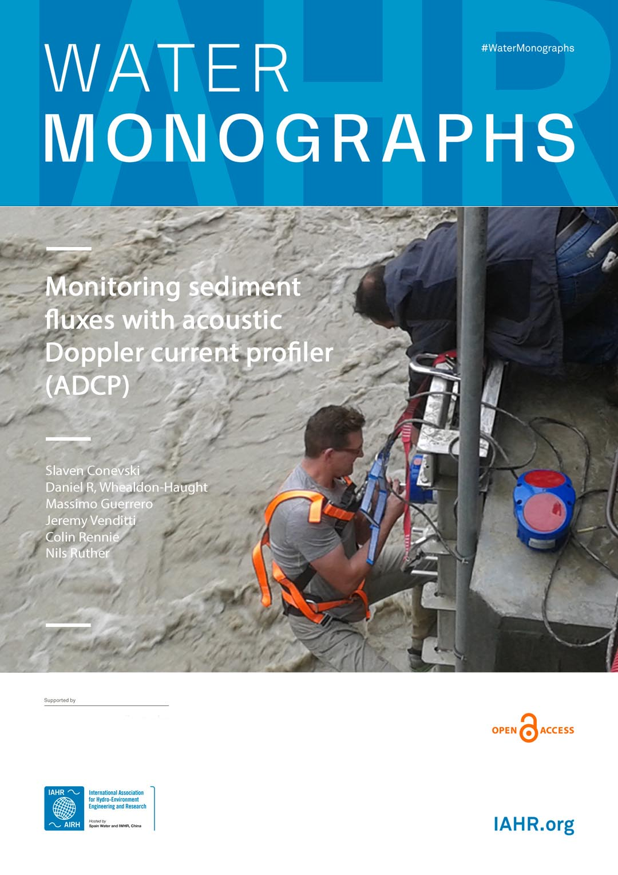
Figure 2: Tentative cover of EMI contribution to Water Monograph Series
Rui Ferreria reported that Optical Flow monograph initially proposed will note be developed because of misalignment between intended content and publication format/timing. A discussion followed on the need of renewing IAHR publication portfolio related to Experimental Methods and possible topics to be covered by Water Monograph Series.
Paolo Salandin proposed possible monograph summarizing specific instruments experience (goods and bads) that could be useful to first time users.

4. EMI electoral process
Election of EMI -LT will take place soon (last third of 2025) to engage new committed members on specific tasks aligned with the strategic plan of IAHR, the strategic plan of EMI and the resulting outcomes from online survey launched in late 2022 within IAHR community.
A call for candidates will be prepared to this scope.

23rd June 2025
Massimo Guerrero, EMI Chair
Margaret Chen, EMI Vice-Chair
Rui M.L. Ferreira, EMI Past Chair

Annex: list of participants to the meeting
LT members
Rui Aleixo (from remote)
Marie Burckbuchler (from remote)
Slaven Conevski
Michael Nones
Tais Yamasaki

Massimo Guerrero, EMI Chair
Rui M.L. Ferreira, EMI Past Chair

Non-LT Members
Gabor Fleit
Flora Pomazi
Nils Ruther
Colin Rennie
Leonardo Schippa
Jochen Aberle
Vladimir Nikora
Leonardo Schippa
Vittorio DiFederico
Paolo Salandin

