Insert your extended abstract title here

Name Surname1, Name Surname2 and Name Surname3

1,3 Affiliation Institution, City, Country, e-mail

2 Affiliation Institution, City, Country, e-mail

ABSTRACT

This document presents the instructions needed to prepare the **2 page- extended abstract (850-1000 words)** in length including figures and references. The various components of your extended abstract [title, text, heads, etc.] are already defined on the style sheet, as illustrated by the portions given in this document. A concise abstract is required. The abstract subsection (in one paragraph of 150 words or less) should briefly state the purpose of the research, the essential new information, the main results, and the principal conclusions. The abstract subsection must be able to stand-alone and references to the manuscript should therefore be avoided. The manuscript must be written in English (including figures and tables) using Arial font. Do not submit any manuscript text smaller than 10 points. **Pages and/or lines must not be numbered.**

**Keywords:**please list a maximum of 5 keywords separated by semicolons and full stop at the end.

1. INTRODUCTION

Please follow the format described here with regard to placement of extended abstract title, length and width of text. These instructions serve as an example for proper manuscript production. The figures can be in color since the extended abstract will be published online.

The authors of the accepted manuscripts must submit the extended abstract before **the deadline** through the [congress website](https://ypcongress.iahr.org).

|  |  |  |
| --- | --- | --- |
|  |  | [1] |
|  |  | [2] |

Table 1. Example of table title.

|  |  |  |  |  |
| --- | --- | --- | --- | --- |
|  | **A** | **B** | **C** | **D** |
|  |  |  |  |  |
| **A** | Aa | Ab | Ac | Ad |
| **B** | Ba | Bb | Bc | Bd |
| **C** | Ca | Cb | Cc | Cd |
| **D** | Da | Db | Dc | Dd |
| **E** | Ea | Eb | Ec | Ed |
|  |  |  |  |  |

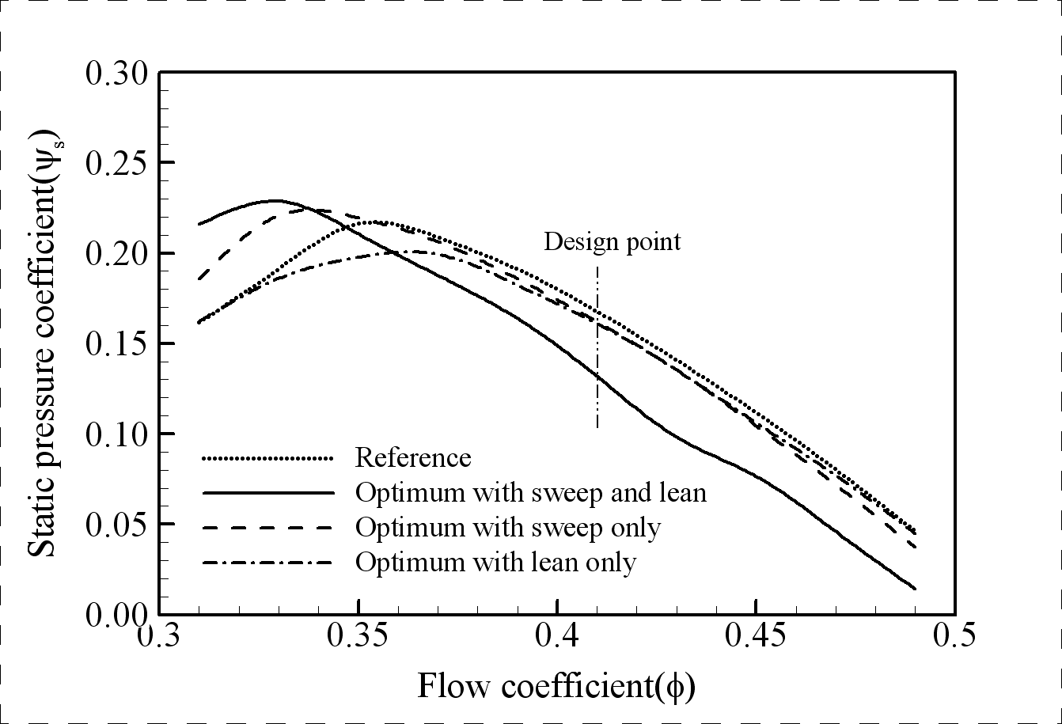

Figure 1. Example of figure title.

1. ANY OTHER POINTS YOU WISH TO ADD
2. CONCLUSIONS

If the formatter still needs to create a component which is not prescribed here, please incorporate applicable criteria that follow the styles provided (e.g., spacing and typeface).

REFERENCES

All references used in the main text should appear together in this section at the end of the extended abstract, listed alphabetically by last name of the first author. Please use Harvard APA 6 or 7 citation standard. Some examples are:

Dong, N.C., Araki, H., Yamanishi, H., and Koga, K. (2005). Simulation of groundwater flow and environmental effects resulting from pumping. *Environmental Geology,* 47 (3), 361-374.

Donelan, M.A. (1978). Whitecaps and momentum transfer. *NATO Conf. on Turbulent fluxes through the sea surface, wave dynamics, and prediction,* Ed. A. Favre and K. Hasselmann, Plenum, NY, 273-287.

Gran, S. (1992). *A course in ocean engineering*. Elsevier, 583 pp.

Hwang, P.A., Hsu, Y.H.L., and Wu, J. (1990). Air bubbles produced by breaking wind waves: a laboratory study. *J. Phys. Oceanography*, 20, 19-28.

**12+1 RULES TO ENSURE YOUR PAPER FOLLOWS THE FORMAT (PLEASE, REMOVE THESE RULES IN YOUR SUBMISSION)**

1. **Read this guide carefully and then, build your paper on it.**
2. **Do not exceed the two pages maximum of the extended abstract length. Longer manuscripts will be returned to the authors for correction.**
3. **Upload your abstract in Word format.**
4. **Do not insert page or section breaks.**
5. **Do not modify the setting of the template (margins, spaces, or sizes).**
6. **Any paper which format is different from the template's setting will be rejected.**
7. **Do not insert any table of contents.**
8. **Please, insert any graphics in picture format.** **Make sure that the text style follows this template and that the text size is readable (not smaller than 10 points).**
9. **Do not use macros or hyperlinks.**
10. **Do not numerate pages and/or lines in the final document.**
11. **Do not use Word’s review mode in the final document.**
12. **Do not modify the header or footer.**
13. **Do not hesitate to** [**contact us**](mailto:iahr.madrid@iahr.org) **for help!**