CSDU-CSSI DAYS 25
II International Conference on Challenges and Perspectives in Urban Water Management Systems
XVIII International Short Course: Water Management in Resilient Cities

The CSDU-CSSI DAYS 25, chaired by Prof. Patrizia Piro and Prof. Bruno Brunone, was hosted by the University of Trieste, Italy, from 17 to 20 November 2025 and organized by the CSDU - Centro Studi iDraulica Urbana - (www.csdu.it) and CSSI - Centro Studi Sistemi Idrici – (www.cssi.unicas.it).
The XVIII International Short Course on Water Management in Resilient Cities, the II International Conference on Challenges and Perspectives in Urban Water Management Systems, and the final event of the SUNRISE Project, were held during CSDU-CSSI DAYS 25 (https://csducssidays25.wordpress.com/). The core idea of the organizers was to create an international forum to promote discussions among researchers, practitioners, and professionals to discuss recent advances in urban water systems.

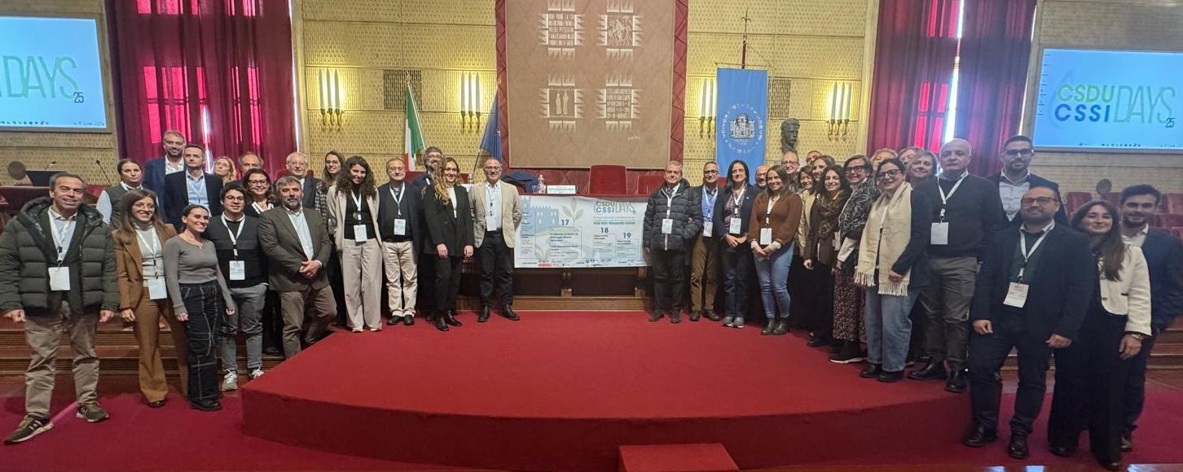
Figure 1: CSDU-CSSI DAYS 25
The XVIII International short courses - Water management in resilient cities (17 November 2025), a training course organized by the University of Trieste in collaboration with Centro Studi iDraulica Urbana (CSDU), funding PNRR-RETURN-SPOKE1, hosted 8 presentations from different experts in the field and a roundtable discussion on resilient water systems.
The II International Conference on Challenges and Perspectives in Urban Water Management Systems (18-19 November 2025) focused on the following main sections: Urban water processes, including the sub-sections Hydrological Dynamics & Climate Change and Water Quality & Environmental Impact of Water Infrastructures; Urban water management, including the sub-sections Sustainable Water Infrastructures & Nature-Based Solutions and Integrated Urban Water Systems & Water Governance. The keynote speakers, whose contributions were highly inspiring, were Prof Petra Amparo Lopez Jiménez from Universitat Politècnica de València, Spain, with a lecture on “Steps for sustainable urban water networks” and Prof Yiping Guo from McMaster University, Canada, with a lecture on “Alternative Computational Approach for the Designing of Low-Impact Development Practices”. A total of forty-five peer-reviewed papers were selected to be presented during the conference and they will be published in a volume of MDPI’s Engineering Proceedings. The “Best Presentation Award” was assigned to Dr. Maria Cristina Morani (University of Naples Federico II) and to Dr. Valentina Marsili (University of Ferrara).
The final event of the SUNRISE (Sustainable Urban areas by Nature-based solutions implementation to mitigate climate impacts and achieve a Resilient, Innovative and Smart Environment) Project (20 November 2025) aimed to present the main findings achieved by this Project, that involves 10 Italian Universities. The SUNRISE Project is a cascading project of the Project Multi-Risk sciEnce for resilient commUnities undeR a changiNg climate” (RETURN) funded under the NRRP, Mission 4 Component 2 Investment 1.3.

Conference “Innovation, Sustainability and Resilience in Urban Drainage Systems”

On October 9, 2025, within the framework of AccadueO, Italy’s leading international exhibition dedicated to the water service sector, held in Bologna, the Centro Studi di Idraulica Urbana (CSDU) organized the conference “Innovation, Sustainability and Resilience in Urban Drainage Systems”.
AccadueO represents a key national and international forum for professionals, institutions, and researchers working on water management, hydraulic engineering, and environmental sustainability.
The conference was highly successful and well attended, fostering a lively exchange of ideas on current challenges and innovative solutions in urban drainage systems.

